# **固件升级-v12.03**

**系统环境**

* ubuntu电脑，安装adb工具，如果已安装，忽略此部分

sudo apt-get update

sudo apt-get install android-tools-adb

* windows电脑，安装adb工具，如果已安装，忽略此部分

参考链接配置：<https://blog.csdn.net/chengyq116/article/details/108291213>

## 🖇️ 文件准备

用户名：share

密码：share

登陆网址：<http://192.168.140.236:8081/#browse/browse>

按需要下载指定日期中的固件，如 X9/aiper-x9/0.1.6/aiper-x9-0.1.6-ota.bin，点击右侧蓝色链接进行下载

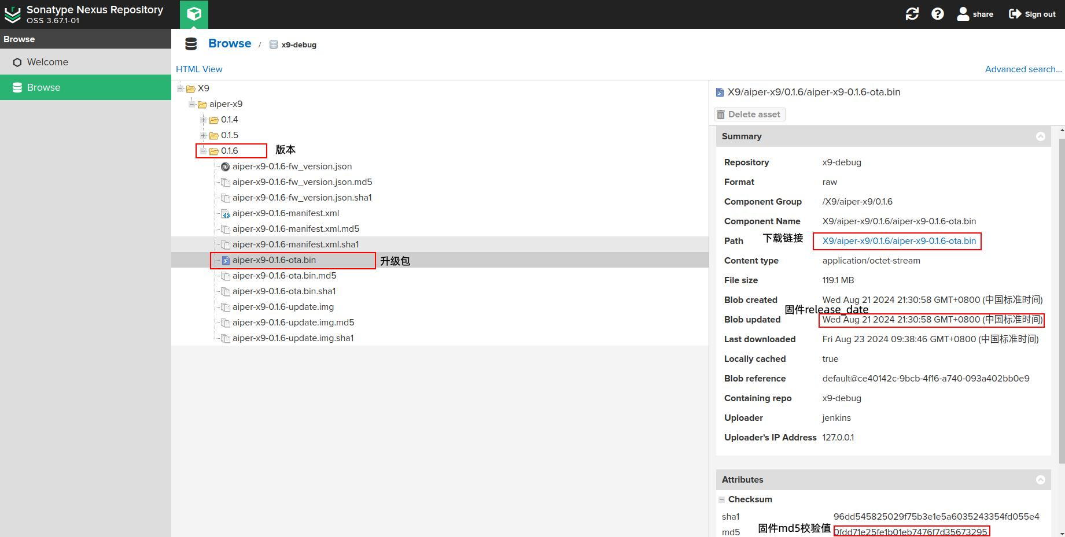

## ⛳ 操作（以ubuntu环境为例）

### **仅升级SOC(升级固件必须以ota.bin命名并放置在 /userdata/ 目录下)**

1. adb方式

adb push aiper-x9-20240523-ota.bin /userdata/ota.bin

adb shell fw_update

1. ssh方式: **机器ip以 192.168.1.1 举例，实际操作请替换自己目标升级设备的ip**

scp aiper-x9-20240523-ota.bin [root@](mailto:root@172.16.140.38)ip[机器ip]:/userdata/ota.bin

//登录机器，密码robot

ssh root@192.168.1.1

//触发升级

fw_update

|  |
| --- |
| **正确升级结果**  [info] 2024-08-02 03:00:10 start 开始升级  [info] 2024-08-02 03:00:45 now is b , set to a 启动分区检查与待切换  [info] 2024-08-02 03:01:20 ota success! 升级成功  [info] 2024-08-02 03:01:20 rm /userdata/root/data_* && reboot 清调试缓存并热重启 |

### **仅升级MCU**

**1.adb方式：**

//主板mcu升级包传输

adb push baseboard_v1.0.9.bin /userdata/baseboard_v1.0.9.bin

//灯板mcu升级包传输

adb push ledboard_v0.0.4.bin /userdata/ledboard_v0.0.4.bin

//进入设备

adb shell

**2.ssh方式：机器ip以 192.168.1.1 举例，实际操作请替换自己目标升级设备的ip**

//主板mcu升级包传输

scp baseboard_v1.0.9.bin root@192.168.1.1:/userdata/baseboard_v1.0.9.bin

//灯板mcu升级包传输

scp ledboard_v0.0.4.bin root@192.168.1.1:/userdata/ledboard_v0.0.4.bin

//登录机器

ssh root@192.168.1.1

**3.设备内，查看工具使用方式及执行MCU升级**

//查看工具使用方式

upgrade_ctl help

upgrade_ctl path_bin version module 0/1[0: running, 1: poweroff]

//执行MCU升级，version请填写与升级包版本一致，module 2 :ota ledboard 3 :ota baseboard

[示例升级ledboard] upgrade_ctl /userdata/ledboard_v0.0.4.bin 0.0.4 2 1

[示例升级baseboard] upgrade_ctl /userdata/baseboard_v1.0.9.bin 1.0.9 3 1

### **一键升级（charge**\mcu\soc）

1. **adb方式：**

//固件包传输

adb push 固件包.bin /userdata/ota.bin

//进入设备

adb shell

//清除升级干扰文件,由于是删除命令,命令一定要使用正确!

rm -rf /userdata/ota/*

//跳过升级限制

touch /tmp/run_ota.mark

//固件包拷贝

cp /userdata/ota.bin /userdata/ota/ota.bin

//触发一键升级

adb shell fw_cut

**2.ssh方式：机器ip以 192.168.1.1 举例，实际操作请替换自己目标升级设备的ip**

//固件包传输,密码robot,首次先拷贝到 /userdata/ 目录下,便于后期重复升级,避免同版本升级的重复推包

scp 固件包.bin root@192.168.1.1:/userdata/ota.bin

//登录机器，密码robot

ssh root@192.168.1.1

//清除升级干扰文件,由于是删除命令,命令一定要使用正确!

rm -rf /userdata/ota/*

//跳过升级限制

touch /tmp/run_ota.mark

//固件包拷贝

cp /userdata/ota.bin /userdata/ota/ota.bin

//触发一键升级

fw_cut 或者 fw_cut &> /dev/null & 前者会持续执行并抛出部分日志,后者需要结合下面命令查看具体进度阶段信息

**结合日志确认升级进展**

robot:~# tail -f /userdata/log/aiper_ota.log

[INFO][2024-11-18 02:34:53] ------> Run ota, extract and update <------(响应命令，启动拆包,留意比对时间戳与触发升级时间点是否一致)

[INFO][2024-11-18 02:34:53] File hasn't been extracted, goon...

[INFO][2024-11-18 02:34:53] Disk space sufficient (2071 MB).

[INFO][2024-11-18 02:34:55] File ota.bin exists, md5: 2332fcf9e0b29be4efd35a81d2469d77

[INFO][2024-11-18 02:34:55] Start extract...

[INFO][2024-11-18 02:35:27] Exec Normal exit with status 0

[INFO][2024-11-18 02:35:27] Extract complete with: basemcu.bin boot.img fw_version.json ledmcu.bin ota.bin rootfs.img

[INFO][2024-11-18 02:35:27] Product match, goon...

[INFO][2024-11-18 02:35:27] Mcu ledboard version = 1.2.3（即将升级 ledboard 版本）

[INFO][2024-11-18 02:35:27] Mcu baseboard version = 1.2.6（即将升级 baseboard 版本）

[INFO][2024-11-18 02:35:27] File extract and json analysis successfully.（升级soc）

[INFO][2024-11-18 02:35:33] Start upgrade mcu ledboard（升级ledboard）

[INFO][2024-11-18 02:36:30] Start upgrade mcu baseboard（升级baseboard）

[INFO][2024-11-18 02:36:45] Check and prepare upgrade soc

[INFO][2024-11-18 02:36:45] Md5 boot match success.

[INFO][2024-11-18 02:36:46] Md5 rootfs match success.

[INFO][2024-11-18 02:36:46] Rm useless files.

[INFO][2024-11-18 02:36:46] Exec Normal exit with status 0

[INFO][2024-11-18 02:36:46] Start upgrade soc（升级soc）

[os_update][info] 2024-11-18 02:36:46 start

[os_update][info] 2024-11-18 02:36:46 now is b , set to a

[INFO][2024-11-18 02:36:49] Update stage1 success.

[INFO][2024-11-18 02:37:05] Update stage2 success.

[os_update][info] 2024-11-18 02:37:06 ota success!

[INFO][2024-11-18 02:37:06] Exec Normal exit with status 0

[INFO][2024-11-18 02:37:06] Update exec success.（soc升级成功）

[INFO][2024-11-18 02:37:19] Triger baseboard reboot device（升级完成,命令mcu进行设备重启,非充电则设备掉电关机,充电则设备自动重启）

设备重启后需要再进行一次版本信息确认

### **校验版本**

robot:~# cat /etc/version

{

"product": "T1 Pro",

"hw_ver": "v2.0",

"fw_ver": "1.15.2.0", 与固件版本一致

"ble_ver": "1.5.1",

"app_ver": "1.15.3",

"mid_ver": "1.15.3",

"navi_ver": "1.15.2",

"slam_ver": "1.15.1",

"basemcu_ver": "1.2.6",

"ledmcu_ver": "1.2.3",

"build_class": "debug",

"release_date": "2024-11-18 02:10:42" 与固件名中时间戳一致, 或与固件下载页面中 'Blob updated 时间匹配相差无几'

}

robot:~# cat /tmp/mcuVer.json

{"base_ver":"1.2.6","led_ver":"1.2.3"} 与上述信息中 "basemcu_ver": "1.2.6", "ledmcu_ver": "1.2.3" 一致 或 与邮件内当前版本mcu的base板、灯板版本一致