**AI Bayes Net Assignment**  S Nishok Kumar

15CS30024

1. Maximum number of edges in a Bayesian Network with n nodes is equal to n(n − 1)/2.

Proof by construction: Consider a BN over X1, X2, . . . Xn such that there is an edge between Xi , Xj∀j > i. The total number of edges in this graph is n − 1 + (n − 2) + . . . + 0 = n(n − 1)/2. To show that you cannot have a directed cycle in this graph, assume the contrary and suppose there is a cycle of the form Xi1 , Xi2 , . . . Xim, Xi1 ; by construction of graph, we have i1 < i2 . . . im < i1 leading to i1 < i1 which is a contradiction. Therefore no cycle exists. Additionally,you cannot construct a BN with more than n(n − 1)/2 edges, since any directed graph with more than n(n − 1)/2 edges should have atleast one pair of vertices for which there is more than one edge implying that you have atleast one edge in both directions resulting in a cycle.

2)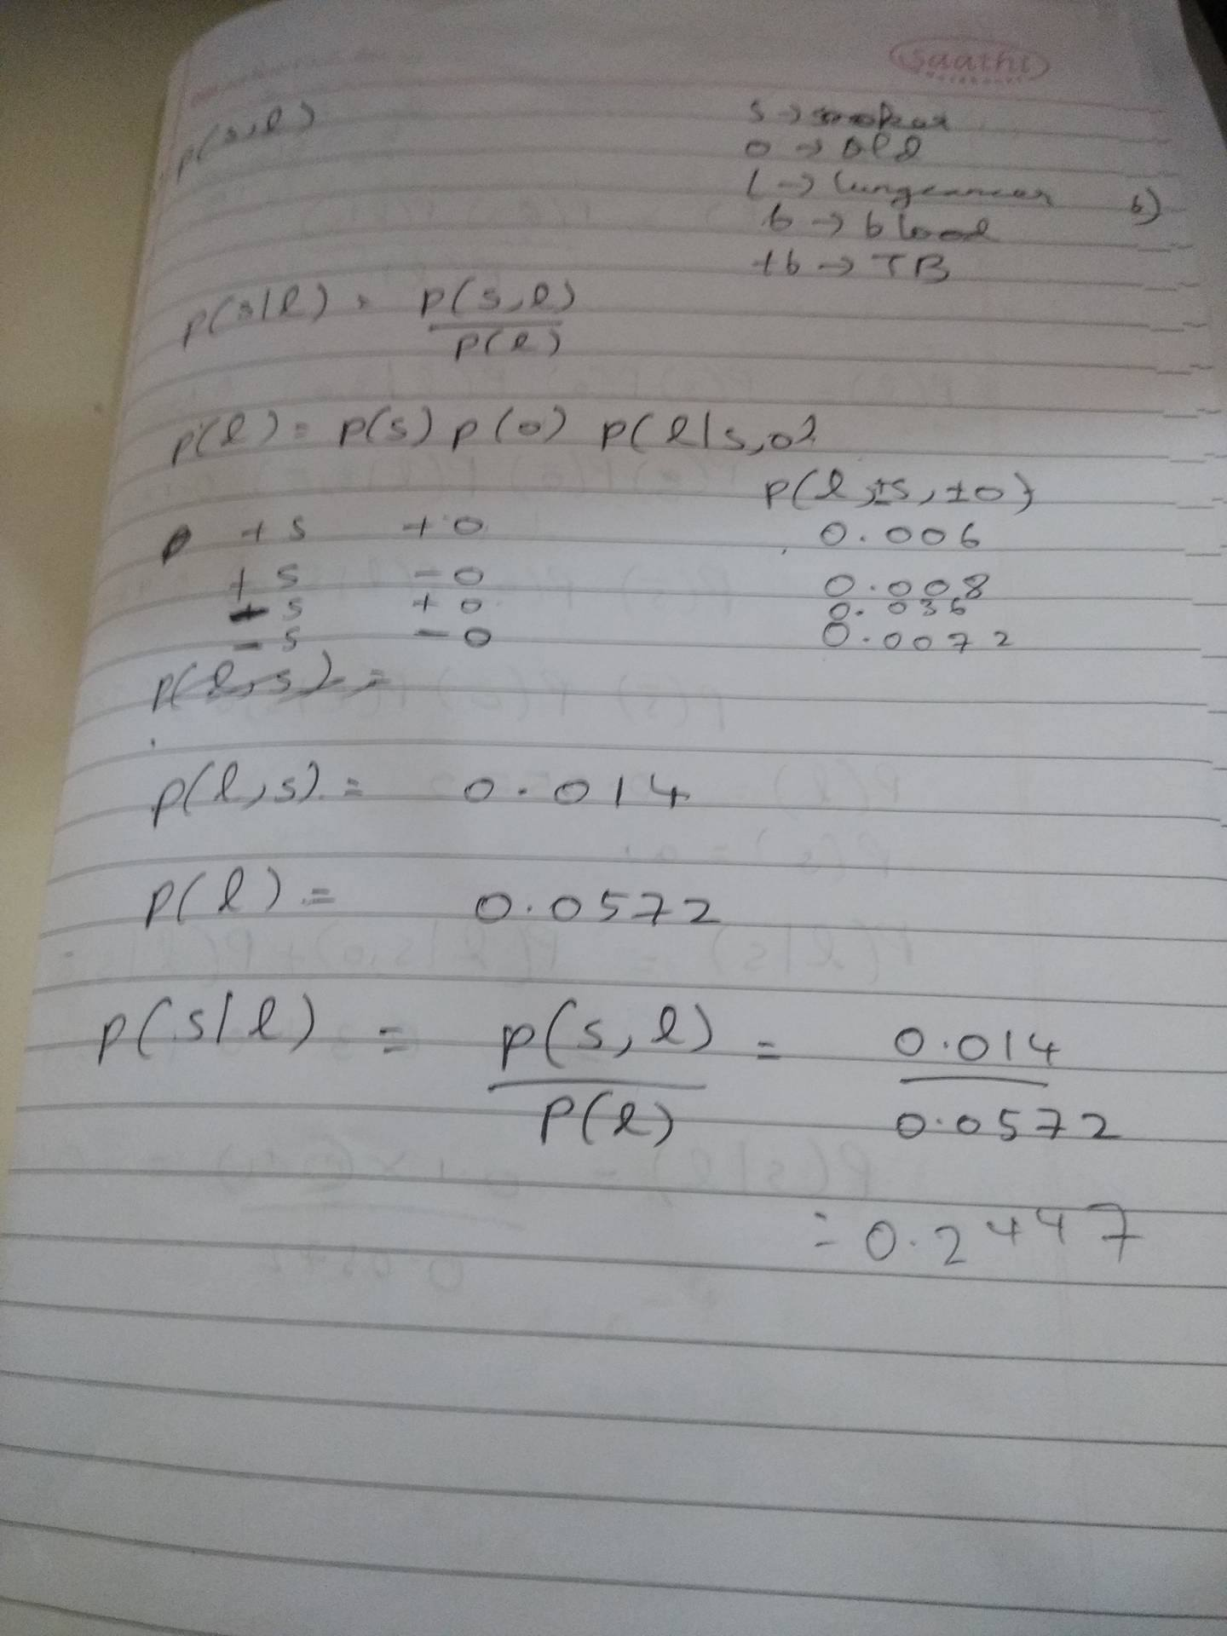

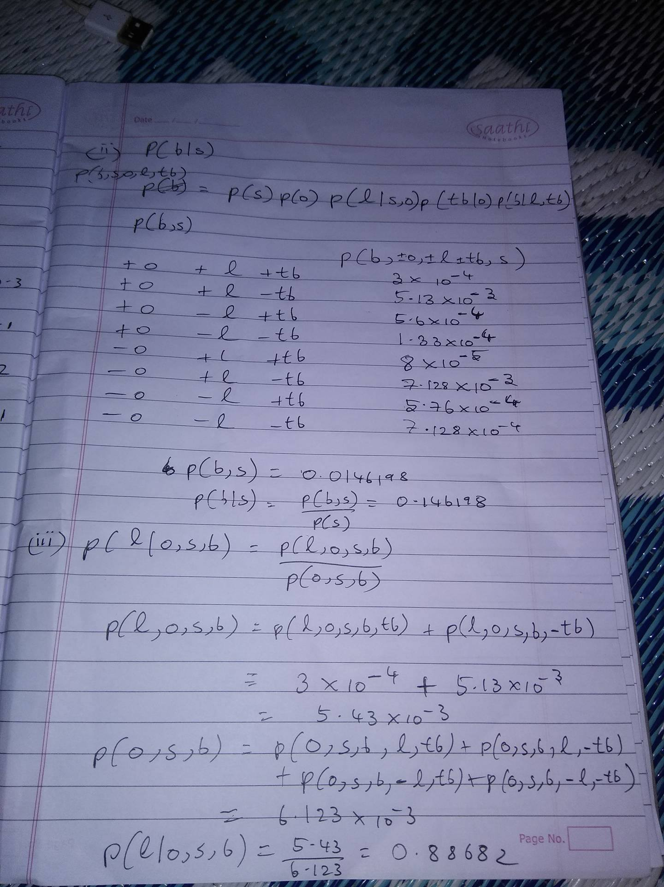

3) 1.For the Bayesian network shown in Figure 1 (a)

• A⊥C | B, D **True**.

All the paths are inactive between A and C.

• B⊥D | A, C **False**.

Notice the v-structure on C; once C is observed the path between B and D is active.

2. For the Bayesian network shown in Figure 1 (b)

• A⊥C | B, D **False**.

There is an active path between A and C once B and D are observed. Notice the v-structure on both B and D.

• B⊥D | A, C **True**.

All the paths between A and C are inactive.

4)

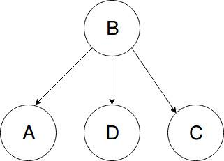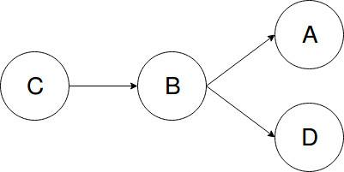

5) a)

i. 5/8

ii. -a +b +c -d

-a -b +c -d

+a -b -c +d

-a +b -c +d

-a -b +c –d

b) −a + b + c − d P(+b | −a)P(−d | +c) = 1/3 ∗ 5/6 = 5/18 = 0.277

+a + b + c − d P(+b | +a)P(−d | +c) = 1/5 ∗ 5/6 = 5/30 = 1/6 = 0.17

+a + b − c − d P(+b | +a)P(−d | −c) = 1/5 ∗ 1/8 = 1/40 = 0.025

−a + b − c − d P(+b | −a)P(−d | −c) = 1/3 ∗ 1/8 = 1/24 = 0.042

P(+c,+a,-d) = 2/3=0.6667

c) Ans=( 5/18+1/24)/(5/18+5/30+1/40+1/24)= 0.625

d) P(D | A) is better suited for likelihood weighting sampling, because likelihood weighting conditions only on upstream evidence.

e) Sequence 1 and Sequence 3 could have been generated by Gibbs Sampling.

Gibbs sampling updates one variable at a time and never changes the evidence. The first and third sequences have at most one variable change per row, and hence could have been generated from Gibbs sampling. In sequence 2, the evidence variable is changed. In sequence 4, the second and third samples have both B and D changing