1. SETUP
   1. 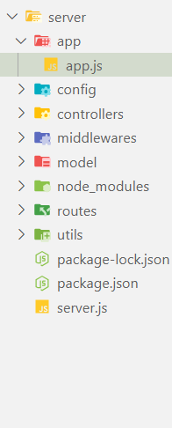
   2. SERVER.JS

import http from 'http';

import app from './app/app.js';

*// create the server*

const PORT = process.env.PORT || 2030;

const server = http.**createServer**(app);

server.**listen**(PORT, console.**log**(`Server is up and running on poprt ${PORT}`));

* 1. APP.JS

import express from 'express';

const app = **express**();

export default app;

* 1. Package.json

{

  "name": "nodejs-api-development",

  "version": "1.0.0",

  "description": "NodeJs Api E-commerce",

  "main": "server.js",

  "type": "module",

  "scripts": {

    "server": "nodemon server.js",

    "start": "node server.js"

  },

  "keywords": [

    "API",

    "NODEJS"

  ],

  "author": "I-Kudo",

  "license": "ISC",

  "dependencies": {

    "express": "^4.19.2",

    "mongoose": "^8.4.1"

  }

}

1. DATA MODELLING
   1. 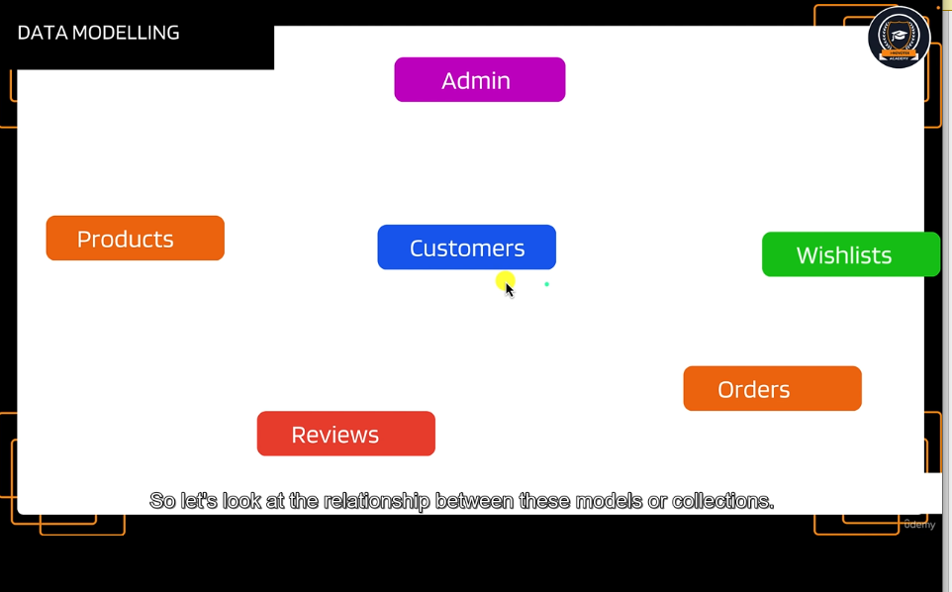
   2. 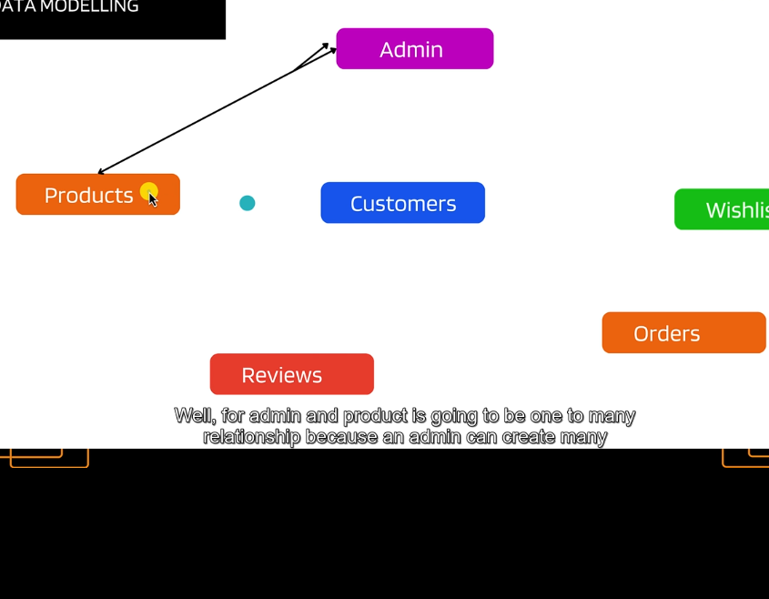
   3. Admin can create many products
   4. 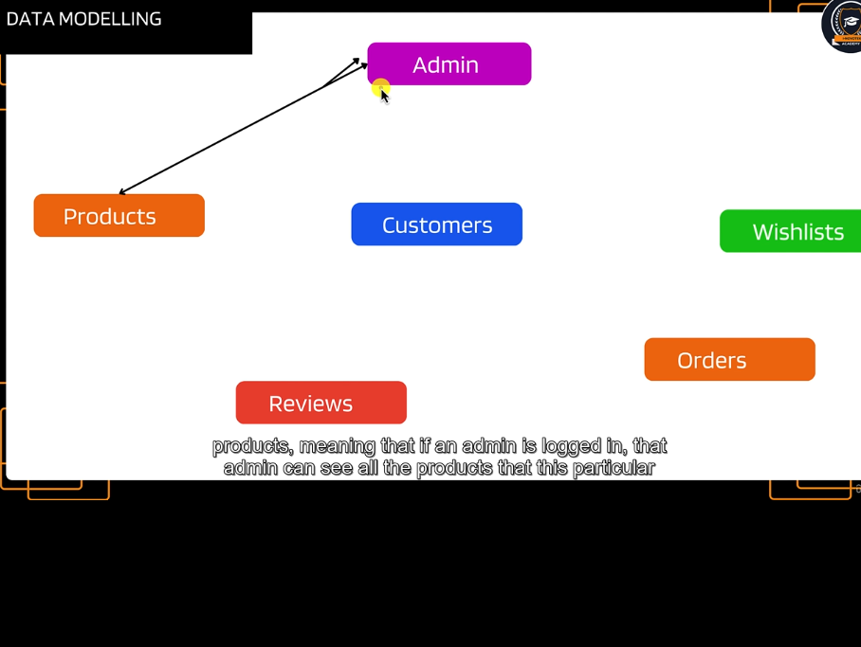
   5. 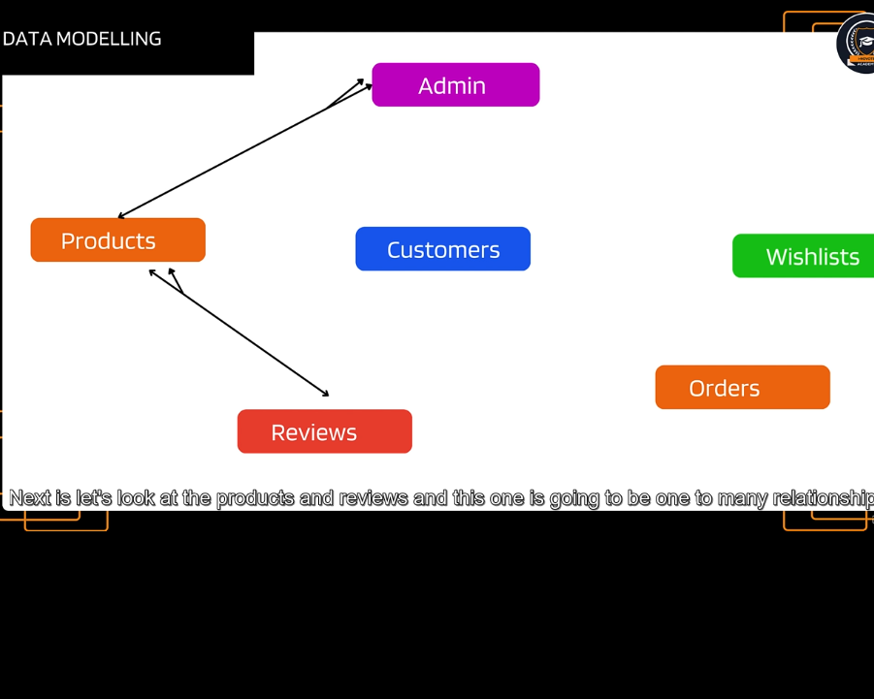
   6. 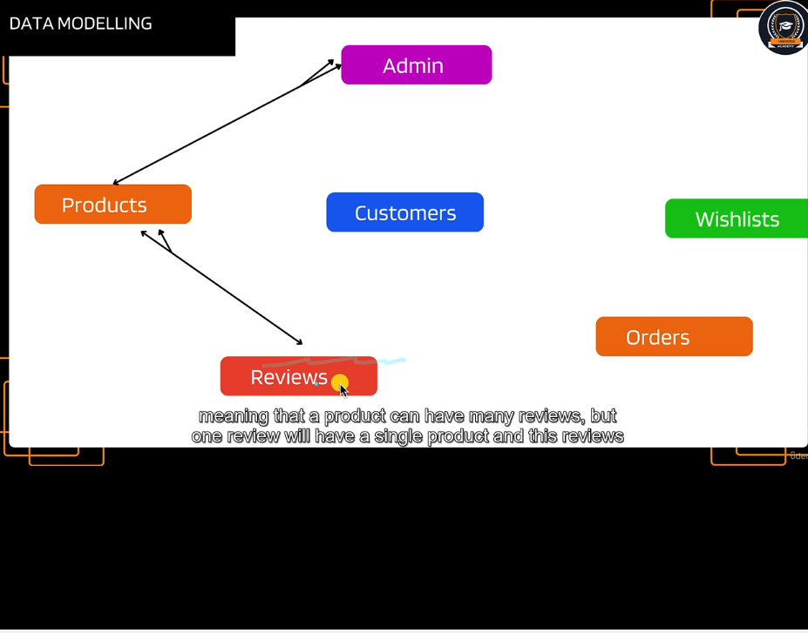
   7. 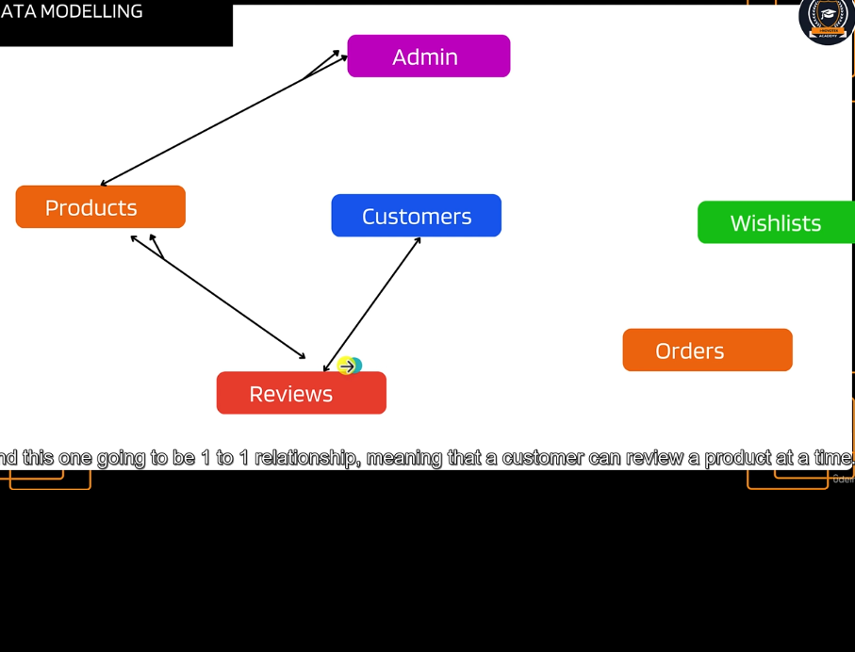
   8. 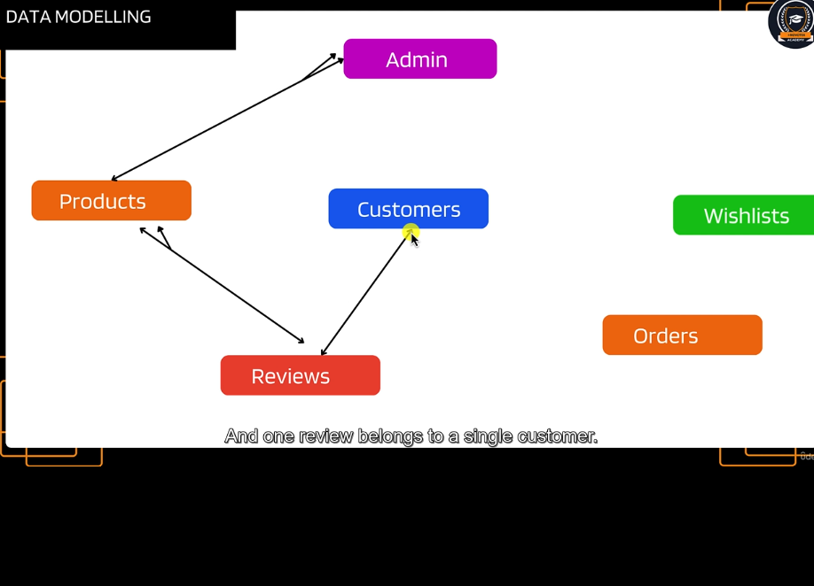
   9. 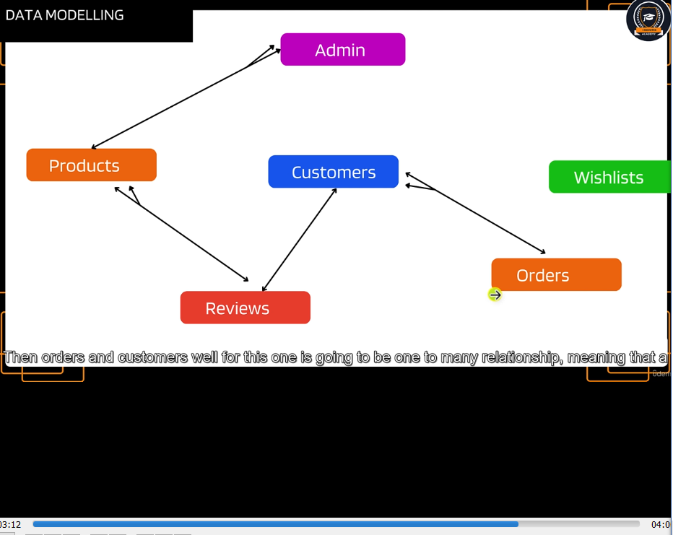
   10. 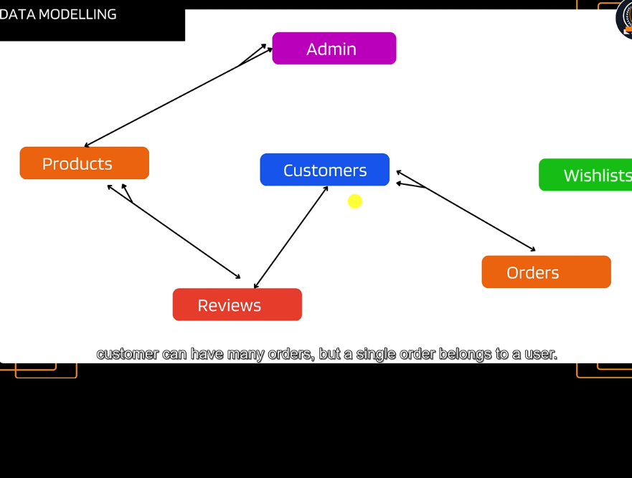
   11. 