2.3 Use cases

This section is insert/delete/edit all information of books. There are a page for librarians when she/he has been login in system can insert/delete/edit from basic to advance information.

2.3.1 Use case : Insert/Update/Delete book information

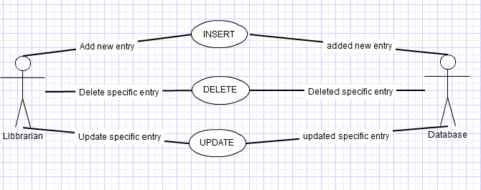

Brief Description:

1. Librarian chooses one in three actions (insert / delete / edit)
2. If action is insert

2.1. Librarian fill information about new book then click submit button.

2.2. This request will send to server. Server will check information is valid, after that new record will be added into database.

3. If actions is delete

3.1. Librarian chooses specific record that wants to delete then click delete button.

3.2. This request will send to server. There are a popup appears and asks for agree or disagree this action.

3.3. If click agreement then the record will be deleted else nothing will be done.

4. If actions is update

4.1. Librarian chooses specific record that wants to update, them click update button

4.2. This request will send to server. Server will check information is valid, after that information will be updated.

5. If action is success, new successful notice will be threw.

## 3.2. Functional Requirements

|  |  |
| --- | --- |
| **Use Case Name:** | Insert/update/edit book information |
| **Priority** | Essential |
| **Trigger** | Menu selection |
| **Precondition** | Is login with librarian’s account |
| **Basic Path** | 1. Librarian sends request to server. 2. Server send this request to database. |
| **Alternate Path** | N/A |
| **Postcondition** | The change in database |
| **Exception Path** | If request is not valid, there no change in database |
| **Other** |  |
| **Reference** | SRS 2.3 |