Problem 1:

1.A

2.A

3.B

4.A, D

5.A

Problem 2:

1.A

2.C

3.A

4.D

5.A

Problem 3:

Problem 4:

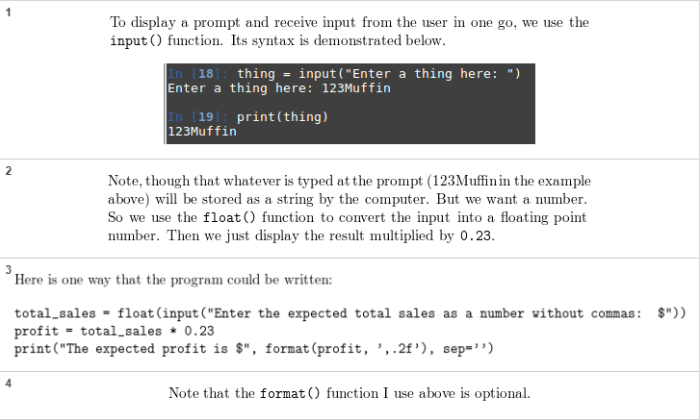



Problem 5:

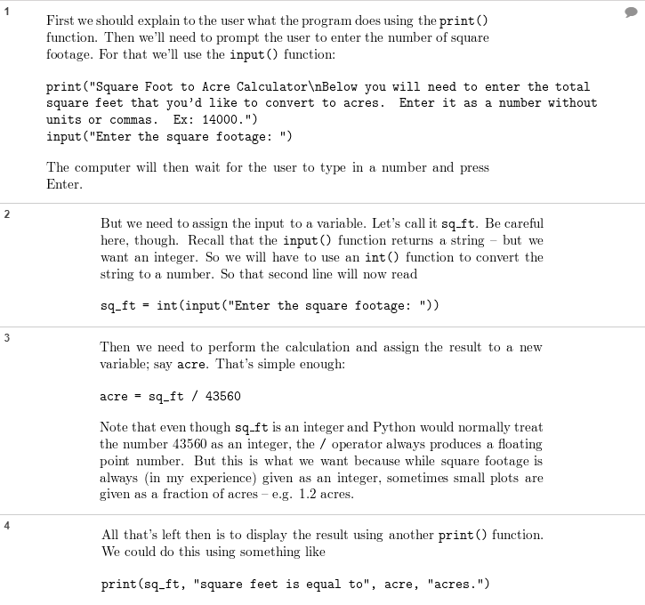

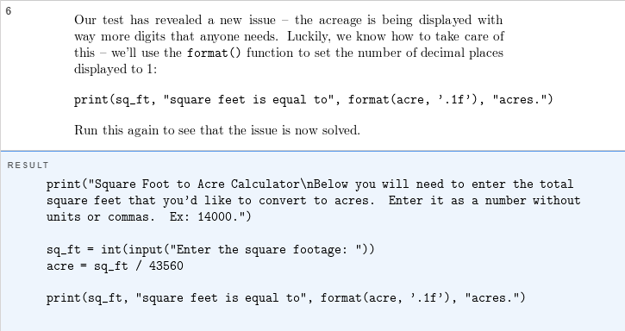

Problem 6:

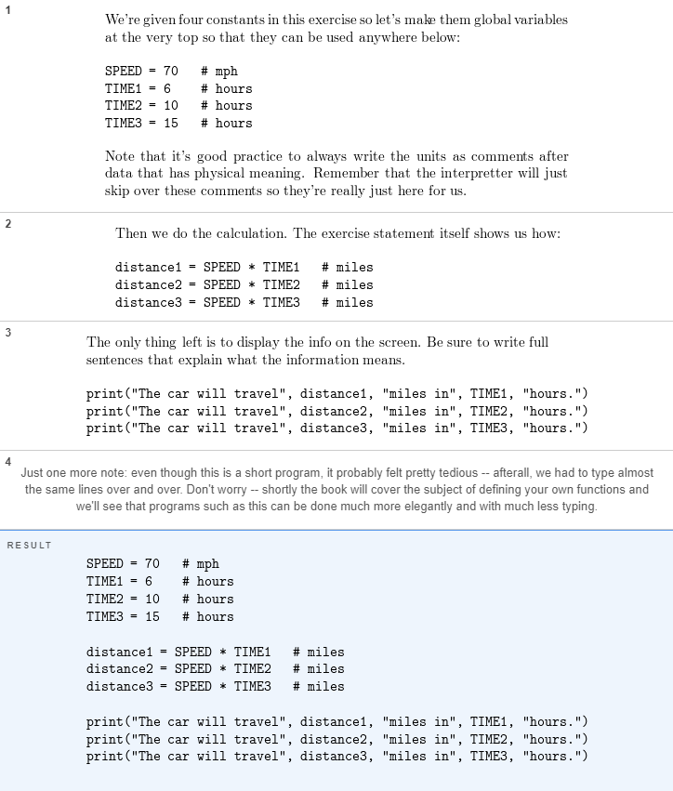

Problem 7:

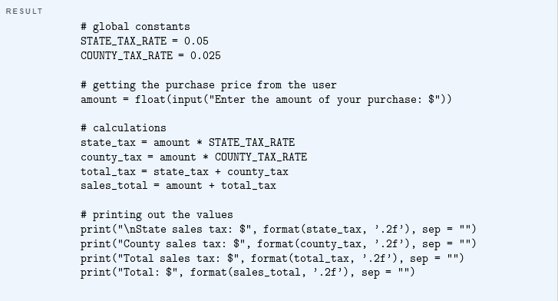

Problem 8:

