**INSTRUCTION FOR USER**

**SPONSOR BY**



|  |  |
| --- | --- |
| Author: |  |
| Vũ Hải Anh | EM-NU17B K63 |
| Nguyễn Quang Anh | IT1 02 |
| Nguyễn Đắc Việt Hà | EM-NU17B K63 |

**TABLE OF CONTENT**

**PART 1: OPERATION OF THE SOFTWARE** 3

**1. Main components** 3

***1.1 Excel file “data”*** 3

***1.2 Excel file “coordinate”*** 4

***1.3 Excel file “result”*** 4

**2. How it works** 4

**PART 2: USER MANUAL** 6

**1. Steps to optimize the distance on the software** 6

**2. Steps to remove added locations and change fleet capacity** 9

***2.1 Delete the location*** 9

***2.2 Change fleet’s capacity*** 11

# **PART 1: OPERATION OF THE SOFTWARE**

## **1. Main components**

To use the software fluently, users must first understand the operating process of the software. When the user downloads and unzips the software file, it will have the following main components:

* Folder extracted from the software's rar file
* Folder “data” contains input data of the software
  + Excel file “data” contains the matrix of customer distances and current fleet capacity of the business
  + Excel file “coordinate” contains coordinates of customer points
* Folder “result” contains output data for each run of the software

### ***1.1 Excel file “data”***

* File excel “data” contains 2 sheets:
  + Sheet 1: contains the distance matrix. Distance matrix is ​​a square matrix representing the distance between any two points (km) like the figure below:

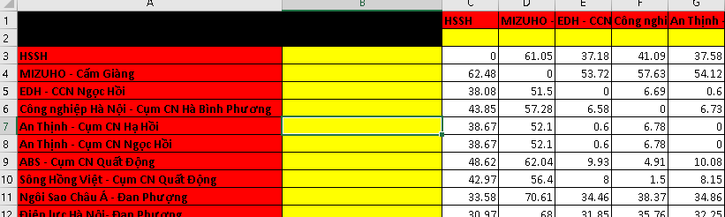

**The red column** represents the departure point, **the red row** represents the destination, note that the software will read the customer's name from the red column and row to display on the software.

**Yellow columns and rows**, users can freely enter information without affecting the software (For example, customer's phone number, specific address ...)

**The white cells** represent the distance traveled by car between the two respective locations of the row and column, the algorithm will read these cells to optimize the distance. For example, cell D3 shows that the distance traveled by car between Ha Binh Phuong Industrial Park and Mizuho is 57.28km.

* + Sheet 2: is the fleet of vehicles classified by capacity (kg). Like sheet 1, the software will read the capacity of each vehicle in the red boxes. For example, in the picture below, the business has vehicles with capacity from 1 ton to 15 tons. For the yellow box, the user can arbitrarily adjust without affecting the software.



### ***1.2 Excel file “coordinate”***

The excel file “coordinate” contains the coordinates of each customer point. The red and white cells also have the same function with sheet 1 in the "data" excel file. For example, in the following figure, column A represents the place name, and columns B and C represent the longitude and latitude respectively.

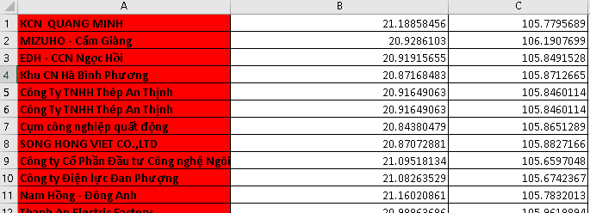

### ***1.3 Excel file “result”***

The excel file “result” records the result after each run the results. Details will be mentioned in the next part.

## **2. How it works**

How the software works is shown in the figure below:

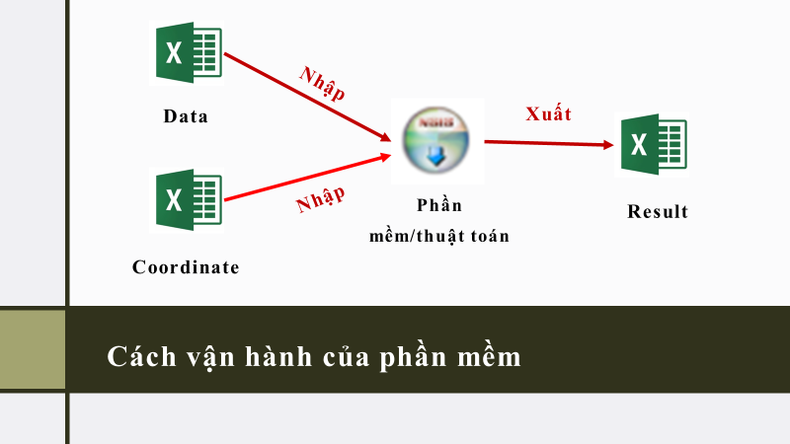

First, the software will get the data from the matrix of distance and fleet capacity in the excel file “data” and customer coordinates in the file “coordinate”. Then use genetic algorithms to find the most optimal route and fleet to serve customers with different demands. The results will be exported to the excel file “Result” for convenient tracking and data retrieval.

**The result after running will be a fleet of vehicles and the optimal route for each vehicle to satisfy the customer's demand load (green point). The optimal route has the beginning and the end point located in the depot (black point).**

# **PART 2: USER MANUAL**

## **1. Steps to optimize the distance on the software**

Images in the manual refer to Vietnamese version. The english version looks almost the same, users still can use this manual for both version of the software.

**B1:** The user clicks on “Add new location” to add the delivery locations and the warehouse from which the vehicle will depart and return.

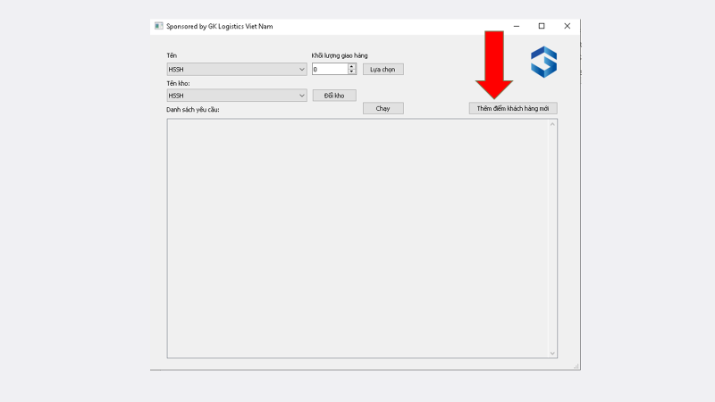

**B2:** The user enters the names and coordinates (longitude and latitude) of the places that the vehicle will visit (depots and customers), then clicks “Add”

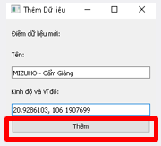

Users do the same with other locations. As shown below we can see the added locations displayed in the “Customers’s name” scroll bar.

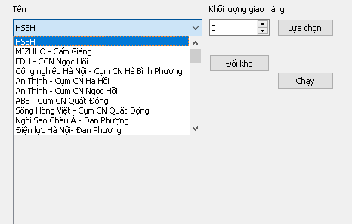

**B3:** The user selects the depot by selecting the point from the "Depot’s name" scroll bar and clicking "Change depot"

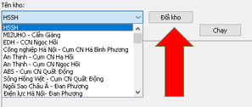

**B4:** To add delivery locations, the user also selects the name of the place to be delivered in the "Customer’s name" scroll bar, enters the volume to be delivered (in kg) to that location and click "Select"

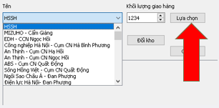

Do the same with other delivery locations and we have a list of locations to deliver as shown in the image below. Users can optionally delete the location in the list or edit the delivery volume by clicking "Delete" or entering a new delivery quantity and clicking "Edit" (blue box).

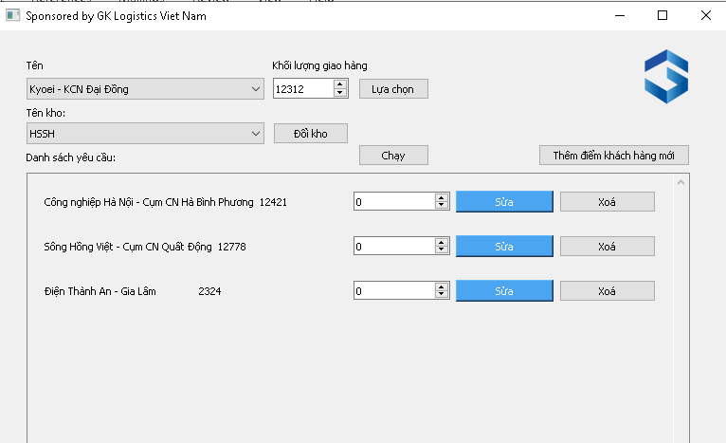

**B5:** Users click "Run" to run the software to solve the optimal road and fleet, the resulting dialog box will appear as shown in the figure.

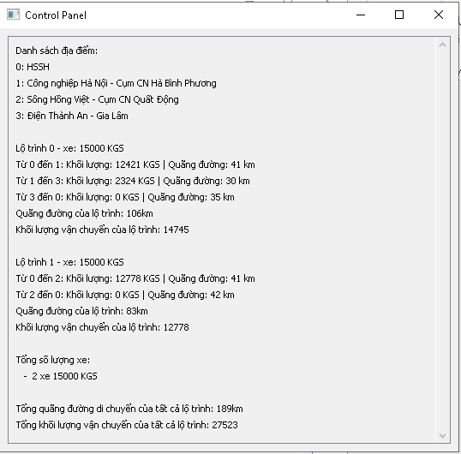

The results are also saved in the excel file “Result” (in the Result folder) for easy data retrieval and processing later. **Do not open the excel file and run the software at the same time.**



## **2. Steps to remove added locations and change fleet capacity**

### ***2.1 Delete the location***

Because the software still does not support the feature of deleting locations on the interface, users will have to delete data directly on excel files "data" and "coordinate"

**B1:** Open file excel “data” và file excel “coordiante”

**B2:** In both excel files, the user deletes all columns and rows of the location need to be deleted (select columns or rows, right-click and select "Delete"). As in the picture below will be the point “Mizuho-Cam Giang”

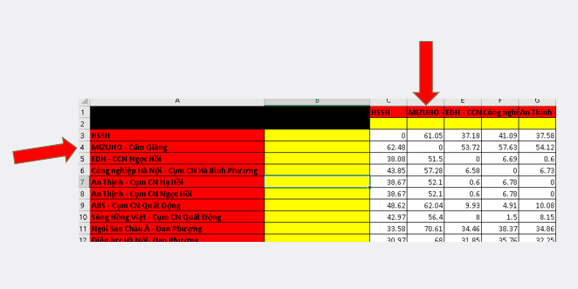

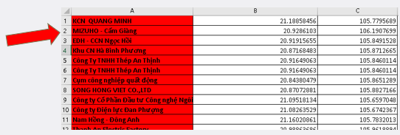

The excel file after deleting

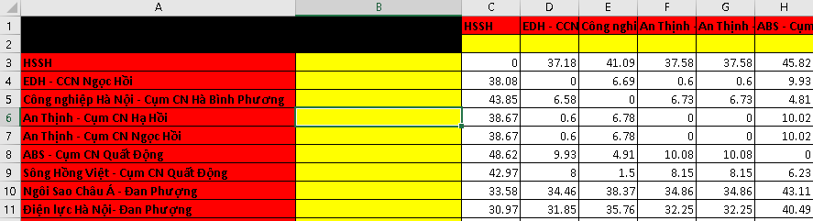

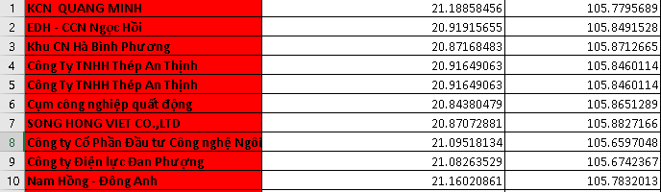

**B3:** When the user opens the software, the "Mizuho-Cam Giang" point will no longer be displayed in the scroll bar

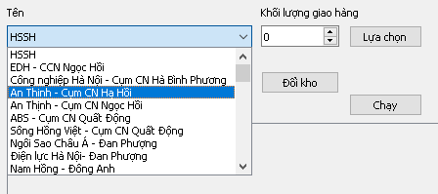

### ***2.2 Change fleet’s capacity***

Users only enter or change data in the red box. For example, we have a fleet of vehicles with a capacity from 1 ton to 15 tons



However, we want to add vehicles with a capacity of 16 tons and 18 tons, users just need to enter the new capacity in the red boxes as shown in the image below.



**After changing data on excel files, users must save the changes before exiting.**