PRACTICAL EXAMINATION 02
Subject code: FER202 – SU25
Duration: 85 minutes
You need to create a motorbike management application using JSON Server, ReactJS, Hooks, React Router, and React Bootstrap. The application should include the following functionalities:
- Create a ReactJS Application. (0.5 marks)
- Initialize a new ReactJS project named fer202-02
- Create and configure JSON Server (0.5 marks)
- Create a db.json file in the root folder to initialize a mock server with the motorbike and user account data as file attachment in Given folder.
- Create a Login Form. (3 marks)
- Create a login form with 2 input fields: Username, Password. (2 marks)
  - Check the validity of the login credentials.
  - If the user enters the correct username and password, a modal should appear displaying the message 'Welcome, <username> login successful!'.
Then redirect to the motorbike list page.
  - If the username or password is incorrect, an alert should appear with the message "Invalid username or password!".
  - Clicking the Cancel button clears all input fields and removes any displayed alerts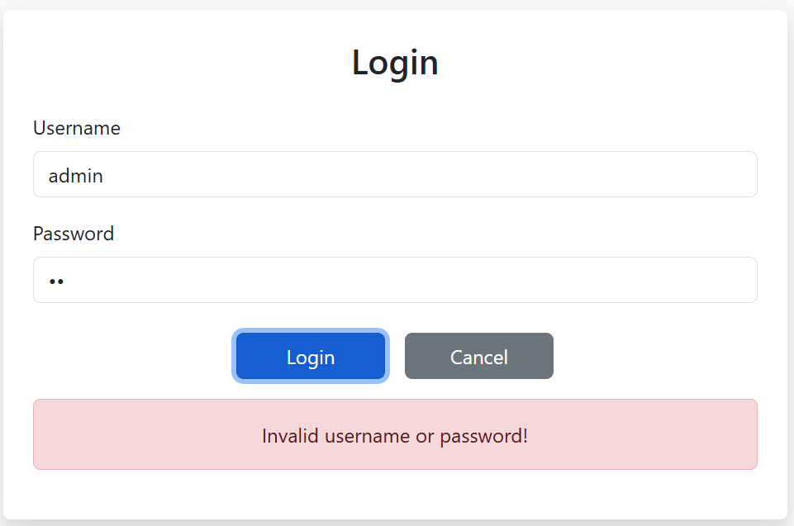
- Use PropTypes to ensure: (1 mark)
  - The setUser function is passed correctly as a required prop.
  - The username and password fields are both strings and are required.
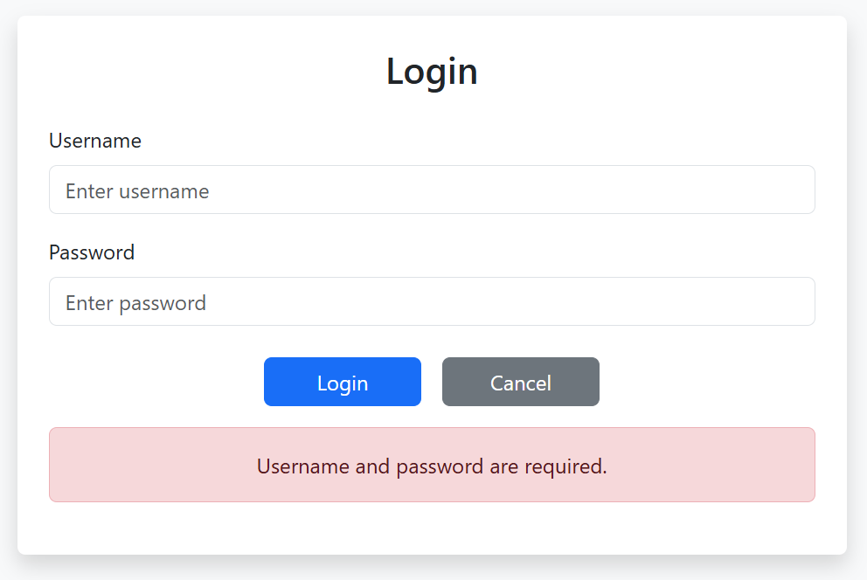
- Create Motormotorbike Management Form (5 marks)
- Use React Router with routes (0.5 mark)
  - /motorbikes
  - /view/:id
  - /cart
- Motorbike list page (/motorbikes) (1 mark)
  - Fetch and display motorbike details (brand, model, year, price, image) from the JSON Server.
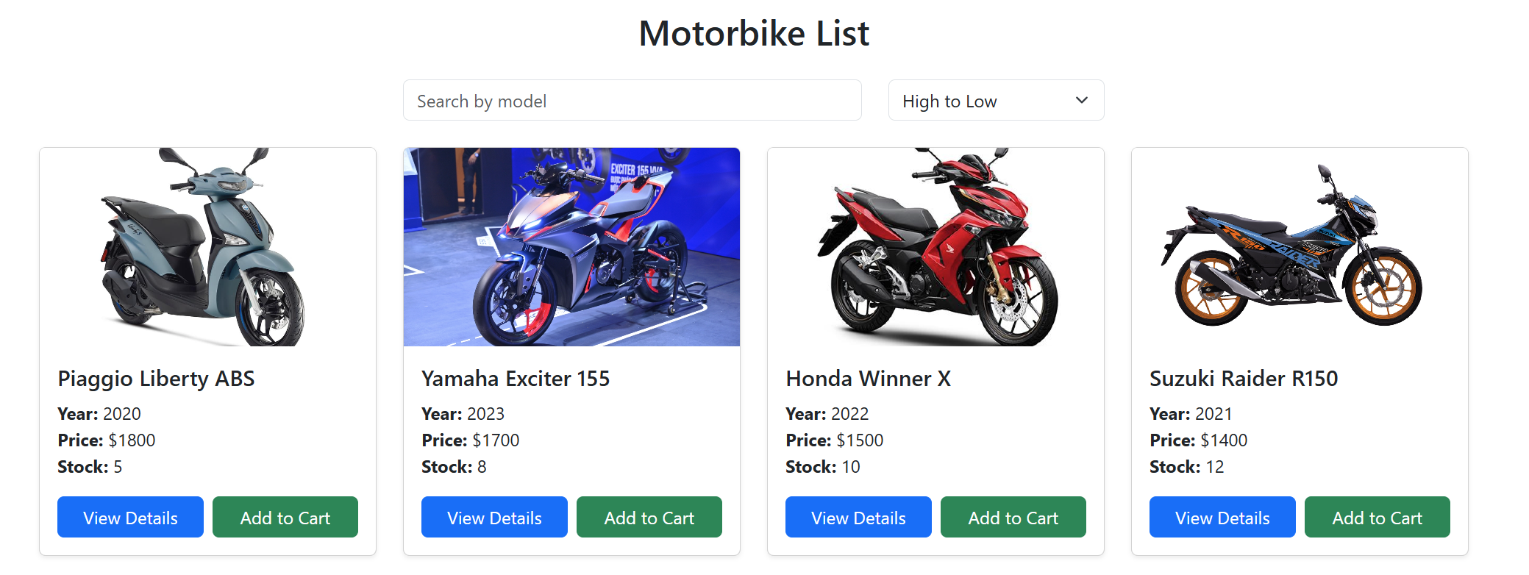
- View motorbike page (0.5 mark)
  - Each motorbike in the list should have a "View Details" button.
  - When clicked, it should display the information of the motorbike.
  - The URL should contain the motorbike id as a parameter, e.g., /motorbikes/:id.
  - If the motorbike with the given id is not found, show a 404 Not Found Page.
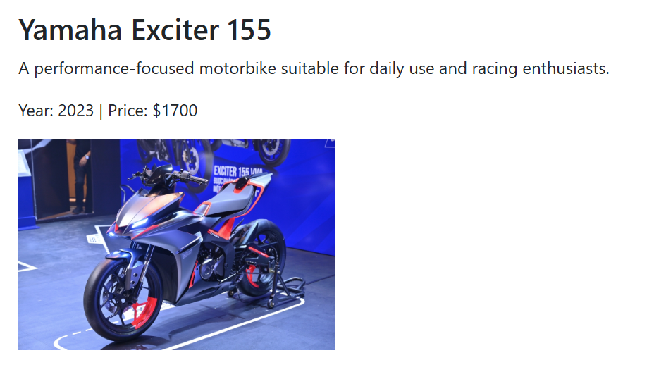
- Search by Name and Sort by Price (1 mark)
  - Search the motorbike by Model (0.5 mark)
  - Sort by price by Price (0.5 mark)
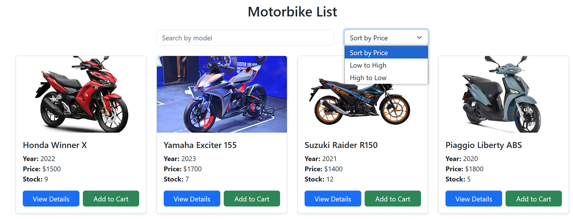
- Add to Cart (1 mark)
  - Add the selected motorbike to cart context/state.
  - Decrease motorbike stock by 1 in JSON Server.
  - Clicking the View Cart button redirects to cart page.
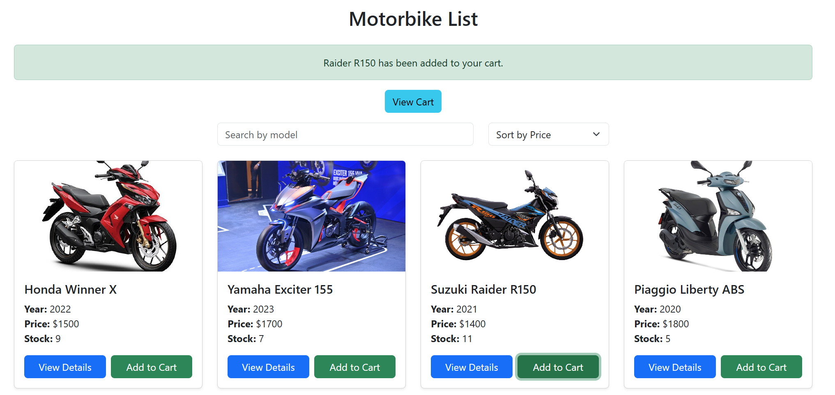
- Cart Page (/cart) (1 mark)
  - Display items in the cart: Title, quantity, subtotal, and total amount.
  - Update the quantity of the motorbike in the cart
  - Option to remove motorbike from cart (restores stock).
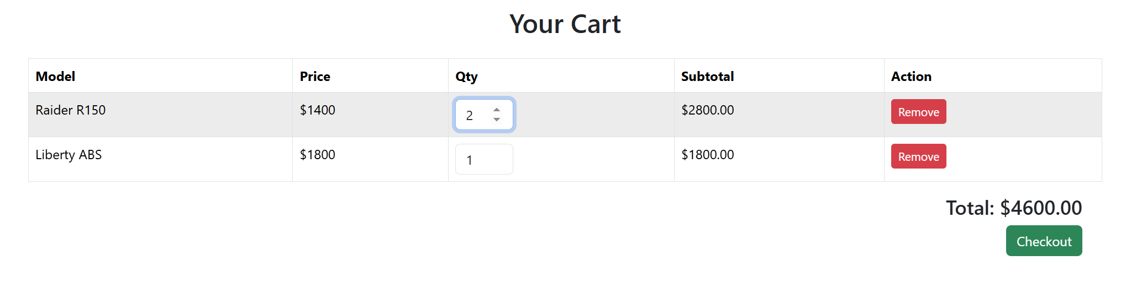
Technical Requirements (1 mark)
- Use React Bootstrap to style the interface and ensure that the application is responsive on mobile devices.
- Ensure that all components are properly validated using PropTypes.
- Use axios or fetch to interact with JSON Server.
- Use useReducer and useContext to manage:
  - Cart state
  - Global bike list
Notes:
- Students need to install and configure all required packages before the test, such as: json-server, react-router-dom, react-bootstrap bootstrap, prop-types, axios, …
- Students are allowed to use resources on their computer, but may only use the Internet to submit their exam.
- If identical test results are detected, the student's work will receive a score of zero.
- If the answer to each question is incorrect or doesn't produce the correct result, the student's work will receive a score of zero.
You must submit a folder that includes your project folder (excluding the node_modules folder) and a Word file named "fer202" that contains snapshots of all your code and results related to each question. Then, compress the folder into a ZIP file named "fptu_fer202.zip" and upload it to the PEA application.

