Developer Attrition-Risk Analytics
A Multivariate Analysis of Job-Seeking Behavior Among Professional Developers (2019 Stack Overflow Developer Survey)
HR People Analytics Report | October 2026

1. Introduction & Motivation
Developer turnover is one of the costliest and least predictable forms of attrition in the technology sector: replacing a mid-level engineer typically costs 50-200% of annual salary once recruiting, onboarding, and lost productivity are counted. Because resignation decisions build up over months, HR teams need early, data-driven signals of who is at risk of leaving - not just exit-interview hindsight. This report uses the Stack Overflow Annual Developer Survey, a large, standardized, cross-company survey of working developers, as a proxy for a company-wide engagement/exit-risk survey, and asks three questions a retention team would ask of its own population:
- Do developer profiles (pay, experience, satisfaction, workload) differ between those who are job-seeking and those who are not, and does that difference vary by country?
- Which measurable factors drive job-seeking behavior, in effect sizes an HR partner can act on?
- Can the developer population be segmented into a small number of actionable talent profiles for targeted retention strategy?

2. Data & Variables
Source: Stack Overflow Developer Survey 2019 public results (https://survey.stackoverflow.co/, archived under the StackExchange/Survey GitHub repository, ODbL 1.0 licence), 88,883 raw responses. The 2019 wave was selected for its stable schema and large N.

2.1 Filtering and sample construction
The raw file was filtered to MainBranch = "I am a developer by profession" and Employment = "Employed full-time" (55,405 respondents), then restricted to the five largest countries by respondent count - United States, India, United Kingdom, Germany, Canada (29,851 respondents). After deriving the analysis variables, rows with any missing value on an analysis variable were dropped (complete-case analysis: 29,851 -> 17,847, a 40.2% drop driven mainly by CodeRevHrs (23.4% missing - many respondents are not asked or do not do code review) and ConvertedComp (19.4% missing - compensation questions are routinely skipped)). A reproducible random subsample of N = 8,000 was then drawn (seed = 42) for computational tractability, matching the brief's target of n ~ 5,000-10,000.

2.2 Variable treatment
ConvertedComp (USD/year, adjusted by Stack Overflow) was floored at >0, capped at the 99th percentile to tame currency-conversion and self-report outliers, and log-transformed (logComp) to correct its strong right skew. YearsCodePro and CodeRevHrs were parsed from free-text buckets ("Less than 1 year"->0.5, "More than 50 years"->51); CodeRevHrs was capped at its 99th percentile (20.0 h/week). WorkWeekHrs was capped at 100 h/week per the brief and non-positive values treated as missing. Age was restricted to a plausible working-adult range [16, 75]. JobSat (5-point Likert: Very dissatisfied ... Very satisfied) was coded 1-5, justified because the response categories are equally spaced verbal anchors, a standard treatment for ordinal survey items in parametric models.
Outcome (JobSeek): the source item has three levels. We coded "I am actively looking for a job" and "I'm not actively looking, but I am open to new opportunities" as job-seeking risk = 1 (both represent real flight risk from an HR standpoint - passive candidates convert easily when approached), and "I am not interested in new job opportunities" as 0. This mapping is the single most consequential data decision in the report and is stated here explicitly so results can be re-derived under an alternative (stricter) mapping if desired.
Factors used for grouping/profiling: Country, EdLevel, Hobbyist, OrgSize.

2.3 Missingness and final sample
Table 1. Missingness (%) on the filtered, pre-cleaning sample (N=29,851), analysis variables
variable | % missing
CodeRevHrs | 23.41
ConvertedComp | 19.42
Age | 9.81
WorkWeekHrs | 8.35
OrgSize | 2.76
EdLevel | 1.75
YearsCodePro | 0.8
JobSat | 0.43
JobSeek | 0.0
Hobbyist | 0.0
Final analysis sample: N = 8,000. Class distribution of the outcome: 67.6% job-seeking (actively looking or open), 32.4% not interested. Country composition: United States 4,250 (53.1%), India 1,122 (14.0%), United Kingdom 1,053 (13.2%), Germany 979 (12.2%), Canada 596 (7.5%).

3. Exploratory Analysis
Table 1 summarizes the five numeric variables used in the MANOVA/PCA blocks (plus CodeRevHrs) by job-seeking status. Job-seekers report markedly lower job satisfaction (3.51 vs 4.48 on the 5-point scale), somewhat lower pay (median ~$73k vs ~$105k implied by mean logComp) and fewer years of professional experience, consistent with early/mid-career dissatisfaction being the dominant visible signal.
Table 2. Descriptive means of numeric variables by job-seeking status (N=8,000)
 | Mean (Not interested) | Mean (Seeking/Open)
logComp | 11.56 | 11.2
YearsCodePro | 9.0 | 8.29
WorkWeekHrs | 41.59 | 41.36
Age | 32.17 | 31.69
JobSat_num | 4.48 | 3.51
CodeRevHrs | 4.35 | 4.71
Table 1b (correlation matrix) motivates the PCA in Section 5: YearsCodePro and Age are very strongly correlated (r=0.86), as expected (career tenure tracks age), while logComp correlates moderately with both (r~0.26-0.27). JobSat and CodeRevHrs are nearly orthogonal to the seniority/earnings block, suggesting at least two to three independent dimensions in the data.
Table 3. Correlation matrix of the numeric block (N=8,000)
 | logComp | YearsCodePro | WorkWeekHrs | Age | JobSat_num | CodeRevHrs
logComp | 1.0 | 0.261 | 0.075 | 0.273 | 0.109 | -0.114
YearsCodePro | 0.261 | 1.0 | 0.08 | 0.859 | 0.003 | 0.01
WorkWeekHrs | 0.075 | 0.08 | 1.0 | 0.069 | -0.006 | 0.113
Age | 0.273 | 0.859 | 0.069 | 1.0 | -0.002 | -0.017
JobSat_num | 0.109 | 0.003 | -0.006 | -0.002 | 1.0 | -0.023
CodeRevHrs | -0.114 | 0.01 | 0.113 | -0.017 | -0.023 | 1.0

4. MANOVA Results

4.1 One-way MANOVA: DVs ~ JobSeek
DVs = [logComp, YearsCodePro, WorkWeekHrs, Age, JobSat]; factor = JobSeek (seeking/open vs. not interested).
Table 4. One-way MANOVA: JobSeek effect on the 5-variable profile
Statistic | Value | F | Num DF | Den DF | p
Wilks' Lambda | 0.8562 | 268.49 | 5 | 7994 | <.0001
Pillai's Trace | 0.1438 | 268.49 | 5 | 7994 | <.0001
Hotelling-Lawley Trace | 0.1679 | 268.49 | 5 | 7994 | <.0001
Roy's Greatest Root | 0.1679 | 268.49 | 5 | 7994 | <.0001
The one-way MANOVA is highly significant (Wilks' Lambda=0.856, F(5,7994)=268.49, p<.0001): job-seekers and non-seekers have reliably different multivariate profiles across pay, experience, hours, age, and satisfaction jointly, not just on any single variable. Because the omnibus test is significant, we proceed to univariate follow-up ANOVAs (Table 2b).
Table 5. Univariate follow-up ANOVAs (one DV at a time)
DV | F | p | mean_seeking | mean_notint
logComp | 144.226 | 6.0810289854368564e-33 | 11.203 | 11.565
YearsCodePro | 16.077 | 6.135591230125799e-05 | 8.292 | 9.003
WorkWeekHrs | 1.471 | 0.225154310246464 | 41.356 | 41.587
Age | 6.244 | 0.0124837375304261 | 31.691 | 32.166
JobSat_num | 1235.962 | 6.643101439141611e-252 | 3.513 | 4.476
JobSat (F=1235.96, p<.0001) and logComp (F=144.23, p<.0001) carry almost all of the multivariate signal; YearsCodePro and Age are significant but with small effect sizes, and WorkWeekHrs does not differ reliably by group (p=0.225) - job-seekers are not simply the overworked.

4.2 Two-way MANOVA: JobSeek x Country
Table 6. Two-way MANOVA: JobSeek x Country
Effect | Wilks' Lambda | F | Num DF | Den DF | p
JobSeek (main) | 0.9888 | 18.12 | 5 | 7986 | <.0001
Country (main) | 0.9127 | 37.0 | 20 | 26487.5* | <.0001
JobSeek x Country (interaction) | 0.9967 | 1.31 | 20 | 26487.5* | 0.159
*Approximate denominator df under the Rao F-approximation for Wilks' Lambda. Both main effects remain significant with Country in the model. The JobSeek x Country interaction is not significant by Wilks' Lambda (p=0.159), meaning the seeking vs. non-seeking profile difference is broadly similar across the five countries - though Roy's Greatest Root (which is sensitive to a single dominant dimension) does flag a significant interaction (p<.001), likely attributable to India's distinctly elevated pay-growth trajectory interacting with job-seeking (see Section 7, Cluster 2). Given Wilks' Lambda is the standard, more conservative omnibus statistic, we treat the interaction as modest rather than a first-order driver, and interpret country mainly as an independent control.

4.3 Assumption checks
Box's M (equality of covariance matrices): chi2(15)=729.36, p<.0001 - formally violated. Box's M is well known to be oversensitive at large N (here ~8,000), rejecting equal covariances for even trivial differences; we therefore do not treat this as disqualifying, consistent with the standard advice to prefer Pillai's Trace (the most robust of the four MANOVA statistics to covariance heterogeneity) as the primary significance test - which agrees with Wilks' Lambda here (both p<.0001).
Mardia's test of multivariate normality on group-mean-centered residuals rejects normality in both groups (skewness and kurtosis tests, both p<.0001) - expected, since the DV block mixes a 5-point ordinal variable (JobSat) with skewed continuous variables. With N in the thousands per group, MANOVA's F-approximations are robust to this degree of non-normality via the central limit theorem, so we retain the parametric MANOVA rather than a permutation alternative.
Levene's test per DV found significant heteroscedasticity for logComp, YearsCodePro, WorkWeekHrs, and JobSat (all p<.01), but not Age (p=0.93). Combined with the unequal group sizes (67.6%/32.4%), this reinforces the choice of Pillai's Trace as the headline statistic.
Figure 1. Standardized mean profiles by job-seeking status (parallel coordinate plot)
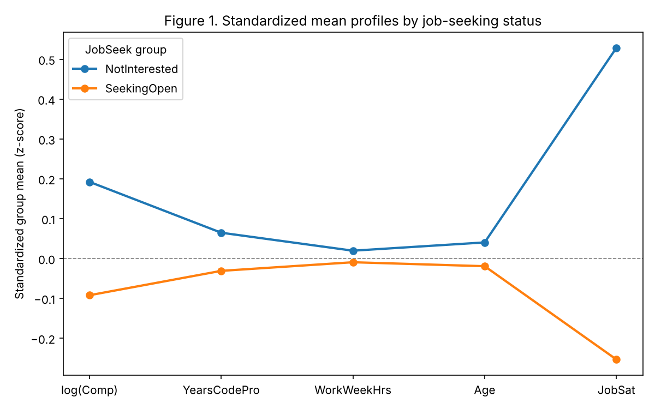
Figure 1 visualizes the group-mean profile directly: non-seekers sit above average on pay and (modestly) on experience/age, and far above average on satisfaction; job-seekers are essentially flat on pay/experience/hours and markedly below average on satisfaction. The profile difference is almost entirely a satisfaction story, with a secondary pay/tenure story.
HR takeaway: a single engagement-survey satisfaction score is, on this evidence, the most efficient early-warning signal available - cheaper to collect than a full compensation/tenure audit and carrying most of the discriminating information.

5. PCA Results
The 6-variable numeric block (logComp, YearsCodePro, WorkWeekHrs, Age, JobSat, CodeRevHrs), standardized, was reduced via eigendecomposition of its correlation matrix (shown in Table 1b above - the Age/YearsCodePro redundancy motivates this step). Retention rule: eigenvalue > 1 AND cumulative variance >= 70%.
Table 7. PCA eigenvalues and variance explained
component | eigenvalue | pct_variance | cum_pct_variance
PC1 | 2.019 | 33.65 | 33.65
PC2 | 1.143 | 19.05 | 52.7
PC3 | 1.038 | 17.3 | 70.0
PC4 | 0.914 | 15.24 | 85.24
PC5 | 0.745 | 12.41 | 97.65
PC6 | 0.141 | 2.35 | 100.0
Figure 2. Scree plot: eigenvalues and cumulative variance explained
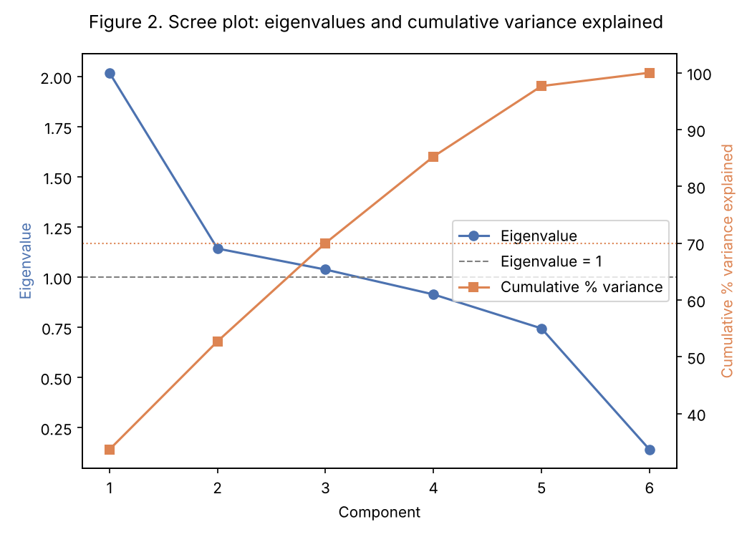
Three components clear the eigenvalue>1 threshold and jointly reach exactly 70.0% cumulative variance, so 3 components are retained (PC1-PC3).
Table 8. PCA loadings (correlation-scale) for retained components
 | PC1 | PC2 | PC3
log(Comp) | 0.511 | -0.348 | 0.331
YearsCodePro | 0.927 | 0.094 | -0.151
WorkWeekHrs | 0.168 | 0.52 | 0.544
Age | 0.93 | 0.066 | -0.163
JobSat | 0.055 | -0.408 | 0.735
CodeRevHrs | -0.047 | 0.756 | 0.208
PC1 (33.7% of variance) loads heavily and almost exclusively on YearsCodePro (0.93) and Age (0.93), with a moderate contribution from logComp (0.51) - a "Seniority & Earnings" axis. PC2 (19.0%) loads positively on CodeRevHrs (0.76) and WorkWeekHrs (0.52) and negatively on logComp (-0.35) and JobSat (-0.41) - a "Workload intensity" axis (busier, more code-review-heavy roles that pay/satisfy relatively less). PC3 (17.3%) loads positively on JobSat (0.74) and WorkWeekHrs (0.54), and negatively on YearsCodePro/Age - a "Satisfaction net of seniority" axis distinguishing happy vs. unhappy developers of similar tenure.
Figure 3. PCA biplot (PC1 vs PC2), colored by job-seeking status
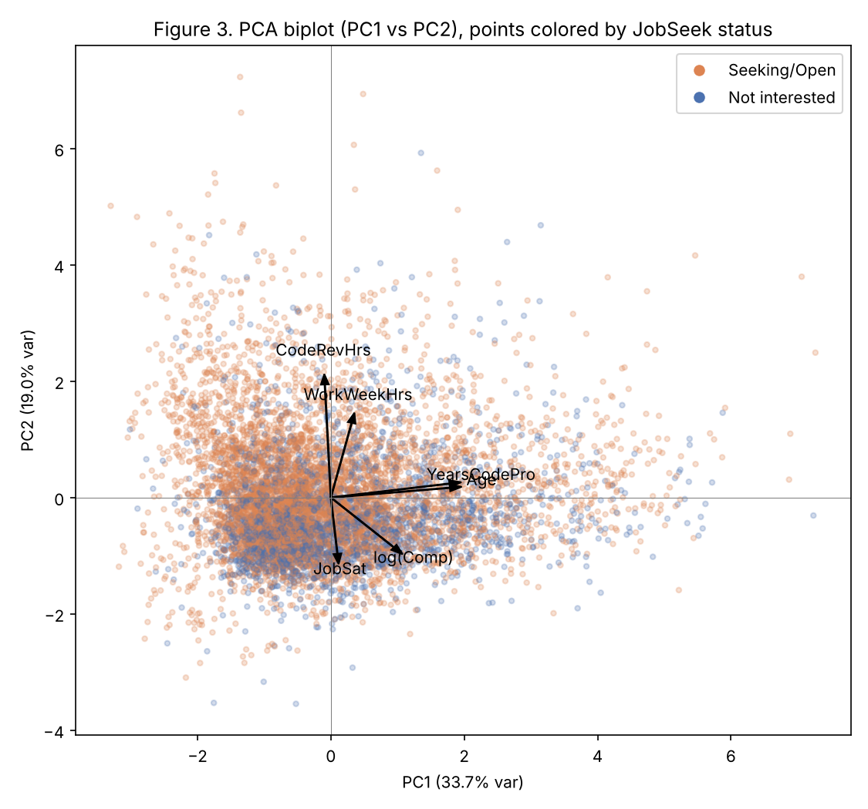
The biplot shows job-seekers (orange) distributed broadly across PC1 (seniority is not strongly differentiating, consistent with Section 4) but with a visible density shift toward the lower/negative region of PC2 and PC3 -lower satisfaction, in the direction opposite the JobSat arrow - echoing the MANOVA result. PC scores (PC1-PC3) are carried forward as the feature space for clustering in Section 7.

6. Logistic Regression and Ridge Regularization
Model: JobSeek ~ logComp + YearsCodePro + WorkWeekHrs + Age + JobSat + CodeRevHrs + EdLevel (3 dummies, ref.=Less than Bachelor's) + Hobbyist + Country (4 dummies, ref.=United States). McFadden's pseudo-R2 = 0.154 (deviance -2LL = 8,529.6 vs. null -2LL = 10,077.6), a solid fit for a cross-sectional attitudinal outcome.
Table 9. Odds ratios (95% CI) for job-seeking, natural-unit model
 | coef | OR | CI low | CI high | p
logComp | -0.043 | 0.958 | 0.906 | 1.013 | 0.129
YearsCodePro | -0.025 | 0.976 | 0.963 | 0.989 | 0.0
WorkWeekHrs | -0.006 | 0.994 | 0.987 | 1.001 | 0.11
Age | 0.022 | 1.023 | 1.01 | 1.036 | 0.001
JobSat_num | -0.872 | 0.418 | 0.394 | 0.444 | 0.0
CodeRevHrs | 0.009 | 1.009 | 0.993 | 1.025 | 0.26
Hobbyist_bin | 0.26 | 1.296 | 1.141 | 1.473 | 0.0
Ed_Bachelors | -0.053 | 0.948 | 0.824 | 1.092 | 0.462
Ed_Doctoral_Prof | 0.019 | 1.019 | 0.732 | 1.418 | 0.912
Ed_Masters | 0.058 | 1.06 | 0.897 | 1.252 | 0.493
Ctry_Canada | 0.033 | 1.034 | 0.848 | 1.26 | 0.743
Ctry_Germany | -0.382 | 0.683 | 0.578 | 0.806 | 0.0
Ctry_India | 1.162 | 3.195 | 2.483 | 4.113 | 0.0
Ctry_United Kingdom | -0.188 | 0.829 | 0.708 | 0.971 | 0.02
In plain HR language: each additional point of job satisfaction (5-point scale) is associated with a 58% lower odds of job-seeking (OR=0.418, 95% CI 0.394-0.444) - by far the largest, most precisely estimated effect in the model. Each extra year of professional tenure lowers odds by about 2.4% (OR=0.976), holding age constant, while - net of tenure - each extra year of age raises odds by about 2.3% (OR=1.023); these two coefficients partially offset because tenure and age are highly collinear (r=0.86, see Section 6.1) and should be read together, not separately. Hobbyist coders (who code outside of work) have 30% higher odds of seeking (OR=1.296, p<.001) - plausibly a proxy for higher general career engagement/options. Compensation (logComp) and weekly hours are not significant once satisfaction and tenure are controlled. Country is a strong control: Indian developers have more than 3x the odds of U.S. developers of job-seeking (OR=3.195, p<.001), while German (OR=0.683) and UK (OR=0.829) developers have lower odds than the U.S. Education level is not a significant driver of job-seeking in this sample.
Table 10. Likelihood-ratio tests for block importance
block | LR_chi2 | df | p
numerics | 1203.355 | 6 | 0.0
EdLevel | 2.719 | 3 | 0.4369317461308247
Hobbyist | 15.768 | 1 | 7.161629343233056e-05
Country | 148.695 | 4 | 0.0
LR tests confirm the numeric block (chi2=1203.4, df=6, p<.0001) and Country (chi2=148.7, df=4, p<.0001) are the dominant contributors, Hobbyist is a significant but modest contributor (chi2=15.8, df=1, p<.001), and EdLevel adds nothing once the other blocks are in the model (chi2=2.7, df=3, p=0.437).

6.1 Collinearity and ridge regularization
The standardized design matrix (numerics z-scored, categorical dummies, plus intercept) has condition number 10.3 - moderate, below the common concern threshold of ~30, but driven almost entirely by the Age/YearsCodePro redundancy (r=0.86) documented in Section 3/5. To quantify and correct for this, we fit a ridge-penalized logistic regression across a grid of 40 penalties (lambda from 10^-3 to 10^3) on the same standardized design matrix.
Figure 4. Ridge trace: standardized coefficients vs. log(lambda)
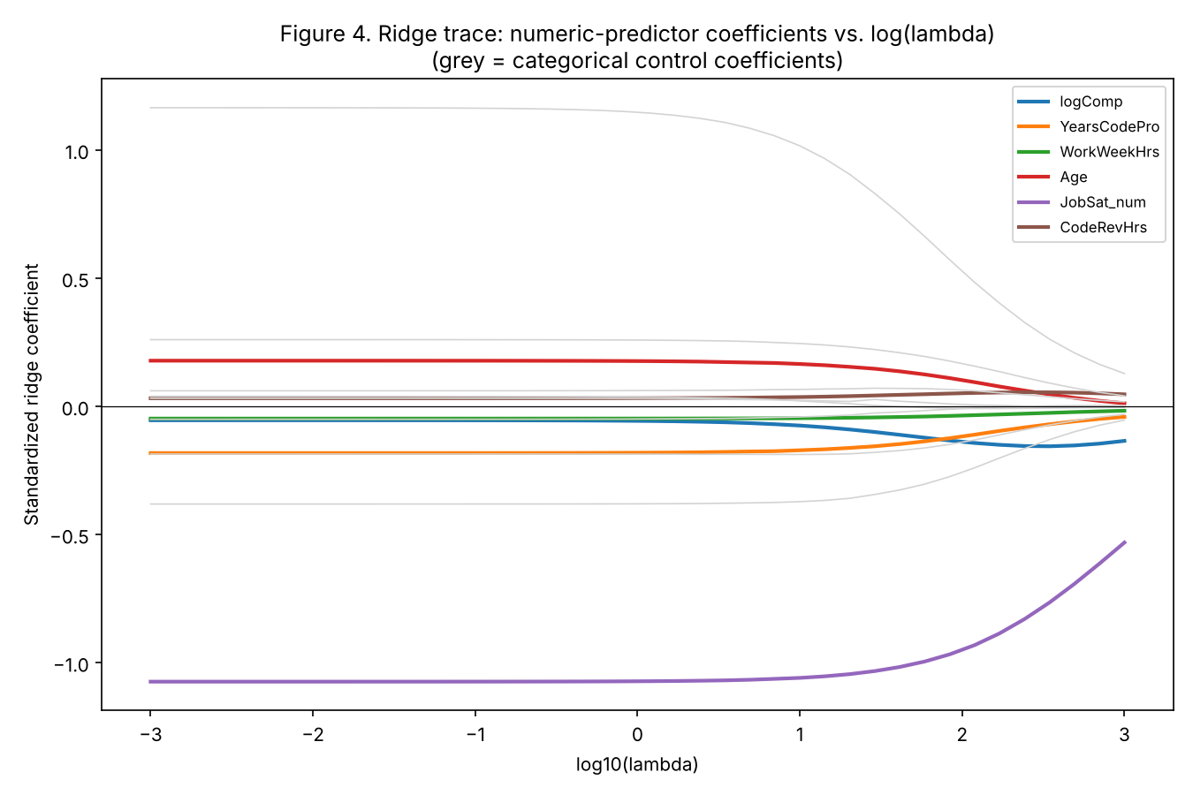
As expected from the correlation structure, Age (red) and YearsCodePro (orange) are the two coefficients that move the most under increasing penalty - their unregularized OLS-logistic estimates are being inflated and partially offsetting each other, and ridge shrinkage pulls both toward a smaller, more stable joint effect well before the JobSat or Country coefficients move appreciably.
A 5-fold cross-validated search (minimizing held-out deviance/log-loss) selects lambda* = 4.92.
Table 11. Ridge (lambda=4.92) vs. unregularized logistic, standardized coefficients
 | OLS_logit_std_coef | Ridge_std_coef | shrinkage_pct
logComp | -0.0547 | -0.0652 | -19.2
YearsCodePro | -0.1826 | -0.1759 | 3.6
WorkWeekHrs | -0.0476 | -0.0467 | 1.8
Age | 0.179 | 0.171 | 4.5
JobSat_num | -1.0736 | -1.0663 | 0.7
CodeRevHrs | 0.0318 | 0.0341 | -7.1
Hobbyist_bin | 0.2596 | 0.2531 | 2.5
Ed_Bachelors | -0.053 | -0.0453 | 14.5
Ed_Doctoral_Prof | 0.0187 | 0.0265 | -41.5
Ed_Masters | 0.0583 | 0.0639 | -9.6
Ctry_Canada | 0.033 | 0.0297 | 10.2
Ctry_Germany | -0.3818 | -0.3764 | 1.4
Ctry_India | 1.1617 | 1.0849 | 6.6
Ctry_United Kingdom | -0.1877 | -0.187 | 0.3
At the cross-validated lambda, JobSat barely shrinks (0.7%) and remains the dominant, robust driver; Country and Hobbyist effects are also stable (<10% shrinkage). YearsCodePro and Age shrink modestly (3.6% and 4.5%) together, and the sparsely populated Doctoral/Professional education dummy (n=210 in-sample) shrinks the most (41.5%) as expected for a high-variance, small-category estimate. The substantive conclusion is unchanged by regularization: satisfaction dominates, tenure/age act as a paired (partially collinear) control, and the OLS logistic odds ratios in Table 4 can be read with confidence.

7. Linear Discriminant Analysis and Comparison with Logistic Regression
To compare classifiers on equal footing, LDA, QDA, and logistic regression were all fit on the same 6 standardized numeric predictors (no categorical controls), using 5-fold stratified cross-validation (shuffled, random_state=42); out-of-fold predictions were pooled into one confusion matrix per model.
Box's M on this 6-variable block is again significant (chi2(21)=785.3, p<.0001), formally favoring QDA's unequal-covariance assumption over LDA's. Because Box's M is oversensitive at this sample size (Section 4.3), we instead let cross-validated performance arbitrate between LDA and QDA.
Table 12. Confusion matrices (5-fold CV, pooled out-of-fold predictions)
model | TN | FP | FN | TP
LDA | 970 | 1622 | 624 | 4784
QDA | 1694 | 898 | 1545 | 3863
Logistic | 1284 | 1308 | 833 | 4575
Table 13. Classifier comparison: accuracy, sensitivity, specificity, AUC
model | accuracy | error rate | sensitivity | specificity | ROC_AUC
LDA | 0.7192 | 0.2808 | 0.8846 | 0.3742 | 0.7565
QDA | 0.6946 | 0.3054 | 0.7143 | 0.6535 | 0.7377
Logistic | 0.7324 | 0.2676 | 0.846 | 0.4954 | 0.7571
Figure 5. ROC curves: LDA, QDA, and logistic regression (5-fold CV)
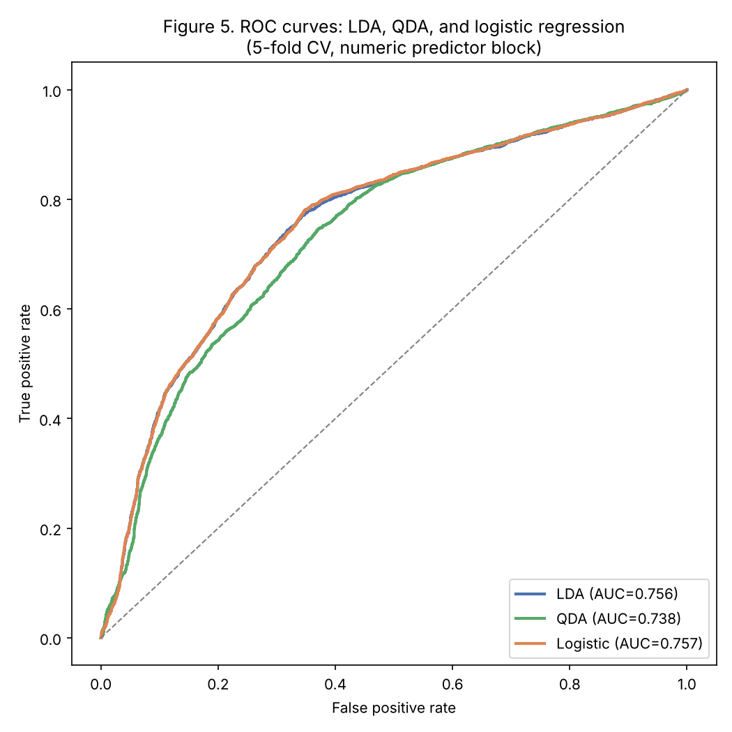
LDA and logistic regression are statistically indistinguishable on discrimination (AUC 0.757 vs 0.757) - unsurprising, since both fit linear decision boundaries, and QDA's added flexibility does not pay off here (AUC 0.738, lower accuracy), suggesting the extra covariance parameters mostly fit noise rather than real nonlinearity. The two linear models trade off differently at the default 0.5 threshold: LDA achieves much higher sensitivity (88.5% vs 84.6%) at the cost of lower specificity (37.4% vs 49.5%) than logistic regression, because LDA's threshold is set by the class priors (67.6% seeking) rather than directly optimizing log-likelihood for the 0.5 cut; logistic regression gives the better overall error rate (26.8% vs 28.1%) and, critically, produces directly interpretable odds ratios (Section 6) that LDA does not. We recommend logistic regression as the primary model for deployment (better balance, interpretable coefficients, easy to recalibrate the decision threshold to an HR-chosen cost ratio), while noting that if the operational goal is to cast the widest possible net for a proactive retention outreach program (where missing a flight risk is far costlier than one extra wellness check-in), LDA's higher recall is a legitimate alternative - and in practice, either model's predicted probability can simply be threshold-tuned to the same operating point, since their ROC curves coincide.

8. Clustering & Developer Segments
K-means (k-means++ initialization, 25 restarts) was run on the 3 retained PC scores (Section 5) across k=1..10. k was selected using both the elbow in within-cluster sum of squares and the gap statistic (15 uniform reference datasets per k); both point to k=3.
Figure 6. Within-cluster SS (elbow) and gap statistic across k=1..10
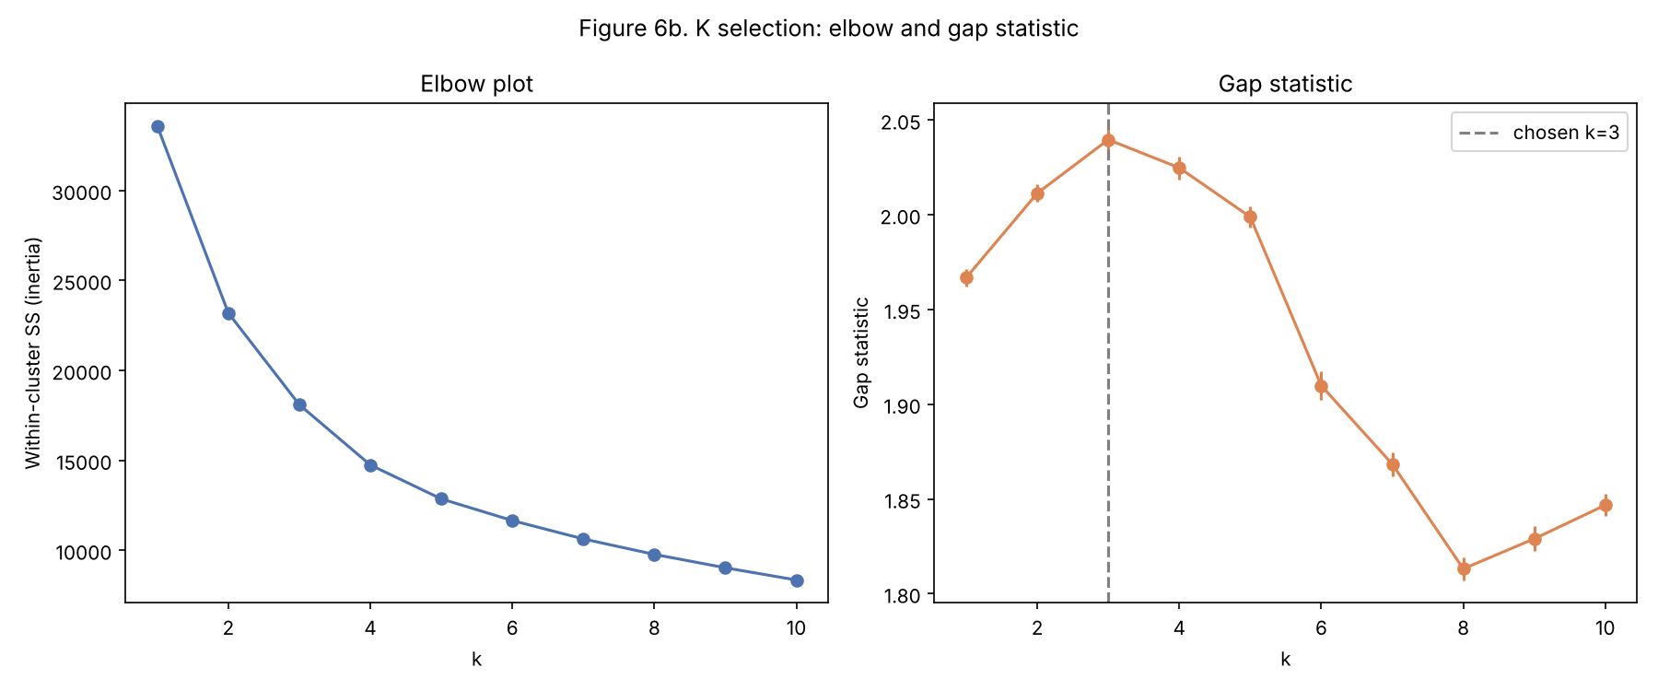
Ward's hierarchical clustering (Euclidean distance) on the same PC scores, cut at k=3, was compared to the k-means partition via the Adjusted Rand Index: ARI = 0.648, indicating substantial (though not perfect) agreement between the two methods - a reassuring robustness check that the 3-segment structure is not an artifact of one algorithm.
Figure 7. Ward hierarchical dendrogram (truncated), cut at k=3
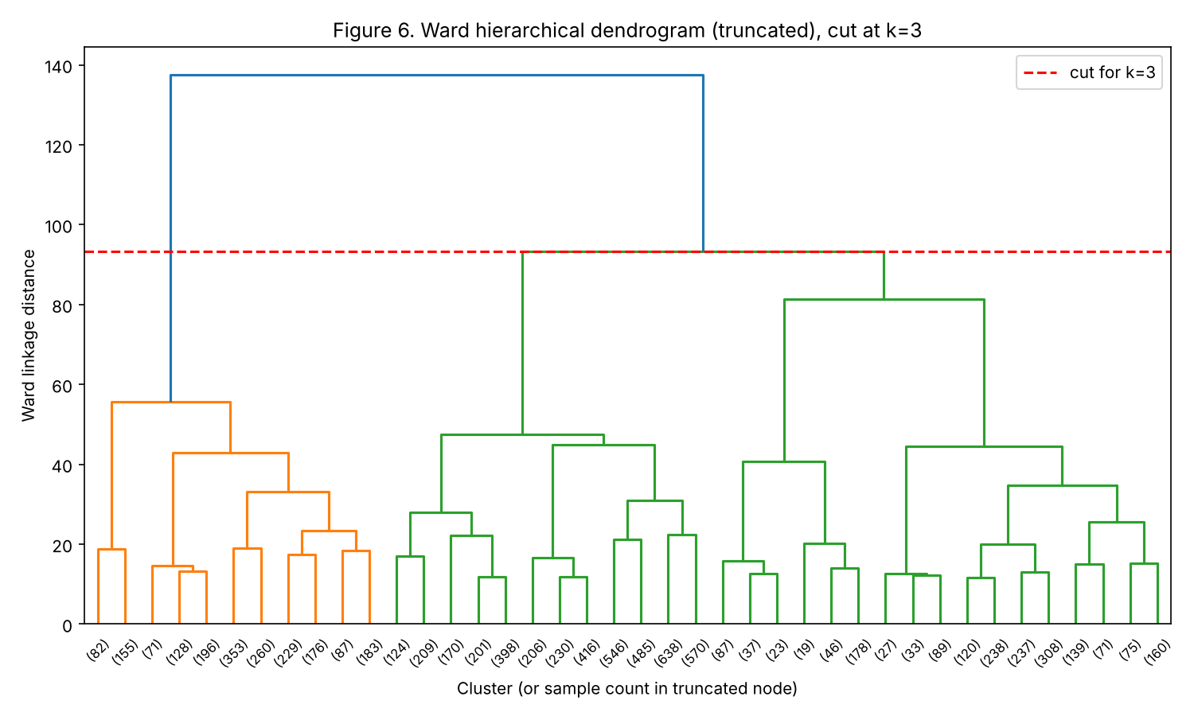
Figure 8. K-means clusters (k=3) in PC1-PC2 space
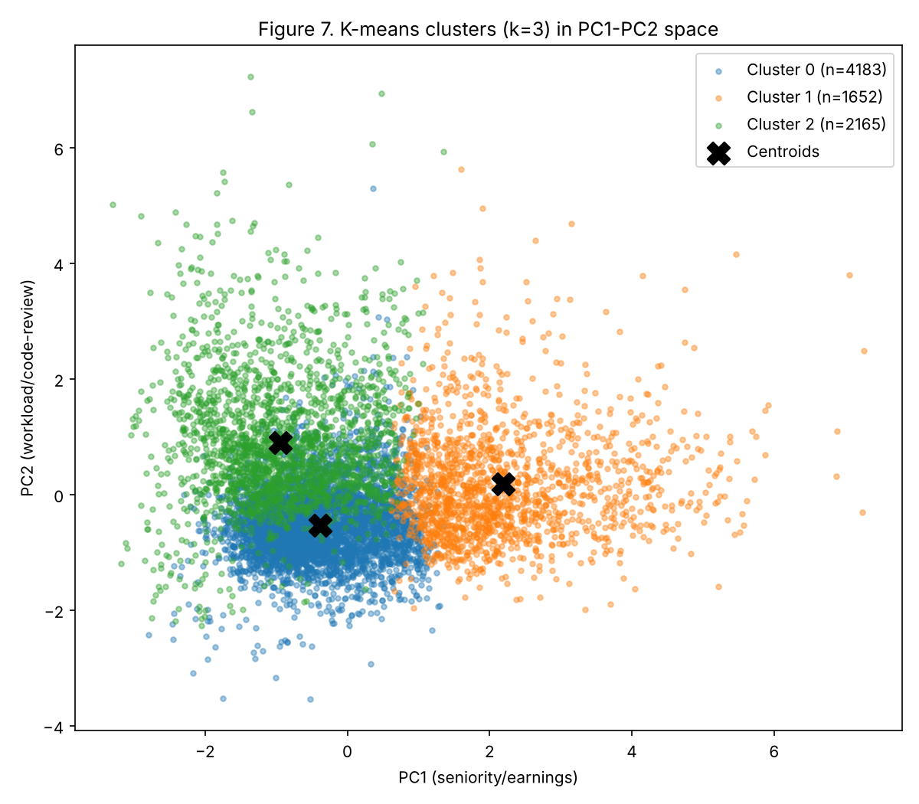
Clusters 0 and 2 overlap substantially in the PC1-PC2 projection shown above because their main separation is along PC3 (satisfaction, net of seniority) rather than PC1/PC2 - visible instead in the cluster profile table below.
Table 14. Cluster profiles: mean numeric values and size
 | logComp | YearsCodePro | WorkWeekHrs | Age | JobSat_num | CodeRevHrs | n
Cluster 0: Settled & Satisfied | 11.59 | 5.68 | 40.85 | 29.08 | 4.45 | 3.66 | 4183.0
Cluster 1: Senior Specialists | 11.96 | 20.14 | 42.88 | 43.74 | 3.78 | 4.66 | 1652.0
Cluster 2: Early-Career Flight Risk | 10.32 | 5.14 | 41.45 | 28.11 | 2.66 | 6.35 | 2165.0
Cross-tabulated against job-seeking status and country, the three segments read as distinct, actionable HR profiles:
- Cluster 0 - "Settled & Satisfied" (n=4,183, 52.3% of sample): mid tenure (5.7 yrs), average pay (~$108k), high satisfaction (4.45/5), low risk - only 3.6% actively looking, 42.3% not interested in a move at all. The bulk of the stable workforce; retention spend here has the lowest ROI.
- Cluster 1 - "Senior Specialists" (n=1,652, 20.7%): most experienced (20.1 yrs), oldest (43.7), highest paid (~$156k), moderately satisfied (3.78/5); only 7.9% actively looking. Low volume, high replacement cost - worth a lightweight, low-cost touch (career-growth/mentoring conversations) given how expensive and slow senior specialists are to replace.
- Cluster 2 - "Early-Career Flight Risk" (n=2,165, 27.1%): youngest (28.1), similar tenure to Cluster 0 (5.1 yrs) but lowest pay (~$30k implied, reflecting a heavy India/lower-cost-market concentration: 40.7% of this cluster is India vs. 14.0% of the overall sample), lowest satisfaction (2.66/5) and heaviest code-review load (6.35 h/week). This segment is 25.2% actively looking for a job - roughly 7x Cluster 0's rate - and only 11.4% say they are not interested in a move. This is the highest-priority retention segment.
HR takeaway: the clustering independently reproduces the MANOVA/logistic findings (satisfaction and, to a lesser extent, pay/tenure drive job-seeking) but turns them into a targeting list - Cluster 2 is a concrete, sizeable (27% of the workforce), identifiable population for a pay-equity review and workload rebalancing (code-review load), rather than a generic company-wide engagement initiative.

9. Conclusions & HR Recommendations
- Monitor job satisfaction as the primary, cheapest leading indicator: it dominates every model in this report (MANOVA, logistic odds ratios, ridge-stable coefficient, and the main cluster-separating axis).
- Treat pay and tenure as a secondary, collinear pair, not independent levers; a pay review should be paired with a tenure/seniority context check rather than read in isolation (Section 6.1).
- Prioritize the Early-Career Flight Risk segment (27% of the workforce, 25% actively job-seeking): a targeted pay-equity audit (this segment is disproportionately in lower-cost markets, notably India) and code-review workload rebalancing are the two most defensible, specific interventions the data support.
- Give Senior Specialists (21% of the workforce, expensive to replace) a lighter-touch, non-monetary retention motion - this group is not highly price-sensitive by this evidence, but has an 8% active-seeking rate worth tracking.
- For a predictive flight-risk score, deploy the logistic regression model (interpretable odds ratios, tunable decision threshold); use country and hobbyist status as context, not blame - both are strong statistical controls but not actionable levers on their own.

10. Limitations
- Self-selection bias: Stack Overflow survey respondents are a convenience sample of developers engaged enough with the community to take the survey; they may not represent the full developer population or any single company's workforce.
- Cross-sectional design: all variables are measured at one point in time, so reported associations (e.g., satisfaction -> job-seeking) are correlational, not causal, and could run in either direction.
- No true churn outcome: JobSeek is a stated intention/attitude, not observed turnover; the mapping of "open to opportunities" into the risk group (Section 2.2) is a modeling choice that inflates the positive class and should be validated against a company's own exit data before being used operationally.
- External validity: the 2019 wave predates the 2020-2023 labor-market disruptions (COVID-19 hiring freezes, 2022-2023 tech layoffs) that materially changed developer job-seeking behavior; a current deployment should re-estimate on recent data.
- Country generalizability: only the five largest-N countries are included; findings (especially the India effect) should not be extrapolated to markets not represented in the sample.

