Online Complaints - Project Report

# 1.INTRODUCTION

**Project Title::** Online complaints

**Team ID:** **LTVIP2025TMID57112**

**Team Leader :** Kudumula Sreenivasulu Reddy

**Team member :** Kalluru Thrishitha

**Team member :** Kamesh Nataraj

**Team member :** Kasireddy Sravani

## 1.1 Project Overview

This project focuses on developing an online complaints system that enables users to lodge complaints efficiently, ensuring transparency and timely resolution.

## 1.2 Purpose

The purpose of this system is to provide a digital platform for citizens/customers to file grievances and monitor their resolution status.

# 2. IDEATION PHASE

## 2.1 Problem Statement

Manual complaint systems are inefficient and lack transparency, causing delays in grievance redressal.

## 2.2 Empathy Map Canvas

The empathy map includes understanding the users’ needs, frustrations, and goals when dealing with complaints.

## 2.3 Brainstorming

Ideas like centralized tracking, notifications, feedback mechanisms, and administrative dashboards were discussed.

# 3. REQUIREMENT ANALYSIS

## 3.1 Customer Journey Map

Illustrates the process from filing to resolution of a complaint.

## 3.2 Solution Requirement

Functional and non-functional requirements of the system.

## 3.3 Data Flow Diagram

DFD Level 0 and Level 1 diagrams show the data movement in the system.

## 3.4 Technology Stack

Frontend: HTML/CSS/JS, Backend: Node.js/PHP, Database: MySQL.

# 4. PROJECT DESIGN

## 4.1 Problem Solution Fit

The online complaint system directly addresses inefficiencies in manual systems.

## 4.2 Proposed Solution

An easy-to-use web portal where complaints can be filed, tracked, and resolved.

## 4.3 Solution Architecture

A layered architecture comprising frontend, backend services, and database.

# 5. PROJECT PLANNING & SCHEDULING

## 5.1 Project Planning

Milestone-based planning for design, development, and testing.

# 6. FUNCTIONAL AND PERFORMANCE TESTING

## 6.1 Performance Testing

Testing the responsiveness, load capacity, and stability of the application.

# 7. RESULTS

## 7.1 Output Screenshots

Screenshots of the key features like complaint form, dashboard, and status tracking.

-Landing page

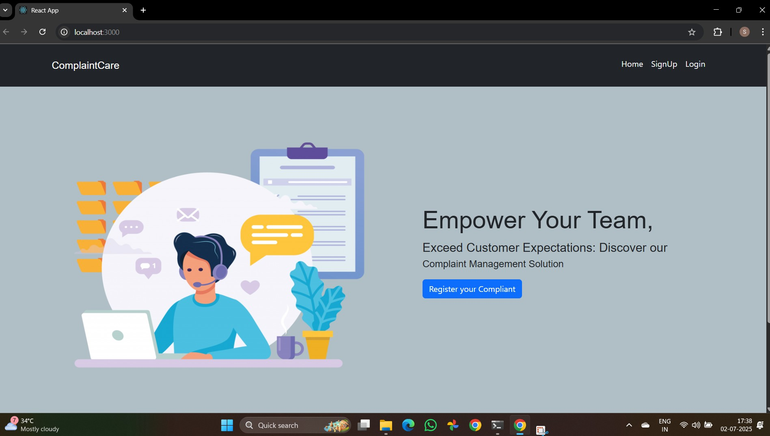

-Signup page

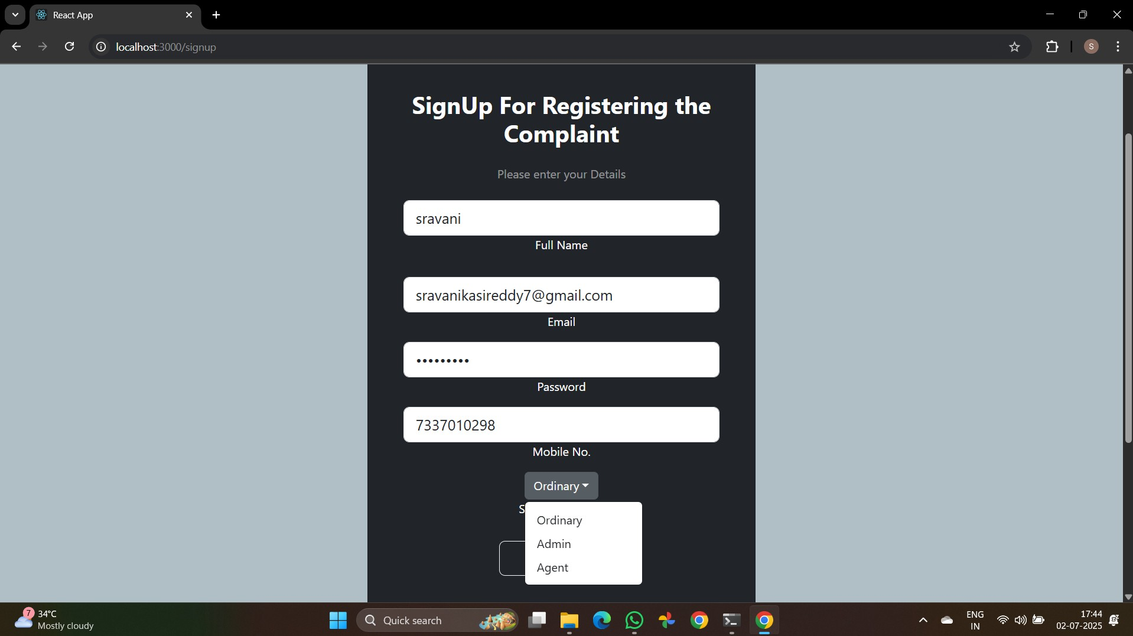

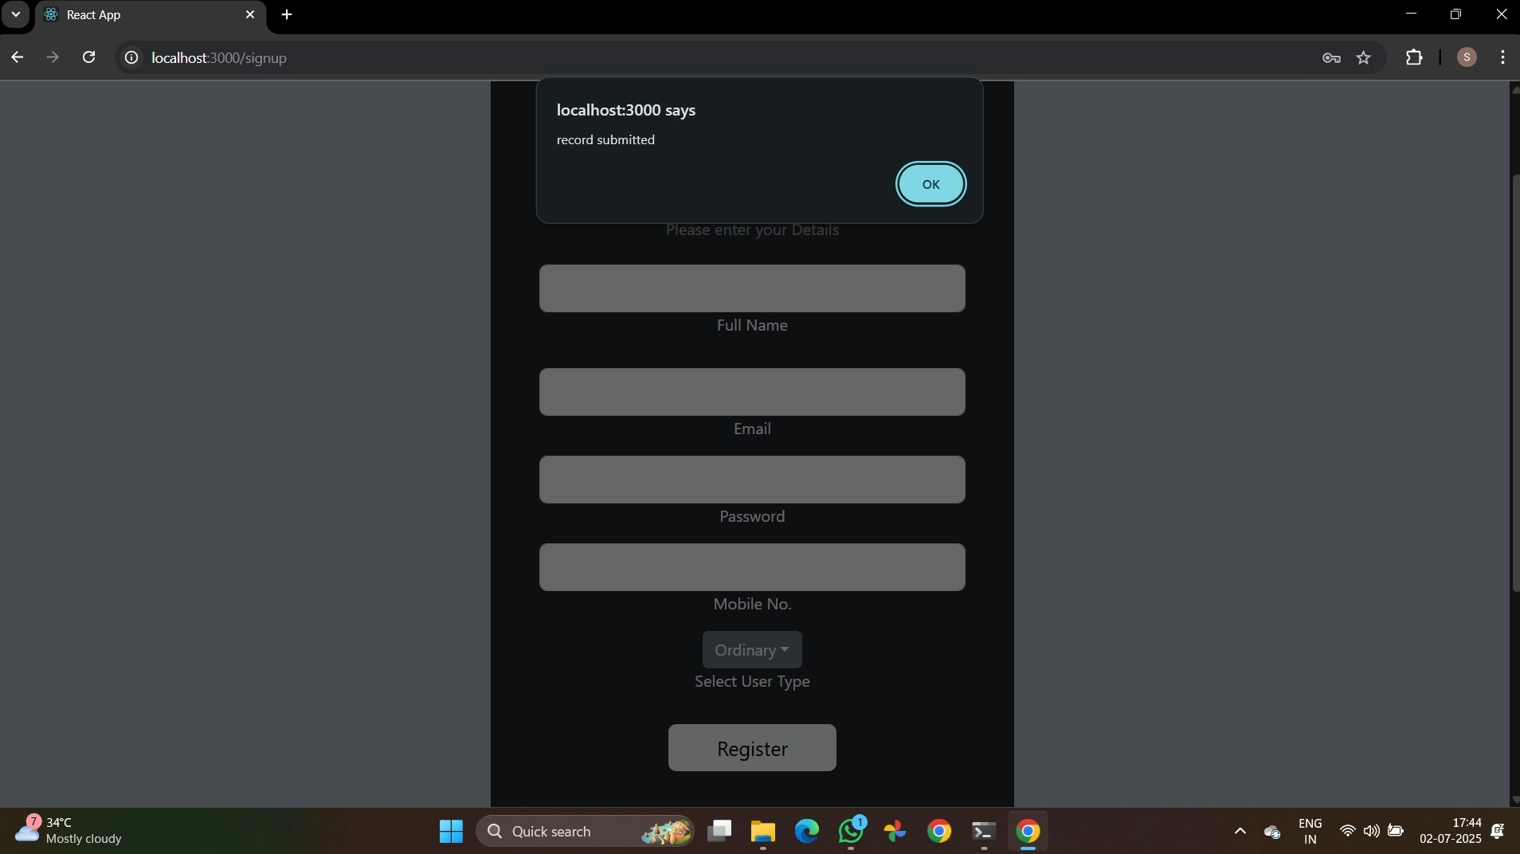

-Login page

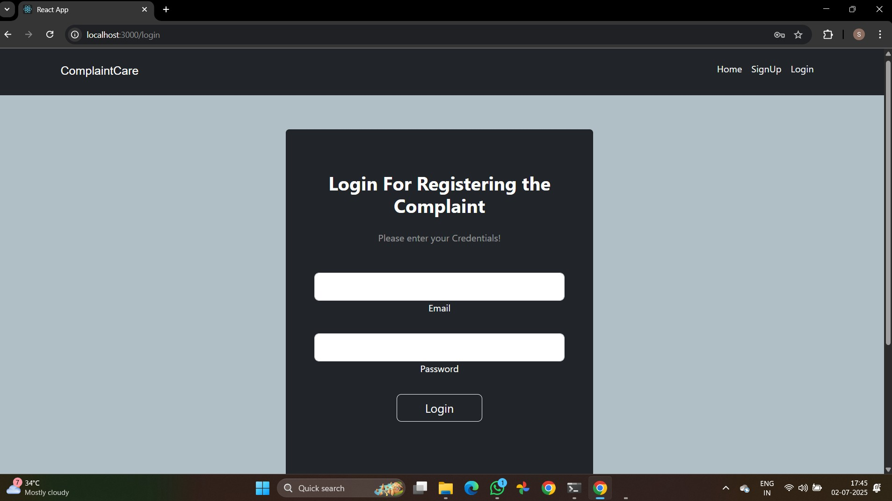

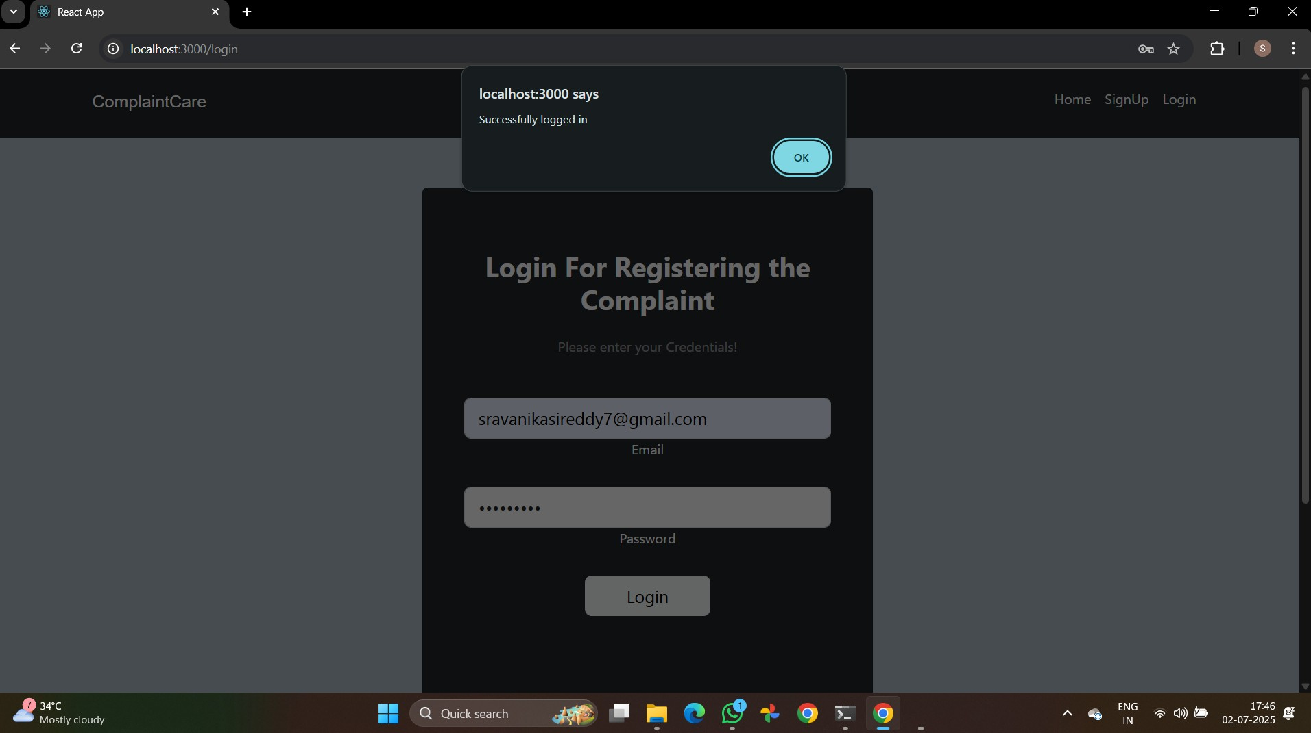

# 8. ADVANTAGES & DISADVANTAGES

Advantages include increased efficiency and transparency. Disadvantages may include digital divide and dependence on internet connectivity.

# 9. CONCLUSION

The online complaints system modernizes grievance handling, offering a scalable and user-friendly platform.

# 10. FUTURE SCOPE

Future enhancements can include AI-based complaint classification, mobile apps, and multilingual support.

# 11. APPENDIX

**Demo : "C:\Users\sowmy\Videos\srav demo.mp4"  
GitHub : https://github.com/kudumulasreenivasulureddy/platformforonlinecomplaints**