ERPNEXT is one of the fastest-growing and most affordable web-based open source on the market with a broad set of capabilities including your legacy accounting,HR,Stock management.

It is an integrated product that manages a large percentage of operations within your organisation. The integration is across all the functions of the company as it creates a single and unified system as opposed to independent and stand-alone applications. e.g (Sage Accounting and Belina for HR)

It helps companies with accounting, project and task management, sales, purchase, inventory, customer relationship management, administration, human resource management, manufacturing, and more.

The most interesting thing about ERPNext is it being an open-source,imagine the savings on the annual software licensing that you would cut on. Comparing products in the markets ERPs like SAP which are now being compared to SAP does not come cheap and yet the same functionality is achieved by ERPNext at a significantly reduced amount. The best cost-cutting decision any CEO can make.

ERPNext is an open source software meaning the modus operandi allows companies to access the source code and customize the source code to their desired output using either internal or external IT resources.
An open source software conforms to the standards below;

- Free distribution
- Source code is available in readable form
- No discrimination against a person or group

The ERPNext software can be installed on the company premises and in the cloud depending on the organisation’s requirements. It allows for full amortization of resources that the company might have invested in if there are servers on premises. It can be used on a wide range of devices so there are no compatibility issues for your windows, Linux,ios and android

ERPNext is often targeted to enterprises whose enterprise requirement is not covered by standard software. With the ever-changing dynamics business requirements are constantly evolving at an exponential rate hence the need to adopt an open-source ERP which develops with the changing trends. It is the ideal ERP for start-ups going to rapidly growing small to medium enterprises ,ERPNext will be the tool used to address the elephant in the room the famous taxes.

With ERPNEXT you can do whatever you want with the software as the technology stack used to build it is also provided to you,that is the frappe framework.

Domains with preconfigured modules ERPNext
- Services
- Manufacturing
- Retail and distribution
- Education
- Non Profit
- Education
- Agriculture
- Healthcare

In each domain,it comes with integrated sub-modules as below

- Sales Management
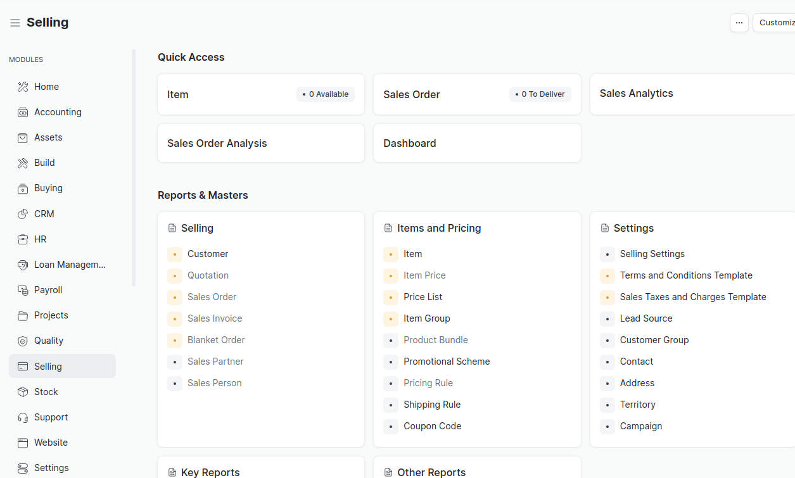

- Point of Sales (PoS)
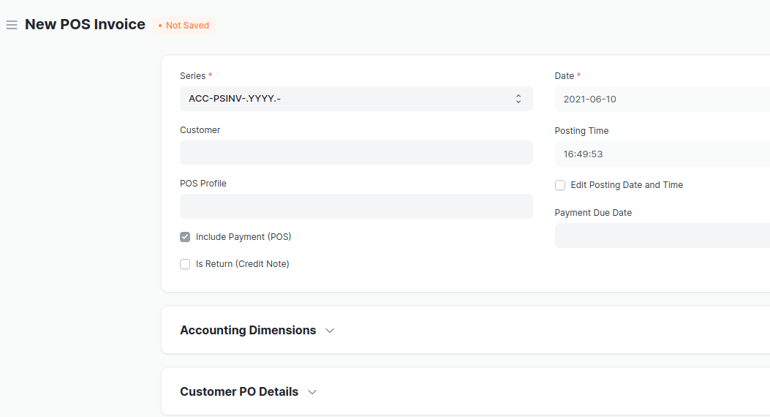
Customer Relationship Management (CRM)
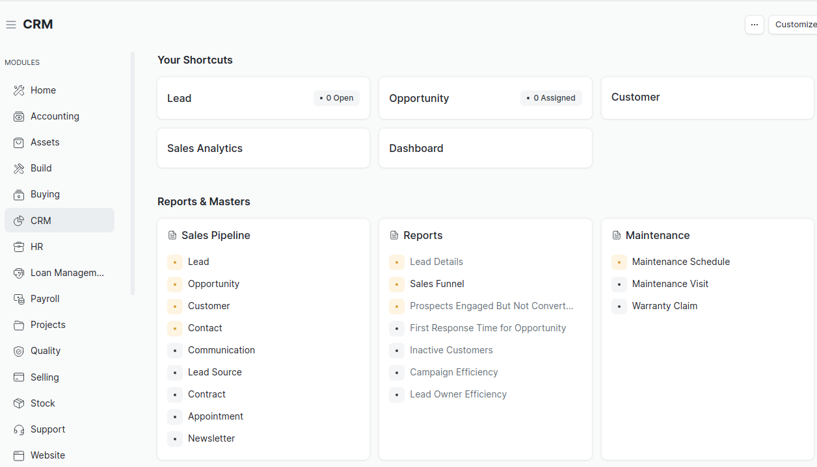
- Business Management
- Purchasing
- Human Resource Management (HRM)
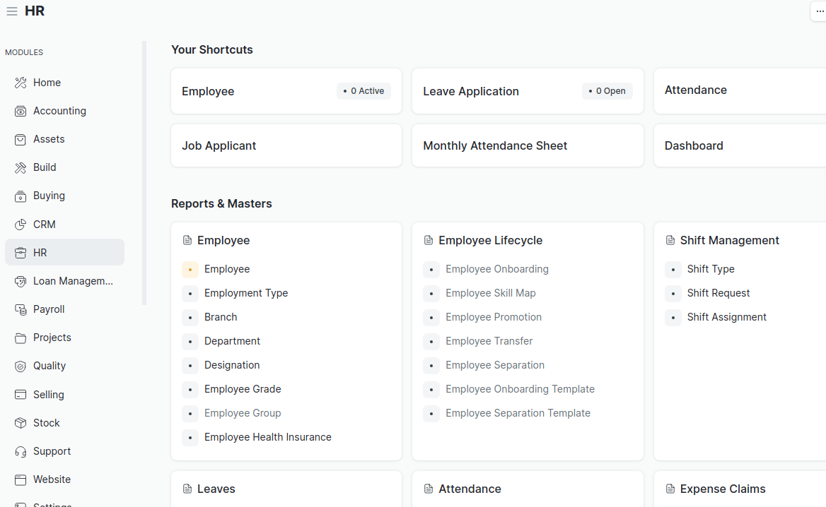
- Asset Management
- Accounting
- Warehouse Management System
- Manufacturing
- Project Management
- and many more that can be added as per cutomization

Support and Maintenance

ERPNext offers support an maintenance and different packages based on the kind of subscription. There are also vendors like Quest ERP Solutions based in Sandton City Johannesburg South Africa which offer 24/7 and custom service level agreements ,consulting services and training on ERPNext.Support services include but not limited to:

- Bug fix warranty
- Upgrade Support
- In App Support
- Product Support
- Migrations
- Security Alerts

In a nutshell,ERPNext was designed to achieve business compliance in the shortest possible time and the most efficient way. Companies that migrated to ERPNext have reduced by over 50% their expenditure on software.

