

——

Monthly network report
  - Komunala Vzorec d.o.o. (sample) · October 2026
Version 1.0 · 6 Nov 2026 · Internal

Summary
In October the network ran without major interruptions. Readings reached 92% of the expected count, mainly because two gateways in zone 4 were offline.

Consumption by zone
The table compares consumption by zone with last October. Values are in MWh.
Location | 2026 | 2025
Cona 1 | 412 | 388
Cona 2 | 356 | 371
Cona 3 | 298 | 305
Cona 4 | 251 | 240
Cona 5 | 214 | 226
Source: sample data (synthetic), October 2026

Operations overview
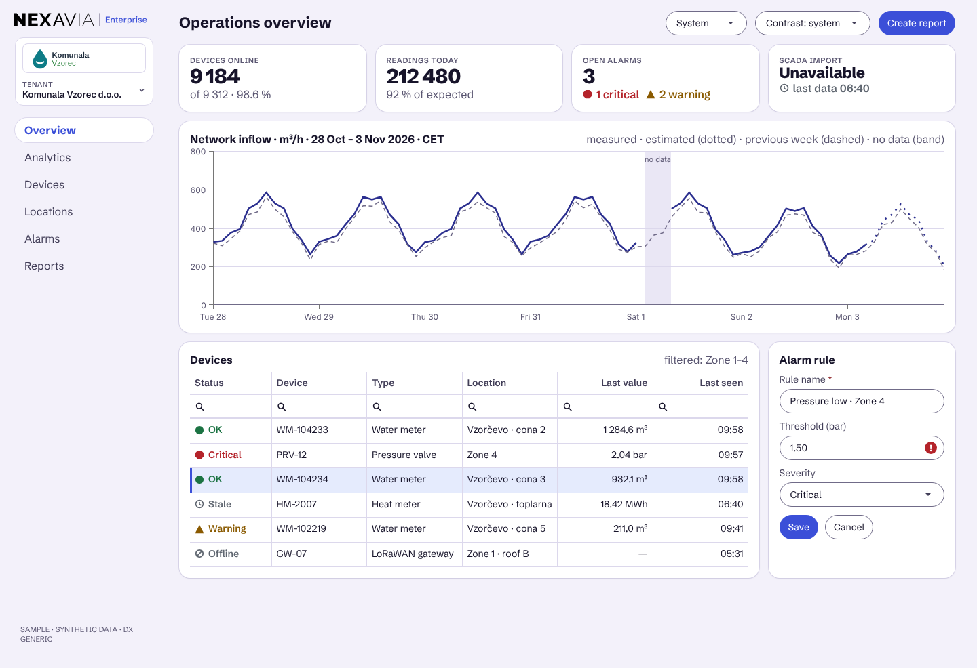
Figure 1: Operations overview (sample data)

Notes on the data
- Estimated values are marked.
- Times are in Central European Time.

