This instruction is written for playing customized animation with the combination of FiVES and FiVES-xml3d client.

1. Run compiled five.exe (located in FiVES/Binaries/Release) with administration right, please make sure you have added SceneParser and CustomizedAnimation plugins additional to original FiVES implementation.
2. Run client.xhtml (located in root of webclients directory) with a web server (e.g. Webstorm, apache ...). If everything works well, you will see a pre-defined boschrexroth and gate_bosch in the center of display area like following:

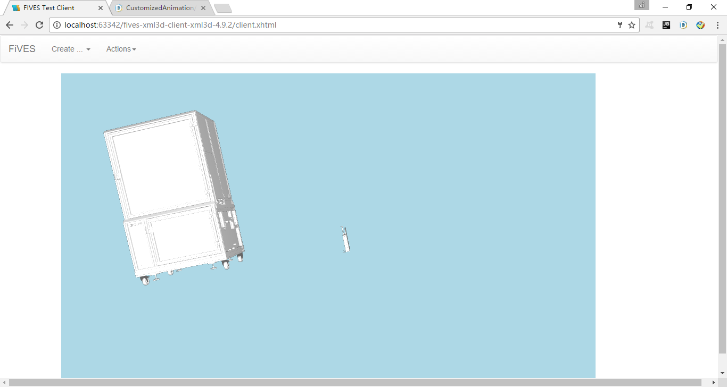

Figure 1. Default scene (use right click to enlarge, left click to rotate the view)

1. Open DHC restlet client[1] in chrome, and import the pre-written rest scripts from ScriptsAndDocuments/Restlet_Chrome_Scripts/CustomizedAnimation.json. There will be three scripts available: SetAnimation, PlaybackAnimation, and StopAnimation.

An example of SetAnimation is like following, every element is explained by red plain:

{

"entityName":["gate_bosch"], (we set the entity name here)

"animationInfo":[

{

"startPoint":[0, 0, 0], (the global start point of animation)

"endPoint":[0, 0, 10], (the global end point)

"speed": 10 (duration of animation, in second)

}

]

}

Please note: We have defined the scene and entity through SceneParser plugin, check out the App.config in SceneParser to find the entity name to set an animation.

1. Run SetAnimation to define an animation, and PlaybackAnimation, Stop Animation to play/stop the animation, you will see the browser display the corresponding customized animation.

1. See <https://client.restlet.com/>