PROJECT PROPOSAL REPORT
Hostel Student Tracking: Digital Hostel Management & Real-Time Occupancy Monitoring
Prepared for: CSE Department
Technology focus: Agentic AI, RAG, MCP, Google Antigravity
Project No. 3 — A smart hostel management platform that digitizes student records, room/occupancy tracking, safety monitoring, and routine hostel assistance.

1. Problem Statement
Traditional hostel management often depends on registers, spreadsheets, manual roll calls, and separate communication channels. This can make it difficult to know current occupancy, identify unauthorized or overdue presence, retrieve hostel rules quickly, and prepare reports.

2. Proposed Solution
The proposed system combines a digital hostel database with real-time check-in/check-out tracking and an Agentic AI assistant. RAG gives the AI grounded access to hostel rules, notices, emergency procedures and approved documents. MCP provides controlled access to operational tools such as student lookup, occupancy queries, alerts and report generation.

3. Main Modules
Module | Purpose
Student Management | Student profile, ID, room, contact and status.
Room Management | Room allocation, capacity and current occupancy.
Check-in / Check-out | QR/RFID-assisted entry and exit events.
Real-time Occupancy | Dashboard showing occupied, vacant and expected rooms.
Safety Monitoring | Overstay, unauthorized-entry and emergency-alert workflows.
AI Hostel Assistant | Natural-language questions for students, wardens and administrators.
RAG Knowledge Base | Hostel rules, FAQs, notices, emergency SOPs and policies.
MCP Tool Layer | Controlled connection between agents and database/notification/report tools.
Reporting | Daily occupancy, attendance, incidents and monthly summary reports.

4. Project Flow
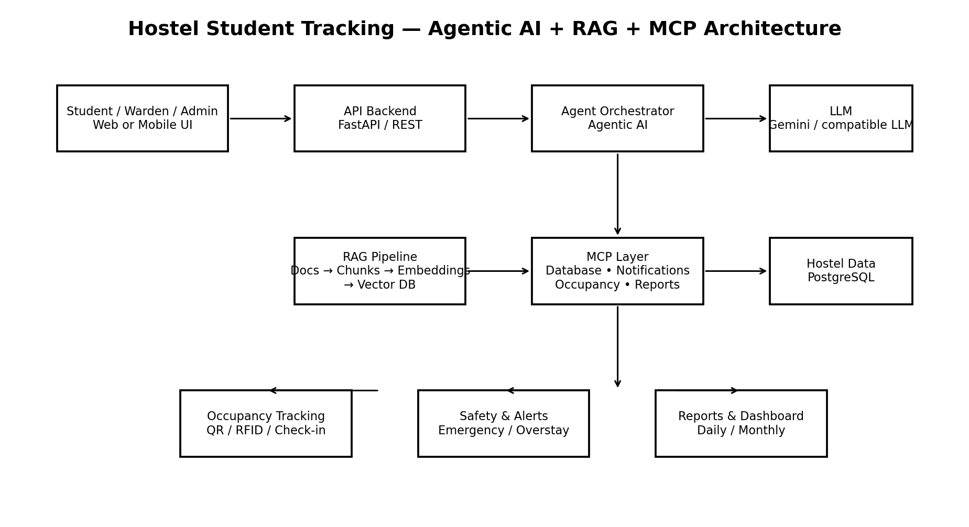
Basic request flow: User → Backend → Agent → RAG and/or MCP tools → verified result → dashboard/alert/report.

5. Agentic AI Design
- Student Assistant Agent: Answers questions about rules, rooms, leave procedures, notices and facilities.
- Warden Monitoring Agent: Checks occupancy anomalies, overdue students and safety events.
- Safety Agent: Handles emergency workflows and prepares alerts/escalations.
- Admin/Report Agent: Generates summaries, occupancy statistics and administrative reports.

6. RAG Workflow
- Collect approved hostel documents: rules, emergency SOPs, notices, FAQs and policies.
- Convert documents to text and divide them into meaningful chunks.
- Create embeddings and store them in a vector database.
- When a user asks a question, retrieve the most relevant chunks.
- Give the retrieved evidence to the AI agent and generate a grounded response.
- For actions that change or retrieve live data, use MCP tools rather than relying on generated text.

7. MCP Workflow
MCP should expose narrowly scoped tools. Example tools: get_student(), get_room_status(), record_checkin(), record_checkout(), get_current_occupancy(), create_alert(), and generate_report(). The agent decides which tool is needed, requests permission where required, executes it, and uses the result.

8. Suggested Technology Stack
Layer | Suggested technology
Frontend | React / HTML-CSS-JavaScript
Backend | Python FastAPI
Database | PostgreSQL
Vector Database | Chroma or FAISS for a prototype
AI | Gemini or another compatible LLM
Agent Layer | Agent framework such as ADK/LangGraph
Protocol | Model Context Protocol (MCP)
Development Environment | Google Antigravity IDE / Agent Manager
Tracking | QR code initially; RFID can be added later

9. Expected Outcomes
- Reduced manual hostel record keeping.
- Near-real-time visibility of room occupancy.
- Faster retrieval of hostel rules and procedures.
- Automated safety and anomaly alerts.
- Natural-language interaction for students and wardens.
- Faster generation of daily and monthly hostel reports.

10. Development Phases
- Phase 1 — Database and student/room management.
- Phase 2 — QR-based check-in/check-out and occupancy dashboard.
- Phase 3 — RAG knowledge base and AI assistant.
- Phase 4 — MCP tools and agentic workflows.
- Phase 5 — Safety alerts, reporting and testing.
- Phase 6 — Deployment, evaluation and documentation.

11. Important Design Principle
The AI should not invent live hostel information. Static policy questions should be grounded through RAG, while live operational questions should use MCP tools connected to the authoritative database. This separation improves reliability and auditability.

