 |  | 
Faculty of Computer Science
Graduation Project Proposal
Supervised By Dr. Samar Adel
saahmed@msa.edu.eg
Khaled Abdelnasser Mahmoud | Mohamed Ibrahim Mosaad
211055 | 211311
Khaled.abdelnasser1@msa.edu.eg | Mohamed.ibrahim38@msa.edu.eg

Advanced Driver Assistance System with Lidar Processing, AR, Reinforcement Learning, and EEG integration

Problem Overview:
Nearly 1 million accidents happened in Egypt’s roads yearly; Surely this happens because of driver’s bad decisions. By analyzing accidents and nearly-accidents from security footages, We Concluded that errors could be avoided if the driver has a predetermination his next decision; predicting car trajectories has been evolved since the rise of self-driving cars (approx. 10 years ago), By doing local survey we concluded that nearly 70% of people will not depend on a computer to control his car. Those an evolutionary driving system will be made to assist drivers and evaluating there decisions according to current road conditions (speed bumps, driving scenarios, etc.). Taking inspiration from chess engines and evaluation techniques and depth of moves, we can approach the problem of evaluating driver’s decision as a problem in the game theory domain, Those a Reinforcement deep learning approach could be achieved, But expanding current vehicle options and other road options could raise a computational problem of unlimited expanding and non-needed choices, we approach this problem by limiting the expanding factors to predetermined decisions which could be predicted from decoding brain signals using EEG with Supervised Machine learning, Those nearly 80% of unnecessary expanding choices will be avoided; Also the need of evolutionary model that aims to learn how to drive in Egyptian roads knowing that not all of the rules are followed by drivers in Egypt this will raise the problem of making a generic road model that aim to understand behaviors rather than rules example ( not all of drivers uses turning signs correctly, and if we train the model to give a more weight about rules, this will make it more biased to human errors ), also the use of pre-made model will raise the same issue.

Project Overview:
Mainly the purpose of developing ADAS (Advanced Driver Assistance System) is to enhance driving experience, predicting and prevention of accidents by using a system which integrates lidar processing with a simulated environment, also reading current car states by decoding CAN Bus protocols to achieve a higher perception of the current state. We choose an out of box experience of visualizing paths and analysis of road using AR (Augmented Reality) Glasses with a non-disturbing graphics technique, also we approach taking user inputs from Brain Signals using EEG (Electroencephalogram), Those introducing an unlimited number of inputs to the gamified environment we made.
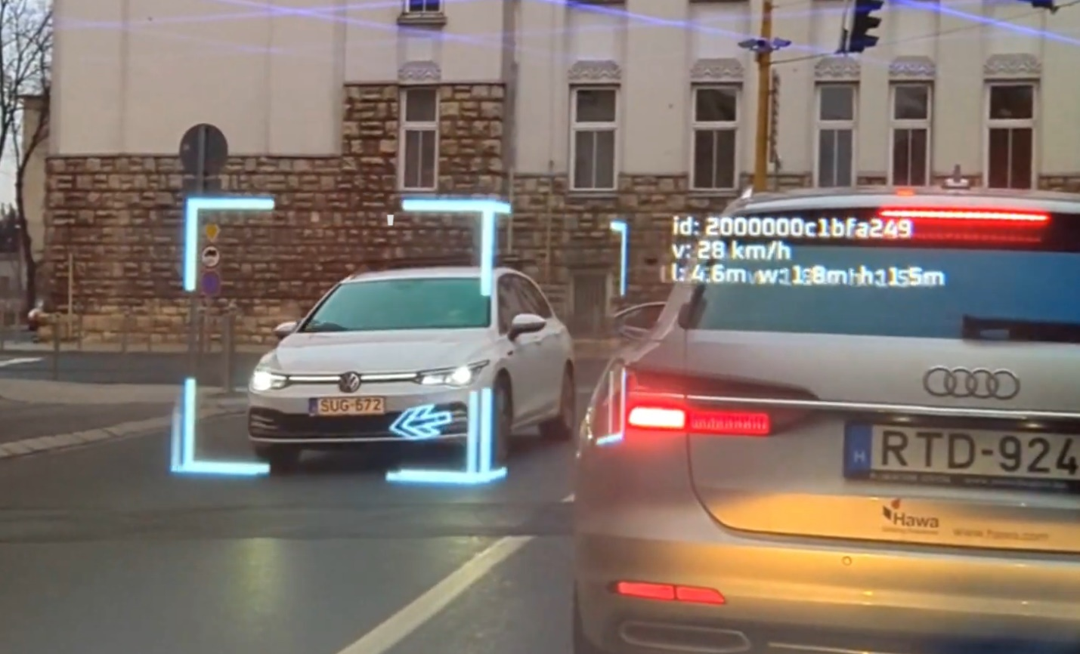
- Why use LIDAR unit?
By comparing LIDAR 3D Object Detection with Computer Vision techniques we concluded that LIDAR’s point cloud is much more accurate than predicting depth from 2D images using triangulate algorithms for depth estimation, Also Computer Vision rises the same problem we trying to solve like (Incoming Headlight Blindness, Detection on dark areas, etc.)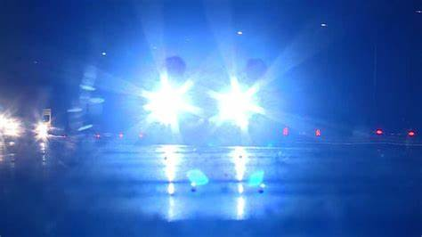
- Why use AR?
Our first approach was to make an AR-HUD which will present our drawing pixels to the Windshield, but this raises the issue of showing blind spots of the driver; Those we thought of using AR Glasses as our final Solution to Give the driver the full functionality and open the potential for more content to be shown (LIDAR real-time view, Parking assist, GPS road navigation, path planning, obstacle detection, Road Analysis, etc.).

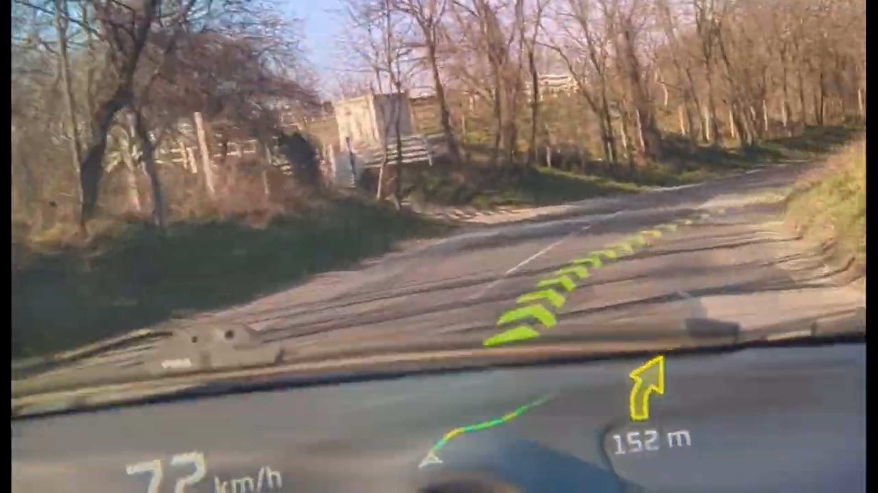

- Why use EEG?
Well this is an optional integration of the system it can work well without it, but as mentioned before the number of inputs of the driver is nearly not possible to introduce rather than making this decision to make the system know it. This will raise an issue of making the bad decision first to warn the user about it, but if we train a classifier that uses Fourier transform of the brain signals to encode it in much more function, we can have an supervised approach by learning our driver next decision and warn him if it was a bad decision example (entering a new lane with taking in consider the car behind you). We thought that Fourier transform will give a higher accuracy in analyzing brain signals as we can transform it into the frequency domain which will aim to loosen the complexity of classifying a non-uniform signal like in brain; Also EEG units could predict driver sleepiness and dizziness, which will help making road much safer by giving the driver alarms.

- Why simulated environment?
Well simulated environment will give us a more flexible/customizable workplace environment for the reinforcement model to train at, having that much capabilities will give us more accurate and faster results when using Evolutionary algorithms in the training also accelerating the learning curve of the model by using more optimized techniques than used in commercial training environments like Carla.

Project Plan:
Developing a real-time decision system require an agile-based SDLC (Software Development Life Cycle) in order to maintain integrity of project modules among each other.
We also recommend separate each module into separate user scenarios, also moving back into previous user scenario is allowed for expanding the functionality.

- Data Collection and preprocessing: (approx. 1:1.5 month/s)
in this phase we aim to collect lidar data for object recognition purposes, also collecting brain signals using EEG for training purposes. The final aim is to make lidar data available to reconstruct simulated environment using it.

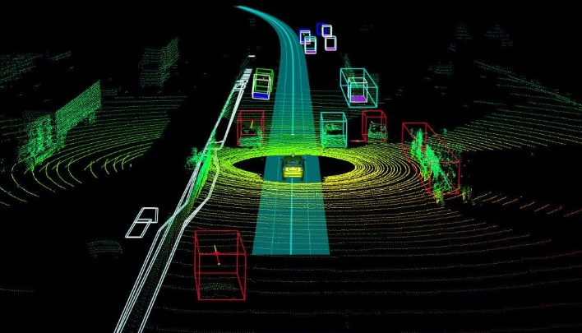 | 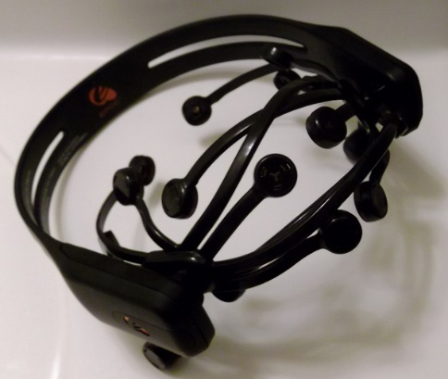

- Building a Gamified Environment: (approx. 1.5 months)
We aim to make a simulated environment using any game engine to reconstruct the current road state after detecting objects on it, also it will make the base for any further updates on the environment.
- Environment Perception: (approx. 1.5 months)
By taking the previous phase results we aim to make algorithms/model to predict objects (vehicles, people, animals, etc.) trajectory in order to make it available for the next phase.

- Reinforcement Learning on existed environment: (approx. 2 months)
Implement RL algorithms to simulate driving scenarios, Train RL models to predict optimal driving actions and evaluating driver actions, Gamify the simulation environment to engage users and gather training data.

- Augmented Reality / Visualization: (approx. 2 months)
As mentioned, the aim of this phase is to visualize for the driver the full functionality of the environment perceptions and making a full integrable interface for the user with a non-disturbing drawing techniques.

- (optional) Handling Inputs From Driver’s Brain Signals: (approx. <1 month)
Collecting and preprocessing labeled driver’s brain signals from real driving scenario can achieve data which could be used in supervised learning to classify it in the future to predict the driver next action.

- Documentation / testing: (flexible)
We recommend doing this phase alternatively along side each phase, to achieve the best documentation and testing each phase after each end will achieve better results than testing it in a separate phase.

Budget:
This project will only cost the Hardware used on it (LIDAR, AR Glasses, and EEG) also AR Glasses and EEG could be DIY (Do It Yourself), but we aim for a premium quality, rather than doing it less functionally.

Conclusion:
This project aims to revolutionize road safety and driver assistance by combining state-of-the-art technologies. By successfully integrating Lidar processing, AR, Reinforcement Learning, and EEG data analysis, we will create an ADAS that not only enhances driver safety but also offers an engaging and informative driving experience; Also this project will be full scalable for future updates.

