Whack-A-Mole – Challenge 1
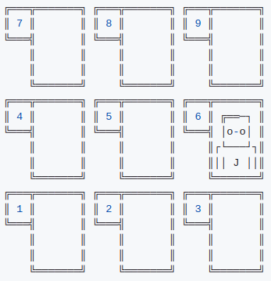
Prerequisite Skills:
- Printing to the console
- User input
- Defining functions
- For/while loops
- If/else statements

Whack-a-mole is a reaction based game where users will have a limited number of time to whack as many moles as they can in the allotted time. Users will receive 1 point for each mole they hit. We will build out the full functionality of this game over the course of several challenge exercises.

Using the starter code provided on Replit (https://replit.com/@csheridan/whack-a-mole1) work to implement the following objectives.

Primary Objectives:
- Set the initial game time variable play_time to 30 seconds.
- Make sure the console has been cleared from any previous games played. Use the following code snippet to clear the console:
os.system('cls' if os.name == 'nt' else 'clear')

- Display the text below before the game starts. The number in “30 seconds” should be a string representation of the play_time variable.

Whack A Mole

You have 30 seconds to whack as many moles as you can before the timer runs out. Use the number keys 1-9 to whack. Are you ready?

Press [y] to play, or [n] to quit.

- If a user enters an n or N
  - Clear the console using the code from step 2.
  - Display the message
Whack A Mole was closed…
  - Exit the game using the command
sys.exit(0)
- Else if user enters y or Y Use the pass statement to do nothing for now. (In the next lesson we will work on adding the game’s functionality. A sample of using pass is provided are

if x == 1:
print(1)
else:
pass

