Whack-A-Mole – Challenge 2
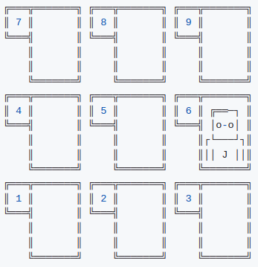
Prerequisite Skills:
- Printing to the console
- User input
- Defining functions
- For/while loops
- If/else statements

Whack-a-mole is a reaction based game where users will have a limited number of time to whack as many moles as they can in the allotted time. Users will receive 1 point for each mole they hit. We will build out the full functionality of this game over the course of several challenge exercises.

Using the starter code provided on Replit (ENTER URL FOR STARTER) work to implement the following objectives.

In this lesson we will focus on defining the Play function and moving the mole. Note: The step number of each primary objective corresponds to a numbered comment in the starter code.

Primary Objectives:
- Import the random module.
- Create a variable called mole_location and set it equal to a random number between 1 & 9.
- Display the game’s title Whack A Mole and an empty board to the users. Note: The board, mole, and an empty hole have been moved to an external file and can be used by calling the variables board, mole, or empty directly.

