Watchtower

Prerequisite Skills:
- User input
- Type casting
- If/else statement
- Relational operators
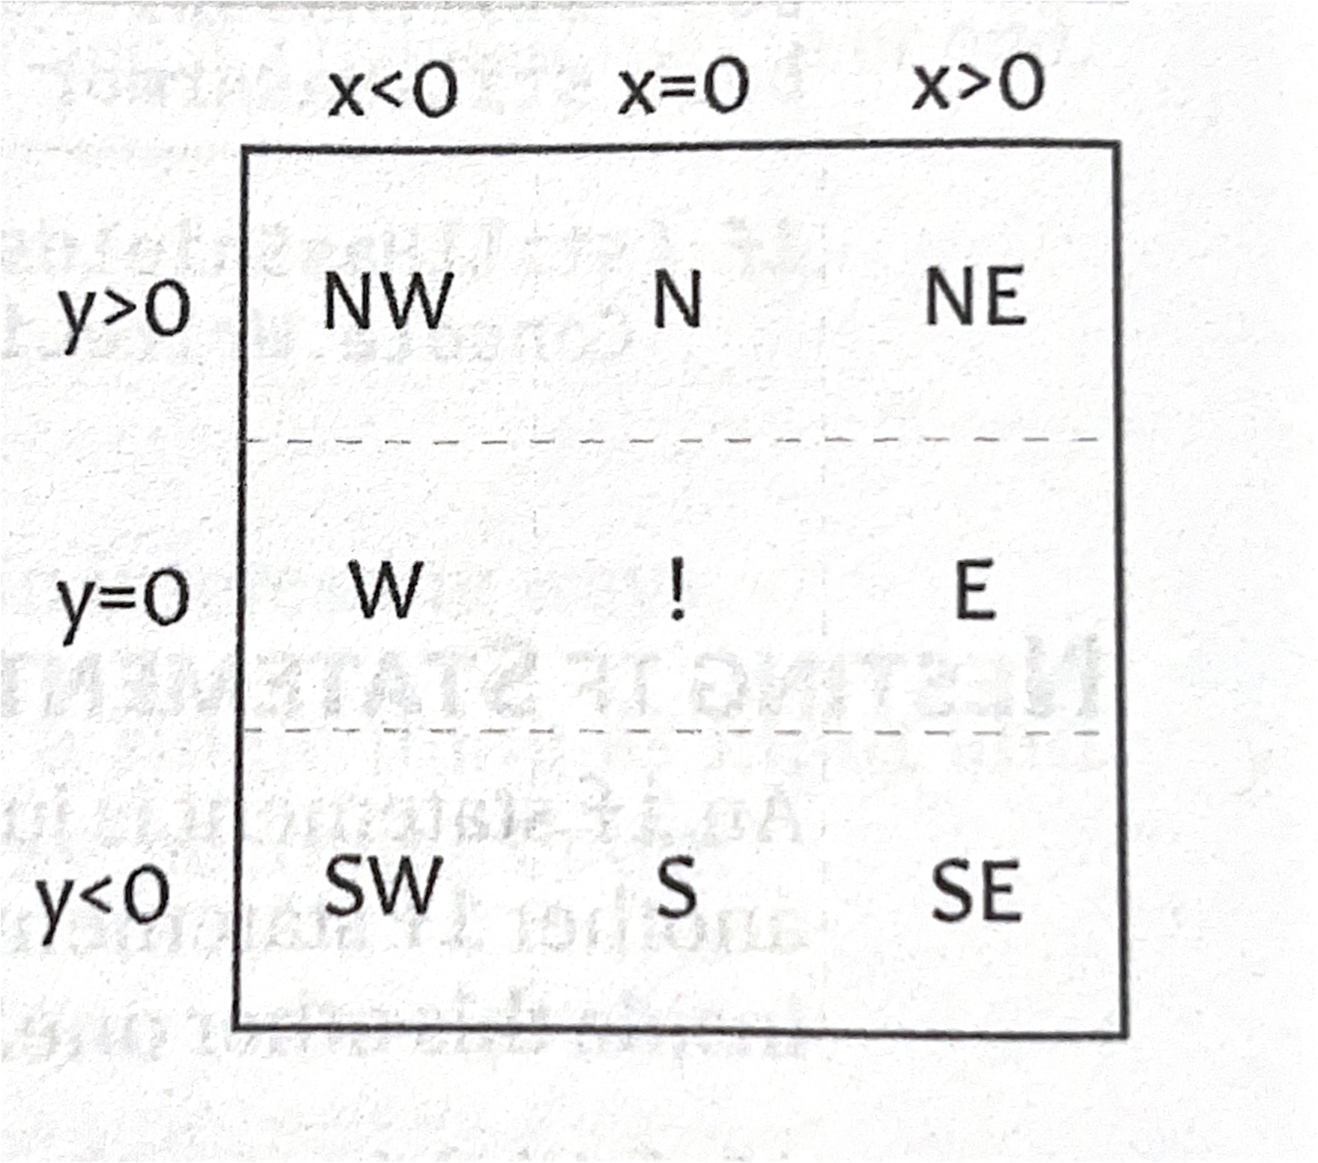
There are watchtowers in the region around Consolas that can alert you when someone is spotted. With some from from you, they can tell which direction people are traveling from the watch tower.

Primary Objectives:
- Ask user for an x value and a y value. These are the coordinates of the people relative to the watchtower’s location.
- Using the image above, if statements, and relational operations, display a message about what direction people are coming from. For example, “People are traveling from the NorthWest” or “They are here!”.

Sample Output:

X Value: -1
Y Value: 0

People are coming from the West.

