1. Introduction
The objective of this project was to design and train a convolutional neural network (CNN) capable of distinguishing between images of dogs and cats. Image classification represents one of the most fundamental problems in computer vision, and it serves as an ideal domain to experiment with neural network architectures, preprocessing techniques, and data augmentation methods. The challenge is not merely to achieve high predictive accuracy, but also to understand which aspects of preprocessing and model design contribute most to robust generalization.

2. Dataset Description
For this work, the Oxford Pets Dataset was used, an open-source dataset originally published by the Visual Geometry Group (VGG) at the University of Oxford. The dataset contains a total of N = 14.005 labeled images of 37 breeds of dogs and cats, each annotated with bounding boxes around the animals’ heads. For the purpose of this binary classification task, all dog breeds were combined into one “dog” class, and all cat breeds into one “cat” class. This simplified setup allowed a focused exploration of preprocessing and modeling strategies while maintaining sufficient variability within each category.
The dataset was accessed through Roboflow Universe and is publicly available under the following link: https://universe.roboflow.com/brad-dwyer/oxford-pets
Images are distributed across three subsets:
- Training set: 12.899 images
- Validation set: 738 images
- Test set: 368 images
Across all subsets, the class distribution is approximately one-third cats and two-thirds dogs, reflecting a moderate class imbalance.
Originally, all images have a resolution of 640×640 pixels. For this project, the images were resized to 128×128 pixels during preprocessing to standardize the input dimensions for the convolutional neural network and to reduce computational complexity. This downscaling preserves sufficient visual detail for classification while enabling faster model training and inference.

3. First Modeling Attempt: Baseline CNN on Full Images
3.1 Data Preparation and Preprocessing
In the first modeling experiment, a simple Convolutional Neural Network (CNN) was built to establish a baseline for binary image classification between cats and dogs. The model architecture followed a classic structure consisting of two convolutional layers, each followed by max-pooling, a flattening operation, a fully connected dense layer with dropout regularization to reduce overfitting, and finally a single sigmoid output neuron for binary prediction. The Adam optimizer was used with a small learning rate (0.0001) to ensure stable convergence during training.
The input data consisted of full, unaltered images from the training set. All images were rescaled to 128×128 pixels and normalized to the [0,1] range. The dataset was split into a training generator and a validation generator, and training was performed over ten epochs. During this phase, only basic preprocessing was applied. No data augmentation, cropping, or balancing was introduced yet.

3.2 Results
The model achieved a training accuracy of approximately .90, while the validation accuracy plateaued at around .75. This gap between training and validation performance indicates a mild degree of overfitting, suggesting that the model learned certain image-specific features that did not generalize well beyond the training set. A likely cause is that the model saw entire images, which often contain large areas of background, inconsistent lighting, and various orientations. These factors may have distracted the model from focusing on the key distinguishing regions — namely, the animals’ faces.
To obtain an unbiased estimate of generalization, the model was finally evaluated on the held-out test set consisting of 368 images. The test accuracy reached .76, with the following confusion matrix and classification report, which can be seen in Table 1 and Table 2.

Table 1
Confusion Matrix regarding first modeling approach.
Variable | Predicted Cat | Predicted Dog
True Cat | 68 | 57
True Dog | 33 | 210
Note. N = 368.

Table 2
Classification report regarding first modeling approach.
Class | Precision | Recall | F1-Score
Cat | .67 | .54 | .60
Dog | .79 | .86 | .82
Note. N = 368.

The results show that while the model was able to classify dogs and cats reasonably well. However, it exhibited a bias toward the dog class, which aligns with the class imbalance in the dataset (approximately two-thirds dogs and one-third cats).
The recall for cats (.54) indicates that the model struggled to correctly identify a significant portion of cat images, often misclassifying them as dogs.
In summary, this baseline model provided a solid starting point, demonstrating that even a simple CNN could achieve around 75–77% accuracy on unprocessed images. However, the performance limitations highlighted the need for data balancing and region-focused training - such as cropping images around the animals’ heads - to enhance the model’s ability to capture discriminative features in later experiments.

4. Second Modeling Attempt: Cropping and Oversampling
4.1 Changes in Modeling Approach
In contrast to the first model, which was trained on the full, uncropped images, the second approach utilized the provided bounding box annotations to crop each image around the animal’s head region.
This modification effectively directed the model’s attention toward the most informative facial features, such as ear shape, eye spacing, and snout structure, while reducing background noise and contextual variation.
Moreover, as cats were underrepresented, oversampling was applied to the training subset to achieve class balance. After resampling, both classes contained 8.814 images each, resulting in a total of 17.628 training samples. Validation and test sets remained untouched to ensure an unbiased evaluation.
4.2 Results
4.2.1 Training and Validation
The network was trained for 10 epochs on the balanced training set, using the validation set for performance monitoring. Training progressed smoothly without divergence, indicating good hyperparameter stability. The model reached near-perfect accuracy on the training set and maintained a strong validation accuracy of 92%, suggesting successful learning without severe overfitting.

Figure 1
Training and Validation Performance of the CNN Model
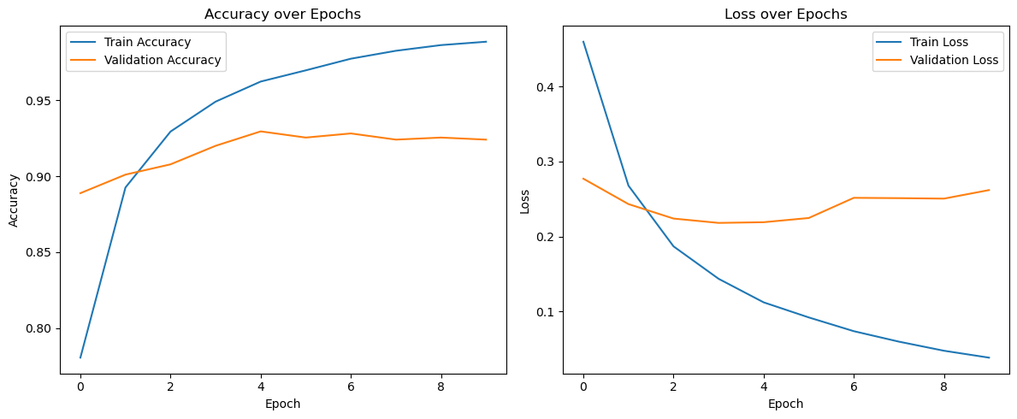
Note. The plots show the evolution of training and validation accuracy (left) and loss (right) across 10 epochs.

Compared to the first attempt (validation accuracy ≈ .75), the improvement to .92 represents a 22% relative gain in predictive performance. The training curve indicated a close alignment between training and validation accuracy, suggesting minimal overfitting and indicating that the new data handling strategy succeeded.

4.2.2 Evaluation on the Test Set
Final model evaluation was conducted on the independent test set of 368 images (125 cats, 243 dogs). The results can be seen in Table 3 and Table 4.

Table 3
Confusion Matrix regarding second modeling approach.
Variable | Predicted Cat | Predicted Dog
True Cat | 114 | 11
True Dog | 17 | 226
Note. N = 368.

Table 4
Classification report regarding second modeling approach.
Class | Precision | Recall | F1-Score
Cat | .87 | .91 | .89
Dog | .95 | .93 | .94
Note. N = 368.

The CNN achieved an overall test accuracy of 92%, demonstrating a high level of generalization.
Compared to the initial model, which reached only 76% accuracy (F1 = .60 for cats and .82 for dogs), this represents a substantial performance improvement. The new approach yielded balanced performance across both classes, indicating that focusing on the cropped head regions enabled the model to learn more discriminative facial features and to reduce background interference.

4.2.3 Visual Interpretation
To better understand which visual features the model relied upon during classification, prototypical representations were generated for each category. This was achieved by averaging all test images belonging to a given class, thereby creating a composite “mean” image that highlights shared structural characteristics. Additionally, pixel-wise variation heatmaps were computed to visualize regions of greatest within-class variability.

Figure 2
Prototypical Faces and Pixel Variation Heatmaps for Cats and Dogs

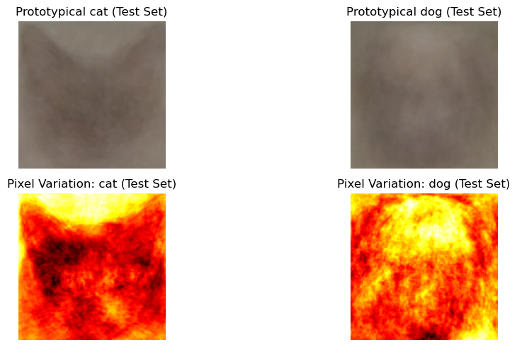

Note. The upper panels display the average facial appearance of cats (left) and dogs (right) computed from the test set. The lower panels show pixel-wise variation heatmaps, highlighting regions of high intra-class variability (visualized with a color map from low to high variation).

The resulting visualizations revealed distinct morphological patterns between the two species. Cats were characterized by pointed, triangular ears and sharper, more angular facial contours, while dogs exhibited rounder head shapes and broader snouts. These prototypical differences closely mirror intuitive anatomical distinctions between the species, suggesting that the CNN successfully learned to focus on key facial cues rather than irrelevant background information. Consequently, the model’s internal representations appear to align with meaningful morphological features that are consistent with human perceptual understanding.

5. Conclusion
The present study demonstrated the progressive refinement of a convolutional neural network (CNN) for binary image classification between cats and dogs. In the initial experiment, the model was trained on the full, unaltered images, which included considerable amounts of background and contextual variation. Although this baseline CNN reached a moderate accuracy of 76% on the test set, its performance revealed systematic weaknesses, particularly a lower recall for the minority “cat” class. These limitations suggested that the network’s attention was partially diverted toward irrelevant image regions, leading to suboptimal feature learning.
The second modeling approach addressed these shortcomings by leveraging the dataset’s bounding box annotations to crop each image around the animal’s head, thereby directing the model’s focus toward the most informative facial regions. Additionally, oversampling was applied to balance the class distribution within the training data. Together, these adjustments produced a substantial improvement: the final CNN achieved 92% accuracy on the test set, with balanced precision and recall across both classes. This represents a 16-point absolute and 22% relative improvement in predictive accuracy compared to the baseline model.
The qualitative analysis of prototypical images and pixel-variation heatmaps provided further insight into the network’s learning behavior. The model appeared to internalize meaningful morphological distinctions - such as the pointed, triangular ears of cats versus the rounder heads and broader snouts of dogs - indicating that it successfully learned discriminative facial features consistent with human perceptual intuition.
In summary, this project illustrates how careful preprocessing and data balancing can dramatically enhance model generalization in visual recognition tasks. Cropping images around salient regions and addressing class imbalance proved to be decisive factors in improving the CNN’s performance. Future work could expand upon these findings by experimenting with deeper architectures, transfer learning, and explicit attention mechanisms to further refine feature localization and robustness.

