- Copy all the folders under “Demo” into “Source_and_Toolchain” folder, then the “Source_and_Toolchain” looks like as the following
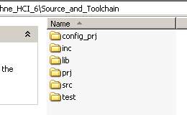

- Run the “load_core_canna.bat” file under “config_prj\core\core_canna”, it will pop up the following dialogue, press OK, the project will be ready.
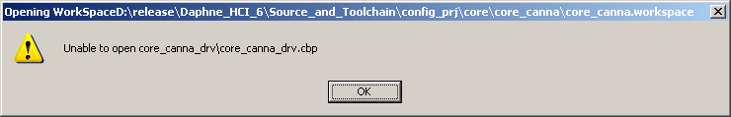

- Rebuild workspace of core, it will produce a lib file named libcore_canna.a in “\lib\jazz”
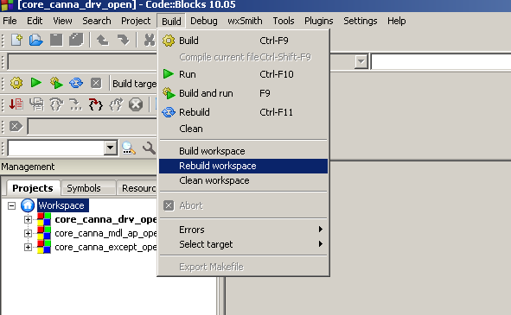

- Rebuild workspace of OTA module and project(“xxx” is the customer name)
- build OTA module
run bat file under config_prj\dvbc\jazz\Daphne\xxx\Daphne_xxx_ota, and build, it will produce jazz_ota_gz.img under
prj\dvbc\Daphne_Ind\customer\xxx\binary\ota_binary

- build project
run bat file under config_prj\dvbc\jazz\Daphne\xxx\Daphne_xxx, and build, it will produce flash.bin under
config_prj\dvbc\jazz\Daphne\xxx\Daphne_xxx\Daphne_xxx\release\binary,
Burn flash.bin into STB and power on.

- PATULOUS function
  - copy kware dir to prj\dvbc\Daphne
  - in build project project build options -→linker settings add kware lib(libdrv_other.a) and third part lib(lib_tf_cas21.r) file and path.
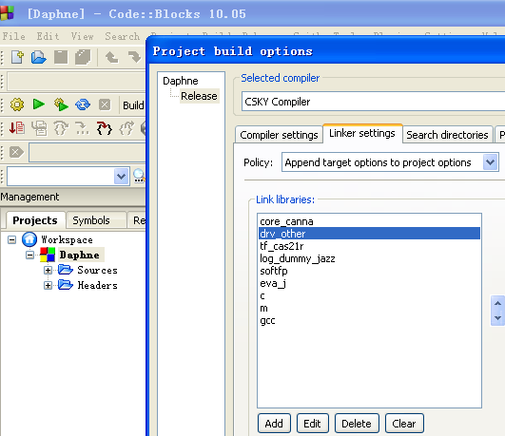
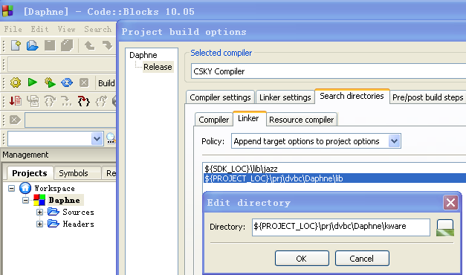
  - add kware include and kware function paths
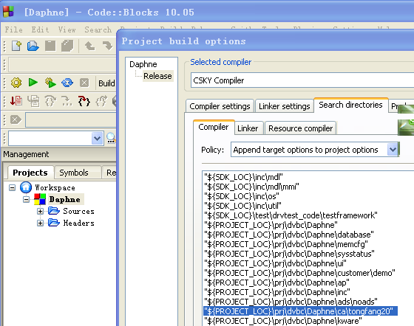

  - add kware function switch (only dephne demo) PATULOUS_FUNCTION_CA
