Openvpn installation and setup procedures (Windows 8.0)

Download Openvpn from <https://openvpn.net/index.php/access-server/overview.html>

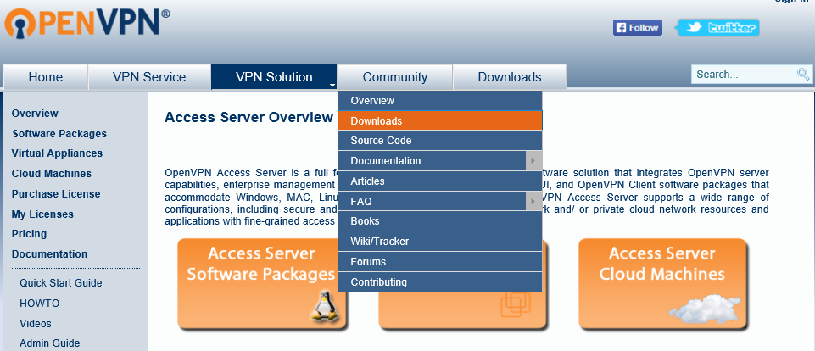



Download the version that supports your Computer OS.

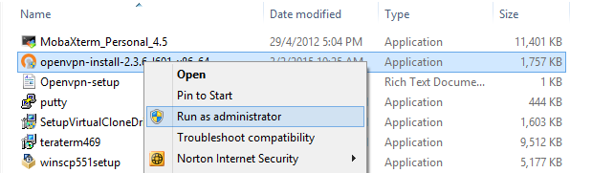

Run the Openvpn installer from the location where the install file was downloaded.

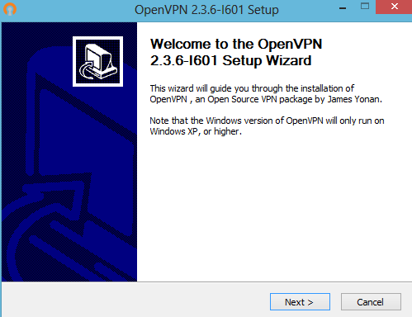

Click Next to proceed with the installation

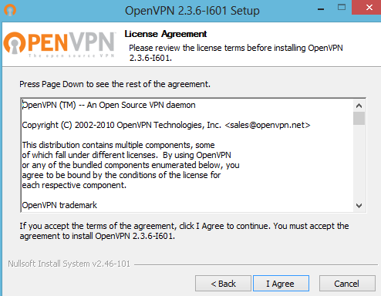

Click I Agree to continue

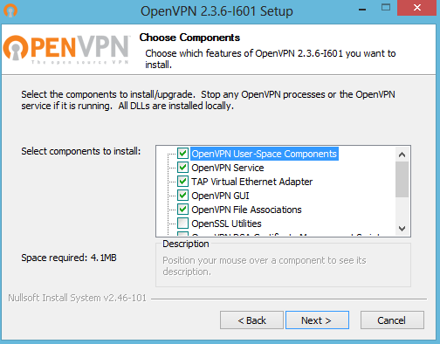

Accept the default selections and click Next

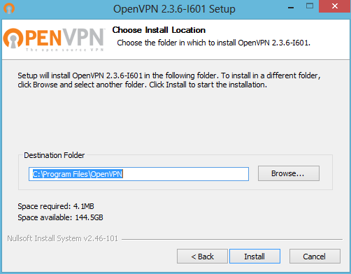

Click Install to start the installation process

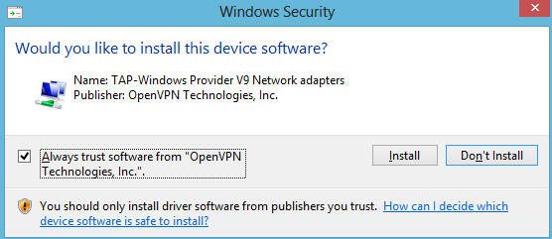

Check "Always trust software from "OpenVPN Technologies, Inc" and click Install to install TAP-Windows Provider V9 Network adapters

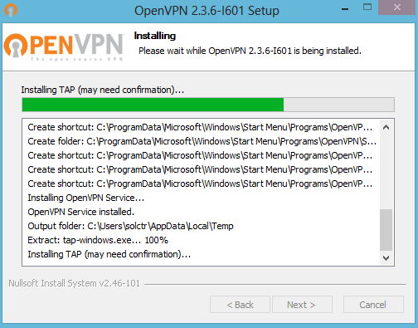

The installation process will resume

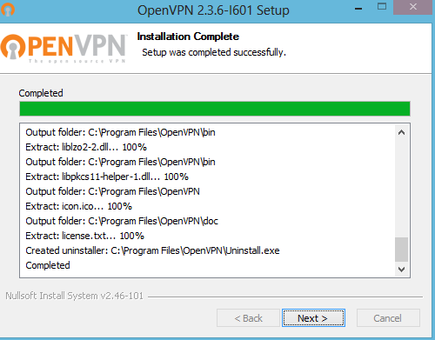

Click Next to complete the installation

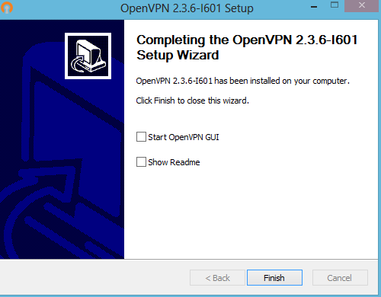

Click Finish to close the installation screen



The OpenVPN icon will be installed on the desktop.

**HP CPC team will send you a file with the VPN client certificates.**

Example: client.tar.gz

Extract the certificate files and manually move the files to the OpenVPN directory at C:\Program Files\OpenVPN\config directory

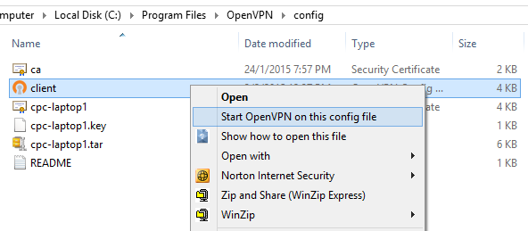

Navigate to the OpenVPN directory at C:\Program Files\OpenVPN\config, right click on the clien.ovpn file and select “Start OpenVPN on this config file”

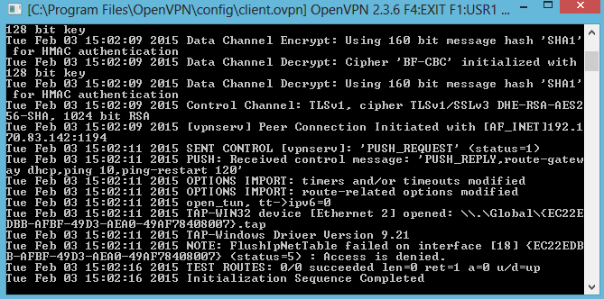

Connection status. Once connected, your computer will get a 10.x IP address.

To end the VPN session, close the above window.

Openvpn installation and setup procedures (Windows 7.0)

Download Openvpn from <https://openvpn.net/index.php/access-server/overview.html>





Download the version that supports your Computer OS.



Run the Openvpn installer from the location where the install file was downloaded.

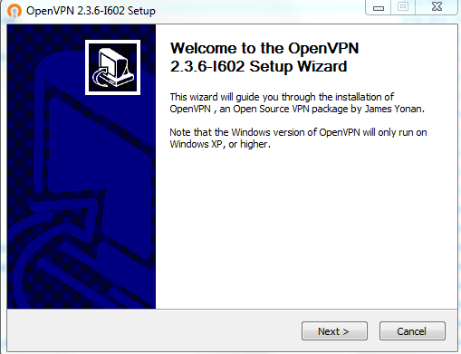

Click Next to continue

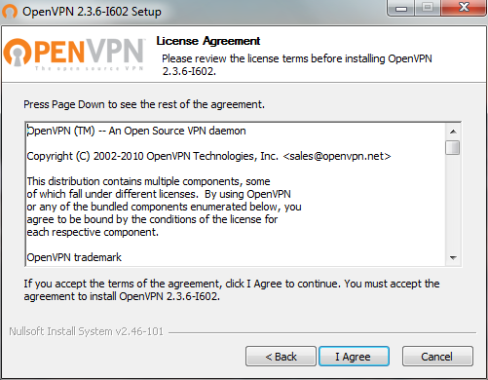

Click I Agree

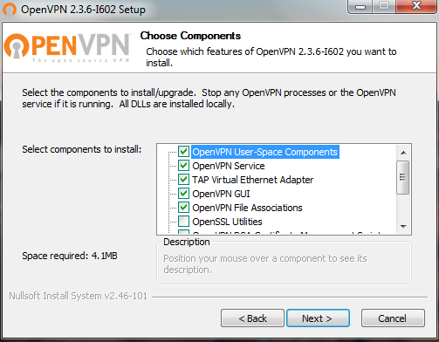

Accept the default selection and click Next.

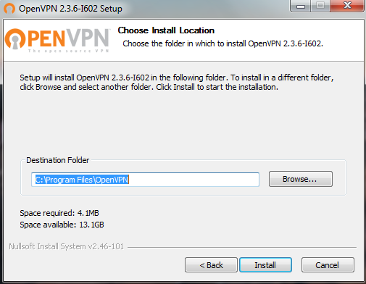

Click Install to start the installation.

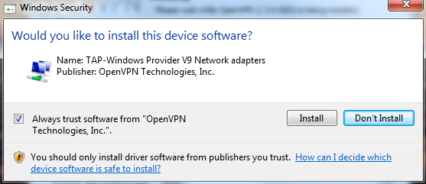

Check "Always trust software from "OpenVPN Technologies, Inc" and click Install to install TAP-Windows Provider V9 Network adapters

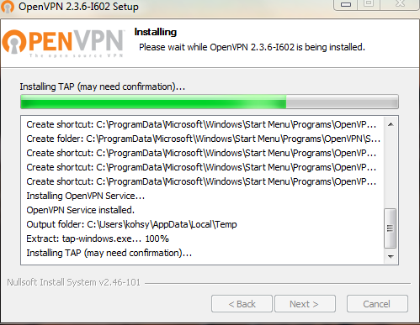

The installation process will resume

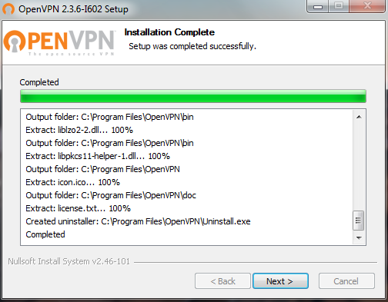

Click Next to complete the installation.

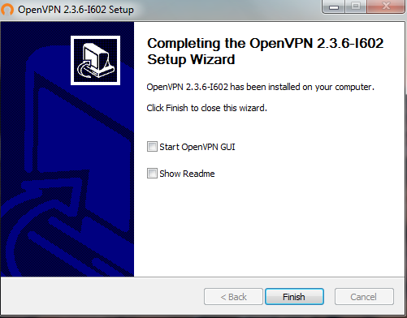

Click Finish to close the installation screen



The OpenVPN icon will be installed on the desktop.

**HP CPC team will send you a file with the VPN client certificates.**

Example: client.tar.gz

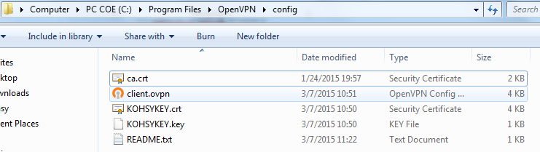

Extract the certificate files and manually move the files to the OpenVPN directory at C:\Program Files\OpenVPN\config directory

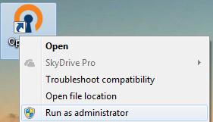 

Once the certificate and config files are copied to C:\Program Files\OpenVPN\config directory, right click on the OpenVPN GUI and select “Run as administrator”, an icon will appear on the system tray

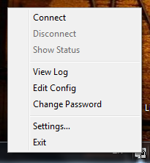

Right click on the icon and select Connect

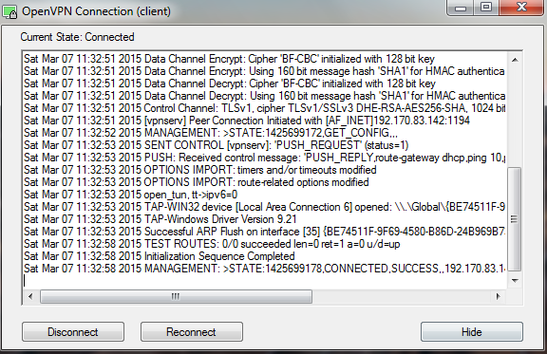

The VPN connection will start and you will see able screen. It will close once connection has been established.



The icon on the system tray will have a green monitor screen.

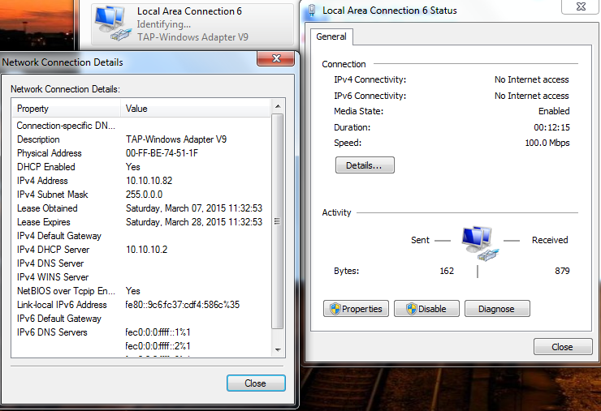

Your computer will get a 10.x IP address.

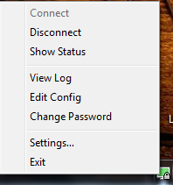

To disconnect from the VPN, right click on the icon on the system tray and select Disconnect.