Номер – tst29_part2
Название - тестирование версии 4.0 (r4429,r4444,beta)

Тестирование сборки r4429

- Проверка pending багов:

1.1 3601351 js ошибки на странице "Система"

Баг исправлен, js ошибок не обнаружено.

  - 3601353 скрипты в WFE, не работают меню

Баг исправлен, но нашел новые проблемы:

  - 3601358 Меню Вид, не работает с кириллическими названиями

Баг исправлен, проблем с кириллицей не обнаружил.

  - 3602225 QueryException, сортировка запущенных процессов по версии

Баг исправлен, сортировка по версии проходит успешно.

  - 3602295 Обладатели полномочий.История.java.lang.NullPointerException

Баг исправлен

  - 3602300 Рушится верстка, некорректные сообщения

Баг исправлен

1.7 3602304 не удаляется процесс с подпроцессом

Сделал процесс и подпроцесс, запустил несколько экземпляров, затем выделил эти процессы, сделал удаление, получил сообщение:
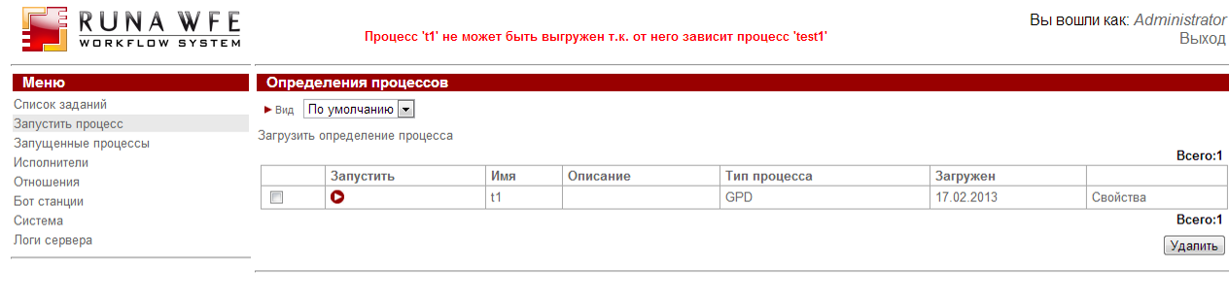

Однако выделив снова процесс t1, он успешно удаляется, т.е. все таки баг исправлен.

  - 3602569 История выполнения экземпляра процесса. Повтор сообщения

Баг исправлен

  - 3602579 Ошибка Ajax запроса. Заместители. Добавить правило

Баг исправлен

  - 3602581 заместители, правила, ArrayIndexOutOfBoundsException

Исполнитель, заместители, добавил ByCode и ByName, кликаю по стрелке сортировки в графе Применить

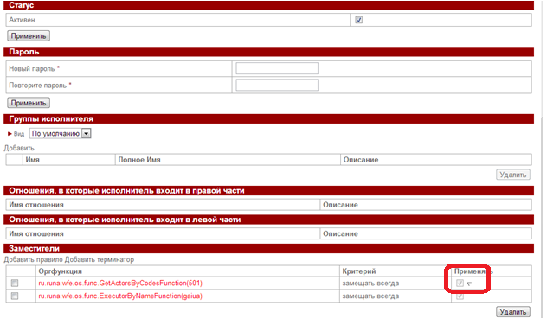

Получаю:
Ошибка: java.lang.NullPointerException

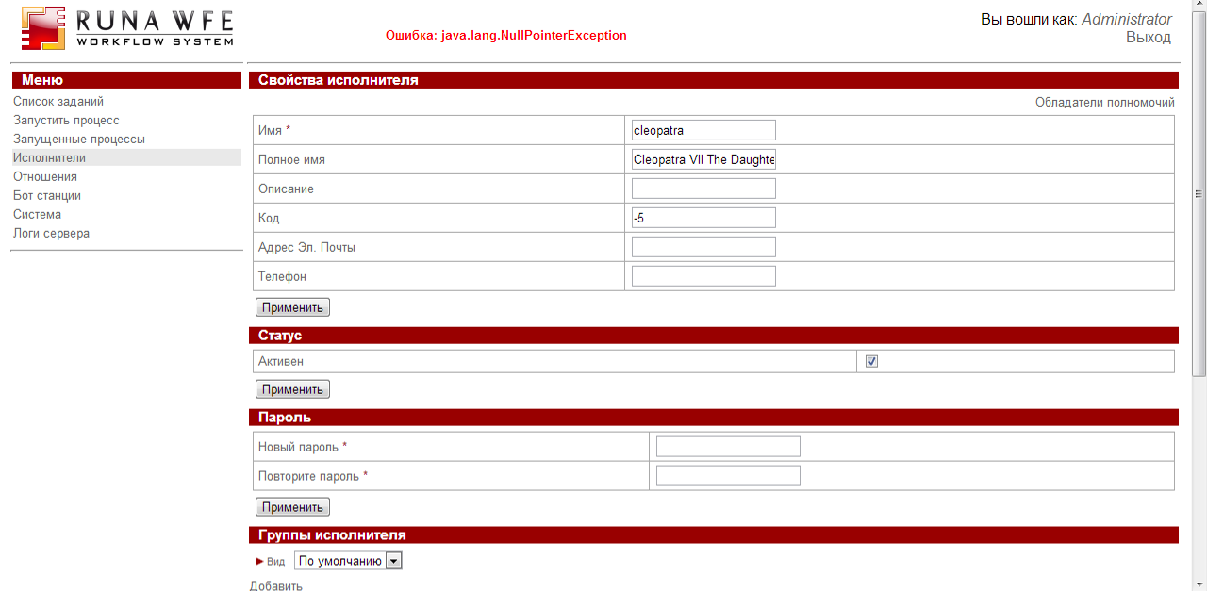

Т.е. баг не совсем исправлен, те же действия приводят к другому exeption. Логи прилагаются.

UPD: Завел баг на трекере (4.0 r4429 Заместители, java.lang.NullPointerException - ID: 3605104), но 2013-02-18 11:23:41 PST был закрыт fixed/closed

- Admin scripts, wfe, сборник багов (4.0alpha r4429) ID: 3605088

2.1 Вызвал скрипт в wfe, нажал Отмена, получаем ошибку в editor.js:1143

Uncaught TypeError: Cannot read property 'select' of null editor.js:1143
Uncaught TypeError: Cannot read property 'History' of null undo.js:148

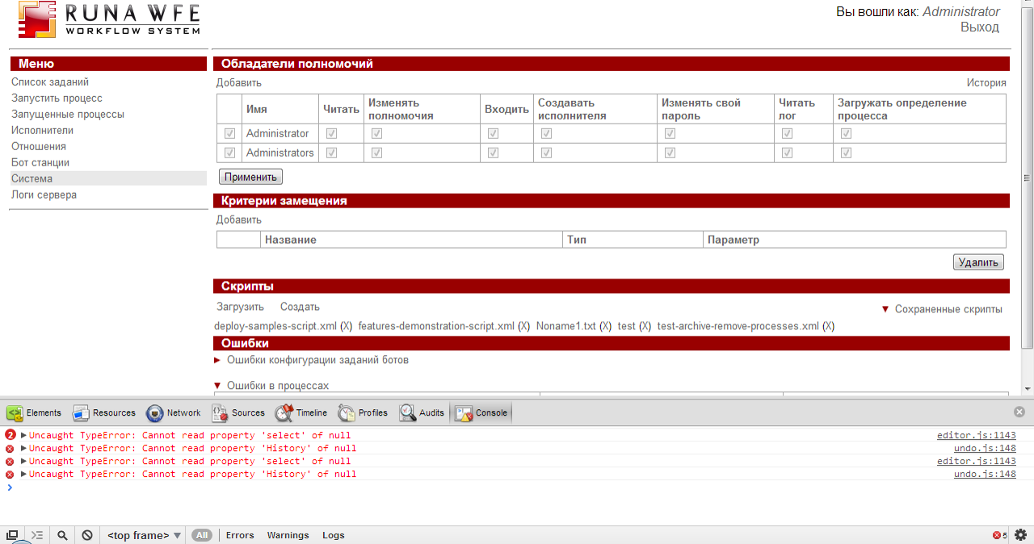

2.2 Вызвал сохраненный скрипт в wfe

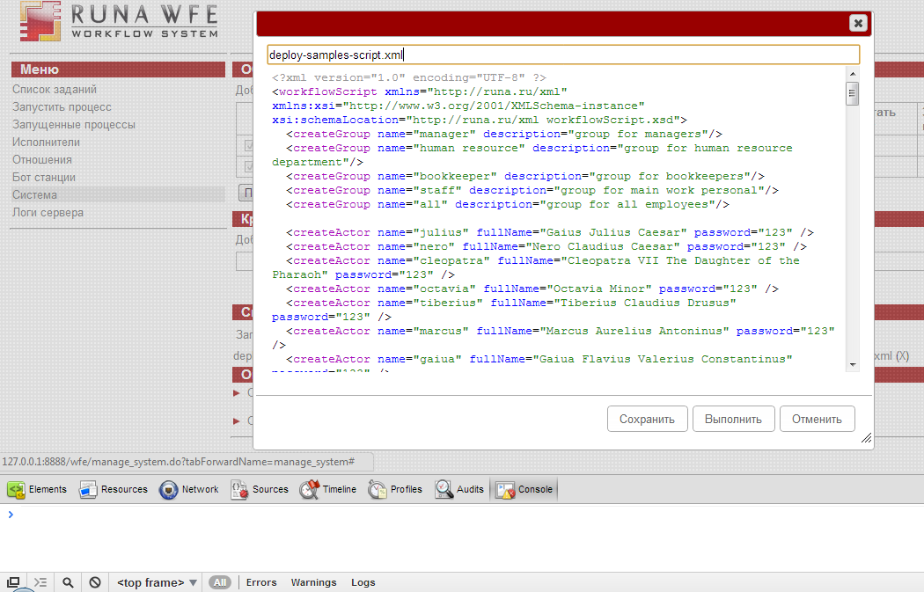

Закрыл с помощью крестика, теперь при вызове скрипта, не показывается текст xml скрипта:

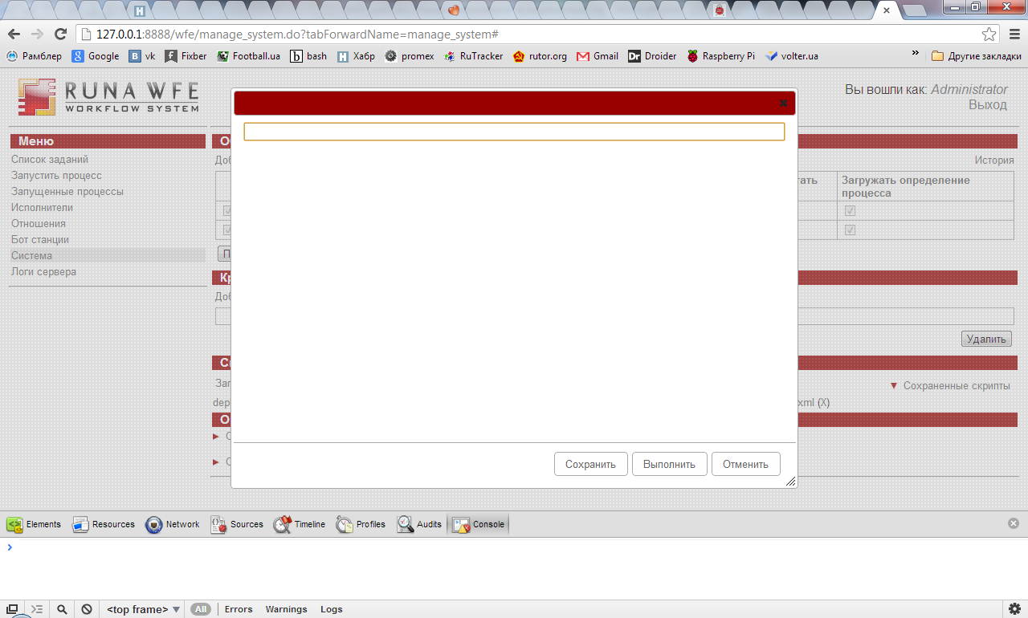

  - Создаю скрипт, вбил имя и текст, нажимаю сохранить

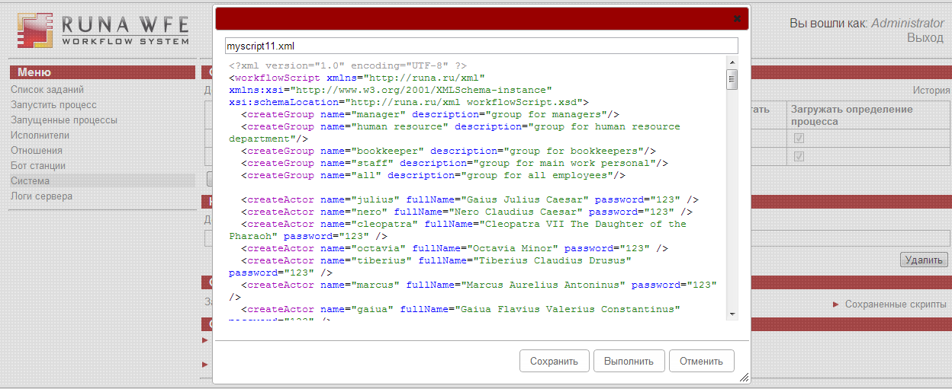

Снова ошибка Uncaught TypeError: Cannot read property 'select' of null

При этом в списке сохраненных, моего скрипта НЕТ

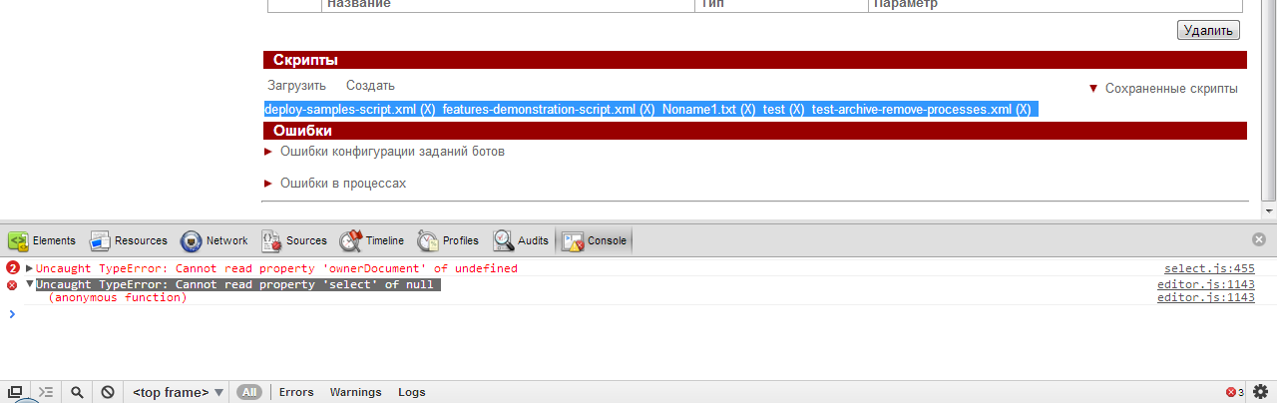

Перезагрузил пару раз страницу, скрипт появился:

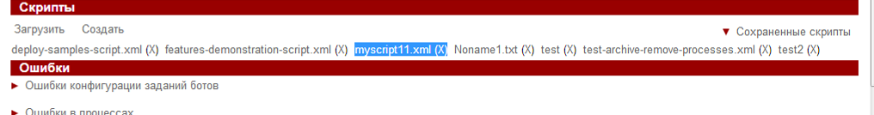

  - Выполняю скрипт deploy-samples-script.xml

<?xml version="1.0" encoding="UTF-8" ?>
<workflowScript xmlns="http://runa.ru/xml" xmlns:xsi="http://www.w3.org/2001/XMLSchema-instance" xsi:schemaLocation="http://runa.ru/xml workflowScript.xsd">
<createGroup name="manager" description="group for managers"/>
<createGroup name="human resource" description="group for human resource department"/>
<createGroup name="bookkeeper" description="group for bookkeepers"/>
<createGroup name="staff" description="group for main work personal"/>
<createGroup name="all" description="group for all employees"/>

<createActor name="julius" fullName="Gaius Julius Caesar" password="123" />
<createActor name="nero" fullName="Nero Claudius Caesar" password="123" />
<createActor name="cleopatra" fullName="Cleopatra VII The Daughter of the Pharaoh" password="123" />
<createActor name="octavia" fullName="Octavia Minor" password="123" />
<createActor name="tiberius" fullName="Tiberius Claudius Drusus" password="123" />
<createActor name="marcus" fullName="Marcus Aurelius Antoninus" password="123" />
<createActor name="gaiua" fullName="Gaiua Flavius Valerius Constantinus" password="123" />
<createActor name="attila" fullName="Attila the King of Huns" password="123" />
<createActor name="caligula" fullName="Gaius Iulius Germanicus" password="123" />
<createActor name="UniversalBot" fullName="Bot for a Demo" password="321" />
<createActor name="StopBot" fullName="Bot for stopping old processes" password="321" />
<createActor name="WebServiceBot" fullName="Bot for executing web service requests" password="321" />

<namedIdentitySet name="allProcesses" type="ProcessDefinition">
<identity name="TextFileCreation"/>
<identity name="BotDemo"/>
<identity name="Businesstrip"/>
<identity name="Vacation"/>
<identity name="Overtime Work"/>
<identity name="Report"/>
<identity name="FileUpload"/>
<identity name="Hello World"/>
<identity name="SubProcess"/>
<identity name="MainProcess"/>
<identity name="MultiInstanceSubProcess"/>
<identity name="MultiInstanceProcess"/>
<identity name="ExecuteFormulaDemo"/>
<identity name="TimerDemo"/>
<identity name="BPMNdemo"/>
<identity name="AjaxFormDemo"/>
<identity name="WebService - who is"/>
<identity name="MSWordReport"/>
</namedIdentitySet>
<namedIdentitySet name="managerProcesses" type="ProcessDefinition">
<identity name="Businesstrip"/>
<identity name="Overtime Work"/>
<identity name="Report"/>
</namedIdentitySet>
<namedIdentitySet name="genericProcesses" type="ProcessDefinition">
<identity name="TextFileCreation"/>
<identity name="BotDemo"/>
<identity name="Vacation"/>
<identity name="FileUpload"/>
<identity name="Hello World"/>
<identity name="MainProcess"/>
<identity name="MultiInstanceProcess"/>
<identity name="ExecuteFormulaDemo"/>
<identity name="TimerDemo"/>
<identity name="AjaxFormDemo"/>
<identity name="BPMNdemo"/>
<identity name="WebService - who is"/>
<identity name="MSWordReport"/>
</namedIdentitySet>

<namedIdentitySet name="allActors" type="Executor">
<identity name="julius"/>
<identity name="nero"/>
<identity name="cleopatra"/>
<identity name="octavia"/>
<identity name="tiberius"/>
<identity name="marcus"/>
<identity name="gaiua"/>
<identity name="attila"/>
<identity name="caligula"/>
<identity name="UniversalBot"/>
</namedIdentitySet>
<namedIdentitySet name="allGroupsExceptALL" type="Executor">
<identity name="manager"/>
<identity name="human resource"/>
<identity name="bookkeeper"/>
<identity name="staff"/>
</namedIdentitySet>

<deployProcessDefinition file="../samples/Hello World.par" />
<deployProcessDefinition file="../samples/BPMNdemo.par" />
<deployProcessDefinition file="../samples/ExecuteFormulaDemo.par"/>
<deployProcessDefinition file="../samples/AjaxFormDemo.par" />
<deployProcessDefinition file="../samples/FileUpload.par" />
<deployProcessDefinition file="../samples/TimerDemo.par" />
<deployProcessDefinition file="../samples/Report.par" />
<deployProcessDefinition file="../samples/Overtime Work.par" />
<deployProcessDefinition file="../samples/Vacation.par" />
<deployProcessDefinition file="../samples/Businesstrip.par" />
<deployProcessDefinition file="../samples/MainProcess.par" />
<deployProcessDefinition file="../samples/SubProcess.par" />
<deployProcessDefinition file="../samples/MultiInstanceProcess.par" />
<deployProcessDefinition file="../samples/MultiInstanceSubProcess.par" />
<deployProcessDefinition file="../samples/BotDemo.par" />
<deployProcessDefinition file="../samples/TextFileCreation.par" />
<deployProcessDefinition file="../samples/WebService - who is.par" />
<deployProcessDefinition file="../samples/MSWordReport/MSWordReport.par" />

<addPermissionsOnDefinition executor="all">
<namedIdentitySet name="allProcesses" type="ProcessDefinition"/>
<permission name="permission.read"/>
<permission name="permission.read_process"/>
</addPermissionsOnDefinition>
<addPermissionsOnDefinition executor="manager">
<namedIdentitySet name="managerProcesses" type="ProcessDefinition"/>
<permission name="permission.start_process"/>
</addPermissionsOnDefinition>
<addPermissionsOnDefinition executor="all">
<namedIdentitySet name="genericProcesses" type="ProcessDefinition"/>
<permission name="permission.start_process"/>
</addPermissionsOnDefinition>

<addExecutorsToGroup name="Administrators">
<executor name="StopBot"/>
</addExecutorsToGroup>

<addExecutorsToGroup name="manager">
<executor name="julius"/>
<executor name="nero"/>
</addExecutorsToGroup>

<addExecutorsToGroup name="human resource">
<executor name="cleopatra"/>
<executor name="octavia"/>
</addExecutorsToGroup>

<addExecutorsToGroup name="bookkeeper">
<executor name="caligula"/>
<executor name="tiberius"/>
</addExecutorsToGroup>

<addExecutorsToGroup name="staff">
<executor name="marcus"/>
<executor name="gaiua"/>
<executor name="attila"/>
</addExecutorsToGroup>

<addExecutorsToGroup name="all">
<namedIdentitySet name="allActors" type="Executor"/>
</addExecutorsToGroup>

<addPermissionsOnSystem executor="all">
<permission name="permission.read"/>
<permission name="permission.login_to_system"/>
</addPermissionsOnSystem>

<addPermissionsOnGroup executor="all">
<namedIdentitySet name="allGroupsExceptALL" type="Executor"/>
<permission name="permission.read"/>
<permission name="permission.list_group"/>
</addPermissionsOnGroup>

<addPermissionsOnActor executor="all">
<namedIdentitySet name="allActors" type="Executor"/>
<permission name="permission.read"/>
</addPermissionsOnActor>

<addPermissionsOnBotStations executor="UniversalBot">
<permission name="permission.read"/>
</addPermissionsOnBotStations>
<addPermissionsOnBotStations executor="StopBot">
<permission name="permission.read"/>
</addPermissionsOnBotStations>
<addPermissionsOnBotStations executor="WebServiceBot">
<permission name="permission.read"/>
</addPermissionsOnBotStations>

<createBotStation name="localbotstation" address="localhost" />
<createBot botStation="localbotstation" name="UniversalBot" password="321" startTimeout="200"/>
<createBot botStation="localbotstation" name="StopBot" password="321" startTimeout="200"/>
<createBot botStation="localbotstation" name="WebServiceBot" password="321" startTimeout="200"/>
<addConfigurationsToBot botStation="localbotstation" name="UniversalBot">
<botConfiguration name="DoNothing" handler="ru.runa.wf.logic.bot.DoNothingTaskHandler" configuration="" />
<botConfiguration name = "create text file" handler="ru.runa.wf.logic.bot.TextReportTaskHandler" configuration="bot/handler/textFile.xml" />
<botConfiguration name = "Generate MS Word Report" handler="ru.runa.wf.logic.bot.MSWordReportTaskHandler" configuration="bot/handler/msword-report.xml" />
</addConfigurationsToBot>
<addConfigurationsToBot botStation="localbotstation" name="StopBot">
<botConfiguration name="state1" handler="ru.runa.wf.logic.bot.CancelOldProcesses" configuration=""/>
</addConfigurationsToBot>
<addConfigurationsToBot botStation="localbotstation" name="WebServiceBot">
<botConfiguration name="Load whois information" handler="ru.runa.wf.logic.bot.WebServiceTaskHandler" configuration="bot/demo/soapBot-whois.xml"/>
</addConfigurationsToBot>

<relation name="Boss">
<left>
<executor name="nero"/>
</left>
<right>
<executor name="caligula"/>
<executor name="attila"/>
</right>
</relation>
<relation name="Boss">
<left>
<executor name="julius"/>
</left>
<right>
<executor name="julius"/>
<executor name="nero"/>
<executor name="cleopatra"/>
<executor name="octavia"/>
<executor name="tiberius"/>
<executor name="marcus"/>
</right>
</relation>

</workflowScript>

Получаю сообщение: скрипт выполнен с ошибками:

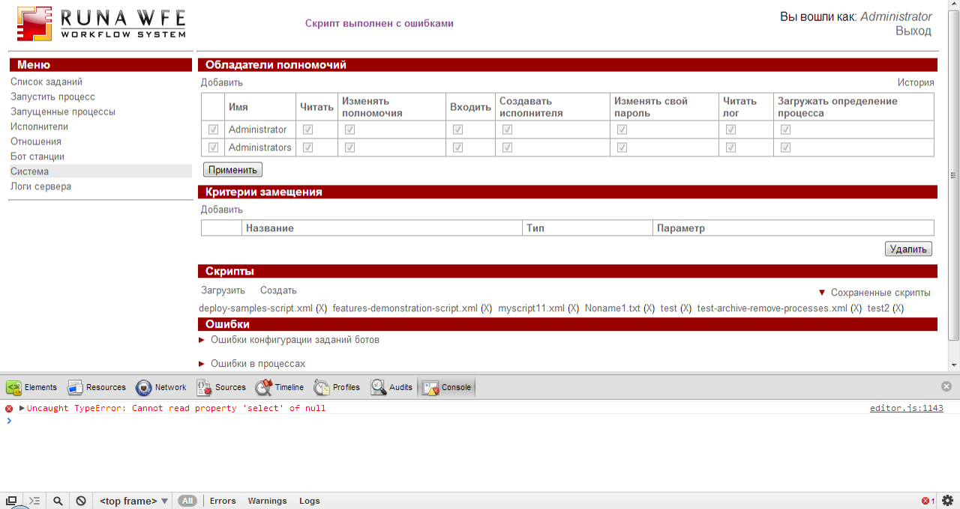

В логах:

2013-02-17 18:36:02,498 ERROR [ru.runa.wfe.service.interceptors.EjbExceptionSupport] ejb call
ru.runa.wfe.script.AdminScriptException: Failed to handle element
<deployProcessDefinition xmlns="http://runa.ru/xml" file="../samples/Hello World.par"/>
at ru.runa.wfe.script.AdminScriptRunner.handleElement(AdminScriptRunner.java:173)
at ru.runa.wfe.script.AdminScriptRunner.runScript(AdminScriptRunner.java:155)
at ru.runa.wfe.service.impl.AdminScriptServiceBean.run(AdminScriptServiceBean.java:51)
at sun.reflect.NativeMethodAccessorImpl.invoke0(Native Method)
at sun.reflect.NativeMethodAccessorImpl.invoke(NativeMethodAccessorImpl.java:39)
at sun.reflect.DelegatingMethodAccessorImpl.invoke(DelegatingMethodAccessorImpl.java:25)
at java.lang.reflect.Method.invoke(Method.java:597)
at org.jboss.aop.joinpoint.MethodInvocation.invokeNext(MethodInvocation.java:112)
at org.jboss.ejb3.interceptor.InvocationContextImpl.proceed(InvocationContextImpl.java:166)
at ru.runa.wfe.service.interceptors.EjbTransactionSupport.invokeWithRetry(EjbTransactionSupport.java:87)
at ru.runa.wfe.service.interceptors.EjbTransactionSupport.process(EjbTransactionSupport.java:37)
at sun.reflect.GeneratedMethodAccessor165.invoke(Unknown Source)
at sun.reflect.DelegatingMethodAccessorImpl.invoke(DelegatingMethodAccessorImpl.java:25)
at java.lang.reflect.Method.invoke(Method.java:597)
at org.jboss.ejb3.interceptor.InvocationContextImpl.proceed(InvocationContextImpl.java:118)
at ru.runa.wfe.service.interceptors.EjbExceptionSupport.process(EjbExceptionSupport.java:27)
at sun.reflect.GeneratedMethodAccessor164.invoke(Unknown Source)
at sun.reflect.DelegatingMethodAccessorImpl.invoke(DelegatingMethodAccessorImpl.java:25)
at java.lang.reflect.Method.invoke(Method.java:597)
at org.jboss.ejb3.interceptor.InvocationContextImpl.proceed(InvocationContextImpl.java:118)
at org.jboss.ejb3.interceptor.EJB3InterceptorsInterceptor.invoke(EJB3InterceptorsInterceptor.java:63)
at org.jboss.aop.joinpoint.MethodInvocation.invokeNext(MethodInvocation.java:101)
at org.jboss.ejb3.entity.TransactionScopedEntityManagerInterceptor.invoke(TransactionScopedEntityManagerInterceptor.java:54)
at org.jboss.aop.joinpoint.MethodInvocation.invokeNext(MethodInvocation.java:101)
at org.jboss.ejb3.AllowedOperationsInterceptor.invoke(AllowedOperationsInterceptor.java:47)
at org.jboss.aop.joinpoint.MethodInvocation.invokeNext(MethodInvocation.java:101)
at org.jboss.ejb3.tx.BMTInterceptor.handleStateless(BMTInterceptor.java:71)
at org.jboss.ejb3.tx.BMTInterceptor.invoke(BMTInterceptor.java:131)
at org.jboss.aop.joinpoint.MethodInvocation.invokeNext(MethodInvocation.java:101)
at org.jboss.aspects.tx.TxPropagationInterceptor.invoke(TxPropagationInterceptor.java:95)
at org.jboss.aop.joinpoint.MethodInvocation.invokeNext(MethodInvocation.java:101)
at org.jboss.ejb3.stateless.StatelessInstanceInterceptor.invoke(StatelessInstanceInterceptor.java:62)
at org.jboss.aop.joinpoint.MethodInvocation.invokeNext(MethodInvocation.java:101)
at org.jboss.aspects.security.AuthenticationInterceptor.invoke(AuthenticationInterceptor.java:77)
at org.jboss.ejb3.security.Ejb3AuthenticationInterceptor.invoke(Ejb3AuthenticationInterceptor.java:110)
at org.jboss.aop.joinpoint.MethodInvocation.invokeNext(MethodInvocation.java:101)
at org.jboss.ejb3.ENCPropagationInterceptor.invoke(ENCPropagationInterceptor.java:46)
at org.jboss.aop.joinpoint.MethodInvocation.invokeNext(MethodInvocation.java:101)
at org.jboss.ejb3.asynchronous.AsynchronousInterceptor.invoke(AsynchronousInterceptor.java:106)
at org.jboss.aop.joinpoint.MethodInvocation.invokeNext(MethodInvocation.java:101)
at org.jboss.ejb3.stateless.StatelessContainer.dynamicInvoke(StatelessContainer.java:304)
at org.jboss.ejb3.remoting.IsLocalInterceptor.invokeLocal(IsLocalInterceptor.java:81)
at org.jboss.ejb3.remoting.IsLocalInterceptor.invoke(IsLocalInterceptor.java:72)
at org.jboss.aop.joinpoint.MethodInvocation.invokeNext(MethodInvocation.java:101)
at org.jboss.ejb3.stateless.StatelessRemoteProxy.invoke(StatelessRemoteProxy.java:107)
at $Proxy218.run(Unknown Source)
at ru.runa.wfe.service.delegate.AdminScriptServiceDelegate.run(AdminScriptServiceDelegate.java:38)
at ru.runa.wfe.service.client.AdminScriptClient.run(AdminScriptClient.java:84)
at ru.runa.common.web.action.AdminkitScriptsAction.execute(AdminkitScriptsAction.java:50)
at org.apache.struts.action.RequestProcessor.processActionPerform(RequestProcessor.java:425)
at org.apache.struts.action.RequestProcessor.process(RequestProcessor.java:228)
at ru.runa.common.web.UTF8RequestProcessor.process(UTF8RequestProcessor.java:41)
at org.apache.struts.action.ActionServlet.process(ActionServlet.java:1913)
at org.apache.struts.action.ActionServlet.doPost(ActionServlet.java:462)
at javax.servlet.http.HttpServlet.service(HttpServlet.java:710)
at javax.servlet.http.HttpServlet.service(HttpServlet.java:803)
at org.apache.catalina.core.ApplicationFilterChain.internalDoFilter(ApplicationFilterChain.java:290)
at org.apache.catalina.core.ApplicationFilterChain.doFilter(ApplicationFilterChain.java:206)
at ru.runa.common.web.filter.HTTPSessionFilter.doFilter(HTTPSessionFilter.java:58)
at ru.runa.common.web.filter.HTTPFilterBase.doFilter(HTTPFilterBase.java:45)
at org.apache.catalina.core.ApplicationFilterChain.internalDoFilter(ApplicationFilterChain.java:235)
at org.apache.catalina.core.ApplicationFilterChain.doFilter(ApplicationFilterChain.java:206)
at ru.runa.af.web.filter.NTLMFilter.doFilter(NTLMFilter.java:52)
at ru.runa.common.web.filter.HTTPFilterBase.doFilter(HTTPFilterBase.java:45)
at org.apache.catalina.core.ApplicationFilterChain.internalDoFilter(ApplicationFilterChain.java:235)
at org.apache.catalina.core.ApplicationFilterChain.doFilter(ApplicationFilterChain.java:206)
at net.bull.javamelody.MonitoringFilter.doFilter(MonitoringFilter.java:206)
at net.bull.javamelody.MonitoringFilter.doFilter(MonitoringFilter.java:179)
at org.apache.catalina.core.ApplicationFilterChain.internalDoFilter(ApplicationFilterChain.java:235)
at org.apache.catalina.core.ApplicationFilterChain.doFilter(ApplicationFilterChain.java:206)
at org.jboss.web.tomcat.filters.ReplyHeaderFilter.doFilter(ReplyHeaderFilter.java:96)
at org.apache.catalina.core.ApplicationFilterChain.internalDoFilter(ApplicationFilterChain.java:235)
at org.apache.catalina.core.ApplicationFilterChain.doFilter(ApplicationFilterChain.java:206)
at org.apache.catalina.core.StandardWrapperValve.invoke(StandardWrapperValve.java:230)
at org.apache.catalina.core.StandardContextValve.invoke(StandardContextValve.java:175)
at org.jboss.web.tomcat.security.SecurityAssociationValve.invoke(SecurityAssociationValve.java:182)
at org.jboss.web.tomcat.security.JaccContextValve.invoke(JaccContextValve.java:84)
at org.apache.catalina.core.StandardHostValve.invoke(StandardHostValve.java:127)
at org.apache.catalina.valves.ErrorReportValve.invoke(ErrorReportValve.java:102)
at org.jboss.web.tomcat.service.jca.CachedConnectionValve.invoke(CachedConnectionValve.java:157)
at org.apache.catalina.core.StandardEngineValve.invoke(StandardEngineValve.java:109)
at org.apache.catalina.connector.CoyoteAdapter.service(CoyoteAdapter.java:262)
at org.apache.coyote.http11.Http11Processor.process(Http11Processor.java:844)
at org.apache.coyote.http11.Http11Protocol$Http11ConnectionHandler.process(Http11Protocol.java:583)
at org.apache.tomcat.util.net.JIoEndpoint$Worker.run(JIoEndpoint.java:446)
at java.lang.Thread.run(Thread.java:662)
Caused by: java.lang.reflect.InvocationTargetException
at sun.reflect.NativeMethodAccessorImpl.invoke0(Native Method)
at sun.reflect.NativeMethodAccessorImpl.invoke(NativeMethodAccessorImpl.java:39)
at sun.reflect.DelegatingMethodAccessorImpl.invoke(DelegatingMethodAccessorImpl.java:25)
at java.lang.reflect.Method.invoke(Method.java:597)
at ru.runa.wfe.script.AdminScriptRunner.handleElement(AdminScriptRunner.java:168)
... 85 more
Caused by: ru.runa.wfe.definition.InvalidDefinitionException: ru.runa.wfe.InternalApplicationException: class not found 'ru.runa.wfe.handler.assign.DefaultAssignmentHandler'
at ru.runa.wfe.definition.jpdl.JpdlXmlReader.readProcessDefinition(JpdlXmlReader.java:137)
at ru.runa.wfe.definition.par.ProcessDefinitionParser.readFromArchive(ProcessDefinitionParser.java:23)
at ru.runa.wfe.definition.par.ProcessArchive.parseProcessDefinition(ProcessArchive.java:83)
at ru.runa.wfe.definition.logic.DefinitionLogic.parseProcessDefinition(DefinitionLogic.java:279)
at ru.runa.wfe.definition.logic.DefinitionLogic.deployProcessDefinition(DefinitionLogic.java:72)
at ru.runa.wfe.script.AdminScriptRunner.deployProcessDefinition(AdminScriptRunner.java:443)
... 90 more
Caused by: ru.runa.wfe.InternalApplicationException: class not found 'ru.runa.wfe.handler.assign.DefaultAssignmentHandler'
at ru.runa.wfe.commons.ClassLoaderUtil.loadClass(ClassLoaderUtil.java:61)
at ru.runa.wfe.commons.ApplicationContextFactory.createAutowiredBean(ApplicationContextFactory.java:128)
at ru.runa.wfe.lang.Delegation.getInstance(Delegation.java:52)
at ru.runa.wfe.definition.jpdl.JpdlXmlReader.readDelegation(JpdlXmlReader.java:401)
at ru.runa.wfe.definition.jpdl.JpdlXmlReader.readSwimlanes(JpdlXmlReader.java:153)
at ru.runa.wfe.definition.jpdl.JpdlXmlReader.readProcessDefinition(JpdlXmlReader.java:126)
... 95 more
Caused by: java.lang.ClassNotFoundException: No ClassLoaders found for: ru.runa.wfe.handler.assign.DefaultAssignmentHandler
at org.jboss.mx.loading.LoadMgr3.beginLoadTask(LoadMgr3.java:306)
at org.jboss.mx.loading.RepositoryClassLoader.loadClassImpl(RepositoryClassLoader.java:521)
at org.jboss.mx.loading.RepositoryClassLoader.loadClass(RepositoryClassLoader.java:415)
at java.lang.ClassLoader.loadClass(ClassLoader.java:247)
at ru.runa.wfe.commons.ClassLoaderUtil.loadClass(ClassLoaderUtil.java:51)
at ru.runa.wfe.commons.ClassLoaderUtil.loadClass(ClassLoaderUtil.java:59)
... 100 more
2013-02-17 18:36:03,063 ERROR [ru.runa.common.web.action.AdminkitScriptsAction] admin scripts action
ru.runa.wfe.script.AdminScriptException: Failed to handle element
<deployProcessDefinition xmlns="http://runa.ru/xml" file="../samples/Hello World.par"/>
at ru.runa.wfe.script.AdminScriptRunner.handleElement(AdminScriptRunner.java:173)
at ru.runa.wfe.script.AdminScriptRunner.runScript(AdminScriptRunner.java:155)
at ru.runa.wfe.service.impl.AdminScriptServiceBean.run(AdminScriptServiceBean.java:51)
at sun.reflect.NativeMethodAccessorImpl.invoke0(Native Method)
at sun.reflect.NativeMethodAccessorImpl.invoke(NativeMethodAccessorImpl.java:39)
at sun.reflect.DelegatingMethodAccessorImpl.invoke(DelegatingMethodAccessorImpl.java:25)
at java.lang.reflect.Method.invoke(Method.java:597)
at org.jboss.aop.joinpoint.MethodInvocation.invokeNext(MethodInvocation.java:112)
at org.jboss.ejb3.interceptor.InvocationContextImpl.proceed(InvocationContextImpl.java:166)
at ru.runa.wfe.service.interceptors.EjbTransactionSupport.invokeWithRetry(EjbTransactionSupport.java:87)
at ru.runa.wfe.service.interceptors.EjbTransactionSupport.process(EjbTransactionSupport.java:37)
at sun.reflect.GeneratedMethodAccessor165.invoke(Unknown Source)
at sun.reflect.DelegatingMethodAccessorImpl.invoke(DelegatingMethodAccessorImpl.java:25)
at java.lang.reflect.Method.invoke(Method.java:597)
at org.jboss.ejb3.interceptor.InvocationContextImpl.proceed(InvocationContextImpl.java:118)
at ru.runa.wfe.service.interceptors.EjbExceptionSupport.process(EjbExceptionSupport.java:27)
at sun.reflect.GeneratedMethodAccessor164.invoke(Unknown Source)
at sun.reflect.DelegatingMethodAccessorImpl.invoke(DelegatingMethodAccessorImpl.java:25)
at java.lang.reflect.Method.invoke(Method.java:597)
at org.jboss.ejb3.interceptor.InvocationContextImpl.proceed(InvocationContextImpl.java:118)
at org.jboss.ejb3.interceptor.EJB3InterceptorsInterceptor.invoke(EJB3InterceptorsInterceptor.java:63)
at org.jboss.aop.joinpoint.MethodInvocation.invokeNext(MethodInvocation.java:101)
at org.jboss.ejb3.entity.TransactionScopedEntityManagerInterceptor.invoke(TransactionScopedEntityManagerInterceptor.java:54)
at org.jboss.aop.joinpoint.MethodInvocation.invokeNext(MethodInvocation.java:101)
at org.jboss.ejb3.AllowedOperationsInterceptor.invoke(AllowedOperationsInterceptor.java:47)
at org.jboss.aop.joinpoint.MethodInvocation.invokeNext(MethodInvocation.java:101)
at org.jboss.ejb3.tx.BMTInterceptor.handleStateless(BMTInterceptor.java:71)
at org.jboss.ejb3.tx.BMTInterceptor.invoke(BMTInterceptor.java:131)
at org.jboss.aop.joinpoint.MethodInvocation.invokeNext(MethodInvocation.java:101)
at org.jboss.aspects.tx.TxPropagationInterceptor.invoke(TxPropagationInterceptor.java:95)
at org.jboss.aop.joinpoint.MethodInvocation.invokeNext(MethodInvocation.java:101)
at org.jboss.ejb3.stateless.StatelessInstanceInterceptor.invoke(StatelessInstanceInterceptor.java:62)
at org.jboss.aop.joinpoint.MethodInvocation.invokeNext(MethodInvocation.java:101)
at org.jboss.aspects.security.AuthenticationInterceptor.invoke(AuthenticationInterceptor.java:77)
at org.jboss.ejb3.security.Ejb3AuthenticationInterceptor.invoke(Ejb3AuthenticationInterceptor.java:110)
at org.jboss.aop.joinpoint.MethodInvocation.invokeNext(MethodInvocation.java:101)
at org.jboss.ejb3.ENCPropagationInterceptor.invoke(ENCPropagationInterceptor.java:46)
at org.jboss.aop.joinpoint.MethodInvocation.invokeNext(MethodInvocation.java:101)
at org.jboss.ejb3.asynchronous.AsynchronousInterceptor.invoke(AsynchronousInterceptor.java:106)
at org.jboss.aop.joinpoint.MethodInvocation.invokeNext(MethodInvocation.java:101)
at org.jboss.ejb3.stateless.StatelessContainer.dynamicInvoke(StatelessContainer.java:304)
at org.jboss.ejb3.remoting.IsLocalInterceptor.invokeLocal(IsLocalInterceptor.java:81)
at org.jboss.ejb3.remoting.IsLocalInterceptor.invoke(IsLocalInterceptor.java:72)
at org.jboss.aop.joinpoint.MethodInvocation.invokeNext(MethodInvocation.java:101)
at org.jboss.ejb3.stateless.StatelessRemoteProxy.invoke(StatelessRemoteProxy.java:107)
at $Proxy218.run(Unknown Source)
at ru.runa.wfe.service.delegate.AdminScriptServiceDelegate.run(AdminScriptServiceDelegate.java:38)
at ru.runa.wfe.service.client.AdminScriptClient.run(AdminScriptClient.java:84)
at ru.runa.common.web.action.AdminkitScriptsAction.execute(AdminkitScriptsAction.java:50)
at org.apache.struts.action.RequestProcessor.processActionPerform(RequestProcessor.java:425)
at org.apache.struts.action.RequestProcessor.process(RequestProcessor.java:228)
at ru.runa.common.web.UTF8RequestProcessor.process(UTF8RequestProcessor.java:41)
at org.apache.struts.action.ActionServlet.process(ActionServlet.java:1913)
at org.apache.struts.action.ActionServlet.doPost(ActionServlet.java:462)
at javax.servlet.http.HttpServlet.service(HttpServlet.java:710)
at javax.servlet.http.HttpServlet.service(HttpServlet.java:803)
at org.apache.catalina.core.ApplicationFilterChain.internalDoFilter(ApplicationFilterChain.java:290)
at org.apache.catalina.core.ApplicationFilterChain.doFilter(ApplicationFilterChain.java:206)
at ru.runa.common.web.filter.HTTPSessionFilter.doFilter(HTTPSessionFilter.java:58)
at ru.runa.common.web.filter.HTTPFilterBase.doFilter(HTTPFilterBase.java:45)
at org.apache.catalina.core.ApplicationFilterChain.internalDoFilter(ApplicationFilterChain.java:235)
at org.apache.catalina.core.ApplicationFilterChain.doFilter(ApplicationFilterChain.java:206)
at ru.runa.af.web.filter.NTLMFilter.doFilter(NTLMFilter.java:52)
at ru.runa.common.web.filter.HTTPFilterBase.doFilter(HTTPFilterBase.java:45)
at org.apache.catalina.core.ApplicationFilterChain.internalDoFilter(ApplicationFilterChain.java:235)
at org.apache.catalina.core.ApplicationFilterChain.doFilter(ApplicationFilterChain.java:206)
at net.bull.javamelody.MonitoringFilter.doFilter(MonitoringFilter.java:206)
at net.bull.javamelody.MonitoringFilter.doFilter(MonitoringFilter.java:179)
at org.apache.catalina.core.ApplicationFilterChain.internalDoFilter(ApplicationFilterChain.java:235)
at org.apache.catalina.core.ApplicationFilterChain.doFilter(ApplicationFilterChain.java:206)
at org.jboss.web.tomcat.filters.ReplyHeaderFilter.doFilter(ReplyHeaderFilter.java:96)
at org.apache.catalina.core.ApplicationFilterChain.internalDoFilter(ApplicationFilterChain.java:235)
at org.apache.catalina.core.ApplicationFilterChain.doFilter(ApplicationFilterChain.java:206)
at org.apache.catalina.core.StandardWrapperValve.invoke(StandardWrapperValve.java:230)
at org.apache.catalina.core.StandardContextValve.invoke(StandardContextValve.java:175)
at org.jboss.web.tomcat.security.SecurityAssociationValve.invoke(SecurityAssociationValve.java:182)
at org.jboss.web.tomcat.security.JaccContextValve.invoke(JaccContextValve.java:84)
at org.apache.catalina.core.StandardHostValve.invoke(StandardHostValve.java:127)
at org.apache.catalina.valves.ErrorReportValve.invoke(ErrorReportValve.java:102)
at org.jboss.web.tomcat.service.jca.CachedConnectionValve.invoke(CachedConnectionValve.java:157)
at org.apache.catalina.core.StandardEngineValve.invoke(StandardEngineValve.java:109)
at org.apache.catalina.connector.CoyoteAdapter.service(CoyoteAdapter.java:262)
at org.apache.coyote.http11.Http11Processor.process(Http11Processor.java:844)
at org.apache.coyote.http11.Http11Protocol$Http11ConnectionHandler.process(Http11Protocol.java:583)
at org.apache.tomcat.util.net.JIoEndpoint$Worker.run(JIoEndpoint.java:446)
at java.lang.Thread.run(Thread.java:662)
Caused by: java.lang.reflect.InvocationTargetException
at sun.reflect.NativeMethodAccessorImpl.invoke0(Native Method)
at sun.reflect.NativeMethodAccessorImpl.invoke(NativeMethodAccessorImpl.java:39)
at sun.reflect.DelegatingMethodAccessorImpl.invoke(DelegatingMethodAccessorImpl.java:25)
at java.lang.reflect.Method.invoke(Method.java:597)
at ru.runa.wfe.script.AdminScriptRunner.handleElement(AdminScriptRunner.java:168)
... 85 more
Caused by: ru.runa.wfe.definition.InvalidDefinitionException: ru.runa.wfe.InternalApplicationException: class not found 'ru.runa.wfe.handler.assign.DefaultAssignmentHandler'
at ru.runa.wfe.definition.jpdl.JpdlXmlReader.readProcessDefinition(JpdlXmlReader.java:137)
at ru.runa.wfe.definition.par.ProcessDefinitionParser.readFromArchive(ProcessDefinitionParser.java:23)
at ru.runa.wfe.definition.par.ProcessArchive.parseProcessDefinition(ProcessArchive.java:83)
at ru.runa.wfe.definition.logic.DefinitionLogic.parseProcessDefinition(DefinitionLogic.java:279)
at ru.runa.wfe.definition.logic.DefinitionLogic.deployProcessDefinition(DefinitionLogic.java:72)
at ru.runa.wfe.script.AdminScriptRunner.deployProcessDefinition(AdminScriptRunner.java:443)
... 90 more
Caused by: ru.runa.wfe.InternalApplicationException: class not found 'ru.runa.wfe.handler.assign.DefaultAssignmentHandler'
at ru.runa.wfe.commons.ClassLoaderUtil.loadClass(ClassLoaderUtil.java:61)
at ru.runa.wfe.commons.ApplicationContextFactory.createAutowiredBean(ApplicationContextFactory.java:128)
at ru.runa.wfe.lang.Delegation.getInstance(Delegation.java:52)
at ru.runa.wfe.definition.jpdl.JpdlXmlReader.readDelegation(JpdlXmlReader.java:401)
at ru.runa.wfe.definition.jpdl.JpdlXmlReader.readSwimlanes(JpdlXmlReader.java:153)
at ru.runa.wfe.definition.jpdl.JpdlXmlReader.readProcessDefinition(JpdlXmlReader.java:126)
... 95 more
Caused by: java.lang.ClassNotFoundException: No ClassLoaders found for: ru.runa.wfe.handler.assign.DefaultAssignmentHandler
at org.jboss.mx.loading.LoadMgr3.beginLoadTask(LoadMgr3.java:306)
at org.jboss.mx.loading.RepositoryClassLoader.loadClassImpl(RepositoryClassLoader.java:521)
at org.jboss.mx.loading.RepositoryClassLoader.loadClass(RepositoryClassLoader.java:415)
at java.lang.ClassLoader.loadClass(ClassLoader.java:247)
at ru.runa.wfe.commons.ClassLoaderUtil.loadClass(ClassLoaderUtil.java:51)
at ru.runa.wfe.commons.ClassLoaderUtil.loadClass(ClassLoaderUtil.java:59)
... 100 more
2013-02-17 18:36:12,811 DEBUG [ru.runa.wfe.commons.cache.CacheStatistic]
Statistic for counter 'ru.runa.wfe.user.cache.allExecutorsLists'. Report interval from 1361118912805 to 1361118972805 ( elapsed 60000 milliseconds).

Полный лог прилагаю
При этом из скрипта ничего не выполнилось, акторы не создались и т.д.
Т.е. получается, что если в скрипте какое-то действие не выполнится, то и все остальные действия также не выполнятся?

UPD: завел баги пункта 2 на трекере Admin scripts, wfe, сборник багов (4.0alpha r4429) - ID: 3605088
Закрыт, установлен статус pending, проверен в сборке r4444, снова есть ошибки

2.5 Создал, и выполняю следующий скрипт:

<?xml version="1.0" encoding="UTF-8" ?>
<workflowScript xmlns="http://runa.ru/xml"xmlns:xsi="http://www.w3.org/2001/XMLSchema-instance"xsi:schemaLocation="http://runa.ru/xml workflowScript.xsd">
<createGroup name="manager" description="group for managers"/>
</workflowScript>
​
Успешно выполнился:

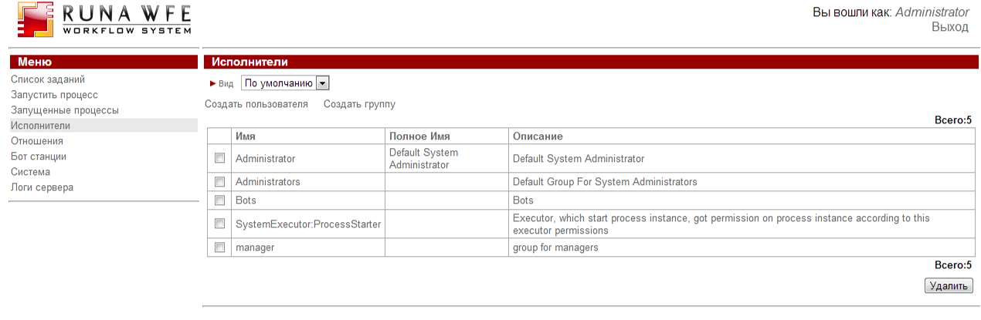

Багов не обнаружено.

- Тестирование GPD

3.1 Отсутствует полоса прокрутки в Palette, Objects (нотация BPMN)

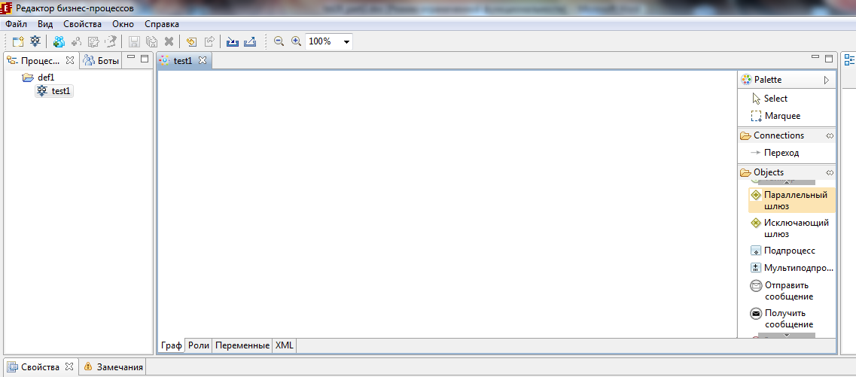

3.2 При сохранении изменений в графе, блокируется интерфейс, при этом сохранение выполняется заметно дольше чем раньше

3.3 Показывать роли на графе (По горизонтали/вертикали) (нотация BPMN)

Выбрал по горизонтали:

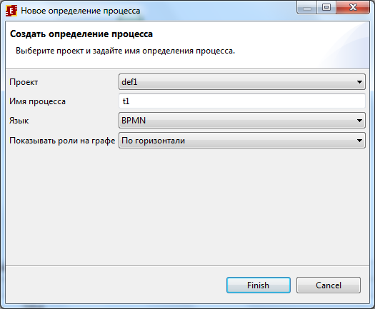

Роль не отображается:

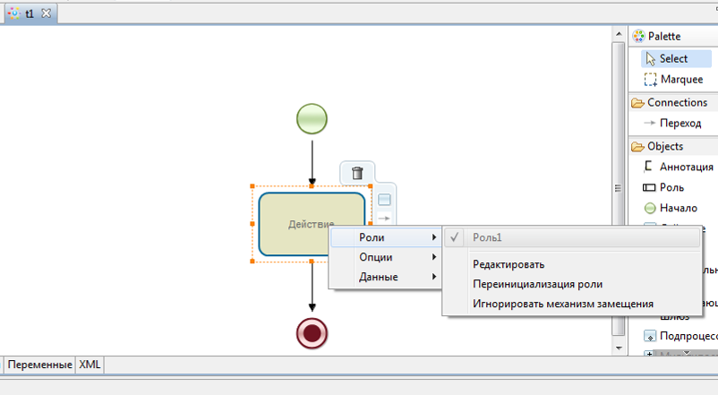

Выбрал по вертикали, роль не отображается:

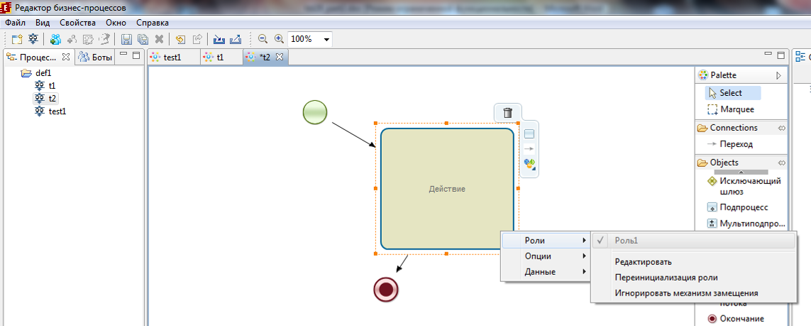

UPD: завел баг на трекере (4.0 r4429 ​ Показывать роли на графе (По гор./верт.) - ID: 3605096), закрыт 2013-02-18 09:10:29 PST , помечен как invalid с комментарием:
Так задумано.
См. 2.png - там в палитре виден новый элемент
Роль, его можно на граф положить.

3.4 Проверка удаления Роли (при удалении роли, предупреждение)

Успешно определяется использование роли

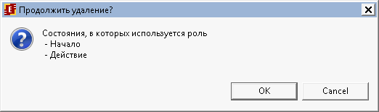

Багов не обнаружено.

3.5 При вызове меню Роли на элементе графа, выбор роли невозможен, список ролей disabled, хотя в свойствах элемента, выбрать роль возможно. (нотация BPMN)

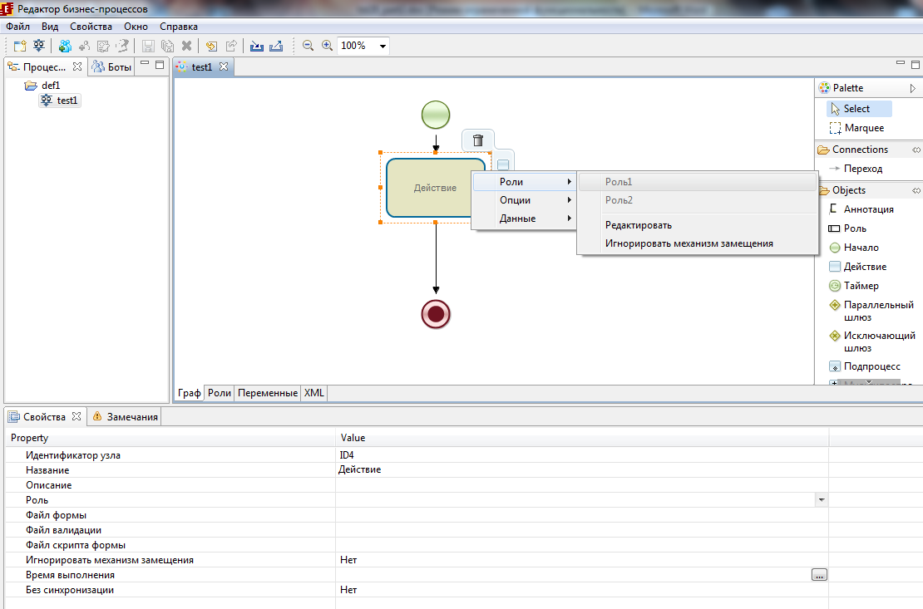

Либо так и задумано и этот список только для чтения, либо баг.

При создании процесса BPMN если выбрать НЕТ в опции “Показывать роли на графе”, то роли доступны для выбора

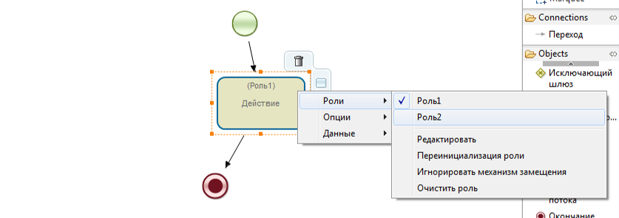

UPD: завел как баг 3605093, но это не баг, необходимо использовать новый элемент палитры (элемент Роль)

3.6 Создание формы, ошибка при закрытии (нотация BPMN):

Создаю форму,
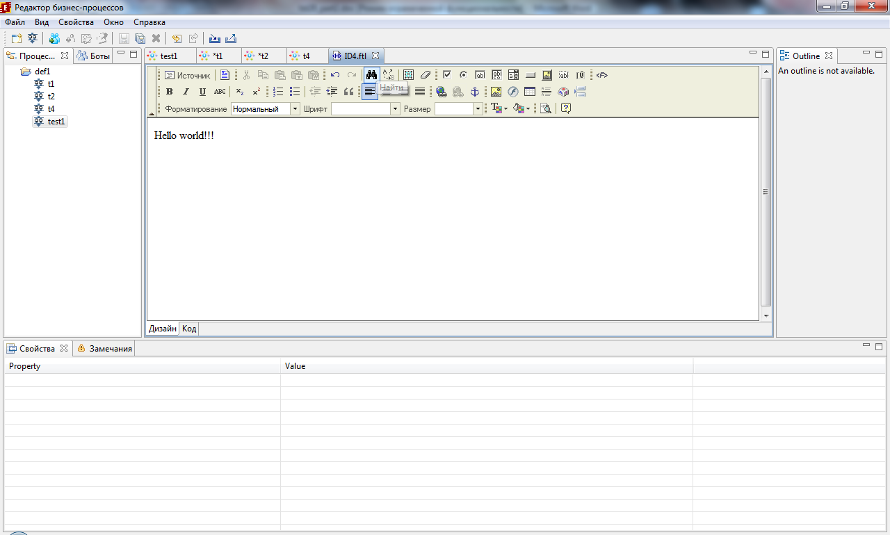

Теперь закрываю форму получаю ошибку:

Failed to create form validation

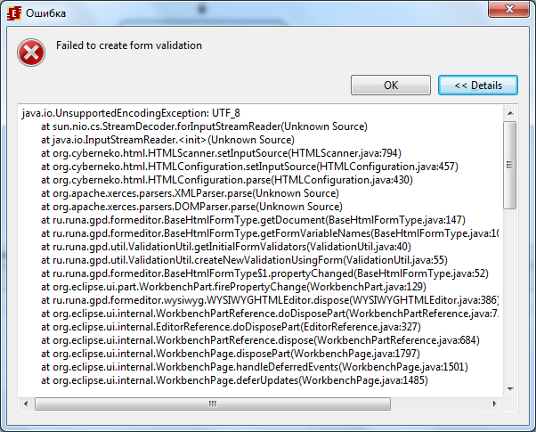

Лог прилагается

UPD: завел баг на трекере (4.0 r4429 ​Failed to create form validation - ID: 3605098), был закрыт 2013-02-18 09:08:52 PST fixed/closed

3.7 При экспорте процесса выдало ошибку:

Ошибка при валидации формы (UTF_8)

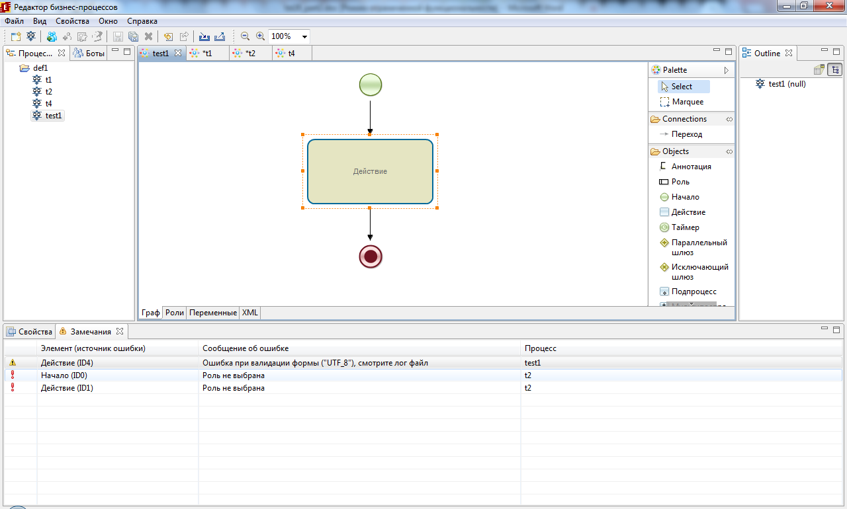

UPD: завел баг на трекере (4.0 r4429 ​Ошибка при валидации формы (UTF_8) - ID: 3605099), но 2013-02-18 09:08:41 PST был закрыт fixed/closed

3.8 Быстрые/горячие клавиши

3.8.1 В нотации JPDL не работает клавиша delete

Выделил элемент графа, нажал delete, элемент не удалился, однако в BPMN срабатывает.

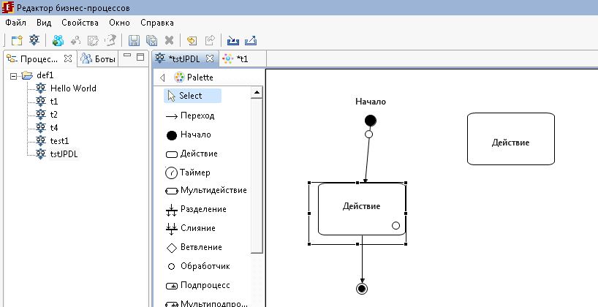

3.8.2 Комбинация ctrl+z не работает в BPMN нотации, но в jpdl работает

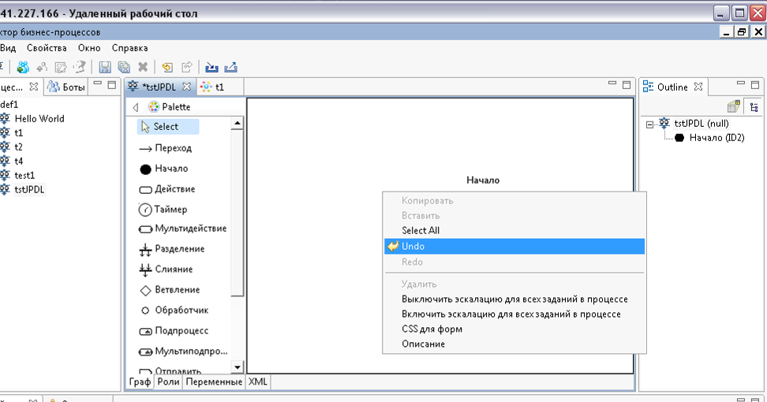

При этом в BPMN отсутствует пункт меню “Undo”, т.е. НЕТ возможности отменить последние действия

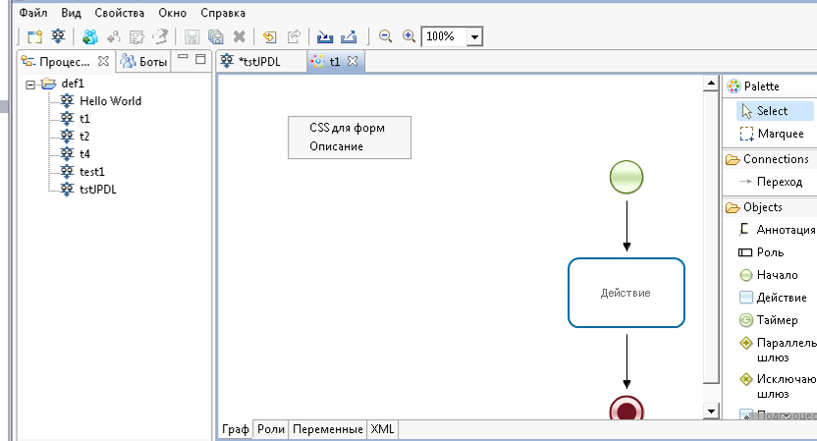

3.8.3 Не работает Копировать вставить

В BPMN нет даже контекстного меню для copy/paste элементов

В JPDL имеются в контекстном меню пункты Копировать и Вставить, но они неактивны,

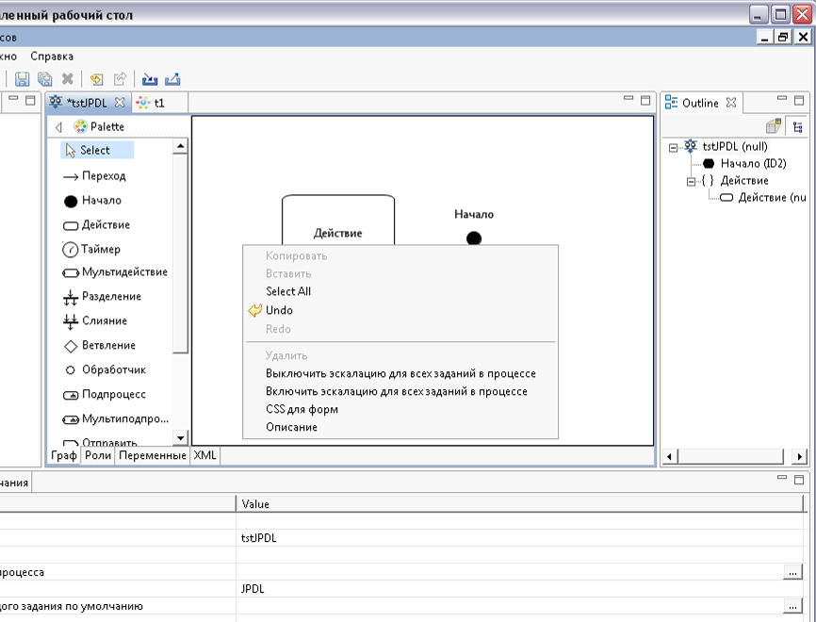

но если на выделенном элементе нажать комбинацию ctrl+c, то пункт Копировать становится активным, но Вставить все равно неактивная

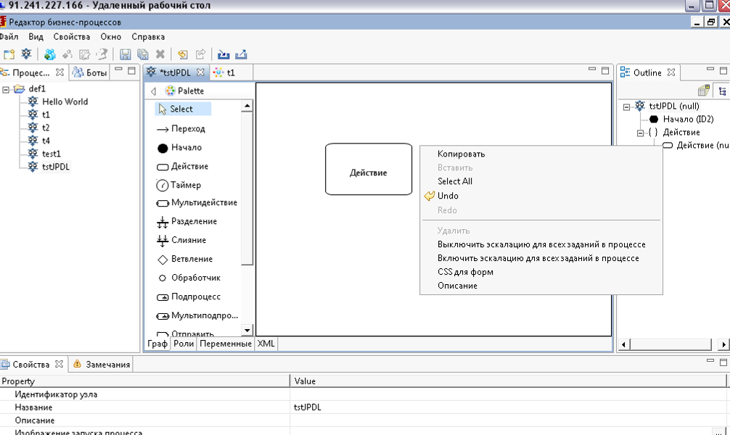

3.8.4 В BPMN не работает CTRL+A

- Использование учебных материалов для студентов в качестве тест-кейсов:

http://wf.runa.ru/rus/doc/RunaWFE._%D0%A3%D1%87%D0%B5%D0%B1%D0%BD%D1%8B%D0%B5_%D0%BC%D0%B0%D1%82%D0%B5%D1%80%D0%B8%D0%B0%D0%BB%D1%8B_%D0%BF%D0%BE_%D0%BF%D1%80%D0%BE%D1%86%D0%B5%D1%81%D1%81%D0%BD%D0%BE%D0%BC%D1%83_%D1%83%D0%BF%D1%80%D0%B0%D0%B2%D0%BB%D0%B5%D0%BD%D0%B8%D1%8E

[В данной сборке НЕ работают формы]

- Остальные кейсы:

- Новые меню в gpd,

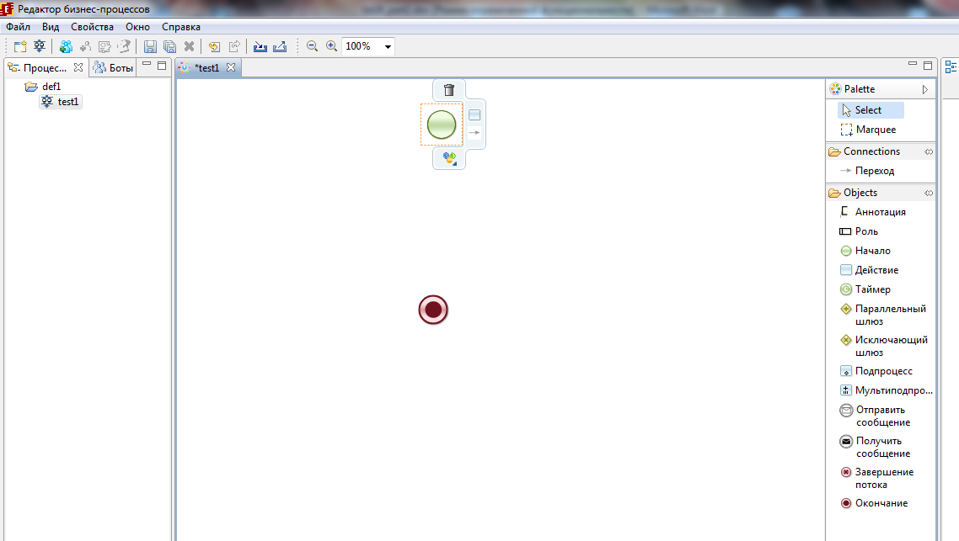

- История административных действий

Она еще не работает?

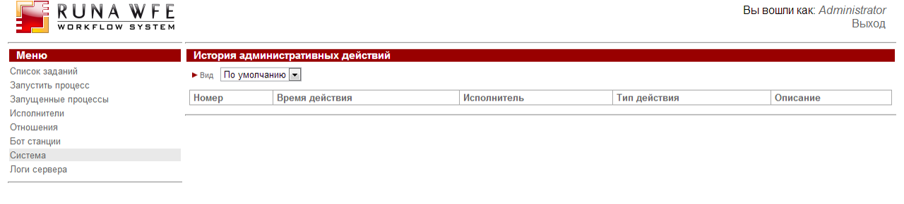

[UPD: В данной сборке еще не работает]

- Не обнаружил как добавлять обработчики в граф процесса?

[UPD: В данной сборке не работают]

- Старые процессы не совместимы? Попытался импортировать в gpd процесс HelloWorld, получил ошибки, он не открывается, и при удалении выдает ошибки

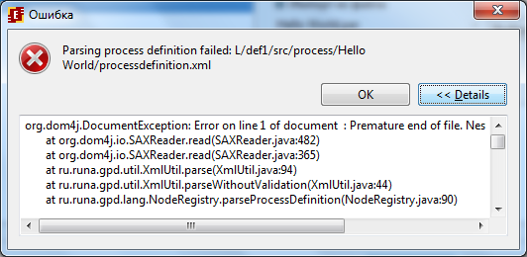

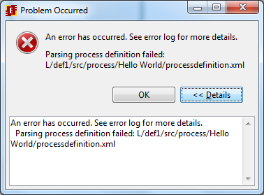
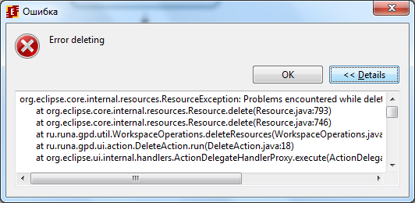

[UPD: Тут действительно был баг, в комментариях было написано что поправили]

- Проверка переменных формы, в подпроцесс передал строку, проинициализированную по умолчанию значением “Hello World”, в подпроцессе сделал форму с валидацией переменной как обязательное поле, при выполнении не проходим валидацию, пишет что поле обязательное для ввода, возможно баг

[UPD: Не баг, ошибся в настройке валидации]

- При выключении сервера, ошибки в кодировке, ранее не было:

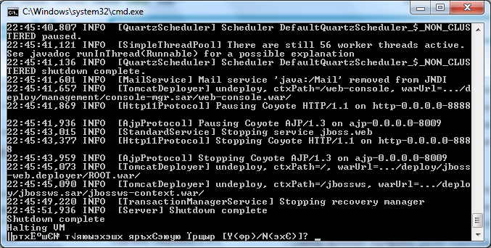

Тестирование сборки r444

Проверка багфиксов:

- Admin scripts, wfe, сборник багов (4.0alpha r4429) - ID: 3605088

Просьба проверить, перед этим почистив
кеш браузера (а также проверить и на
других браузерах).
1) У меня не воспроизводится
2) Исправил
3) У меня после 1-й перезагрузки
появляется
4) Это нормально, не все операции скрипта
выполнены успешно (например процесс уже
был загружен с таким именем)

1). Открываем консоль chrome, захожу в wfe система, выбрал сохраненные скрипты, открыл скрипт, нажал Отмена, в js консоли chrome получаю сообщение об ошибке вида:
Uncaught TypeError: Cannot read property 'select' of null editor.js:1143

Если закрывать окно кнопкой Отмена, то получаем еще ошибки:

Uncaught Error: cannot call methods on dialog prior to initialization; attempted to call method 'destroy'

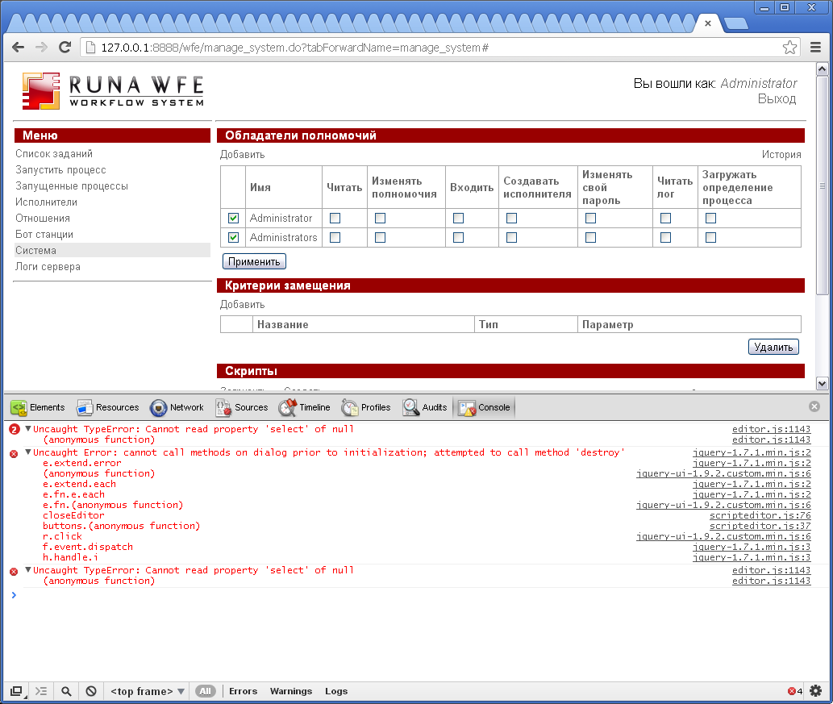

Баг не исправлен.

В FF:
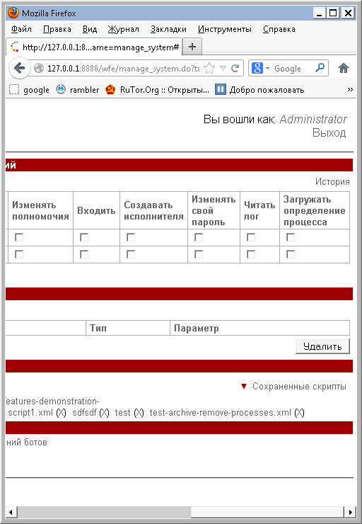

2). Закрытие окна wfe с помощью крестика – Баг Исправлен

3). Создаю новый скрипт, вбиваю название myscript11.xml, текст скрипта, сохраняю, в списке его нет, появляется только после перезагрузки страницы, что неудобно, и по сути это баг, при этом в той же js консоли появляются ошибки:

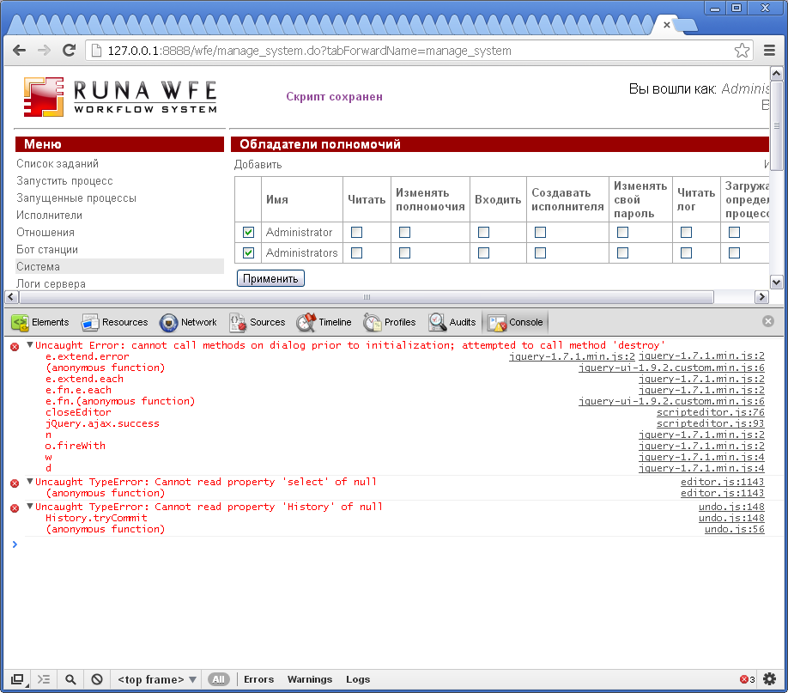

Баг не исправлен.

- Баг 3.6RC NullPointerException при переиме-нии роли бота в gpd,

Была роль bot, проинициализирована как UniversalBot
Данная роль используется в одном узле процесса
Пытаюсь переименовать роль bot в Бот1, формируется форма для рефакторинга, нажимаю Готово
получаю сообщение об ошибке

Проверка на r4444:

Импортирую бот станцию, боты, и задания, которые использовались по умолчанию в 3.6
Импортирую процесс, на котором возникали проблемы

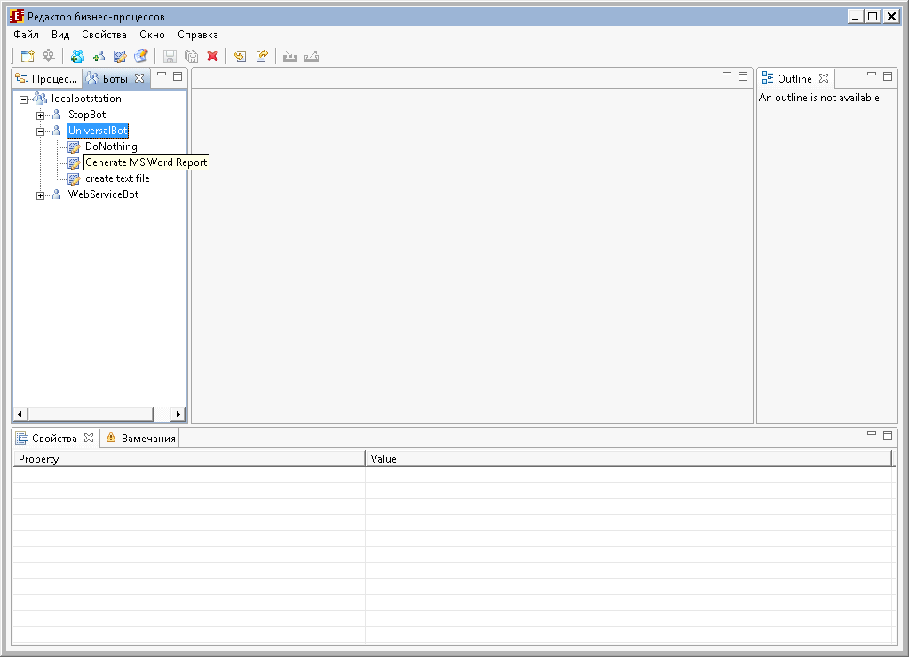

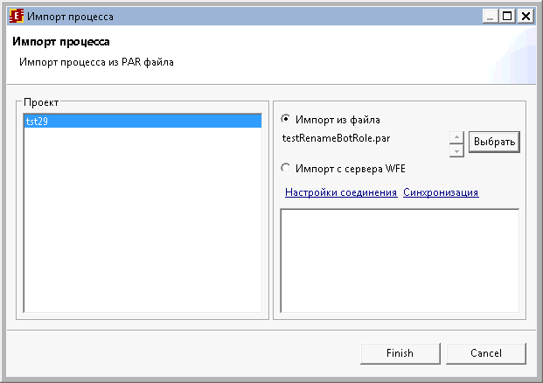

Проверить баг фикс не удалось, т.к. роль не инициализируется ботом, не обнаружил возможность привязки задачи к боту, возможно в данной версии это не работает??

“…Сегодня выложили на sourceforge сборку r4444 (она еще без RTN, но уже с обработчиками для тестирования).
Протестируйте в ней, пожалуйста, обработчик отправки email и оповещения о невыполненных заданиях…. “

- Тестирование обработчика email

Создаем процесс (jpdl) с обработчиком email

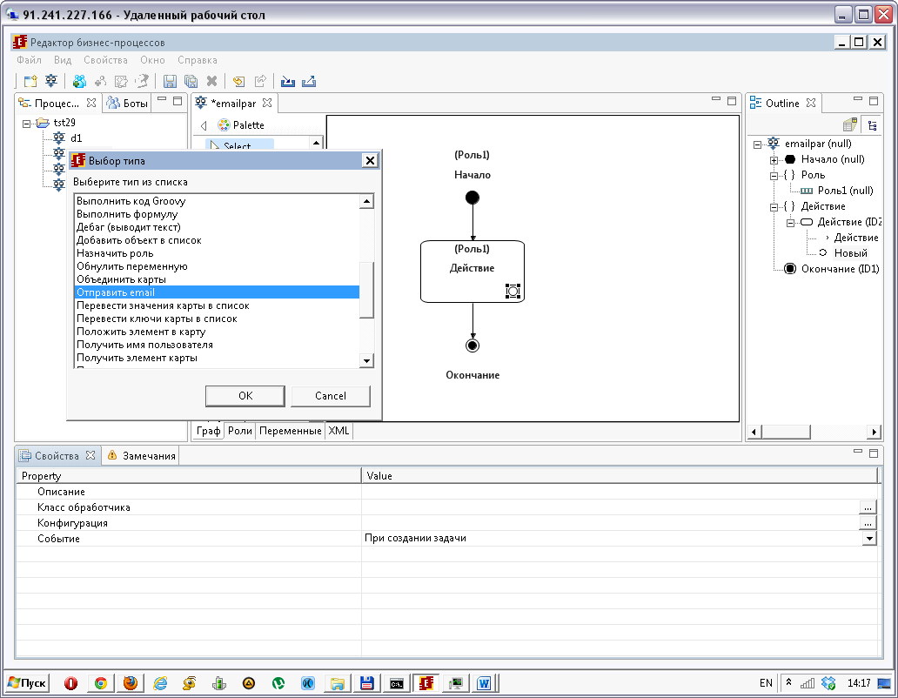

Завел тестовый аккаунт

Создаем процесс, на форме вводится текст сообщения в переменную msg типа Текст, затем вызывается обработчик email, который отправляет сообщение:

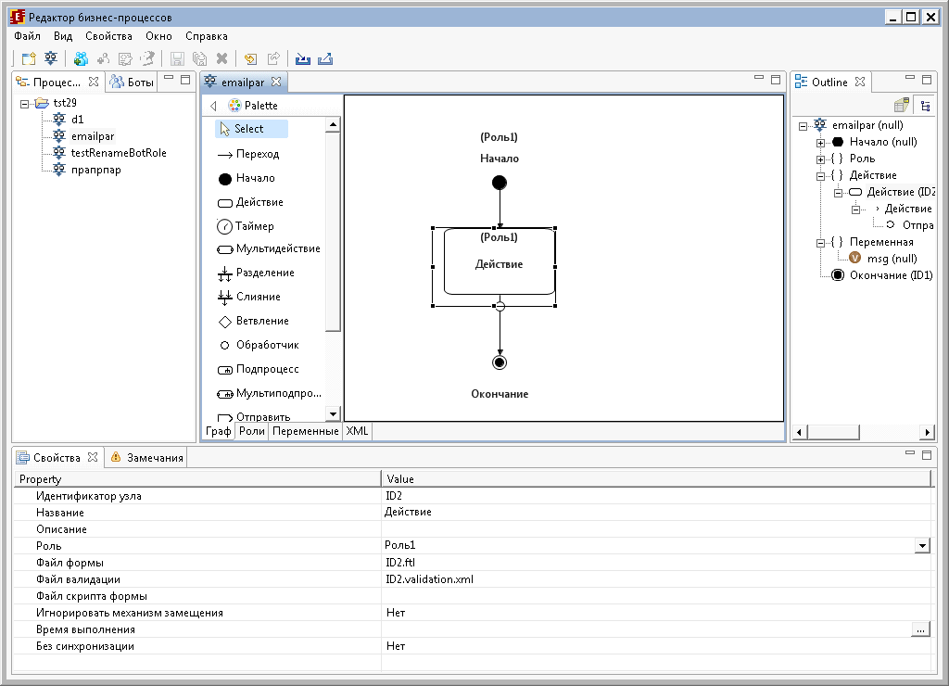

Создаю форму (freemarker теги)
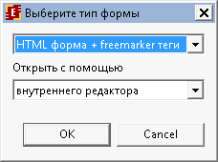

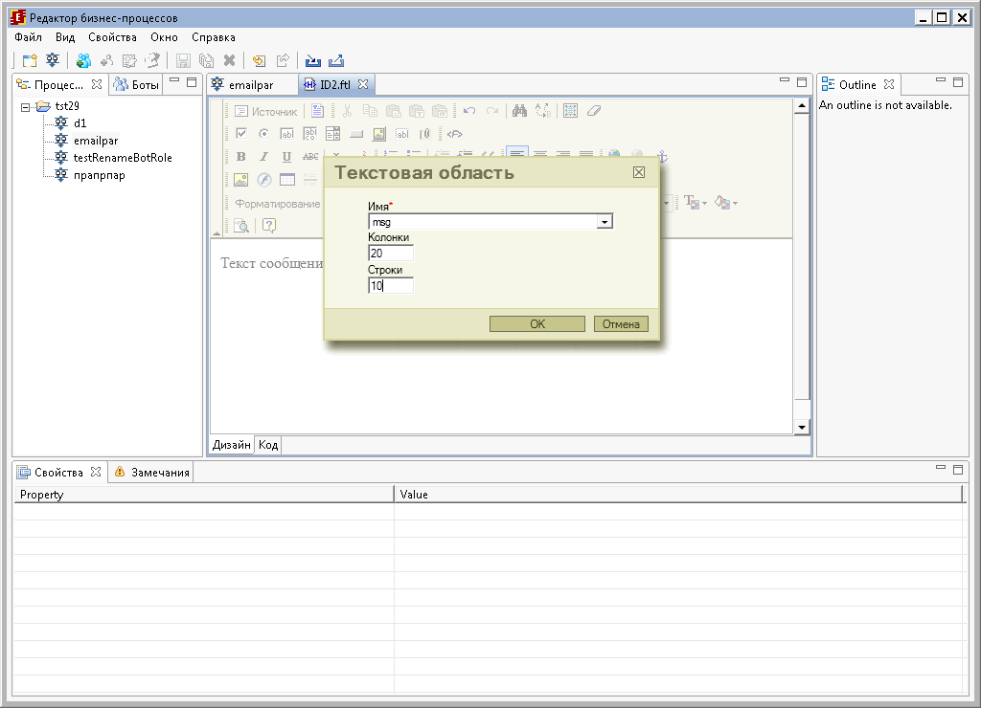

БАГ: Не сохраняется форма

Добавил на форму текстовую область, связанную с переменной msg, закрываю форму, сохраняю изменения, снова открываю форму, она пустая!!!
Проверял как в bpmn так и jpdl

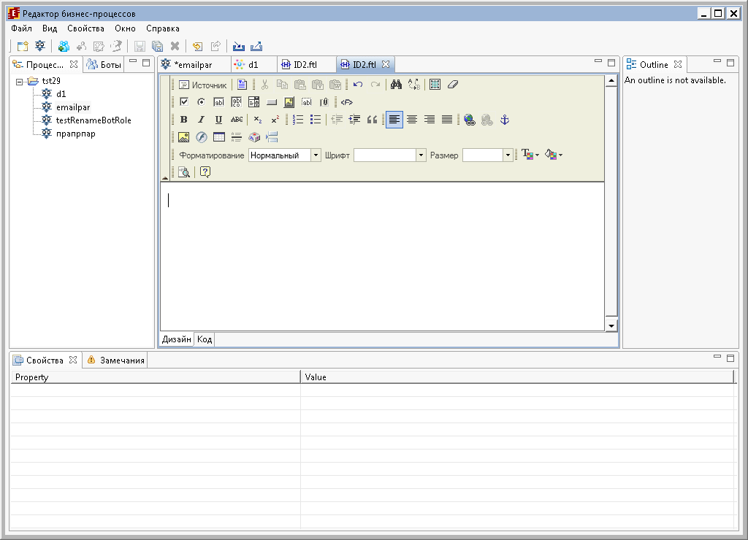

Далее удаляю форму, создаю форму в этом же узле но с использованием custom тегов, получаю сообщение

DEPRACATED. Creation does not allowed

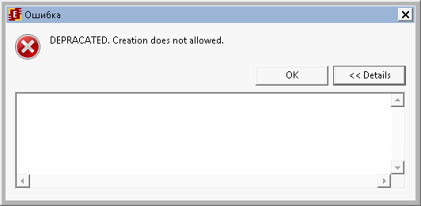

В логах при этом пусто!!!
Проблема наблюдается как при использовании jpdl так и bpmn

[UPD: В комментариях к багу на трекере, говорится что сообщение локализовано, т.е. не баг]

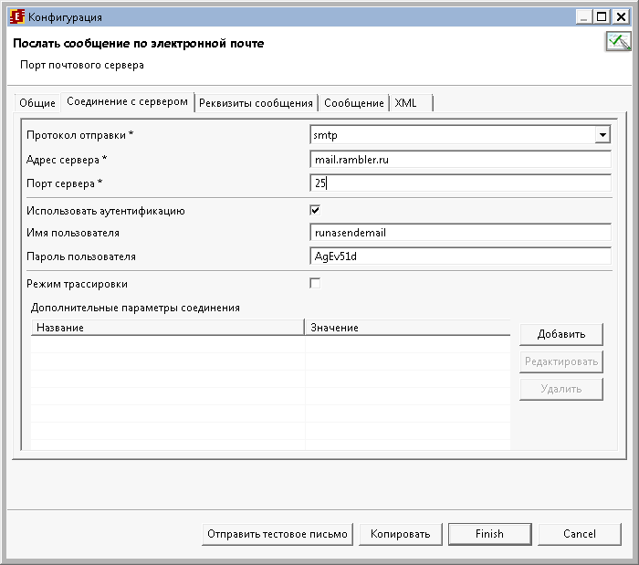

- Оповещение о невыполненных заданиях

Багов не обнаружено

- Тестирование изменений связанных со слияниями (имеются изменения в работе слияний)

Багов не обнаружено

- Тестирование devstudio

  - Ошибка при удалении ботстанции в devstudio

Попытался удалить бот станцию, получил сообщение об ошибке:

Error deleting

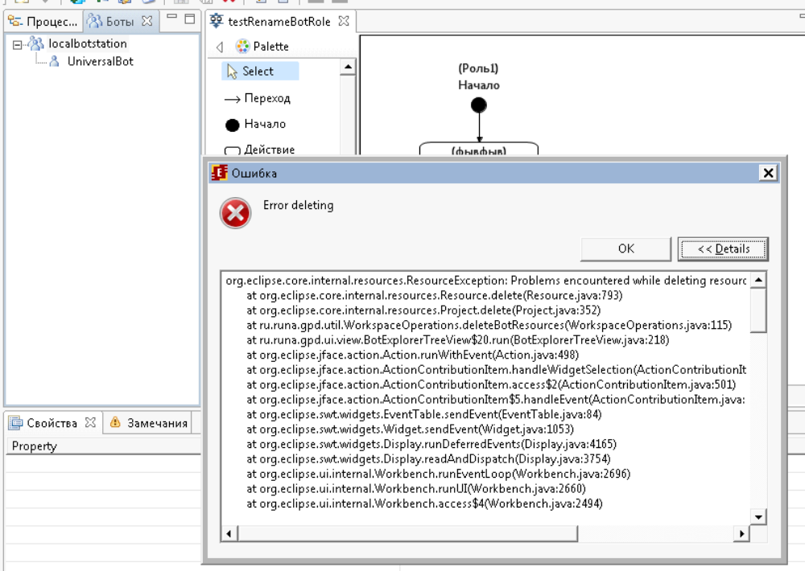

В логах:

!ENTRY ru.runa.gpd 4 0 2013-02-21 13:04:38.124
!MESSAGE Error deleting
!STACK 1
org.eclipse.core.internal.resources.ResourceException: Problems encountered while deleting resources.
at org.eclipse.core.internal.resources.Resource.delete(Resource.java:793)
at org.eclipse.core.internal.resources.Project.delete(Project.java:352)
at ru.runa.gpd.util.WorkspaceOperations.deleteBotResources(WorkspaceOperations.java:115)
at ru.runa.gpd.ui.view.BotExplorerTreeView$20.run(BotExplorerTreeView.java:218)
at org.eclipse.jface.action.Action.runWithEvent(Action.java:498)
at org.eclipse.jface.action.ActionContributionItem.handleWidgetSelection(ActionContributionItem.java:584)
at org.eclipse.jface.action.ActionContributionItem.access$2(ActionContributionItem.java:501)
at org.eclipse.jface.action.ActionContributionItem$5.handleEvent(ActionContributionItem.java:411)
at org.eclipse.swt.widgets.EventTable.sendEvent(EventTable.java:84)
at org.eclipse.swt.widgets.Widget.sendEvent(Widget.java:1053)
at org.eclipse.swt.widgets.Display.runDeferredEvents(Display.java:4165)
at org.eclipse.swt.widgets.Display.readAndDispatch(Display.java:3754)
at org.eclipse.ui.internal.Workbench.runEventLoop(Workbench.java:2696)
at org.eclipse.ui.internal.Workbench.runUI(Workbench.java:2660)
at org.eclipse.ui.internal.Workbench.access$4(Workbench.java:2494)
at org.eclipse.ui.internal.Workbench$7.run(Workbench.java:674)
at org.eclipse.core.databinding.observable.Realm.runWithDefault(Realm.java:332)
at org.eclipse.ui.internal.Workbench.createAndRunWorkbench(Workbench.java:667)
at org.eclipse.ui.PlatformUI.createAndRunWorkbench(PlatformUI.java:149)
at ru.runa.gpd.Application.start(Application.java:16)
at org.eclipse.equinox.internal.app.EclipseAppHandle.run(EclipseAppHandle.java:196)
at org.eclipse.core.runtime.internal.adaptor.EclipseAppLauncher.runApplication(EclipseAppLauncher.java:110)
at org.eclipse.core.runtime.internal.adaptor.EclipseAppLauncher.start(EclipseAppLauncher.java:79)
at org.eclipse.core.runtime.adaptor.EclipseStarter.run(EclipseStarter.java:344)
at org.eclipse.core.runtime.adaptor.EclipseStarter.run(EclipseStarter.java:179)
at sun.reflect.NativeMethodAccessorImpl.invoke0(Native Method)
at sun.reflect.NativeMethodAccessorImpl.invoke(Unknown Source)
at sun.reflect.DelegatingMethodAccessorImpl.invoke(Unknown Source)
at java.lang.reflect.Method.invoke(Unknown Source)
at org.eclipse.equinox.launcher.Main.invokeFramework(Main.java:622)
at org.eclipse.equinox.launcher.Main.basicRun(Main.java:577)
at org.eclipse.equinox.launcher.Main.run(Main.java:1410)
Contains: Could not delete '/localbotstation/src'.
org.eclipse.core.internal.resources.ResourceException: Problems encountered while deleting resources.
at org.eclipse.core.internal.localstore.FileSystemResourceManager.delete(FileSystemResourceManager.java:352)
at org.eclipse.core.internal.resources.ResourceTree.internalDeleteFolder(ResourceTree.java:352)
at org.eclipse.core.internal.resources.ResourceTree.internalDeleteProject(ResourceTree.java:387)
at org.eclipse.core.internal.resources.ResourceTree.standardDeleteProject(ResourceTree.java:837)
at org.eclipse.core.internal.resources.Resource.unprotectedDelete(Resource.java:1939)
at org.eclipse.core.internal.resources.Resource.delete(Resource.java:780)
at org.eclipse.core.internal.resources.Project.delete(Project.java:352)
at ru.runa.gpd.util.WorkspaceOperations.deleteBotResources(WorkspaceOperations.java:115)
at ru.runa.gpd.ui.view.BotExplorerTreeView$20.run(BotExplorerTreeView.java:218)
at org.eclipse.jface.action.Action.runWithEvent(Action.java:498)
at org.eclipse.jface.action.ActionContributionItem.handleWidgetSelection(ActionContributionItem.java:584)
at org.eclipse.jface.action.ActionContributionItem.access$2(ActionContributionItem.java:501)
at org.eclipse.jface.action.ActionContributionItem$5.handleEvent(ActionContributionItem.java:411)
at org.eclipse.swt.widgets.EventTable.sendEvent(EventTable.java:84)
at org.eclipse.swt.widgets.Widget.sendEvent(Widget.java:1053)
at org.eclipse.swt.widgets.Display.runDeferredEvents(Display.java:4165)
at org.eclipse.swt.widgets.Display.readAndDispatch(Display.java:3754)
at org.eclipse.ui.internal.Workbench.runEventLoop(Workbench.java:2696)
at org.eclipse.ui.internal.Workbench.runUI(Workbench.java:2660)
at org.eclipse.ui.internal.Workbench.access$4(Workbench.java:2494)
at org.eclipse.ui.internal.Workbench$7.run(Workbench.java:674)
at org.eclipse.core.databinding.observable.Realm.runWithDefault(Realm.java:332)
at org.eclipse.ui.internal.Workbench.createAndRunWorkbench(Workbench.java:667)
at org.eclipse.ui.PlatformUI.createAndRunWorkbench(PlatformUI.java:149)
at ru.runa.gpd.Application.start(Application.java:16)
at org.eclipse.equinox.internal.app.EclipseAppHandle.run(EclipseAppHandle.java:196)
at org.eclipse.core.runtime.internal.adaptor.EclipseAppLauncher.runApplication(EclipseAppLauncher.java:110)
at org.eclipse.core.runtime.internal.adaptor.EclipseAppLauncher.start(EclipseAppLauncher.java:79)
at org.eclipse.core.runtime.adaptor.EclipseStarter.run(EclipseStarter.java:344)
at org.eclipse.core.runtime.adaptor.EclipseStarter.run(EclipseStarter.java:179)
at sun.reflect.NativeMethodAccessorImpl.invoke0(Native Method)
at sun.reflect.NativeMethodAccessorImpl.invoke(Unknown Source)
at sun.reflect.DelegatingMethodAccessorImpl.invoke(Unknown Source)
at java.lang.reflect.Method.invoke(Unknown Source)
at org.eclipse.equinox.launcher.Main.invokeFramework(Main.java:622)
at org.eclipse.equinox.launcher.Main.basicRun(Main.java:577)
at org.eclipse.equinox.launcher.Main.run(Main.java:1410)
Contains: Problems encountered while deleting files.
Contains: Could not delete: C:\runa4\RunaWFE_DeveloperStudio.r4444\gpd4\workspace\localbotstation\src\botstation\UniversalBot\Task1.conf.
Contains: Could not delete: C:\runa4\RunaWFE_DeveloperStudio.r4444\gpd4\workspace\localbotstation\src\botstation\UniversalBot.
Contains: Could not delete: C:\runa4\RunaWFE_DeveloperStudio.r4444\gpd4\workspace\localbotstation\src\botstation.
Contains: Could not delete: C:\runa4\RunaWFE_DeveloperStudio.r4444\gpd4\workspace\localbotstation\src.
Contains: Could not delete 'C:\runa4\RunaWFE_DeveloperStudio.r4444\gpd4\workspace\localbotstation'.
!SUBENTRY 1 org.eclipse.core.resources 4 273 2013-02-21 13:04:38.127
!MESSAGE Problems encountered while deleting resources.
!SUBENTRY 2 org.eclipse.core.resources 4 273 2013-02-21 13:04:38.127
!MESSAGE Could not delete '/localbotstation/src'.
!STACK 1
org.eclipse.core.internal.resources.ResourceException: Problems encountered while deleting resources.
at org.eclipse.core.internal.localstore.FileSystemResourceManager.delete(FileSystemResourceManager.java:352)
at org.eclipse.core.internal.resources.ResourceTree.internalDeleteFolder(ResourceTree.java:352)
at org.eclipse.core.internal.resources.ResourceTree.internalDeleteProject(ResourceTree.java:387)
at org.eclipse.core.internal.resources.ResourceTree.standardDeleteProject(ResourceTree.java:837)
at org.eclipse.core.internal.resources.Resource.unprotectedDelete(Resource.java:1939)
at org.eclipse.core.internal.resources.Resource.delete(Resource.java:780)
at org.eclipse.core.internal.resources.Project.delete(Project.java:352)
at ru.runa.gpd.util.WorkspaceOperations.deleteBotResources(WorkspaceOperations.java:115)
at ru.runa.gpd.ui.view.BotExplorerTreeView$20.run(BotExplorerTreeView.java:218)
at org.eclipse.jface.action.Action.runWithEvent(Action.java:498)
at org.eclipse.jface.action.ActionContributionItem.handleWidgetSelection(ActionContributionItem.java:584)
at org.eclipse.jface.action.ActionContributionItem.access$2(ActionContributionItem.java:501)
at org.eclipse.jface.action.ActionContributionItem$5.handleEvent(ActionContributionItem.java:411)
at org.eclipse.swt.widgets.EventTable.sendEvent(EventTable.java:84)
at org.eclipse.swt.widgets.Widget.sendEvent(Widget.java:1053)
at org.eclipse.swt.widgets.Display.runDeferredEvents(Display.java:4165)
at org.eclipse.swt.widgets.Display.readAndDispatch(Display.java:3754)
at org.eclipse.ui.internal.Workbench.runEventLoop(Workbench.java:2696)
at org.eclipse.ui.internal.Workbench.runUI(Workbench.java:2660)
at org.eclipse.ui.internal.Workbench.access$4(Workbench.java:2494)
at org.eclipse.ui.internal.Workbench$7.run(Workbench.java:674)
at org.eclipse.core.databinding.observable.Realm.runWithDefault(Realm.java:332)
at org.eclipse.ui.internal.Workbench.createAndRunWorkbench(Workbench.java:667)
at org.eclipse.ui.PlatformUI.createAndRunWorkbench(PlatformUI.java:149)
at ru.runa.gpd.Application.start(Application.java:16)
at org.eclipse.equinox.internal.app.EclipseAppHandle.run(EclipseAppHandle.java:196)
at org.eclipse.core.runtime.internal.adaptor.EclipseAppLauncher.runApplication(EclipseAppLauncher.java:110)
at org.eclipse.core.runtime.internal.adaptor.EclipseAppLauncher.start(EclipseAppLauncher.java:79)
at org.eclipse.core.runtime.adaptor.EclipseStarter.run(EclipseStarter.java:344)
at org.eclipse.core.runtime.adaptor.EclipseStarter.run(EclipseStarter.java:179)
at sun.reflect.NativeMethodAccessorImpl.invoke0(Native Method)
at sun.reflect.NativeMethodAccessorImpl.invoke(Unknown Source)
at sun.reflect.DelegatingMethodAccessorImpl.invoke(Unknown Source)
at java.lang.reflect.Method.invoke(Unknown Source)
at org.eclipse.equinox.launcher.Main.invokeFramework(Main.java:622)
at org.eclipse.equinox.launcher.Main.basicRun(Main.java:577)
at org.eclipse.equinox.launcher.Main.run(Main.java:1410)
Contains: Problems encountered while deleting files.
Contains: Could not delete: C:\runa4\RunaWFE_DeveloperStudio.r4444\gpd4\workspace\localbotstation\src\botstation\UniversalBot\Task1.conf.
Contains: Could not delete: C:\runa4\RunaWFE_DeveloperStudio.r4444\gpd4\workspace\localbotstation\src\botstation\UniversalBot.
Contains: Could not delete: C:\runa4\RunaWFE_DeveloperStudio.r4444\gpd4\workspace\localbotstation\src\botstation.
Contains: Could not delete: C:\runa4\RunaWFE_DeveloperStudio.r4444\gpd4\workspace\localbotstation\src.
!SUBENTRY 3 org.eclipse.core.resources 4 273 2013-02-21 13:04:38.128
!MESSAGE Problems encountered while deleting resources.
!SUBENTRY 4 org.eclipse.core.filesystem 4 273 2013-02-21 13:04:38.128
!MESSAGE Problems encountered while deleting files.
!SUBENTRY 5 org.eclipse.core.filesystem 4 273 2013-02-21 13:04:38.128
!MESSAGE Could not delete: C:\runa4\RunaWFE_DeveloperStudio.r4444\gpd4\workspace\localbotstation\src\botstation\UniversalBot\Task1.conf.
!SUBENTRY 5 org.eclipse.core.filesystem 4 273 2013-02-21 13:04:38.128
!MESSAGE Could not delete: C:\runa4\RunaWFE_DeveloperStudio.r4444\gpd4\workspace\localbotstation\src\botstation\UniversalBot.
!SUBENTRY 5 org.eclipse.core.filesystem 4 273 2013-02-21 13:04:38.129
!MESSAGE Could not delete: C:\runa4\RunaWFE_DeveloperStudio.r4444\gpd4\workspace\localbotstation\src\botstation.
!SUBENTRY 5 org.eclipse.core.filesystem 4 273 2013-02-21 13:04:38.129
!MESSAGE Could not delete: C:\runa4\RunaWFE_DeveloperStudio.r4444\gpd4\workspace\localbotstation\src.
!SUBENTRY 2 org.eclipse.core.resources 4 273 2013-02-21 13:04:38.129
!MESSAGE Could not delete 'C:\runa4\RunaWFE_DeveloperStudio.r4444\gpd4\workspace\localbotstation'.

  - Проверка механизма привязки бота, инициализация роли ботом

Импортировал бот станцию с ботами и заданиями, которые использовались в 3.6 (стандартная localbotstation), создал процесс, роль инициализировал ботом UniversalBot, но как только нажал ОК, в колонке инициализатор напротив названия роли, пусто, т.е. ничего не проинициализировано.

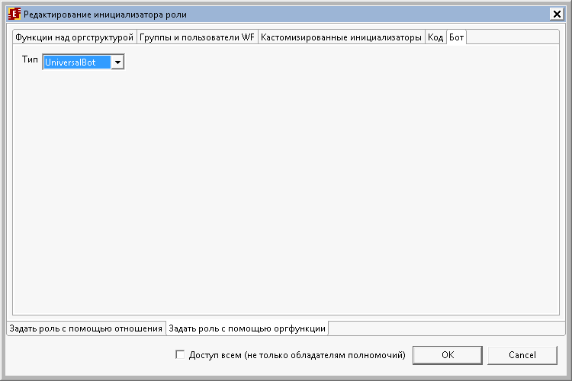

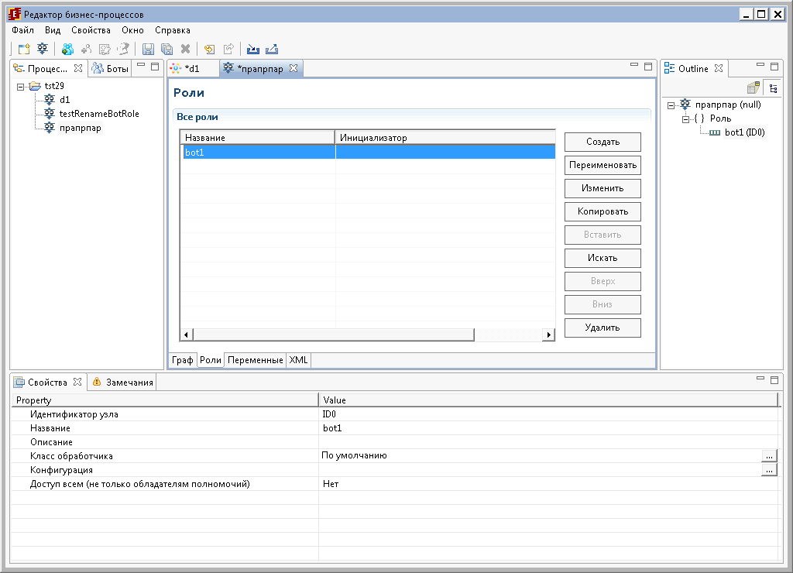

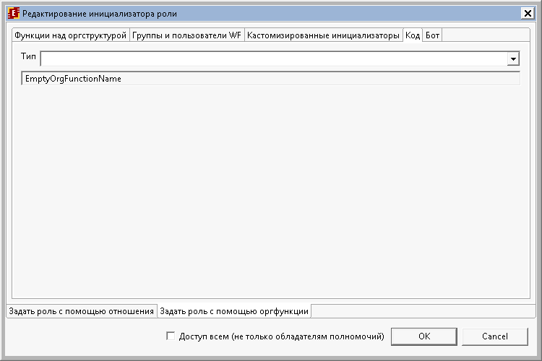

Да и возможности привязки задания в процессах (jpdl,bpmn) не обнаружил.

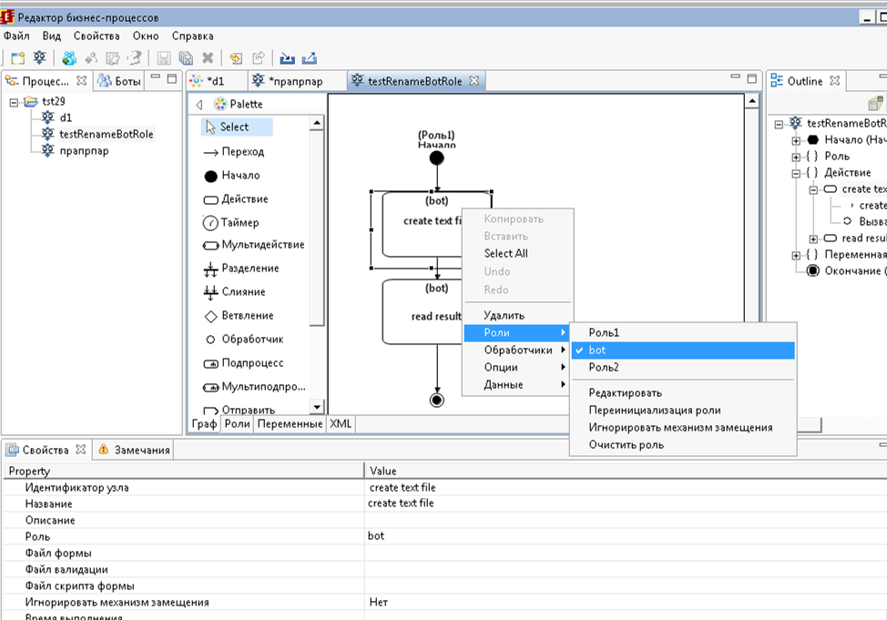

Тестирование сборки 4.0beta(+jboss7)

- Проверка поднятых старых pending багов

Результат: Большинство багов еще не исправлено в 4.0beta, обновил статусы багов на трекере

Следующие запланированные кейсы будут проверены уже в релизе 4.x, т.к. сборка beta уже неактуальна на данный момент

- Тестирование установки (проверка инсталлятора)
- Тестирование слияний
- Тестирование email обработчиков
- Jboss7
- ….

