RunaWFE. Guide for installation and configuration.
Version 3.0
© 2004-2012, ZAO Runa, this document is available under GNU FDL license. RUNA WFE is an open source system distributed under a LGPL license ( http://www.gnu.org/licenses/lgpl.html).

Installation

Variants of distribution
- 1. As specialized distibutives for different OS.
- 2. As a binary package bundled with a compatible version of JBOSS Application Server.
- 3. It is also possible to build Runa WFE from source.

Specialized distributive installation
Specialized distributives are the installation packages for diffent OS (rpm/deb for Linux, installer exe for Windows). They can be downloaded from sourceforge portal: http://sourceforge.net/projects/runawfe/files
Here are the list of the components that can be installed via specialized distributive:
Client side components:
- Client (web-interface)
- Graphic business process designer
- Business process simulator
- Task notifier
Server side components:
- RunaWFE-Server
- Bot station
Components interaction:
RunaWFE-Server is started on one server.
Bot stations can be started on several servers.
Browser with system web-interface and task notifier are started on clients computers.
Graphic business process designer and process simulator can be run on the client computers.
Components features:
RunaWFE-server contains deployed business process definitions and started business processes instances.
Bot stations contain bots, that check out RunaWFE-server periodically. If started business process instances have tasks for bots, bots perform the tasks and return results to the RunaWFE-server process instances.
Via RunaWFE web-interface user can:
- Recieve, filter, perform the tasks of business process instances
- Start new business process instances
- View the properties of started business process instances
- Deploy new business process definitions (if permission is granted)
Via RunaWFE web-interface administrator can:
- Create/remove actors and groups
- Include/exclude actors to/from groups
- Grant permissions on system objects to actors and groups
- Forcedly stop business process instances
- Add/change actors substitutions rules
Via graphic process designer analyst can
- Develop business processes and export them to the file system
Via business process simulator analyst can
- Test developed business processes on the simulated configuration on the analyst client computer without(before) deploying new processes to the enterprise system.
Note. RunaWFE-server contains a local bot station. That's why it is possible to install bot station as a separate component only on the computer where the RunaWFE-server is not installed.
Note. RunaWFE-server and simulator must not be installed on one and the same computer.

Specialized distributive installation for Windows OS
Insert disk into drive (in case you have it on disk) or run RunaWFE-Installer.exe (if you have it as exe-file). The LGPL license notice will appear.
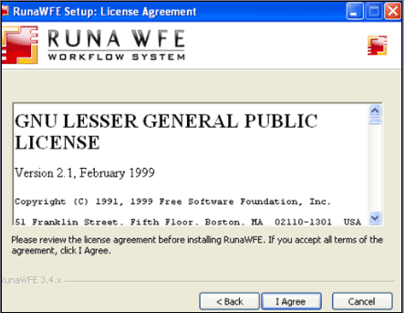After confirming it you'll have to choose what components you are going to install - client side or server side.
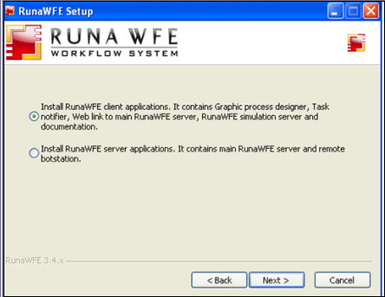Then you'll have to specify the particular components from the list.
client side
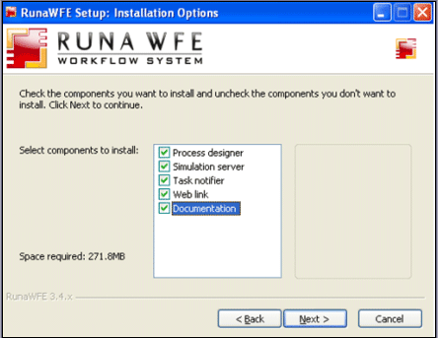server side
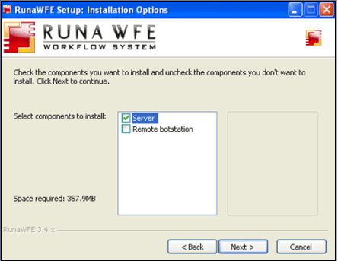After the installation is over the "Finished" message will appear.
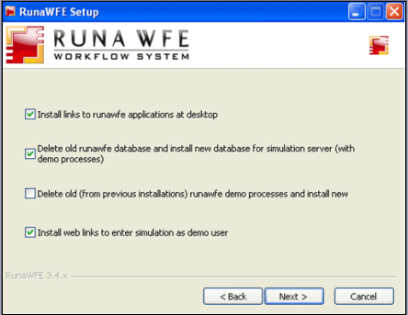Next
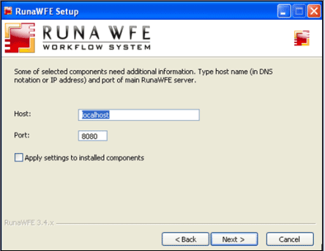Next
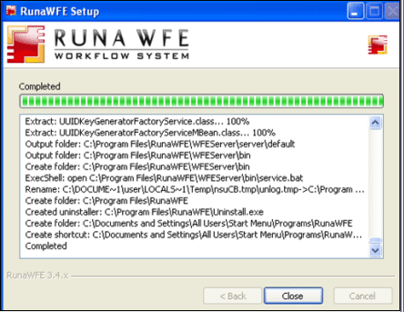For the first glimpse of the system it is recommended to install the client side components. Simulator client side component is an adapted for a workstation version of the RunaWFE-server and contains a local bot station. That's why the client side components are sufficient to get to know all RunaWFE features.
After client side components installation, you can start it via system menu (Start / Programs / RunaWFE) or icons on the desktop.
In order to start and execute business process you should start RunaWFE server (simulator). It can be done for example via menu command Start / Programs / RunaWFE / Start Simulation. Then run program web interface Start / Programs / RunaWFE / Simulation Web Interface. Default administrator login is "Administrator" (case sensitive) and password is "wf".
The main component is the RunaWFE-server (in client side installation version - it is Simulator). All other components are optional. When the RunaWFE-server (Simulator) is installed web browser is sufficient to work with the system.

Specialized distributive installation for Linux OS
Linux OS distributives consist of rpm or deb packages. Download packages for your OS from http://sourceforge.net/projects/runawfe/files (packages are in Distributives/Distributives for Linux).
Here is the list of supplied packages:
- runawfe-jboss — jboss that is necessary for all runawfe servers types to work
- runawfe-simulation — WFE Simulator. Allows to run and stop WFE-server via OS main menu commands (Office submenu) and also contains a link to a system web-interface.
- runawfe-gpd — Graphic Process Designer.
- runawfe-notifier - task notifier
- runawfe-doc - documentation
- runawfe-commonlibs — libraries for different servers types
- runawfe-common — common components of the main menu
- runawfe-client-conf — Client components configuration to WFE server
- runawfe-client — a link to a web interface of WFE server
- runawfe-adminkit — administrative scripts
- runawfe-server — WFE server
- runawfe-botstation — remote bot station
runawfe-server and runawfe-botstation are useful only for enterprise installation. In order to get to know the RunaWFE it is recommended to install runawfe-simulation, runawfe-gpd, runawfe-notifier, runawfe-doc packages and all their dependencies. Such installation allows to create/edit business processes, view server and task notifier work. Also runawfe-simulation includes a testing data base with demo-configuration loaded (similar to that of wfdemo.runa.ru)
Currently there are RunaWFE specialized distributives for the following Linux based OSes:
- Debian
- Mandriva
- ALT Linux
- Ubuntu
- Fedora

See more details about installation below:

Debian:
At first make sure that software sources for dependences search and installation are correctly set. Use "Software Sources" or turn on necessary repositories in /etc/apt/sources.list file.
For example:
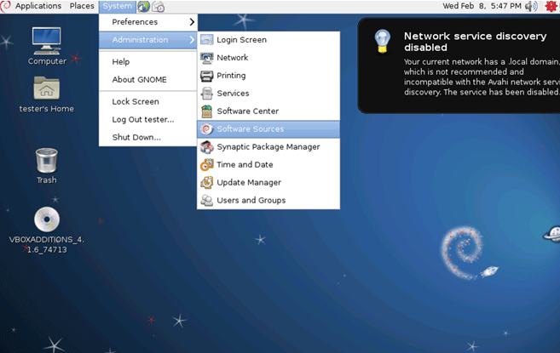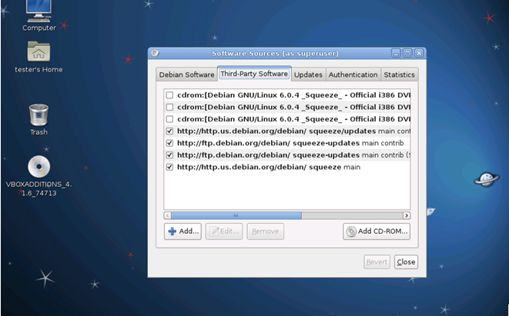
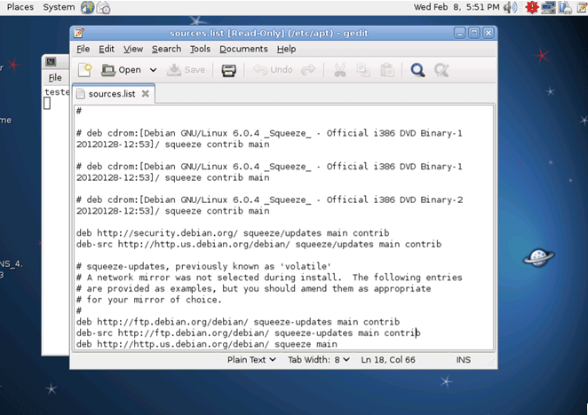After this set up you can proceed with RunaWFE packages installation. The best way to do it is to use dpkg and gdebi-gtk.
Installing jboss
sudo dpkg -i ./ runawfe-jboss_4.2.3.GA-1_all.deb
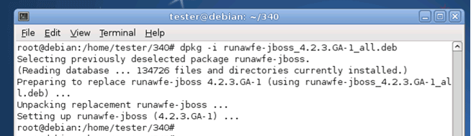To resolve all dependencies between packages it is necessary to use gdebi-gtk.
Install packages common, commonlibs (with all their dependencies)
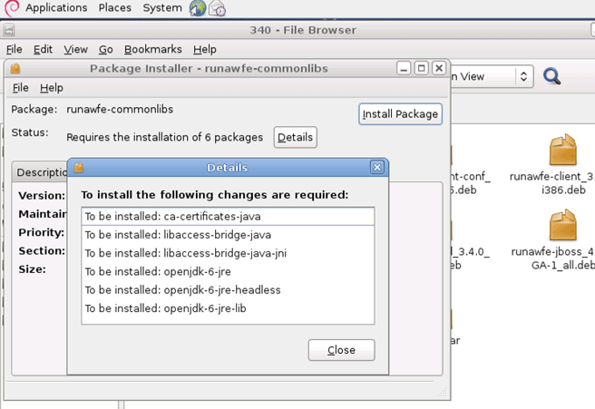Next you should install adminkit, clientconf, client, simulation, doc
During notifier installation there are several dependencies that have to be installed.
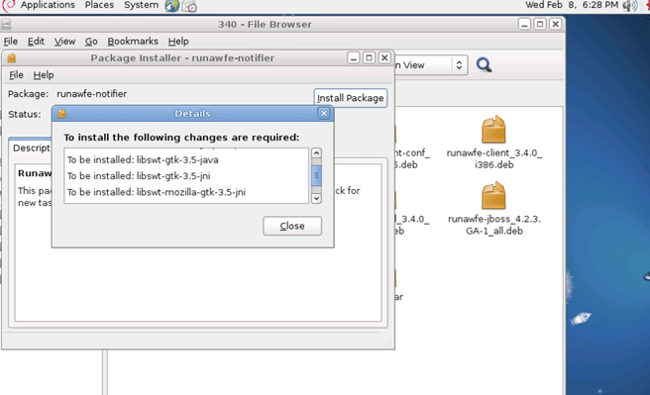install gpd

Mandriva:
At first you should set software sources for search and installation of dependences. It is best to use rpm and urpmi.
Install java-1.6.0-openjdk using urpmi
urpmi java-1.6.0-openjdk
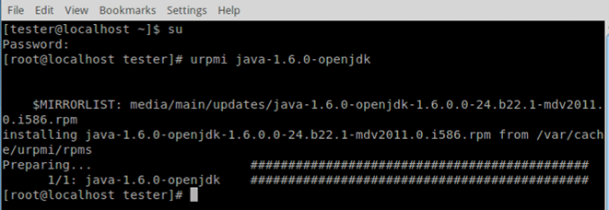Next install packages using rpm.
Jboss, common, commonlibs, adminkit, clientconf, client, simulation, doc
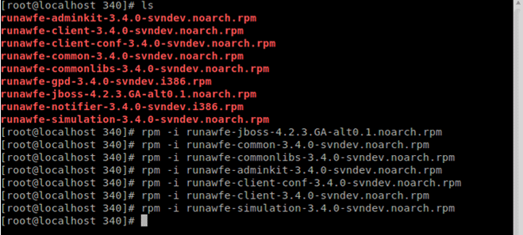Before installing notifier it is necessary to find and install eclipse-swt package
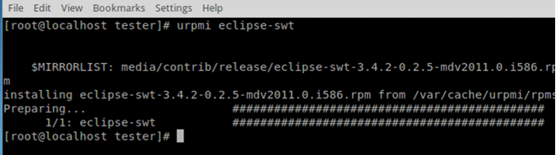Install eclipse-swt of version 3.5 or above
Currently (Feb, 2012) in Mandriva repository there is no eclipse-swt of version 3.5 or above. Without it notifier and gpd will not work.
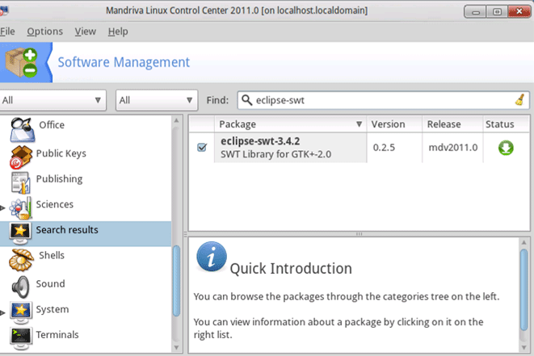Install notifier and gpd using rpm
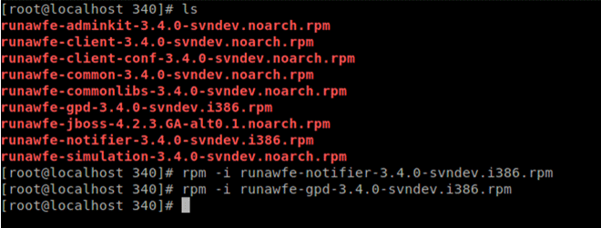

ALT Linux:
At first it is necessary to check and/or configure software sources for dependencies.
For example:
Configured repositories:
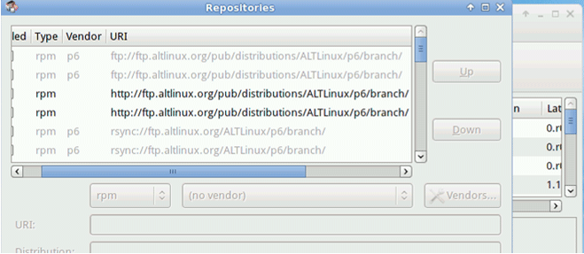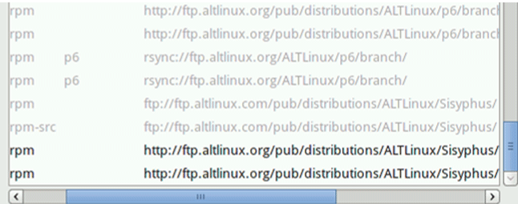
For the correct work of Sisyphus repository sometimes it is necessary to add a string:
APT::Cache-Limit 100000000
to /etc/apt/apt.conf file
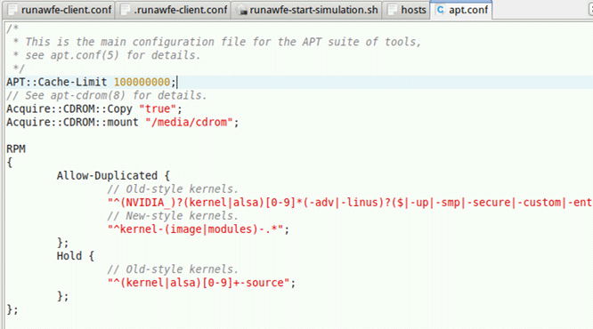You must consider that the version of runawfe in repository may be not the latest one.
For example:
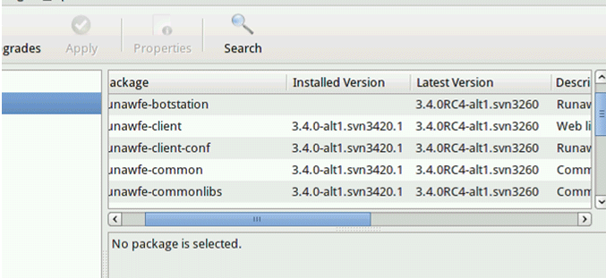Install the following packages (with the help of rpm):
runawfe-jboss, common, commonlibs, adminkit, clientconf, client, simulation, doc,
notifier (depends on – eclipse-swt).
Install eclipse-swt using apt:
apt-get install eclipse-swt
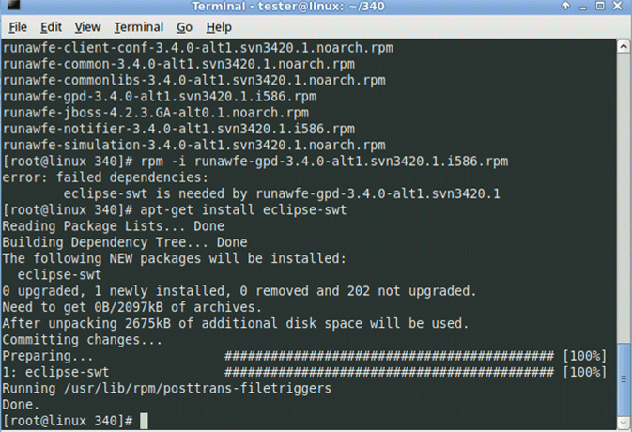GPD also requires dependencies:
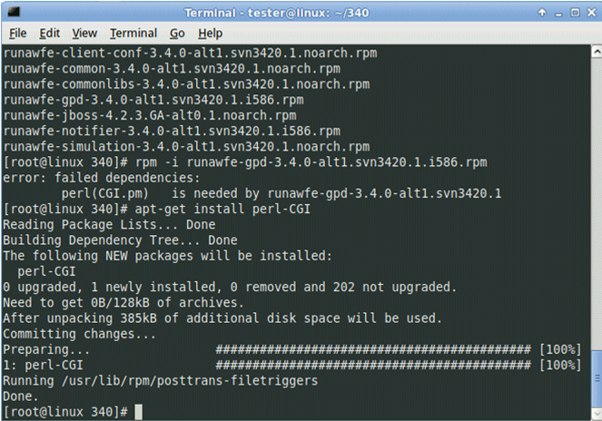Install perl-CGI which is required for the work using apt:
apt-get install perl-CGI
If any other dependences are required use apt-get install to install them.
After runa packages installation, run installed application from /usr/sbin/
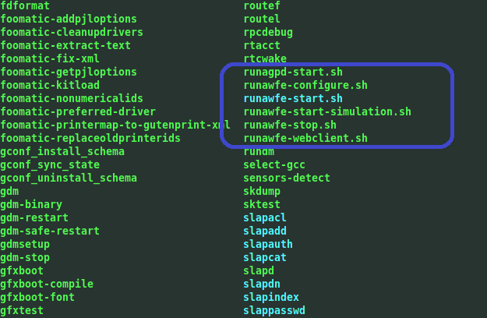

Ubuntu:
Install jboss
sudo dpkg -i jboss.deb
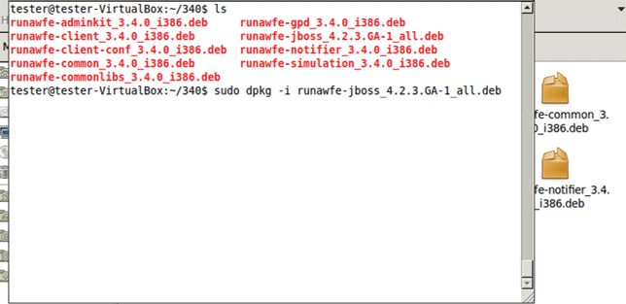- common,
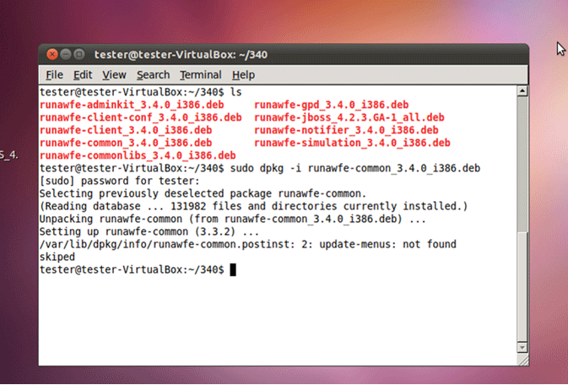commonlibs requires openjdk-6-jre
Install jdk6 with all required dependences
sudo aptitude install openjdk-6-jre

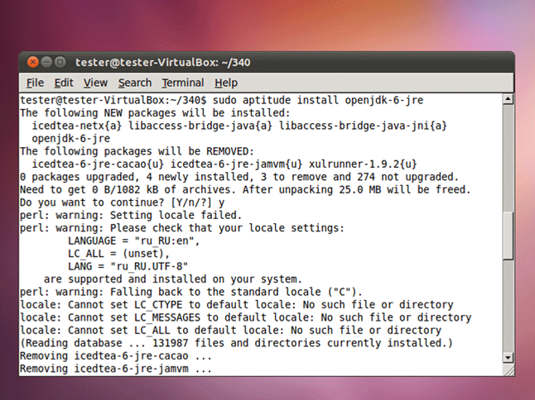Install commonlibs
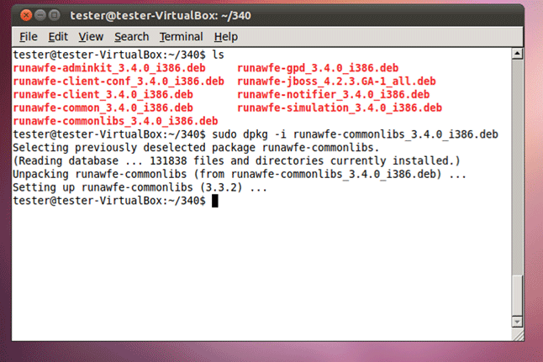Next install adminkit, clientconf, client, simulation
Notifier requires dependences installation:
It is necessary to install libswt-gtk version 3.5, but currently it is version 3.6 that is in repository, and notifier will not work with it.
To install swt-gtk version 3.5 add a repository
deb http://archive.ubuntu.com/ubuntu lucid main
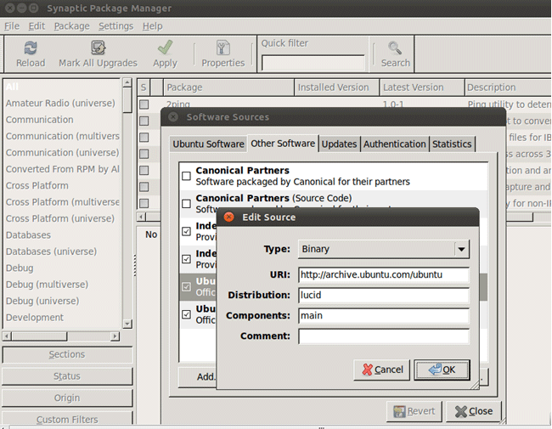Next find and install libswt with the help of aptitude
sudo aptitude install libswt-gtk-3.5-java
sudo aptitude install libswt-mozilla-gtk-3.5-jni
Then install notifier и gpd

Fedora:
Use rpm and yum for packages installation
Find and install java-1.6.0-openjdk using yum
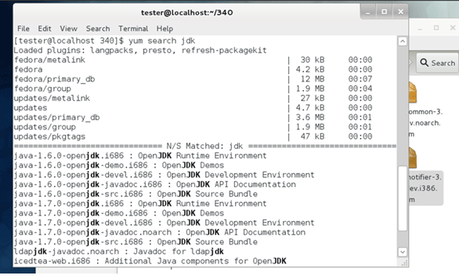
yum install java-1.6.0-openjdk.i686
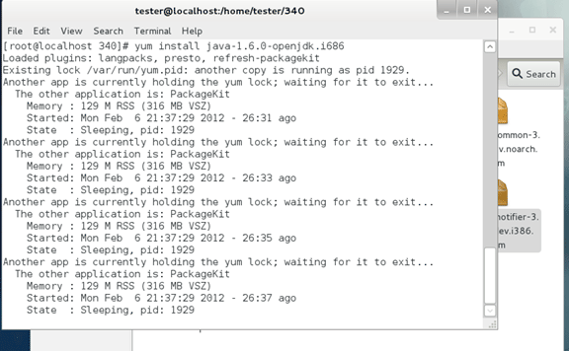install jboss
rpm -i jboss
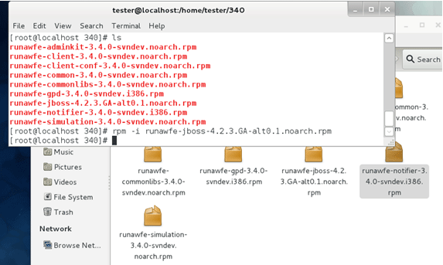install common, commonlibs, adminkit, clientconf, client, simulation, doc
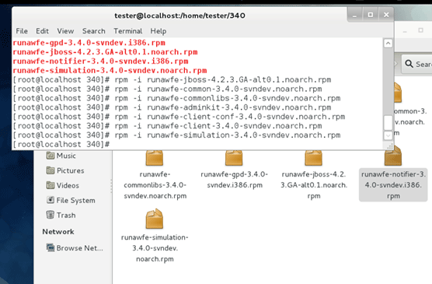Notifier package requires eclipse-swt
Find it and install using yum
yum install eclipse-swt.i686
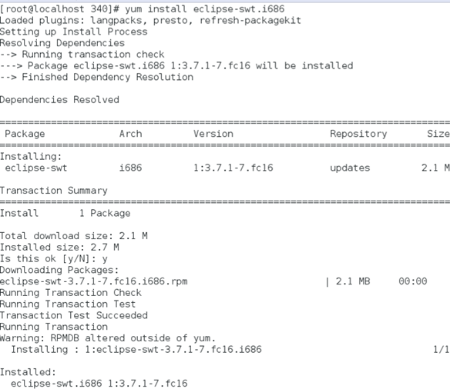Install notifier and gpd
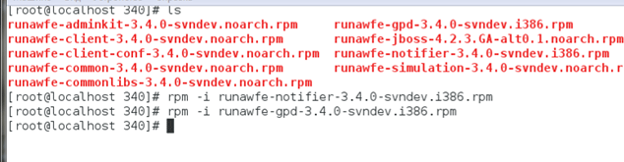

Binary distribution
This distribution is an archive file, that contains compiled source, configured JBoss server and all required libraries. You can download the archive from http://sourceforge.net/projects/runawfe/files

Prerequisites
Hardware and software requirements:
Server machine - Pentium 4 or higher, RAM 512Mb, free HDD space 2Gb, OS - Windows 2000 or higher, Linux Debian 3.0 or higher, Fedore Core 3 or higher, AltLinux 4.0 or higher, Sun Solaris 10.
Client machine must allow installing web-browser that supports HTML 4.0
Also J2SE SDK JDK 5.0 or higher is required. It can be downloaded from http://java.sun.com/j2se/1.5.0/download.jsp

Installation procedure
1. Download and install JDK 6.0 and set JAVA_HOME environmental variable ( http://www.jboss.org/wiki/Wiki.jsp?page=JBossInstallation).
2. Download runawfe-x.x.x-bin.zip from “Files” page on RunaWFE project ( http://sourceforge.net/projects/runawfe). Unpack runa-wfe-*.zip archive to any folder on the server, folder name must not contain spaces. This folder will be here forth named $DIST_ROOT
Runa WFE is ready to go. To start the system, please execute run.bat (Windows) or run.sh (Unix) from wfe-x.x.x/bin folder.
Navigate your browser to http://localhost:8080/wfe. Default credentials are:
Login: Administrator
Password: wf

Building from Source
The distributive is an archive file with all the project source code. It can be downloaded from http://sourceforge.net/projects/runawfe/files

Prerequisites
Hardware and software requirements:
Server machine - Pentium 4 or higher, RAM 512Mb, free HDD space 2Gb, OS - Windows 2000 or higher, Linux Debian 3.0 or higher, Fedore Core 3 or higher, AltLinux 4.0 or higher, Sun Solaris 10.
Client machine must allow installing web-browser that supports HTML 4.0
Also
- J2SE SDK JDK 6.0. It can be downloaded from http://www.oracle.com/technetwork/java/javasebusiness/downloads/java-archive-downloads-javase6-419409.html
- Apache Ant 1.8.2, can be downloaded from http://ant.apache.org/bindownload.cgi
- System must be deployed on Jboss 4.2.3.GA which can be downloaded from http://sourceforge.net/projects/jboss/files/JBoss/JBoss-4.2.3.GA/jboss-4.2.3.GA.zip/download
All other necessary libraries and frameworks are bundled with Runa WFE source distribution and can be found in wfe/lib subfolder.

Preparing the build
- Install J2SE SDK and set JAVA_HOME environmental variable ( http://www.jboss.org/wiki/Wiki.jsp?page=JBossInstallation)
- Install JBoss Application Server ( http://docs.jboss.org/jbossas/admindevel326/html/ch01.html)Note: JBoss configuration used in this manual is called default
- Either using any compatible SVN-client download the source code from the repository or download and unpack a source snapshot called runa-wfe-*.*.*-src.zip
- Install Apache Ant 1.8.2. Make sure that junit.jar library is available for Ant. Copy junit-x.x.x.jar to $ANT_HOME$/lib folder.(look at http://ant.apache.org/manual/OptionalTasks/junit.html for a complete discussion)
- Next edit /build.properties in the project root folder:
Property jboss.home.dir must point to your JBoss installation directory
for Windows:
jboss.home.dir = C:/jboss-4.2.x
for Unix:
jboss.home.dir = /opt/jboss-4.2.x
Note. Default RunaWFE datasource is JBoss HSQL with JNDI name java:/DefaultDS

Performing build
Run ANT installation script in the root folder of the project:
ant install.wfe
This command will build and install Runa WFE into your JBoss installation folder.
Note. In case of AltLinux 4.0 port 8080 is used by system services, and you should use another port instead: Open in a text editor file $(JBoss_Home)/server/default/deploy/jbossweb-tomcat55.sar/server.xml
Find string:
<Connector port="8080" address="${jboss.bind.address}" maxThreads="500" minSpareThreads="25" maxSpareThreads="75" enableLookups="false" redirectPort="8443" acceptCount="100" connectionTimeout="20000" disableUploadTimeout="true" URIEncoding="UTF-8"/>
Change port 8080 to another port (as usual, in OS AltLinux 4.0 port 28080 is used)
In case of OS AltLinux when you use bot station or task notifiers you should map localhost to a real IP computer address instead of 127.0.0.1 (it is done in /etc/hosts file on the server). It necessary for correct RMI client-server interaction.

Running and halting the system
Note. By default JBoss-4.2.3 is available only on local interface (because of security reasons). When you install Windows OS version of system with the help of installer, you have JBoss already configured for network connections. To make JBoss available on all set interfaces run run.bat (.sh) with "-b 0.0.0.0" parameter. Or you can place this parameter into run.bat(.sh) script.

Running system for Specialized distributives

Windows OS distributive
Simulator can be run on the client computer via system menu Start / Programs / RunaWFE / Start simulation or via desktop icon "Start simulation".
If you've installed server or remote bot station, then jboss is installed as service and it will be started automatically every time the system is started.

Linux OS distributives
Simulator can be run on the client computer via system menu or via desktop icon "Start simulation".
If you've installed server or remote bot station, then jboss is installed as demon and it will be started automatically every time the system is started.

Running system for binary distribution
You should have permission to run applications that listen to ports used by the application server (it is a part of the system), by default these ports are 1098, 1099, 8083, 4444, 4445, 8080.
Go to the $(JBoss_Home)/bin folder. Run run.bat (run.sh).

Halting the system for Specialized distributives

Windows OS distributive
The simulator on the client computer can be stopped via system menu Start / Programs / RunaWFE / Stop simulation or via desktop icon "Stop simulation".
If you've installed server or remote bot station, you should stop jboss service to stop the system.

Linux OS distributives
The simulator on the client computer can be stopped via system menu or via desktop icon "Stop simulation".
If you've installed server or remote bot station, you should stop jboss demon to stop the system.

Halting the system for binary distribution
Go to $(JBoss_Home)/bin Run shutdown.bat -S (shutdown.sh -S)

Login to the system
Open web browser on page http://<servername>:8080/wfe Here <servername> is the server address. If RunaWFE is installed on local computer, then use localhost as <servername>.
Note. In AltLinux 4.0 case 8080 is used by system services and another port is used for RunaWFE (see @@installing RunaWFE). Usually it is port 28080. So the page will be http://<servername>:28080/wfe
Note. If SSL protocol is used the address will be: https://<servername>:8443/wfe
The page in web browser should contain login form, default administrator login is "Administrator" (case sensitive) and password is "wf".
Note. Demo process are in $(DIST_ROOT)/samples folder.

Bots Configuration

Introduction to Bot
Runa WFE Bot is a program that participates in business processes. Every bot has a link to a Runa WFE actor. Bot executes tasks under the name of this actor. Runa WFE does not distinguish bots from humans.
All bots run inside special environment that is known as WFE Bot Invoker. This application periodically activates all registered bots. Every bot receives tasks assigned to the actor it represents. Then bot passes the tasks to corresponding task handler. When task is performed bot executes activity in workflow process and passes parameters to the process.
Examples of bot task handlers are: generate report, store data to database, send sms, send email, start process, cancel process, write file to disk.
Since Runa WFE 2.1 sample configuration contains several implemented task handlers:
- E-mailTaskHandler
- DatabaseTaskHandler
- CancelProcessTaskHandler
- SwimlaneAssignerTaskHandler
- UpdatePermissionsTaskHandler
It is always possible to write your own bots using Runa WFE API.

Bot configuration
In order to configure bots and botstations click on Bot Station menu item of the main menu from the RunaWFE web-interface. This menu item is visible and active if the currently logged on user has the right to read botstations information. In order to change botstation configuration the user must possess the right to configure botstation.
The default RunaWFE-server configuration has one botstation (localbotstation) and two bots, that are used in the demo processes. In order to perform a task assigned to bot the botstation starts a task handler which corresponds to this particular bot and this particular task.
If you want to add a new task handler that is not present in the default RunaWFE system and you want to put it in a .jar file that is not included in the default RunaWFE system, it is necessary to add the new .jar file name to a wfe.bots.jar.filename property value list in file common_settings.properties. Names of .jar files are separated by “;” symbol. In the bot web-interface in bots column you will see only those task handlers that are found in .jar files enumerated in the wfe.bots.jar.filename property.

Start and Stop Bots in Running System
Open the Bot Station page from the main menu of RunaWFE web-interface. Choose a botstation from the list and click on its name. A page with the chosen botstation basic information will open. Bot Station status indicates if the bots periodic invocation is on. To switch on/off the bots periodic invocation you should click the big button there.
You can also view botstation status, start and stop bot invocation via adminkit utility. It can be found in jboss-root/adminkit folder. First you should set botstation address in the adminkit/bot_delegate.properties file by editing ru.runa.bot.delegate.remote.provider.url.default parameter. By default it is set to a localbotstation. To view bot invocation status run adminkit/bot-invoker.bat status. To start(stop) periodic bots invocation run adminkit/bot-invoker.bat start (stop correspondently).
Note. There can be an implicit bots invocation. If a process contains a BotInvokerActionHandler it will perform bots invocation regardless of periodic bot invocation status.

Adding and Removing Bots
In order to add a bot to botstation first you should create a new user with the bot's name. (Use Administrator guide for creating new user instructions). Then navigate to botstation page and click on “Add bot” link. On the adding new bot page you should choose the user you've created for the bot and type its password. After adding a new bot the task list for this bot will be empty.
In order to remove a bot from botstation navigate to botstation page and check all the bots you want to delete. Then click the remove button. The bots and all their tasks configurations will be removed.

Changing Bots' Configuration
Choose bot station from main RunaWFE web-interface menu, then choose the bot you want change configuration for and click on it. You will see the page with all bot's tasks, their handlers and configurations. You can upload a new configuration file for a task or you can edit the current task configuration file (the latter requires browser with javascript support). After uploading a new configuration file you should click click “Apply” button in the bottom of the task section
If you want to remove a task from the list, uncheck it and click “Apply”. After it the selected tasks will disappear from the task list.
The new parameters come into effect immediately after clicking “Apply” (system reload is not necessary) and are used during next bot invocation.

Setting botstation parameters on RunaWFE server
There's a localbotstation botstation on RunaWFE server in a default configuration. The name and password for botstation are set in jboss-root/server/default/conf/bot/botstation.xml. You can also set a number of threads in which bots perform tasks via thread-pool-size parameter in botstation.xml.
If you want to use a remote botstation, you should:
- fill in your RunaWFE server name and port when asked during remote botstation installation.
- on your RunaWFE server add a new actor with remote botstation name as new actor's name. (This can be an arbitrary name). (see Administration guide for how to add a new actor)
- navigate to Bot Stations page from the main menu and click “Add Bot Station”. Choose name of newly created remote botstation actor and fill in the url of remote botstation, e.g. jnp://remotebotstationhostname:1099
- on the remote botstation jboss server in jboss-root/server/default/conf/bot/botstation.xml specify the name and the password of the remote botstation actor that you've created on your RunaWFE server

Authentication

Authentication configuration
Runa WFE uses JAAS for authentication. Main configuration file for authentication is login_module.properties. This file is plain .properties file which defines login modules and their requirements.
Runa WFE provides following modules:
- ru.runa.af.authenticaion.InternalDBPasswordLoginModule – module authenticates username and password against internal Runa WFE database
- ru.runa.af.authenticaion.ADPasswordLoginModule – module authenticates username and password against Microsoft Active Directory server
- ru.runa.af.authenticaion.NTLMLoginModule – module authenticates NTLM authentication digest against Windows domain PDC

NTLM Authentication
NTLM authentication allows to use Windows domain user account data to authenticate user on the RunaWFE server. NTLM login module uses two configuration files: ntlm_support.properties and ad_password_login_module.properties. These files are located in <server name>/conf directory.
To enable NTLM authentication:
- add NTLM login module in $DIST_ROOT/server/default/conf/login_module.properties. E.g. ru.runa.af.authenticaion.NTLMLoginModule=SUFFICIENT
- configure domain name in $DIST_ROOT/server/default/conf/ntlm_support.properties by setting the “domain” parameter to YOUR_DOMAIN_NAME and in $DIST_ROOT/server/default/conf/ad_password_login_module.properties setting the “ru.runa.af.active.directory.damain.name” parameter to YOUR_DOMAIN_NAME
- activate ntlm support by setting ntlm_supported=true in $DIST_ROOT/server/default/conf/ntlm_support.properties
All users that have account in the Windows domain YOUR_DOMAIN_NAME will be able to authenticate on the RunaWFE system via http://<servername>/wfe/ntlmlogin.do page. (NTLM authentication can also work over HTTPS)
It is necessary to add all Windows domain users to the RunaWFE system and give them permission to login to RunaWFE. It can be done via web-interface (see Adminitration guide) or via administration script. While user don't exist in RunaWFE system he(she) cannot authenticate.
To switch off NTLM support set ntlm_supported=false in $DIST_ROOT/server/default/conf/ntlm_support.properties
After changing NTLM configuration it is necessary to restart the RunaWFE server.

Kerberos Authentication
Note. For Kerberos all user's names a principals are case sensitive.
Create a domain user (e.g. WorkflowUser). Open WorkflowUser properties and check “Use DEC encryption”. After setting this property you should change WorkflowUser password, (then this new password will be DES encrypted).
For the sake of making an example, let's say that we are in test.com domain, RunaWFE server is on wfserver.test.com, and in krb5.ini default_realm = TEST.COM. (The example of krb5.ini you can find in trunk\wfe\resources\windows-server-configuration\winnt\krb5.ini) You must edit(or create) Kerberos krb5.ini file on RunaWFE server computer and all RunaWFE clients computers. This file must be placed in Windows home directory.
You must set the following encryption algorithms:
[libdefaults]
default_tkt_enctypes = des-cbc-md5 des-cbc-crc des3-cbc-sha1
default_tgs_enctypes = des-cbc-md5 des-cbc-crc des3-cbc-sha1
permitted_enctypes = des-cbc-md5 des-cbc-crc des3-cbc-sha1
For more detailed Kerberos krb5.ini description see http://web.mit.edu/kerberos/www/krb5-1.4/krb5-1.4.3/doc/krb5-admin/krb5.conf
You will need setspn and ktpass utilities that can be downloaded form Microsoft sity as part of the Support tools.
Create an SPN (used for Kerberos authentication via web-interface only):
setspn -A HTTP/wfserver.test.com@TEST.COM TEST\WorkflowUser
ktpass -princ HTTP/wfserver.test.com@TEST.COM -pass WorkflowUser_password -mapuser TEST\WorkflowUser
where TEST is NetBIOS name.
The latest command may cause a warning “WARNING: pType and account type do not match. This might cause problems”, that can be safely ignored.
In RunaWFE configuration files server/default/conf/kerberos_module.properties and kerberos_web_support.properties change WFTestUser and HTTP/alcomputer to HTTP/wfserver.test.com (for java 1.5) or WorkflowUser (for java 1.6).
You should create keytab file on wfserver.test.com (with the help of ktab from JAVA_HOME/bin):
for java 1.5: ktab -a HTTP/wfserver.test.com@TEST.COM WorkflowUser_password -k absolute_path_and_name_for_new_keytab_file
for java 1.6 ktab -a WorkflowUser@TEST.COM WorkflowUser_password -k absolute_path_and_name_for_new_keytab_file
Set keyTab = absolute_path_and_name_for_new_keytab_file in kerberos_module.properties and kerberos_web_support
For the correct work of runa task notifier(rtn) you should set the serverPrincipal property value in rtn kerberos_module.properties to the same value as it is set in kerberos_module.properties on RunaWFE server.
In all property files mentioned above, you should change appName property:
for java 1.5 appName = com.sun.security.jgss.*
for java 1.6 appName = com.sun.security.jgss.krb5.*

Active Directory authentication
Open $(DIST_ROOT)/server/default/conf/login_module.properties file and set ru.runa.af.authenticaion.ADPasswordLoginModule=SUFFICIENT
Open $DIST_ROOT)/server/default/conf/ad_password_login_module.properties file and set ru.runa.af.active.directory.server.url=[ldap:// ldap://]<your.domain.ip.or.name>
ru.runa.af.active.directory.damain.name=<YOUR_DOMAIN_NAME>
It is necessary to add all domain users to the RunaWFE system and give them permission to login to RunaWFE. It can be done via web-interface (see Adminitration guide) or via administration script.
You can disable AD authentication by commenting out the
ru.runa.af.authenticaion.ADPasswordLoginModule=SUFFICIENT
string in $DIST_ROOT/server/default/conf/login_module.properties

Setting up work with database

Default database
By default Runa WFE is configured to use the embedded hsqldb database. Jboss.org/wiki says that “hsqldb is not a production quality database. It is suitable for demos and testing. JBoss ships with the database to help you get something working out of the box”. So does Runa WFE. If you plan to use Runa WFE for production environment you should consider using another database engine for persistence, e.g. MySQL, MS SQL Server, Oracle, etc.

Switching to MSSQL
Put the MSSQL JDBC-driver (jtds.jar file) to the ${jboss.home}/server/default/lib folder.
In $(DIST_ROOT)/server/default/conf/hibernate.cfg.xml file set
- <property name="dialect">org.hibernate.dialect.SQLServerDialect</property>
- <property name="hibernate.connection.datasource">java:/mssqlds</property>
Create mssql-ds.xml datasource file in ${jboss.home}/server/default/deploy/. The file name can be chosen arbitrarily. The file content should look like this:
<?xml version="1.0" encoding="UTF-8"?>
<datasources>
<local-tx-datasource>
<jndi-name>mssqlds</jndi-name>
<connection-url>jdbc:jtds:sqlserver://<server>;databaseName=<database></connection-url>
<driver-class>net.sourceforge.jtds.jdbc.Driver</driver-class>
<user-name>user</user-name>
<password>****</password>
</local-tx-datasource>
</datasources>
Here is a connection-url example:
jdbc:jtds:sqlserver://SQL_SERVER_NAME;databaseName=your_database_name

Switching to Oracle
Put the Oracle JDBC-driver (jtds.jar file) to the ${jboss.home}/server/default/lib folder.
In $(DIST_ROOT)/server/default/conf/hibernate.cfg.xml file set
- <property name="dialect">org.hibernate.dialect.OracleDialect</property>
- <property name="hibernate.connection.datasource">java:/OracleDS</property>
Create oracle-ds.xml datasource file in ${jboss.home}/server/default/deploy/. The file name can be chosen arbitrarily. The file content should look like this:
<?xml version="1.0" encoding="UTF-8"?>
<datasources>
<local-tx-datasource>
<jndi-name>OracleDS</jndi-name>
<connection-url>jdbc:oracle:thin:@localhost:1521:XE</connection-url>
<driver-class>oracle.jdbc.driver.OracleDriver</driver-class>
<user-name>wfe</user-name>
<password>wfe</password>
<min-pool-size>5</min-pool-size>
<max-pool-size>20</max-pool-size>
<idle-timeout-minutes>0</idle-timeout-minutes>
<track-statements/>
<prepared-statement-cache-size>32</prepared-statement-cache-size>
<valid-connection-checker-class-name>org.jboss.resource.adapter.jdbc.vendor.OracleValidConnectionChecker</valid- connection-checker-class-name>
</local-tx-datasource>
</datasources>

Switching to MySQL
Put the MySQL JDBC-driver in ${jboss.home}/server/default/lib folder.( MySQL Connector/J is the official JDBC-driver for MySQL)
In $(DIST_ROOT)/server/default/conf/hibernate.cfg.xml file set
- <property name="dialect">org.hibernate.dialect.MySQLDialect</property>
- <property name="hibernate.connection.datasource">java:/mysqlds</property>
Create mysql-ds.xml datasource file in ${jboss.home}/server/default/deploy/. The file name can be chosen arbitrarily. The file content should look like this:
<?xml version="1.0" encoding="UTF-8"?>
<datasources>
<local-tx-datasource>
<jndi-name>runawfe-ds</jndi-name>
<connection-url>jdbc:mysql://<server>[:port]/<database>?useUnicode=true&amp;characterEncoding=UTF-8</connection-url>
<driver-class>com.mysql.jdbc.Driver</driver-class>
<user-name>user</user-name>
<password>****</password>
</local-tx-datasource>
</datasources>
Here is a connection-url example:
jdbc:mysql://YourIp:3306/DEMO_WF_DB? UseUnicode=true&characterEncoding=UTF-8

System Logging Description
RunaWFE uses log4j for logging. ( http://logging.apache.org/log4j).
Default log4j settings provide the following:
- RunaWFE log files are placed in $DIST_ROOT/server/default/log
- Two log files are generated: boot.log (server booting information) and server.log (all the logs generated while server is on)
Log4j framework for RunaWFE server is configured in $DIST_ROOT/server/default/conf/jboss-log4j.xml

Configuration of SMTP Logging
To turn on log4j email log feature it is necessary to add an appender and associate it with needed messages categories.
To add an SMTP appender you may use the following configuration file snippet:
<appender name="SMTP" class="org.apache.log4j.net.SMTPAppender">
<errorHandler class="org.jboss.logging.util.OnlyOnceErrorHandler"/>
<param name="EvaluatorClass" value="ru.runa.log4j.AnyMessageTriggeringEventEvaluator"/>
<param name="To" value="user@runa.ru"/>
<param name="From" value="nobody@wf.runa.ru"/>
<param name="Subject" value="JBoss Sever Errors"/>
<param name="SMTPHost" value="rm_exchange.runa.ru"/>
<param name="BufferSize" value="128"/>
<layout class="org.apache.log4j.PatternLayout">
<param name="ConversionPattern" value="[%d{ABSOLUTE},%c{1}] %m%n"/>
</layout>
</appender>
The configuration parameters:
- EvaluatorClass – is a class that determines the log sending policy, default policy is caching all messages till the first error message appears, then all the cached messages are sent and the cache is cleared. AnyMessageTriggeringEventEvaluator sends the messages as they appear regardless of their type. (AnyMessageTriggeringEventEvaluator supplied in log4j-extra.jar)
- To – the letters recipient (email address)
- From – the letters sender (email address)
- Subject – the letters subject (email subject)
- SMTPHost – the host name used for sending email
- BufferSize – the capacity of messages buffer (default value 512). When the limit is reached the oldest messages are replaced with recent ones
- errorHandler – messages handler. org.jboss.logging.util.OnlyOnceErrorHandler logs only new messages, all the following up same messages (with the same message attributes) are discarded
- layout – the description of the sent messages format.
Use the following way to associate appender with a category. For a simple category you can add a reference to appender in category elements, for example:
<category name="ru.runa">
<priority value="DEBUG"/>
<appender-ref ref="SMTP"/>
</category>
SMTP here is a name of an appender that defined earlier.
For the root category the appender reference can be added into root category elements, e.g.:
<root>
<appender-ref ref="SMTP"/>
<appender-ref ref="FILE"/>
</root>

Setting up Event Viewer logging
To set up log message to Windows Event Viewer it is necessary
- to add Event Viewer appender
- to associate the appender with chosen message categories
- to place NTEventLogAppender.dll library (it is shipped separately) to directory, that is present in system PATH variable.
Here's the configuration code for Event Viewer Appender:
<appender name="NTEventViewer" class="org.apache.log4j.nt.NTEventLogAppender">
<errorHandler class="org.jboss.logging.util.OnlyOnceErrorHandler"/>
<param name="source" value="RunaWFE"/>
<layout class="org.apache.log4j.PatternLayout">
<param name="ConversionPattern" value="%d{ISO8601}: [%t] %C{1}, %p, %c: %m%n"/>
</layout>
</appender>
The parameters are:
- source – the source of the messages that are placed in Event Viewer
- errorHandler – see this parameter description in SMTP appender parameters.
The appender – categories association is configured the same way as for SMTP appender.
The default appenders are:
appender | Short description
FILE | server.log will be used to accumulate log messages
CONSOLE | Application server console is the target for the log messages

Performance tuning
Server hardware requirements are variable and depend significantly on the number of concurrent users that will be accessing the system. You should tune the memory and garbage collection parameters for the JVM as appropriate for your use-case.

JVM Settings
Use file run.bat (on Windows) or run.sh on Linux. Change JAVA_OPTS parameters in it.
For example in run.bat edit line
set JAVA_OPTS=%JAVA_OPTS% -Xms128m -Xmx512m
For most cases, tuning the JVM is done with the following steps:
- Assign as much RAM as possible for the JVM (-Xmx8GB)
- Set the perm gen to 256M (-XX:MaxPermSize:256m)
- Ensure the "server" VM is used (-server)
Be aware that to avoid memory swapping, -Xmx should never exceed the amount of available RAM in the system. Remember to leave room in memory for the OS and other applications.
In general, if you don't give the JVM enough heap space, playing with other JVM settings will not help. Once the JVM has enough heap space, playing with other JVM settings influence performance much.
The following settings are used on a home server 32-bit, dual-core per CPU, 4GB RAM environment.
-server -Xms512m -Xmx1024m -XX:+HeapDumpOnOutOfMemoryError -XX:+PrintConcurrentLocks -XX:MaxPermSize=256m

How to get memory and stack dumps for performance analysis

Using JDK utilities
Change to folder ${JDK}\bin\.
In order to get memory dump run command:
jmap -dump:format=b,file=heap.bin pid, where pid is the process identifier

In order to get stack dump run command:
jstack pid, where pid is the process identifier

If it doesn't work and problems like "Insufficient memory space to run command" occur, it is recommended to use one of the ways described below:

Using JavaMelody
Project url: http://code.google.com/p/javamelody/
This tool allows not only to get memory dumps but it can also help to analyze the system behavior. The additional load is small and it makes it possible to use this tool on production server while it works as usual.
Fast configuration (for more details see the java melody project documentation)
- Download the distributive (for example javamelody-1.35.0.zip)
- Add files javamelody.jar, jrobin-xxx.jar to ${WFEServer}/server/default/deploy/wfe.war/WEB-INF/lib
- Add into file ${WFEServer}/server/default/deploy/wfe.war/WEB-INF/web.xml the following
<filter> <filter-name>monitoring</filter-name> <filter-class>net.bull.javamelody.MonitoringFilter</filter-class> </filter> <filter-mapping> <filter-name>monitoring</filter-name> <url-pattern>/*</url-pattern> </filter-mapping> <listener> <listener-class>net.bull.javamelody.SessionListener</listener-class> </listener>
- (only for SQL analysis)
Add the following property to ${WFEServer}/server/default/conf/hibernate.cfg.xml:
<property name="hibernate.jdbc.factory_class">net.bull.javamelody.HibernateBatcherFactory</property>
After that run WFE and browse http://localhost:8080/wfe/monitoring. This interface helps to find system performance bottlenecks and to make dumps.

Using VisualVM
Project url: visualvm.java.net
If you run VisualVM on the same computer as WFE and VisualVM finds WFE process then no further configuration is needed.
If you run VisualVM on the other computer or VisualVM couldn't find the WFE process (as it usually happens if these programs run under different users) then following configuration is needed:
JAVA_OPTS variable should be configured in run.bat (Windows) or in run.sh (Linux).
For example it can be done like that:
set JAVA_OPTS=%JAVA_OPTS% -Dcom.sun.management.jmxremote.port=6767 -Dcom.sun.management.jmxremote.ssl=false -Dcom.sun.management.jmxremote.authenticate=false
Ensure that port 6767 is not blocked by Firewall.
JMX Connection is used to connect with VisualVM.
After successful connection popup menu on right mouse click contains options Thread Dump, Heap Dump. Also this tool helps to monitor the process. It is unadvised to leave the connection open for a long time in production mode because of the constant data sending from JVM to VisualVM.

Other configurations

Completed business processes jbpm logs transition to separate tables management
In order to optimize the system performance jbpm logs for finished BP are being moved from the main log table into special separately created tables. This prevents the main log table size from overgrowing and from deteriorating performance. The period between log transitions is set in ru.runa.wf.logrotation.period parameter in wf_logic.properties file. The default period is 5 minutes. If the log transition is not desirable during working day time it can be switched off by setting a negative value to ru.runa.wf.logrotation.period parameter. But in this case it is strongly recommended to set up the log transition in the not working day hours.

Strong passwords support
To improve the system security you can impose restrictions on user's passwords. If the parameter strong.passwords.regexp is set then all the user's password must match the set regular expression. If the new password doesn't match the pattern, the system wouldn't let set such password.

Presentation Fields Management
The fields in the views of different lists (task list, process list) of the web user interface can be ENABLED, DISABLED or HIDDEN. This can be set in presentationFields.properties for every field of the interface. The default value set to ENABLED.
ENABLED value means that the field is shown in the view and user can use this field for filters, sorting and grouping actions.
HIDDEN means that the field is not shown in the view and filters, sorting and grouping actions for this field are not available for user to change, but if any of it has been set before the value for the field is changed to HIDDEN, the effect of filters is still remains for the views.
If you don't want the hidden field to affect sorting and grouping use DISABLED.
DISABLED means that the field is not shown and filters, sorting and grouping is not only not available for user but also any of it previously set has no effect on views. For example if filters for the field are set before the field is changed to DISABLED state, there will be no effects from those filters in the view anymore.

Setting Mode For Business Process Properties viewing
There are 2 modes currently implemented for business process properties view:
1)Both graph and properties of business properties are on one web-page. This mode is on if show.graph.mode in %JBOSS_HOME%/server/default/conf/showGraphMode.properties set to false.
2) Business process graph and properties are placed on different web-pages and you can navigate from one to another via a link in the upper right conner of web-page. This mode is on if show.graph.mode in %JBOSS_HOME%/server/default/conf/showGraphMode.properties set to true.

