Номер – tst60
Название - No more handles, OutOfMemory на формах

новый редактор сбоит на формах (out of memory) иногда. Можешь исследовать его на предмет работы с большими формами в IE и Mozilla?

No more handles:
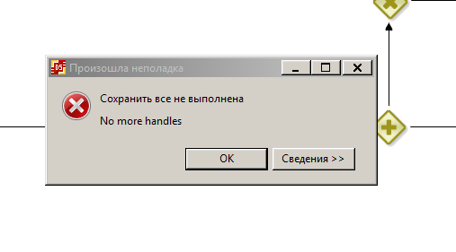
- IE10, сборка редактора из trunk x86
- IE11, редактор из проекта СУТС
Параметры JVM стандартные
Создаю очень большого размера область графа, (передвигаю граф все время в крайний правый угол)
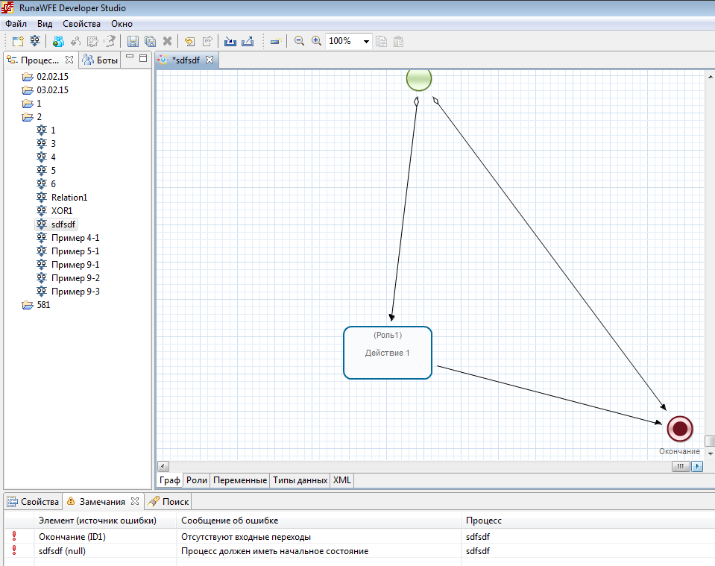
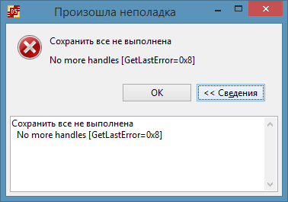
В какой-то момент перестало работать сохранение, в логах нашел ошибку:
!ENTRY org.eclipse.ui 4 0 2015-02-04 21:38:04.929
!MESSAGE Unhandled event loop exception
!STACK 0
org.eclipse.swt.SWTError: No more handles [GetLastError=0x8]
at org.eclipse.swt.SWT.error(SWT.java:4308)
at org.eclipse.swt.graphics.Image.init(Image.java:1598)
at org.eclipse.swt.graphics.Image.<init>(Image.java:181)
at ru.runa.gpd.editor.gef.GEFImageHelper.save(GEFImageHelper.java:44)
at ru.runa.gpd.editor.ProcessEditorBase.doSave(ProcessEditorBase.java:278)
at ru.runa.gpd.ui.action.Save.run(Save.java:9)
at org.eclipse.ui.internal.PluginAction.runWithEvent(PluginAction.java:251)
at org.eclipse.ui.internal.WWinPluginAction.runWithEvent(WWinPluginAction.java:229)
at org.eclipse.jface.action.ActionContributionItem.handleWidgetSelection(ActionContributionItem.java:584)
at org.eclipse.jface.action.ActionContributionItem.access$2(ActionContributionItem.java:501)
at org.eclipse.jface.action.ActionContributionItem$5.handleEvent(ActionContributionItem.java:411)
at org.eclipse.swt.widgets.EventTable.sendEvent(EventTable.java:84)
at org.eclipse.swt.widgets.Widget.sendEvent(Widget.java:1053)
at org.eclipse.swt.widgets.Display.runDeferredEvents(Display.java:4165)
at org.eclipse.swt.widgets.Display.readAndDispatch(Display.java:3754)
at org.eclipse.ui.internal.Workbench.runEventLoop(Workbench.java:2701)
at org.eclipse.ui.internal.Workbench.runUI(Workbench.java:2665)
at org.eclipse.ui.internal.Workbench.access$4(Workbench.java:2499)
at org.eclipse.ui.internal.Workbench$7.run(Workbench.java:679)
at org.eclipse.core.databinding.observable.Realm.runWithDefault(Realm.java:332)
at org.eclipse.ui.internal.Workbench.createAndRunWorkbench(Workbench.java:668)
at org.eclipse.ui.PlatformUI.createAndRunWorkbench(PlatformUI.java:149)
at ru.runa.gpd.Application.start(Application.java:19)
at org.eclipse.equinox.internal.app.EclipseAppHandle.run(EclipseAppHandle.java:196)
at org.eclipse.core.runtime.internal.adaptor.EclipseAppLauncher.runApplication(EclipseAppLauncher.java:110)
at org.eclipse.core.runtime.internal.adaptor.EclipseAppLauncher.start(EclipseAppLauncher.java:79)
at org.eclipse.core.runtime.adaptor.EclipseStarter.run(EclipseStarter.java:344)
at org.eclipse.core.runtime.adaptor.EclipseStarter.run(EclipseStarter.java:179)
at sun.reflect.NativeMethodAccessorImpl.invoke0(Native Method)
at sun.reflect.NativeMethodAccessorImpl.invoke(Unknown Source)
at sun.reflect.DelegatingMethodAccessorImpl.invoke(Unknown Source)
at java.lang.reflect.Method.invoke(Unknown Source)
at org.eclipse.equinox.launcher.Main.invokeFramework(Main.java:622)
at org.eclipse.equinox.launcher.Main.basicRun(Main.java:577)
at org.eclipse.equinox.launcher.Main.run(Main.java:1410)

Уже ранее находили эту проблему
https://sourceforge.net/p/runawfe/bugs/669/
И она была решенаю

Видимо проблема здесь
GEFImageHelper.java:44
OutOfMemory на формах

- IE10, сборка редактора из trunk x86
- IE11, редактор из проекта СУТС
Параметры JVM стандартные

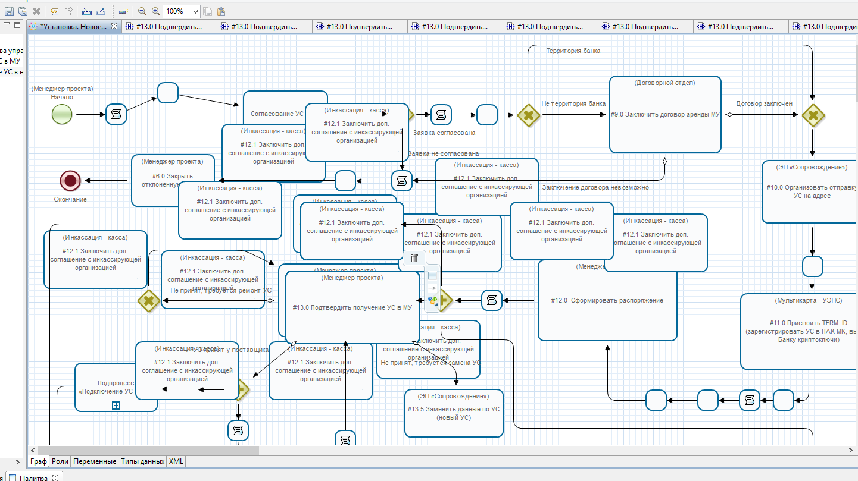

Открыл порядка 25 форм #13.0 (сделал копии этого узла), после чего перестало работать сохранение, в логах ошибка:

!ENTRY org.eclipse.ui 4 0 2015-02-04 23:02:21.289
!MESSAGE Unhandled event loop exception
!STACK 0
java.lang.OutOfMemoryError: Java heap space
at org.eclipse.swt.graphics.Image.getImageData(Image.java:1451)
at ru.runa.gpd.editor.gef.GEFImageHelper.save(GEFImageHelper.java:53)
at ru.runa.gpd.editor.ProcessEditorBase.doSave(ProcessEditorBase.java:278)
at ru.runa.gpd.ui.action.SaveAll.run(SaveAll.java:20)
at org.eclipse.ui.internal.PluginAction.runWithEvent(PluginAction.java:251)
at org.eclipse.ui.internal.WWinPluginAction.runWithEvent(WWinPluginAction.java:229)
at org.eclipse.jface.action.ActionContributionItem.handleWidgetSelection(ActionContributionItem.java:584)
at org.eclipse.jface.action.ActionContributionItem.access$2(ActionContributionItem.java:501)
at org.eclipse.jface.action.ActionContributionItem$5.handleEvent(ActionContributionItem.java:411)
at org.eclipse.swt.widgets.EventTable.sendEvent(EventTable.java:84)
at org.eclipse.swt.widgets.Widget.sendEvent(Widget.java:1053)
at org.eclipse.swt.widgets.Display.runDeferredEvents(Display.java:4165)
at org.eclipse.swt.widgets.Display.readAndDispatch(Display.java:3754)
at org.eclipse.ui.internal.Workbench.runEventLoop(Workbench.java:2701)
at org.eclipse.ui.internal.Workbench.runUI(Workbench.java:2665)
at org.eclipse.ui.internal.Workbench.access$4(Workbench.java:2499)
at org.eclipse.ui.internal.Workbench$7.run(Workbench.java:679)
at org.eclipse.core.databinding.observable.Realm.runWithDefault(Realm.java:332)
at org.eclipse.ui.internal.Workbench.createAndRunWorkbench(Workbench.java:668)
at org.eclipse.ui.PlatformUI.createAndRunWorkbench(PlatformUI.java:149)
at ru.runa.gpd.Application.start(Application.java:19)
at org.eclipse.equinox.internal.app.EclipseAppHandle.run(EclipseAppHandle.java:196)
at org.eclipse.core.runtime.internal.adaptor.EclipseAppLauncher.runApplication(EclipseAppLauncher.java:110)
at org.eclipse.core.runtime.internal.adaptor.EclipseAppLauncher.start(EclipseAppLauncher.java:79)
at org.eclipse.core.runtime.adaptor.EclipseStarter.run(EclipseStarter.java:344)
at org.eclipse.core.runtime.adaptor.EclipseStarter.run(EclipseStarter.java:179)
at sun.reflect.NativeMethodAccessorImpl.invoke0(Native Method)
at sun.reflect.NativeMethodAccessorImpl.invoke(Unknown Source)
at sun.reflect.DelegatingMethodAccessorImpl.invoke(Unknown Source)
at java.lang.reflect.Method.invoke(Unknown Source)
at org.eclipse.equinox.launcher.Main.invokeFramework(Main.java:622)
at org.eclipse.equinox.launcher.Main.basicRun(Main.java:577)

Изменяю параметры JVM:
-vmargs
-Xms256m
-Xmx512m
-XX:PermSize=256m
-XX:MaxPermSize=256m

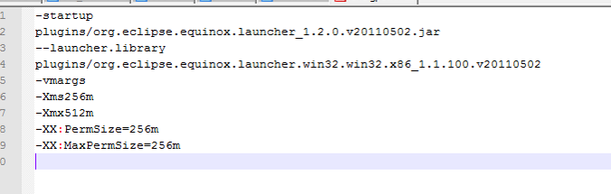
Проверяю как теперь работает:
При открытии очередной формы (около 20), возникла ошибка:
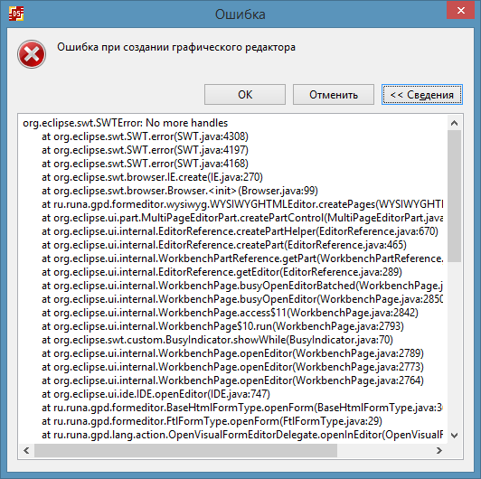
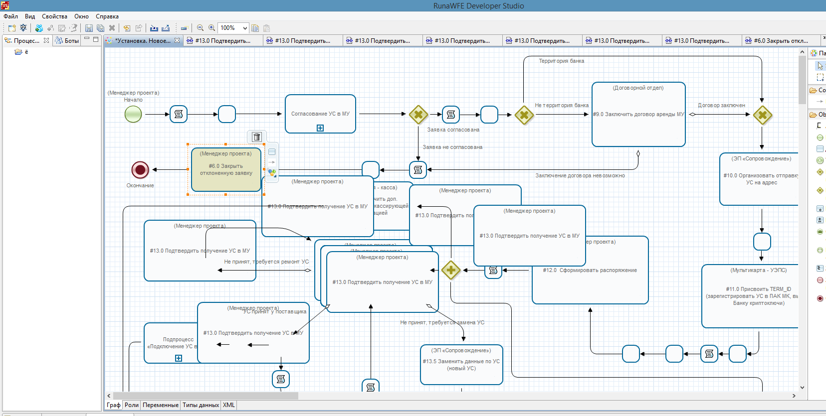
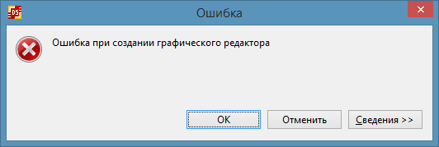

Дизайн формы не работает
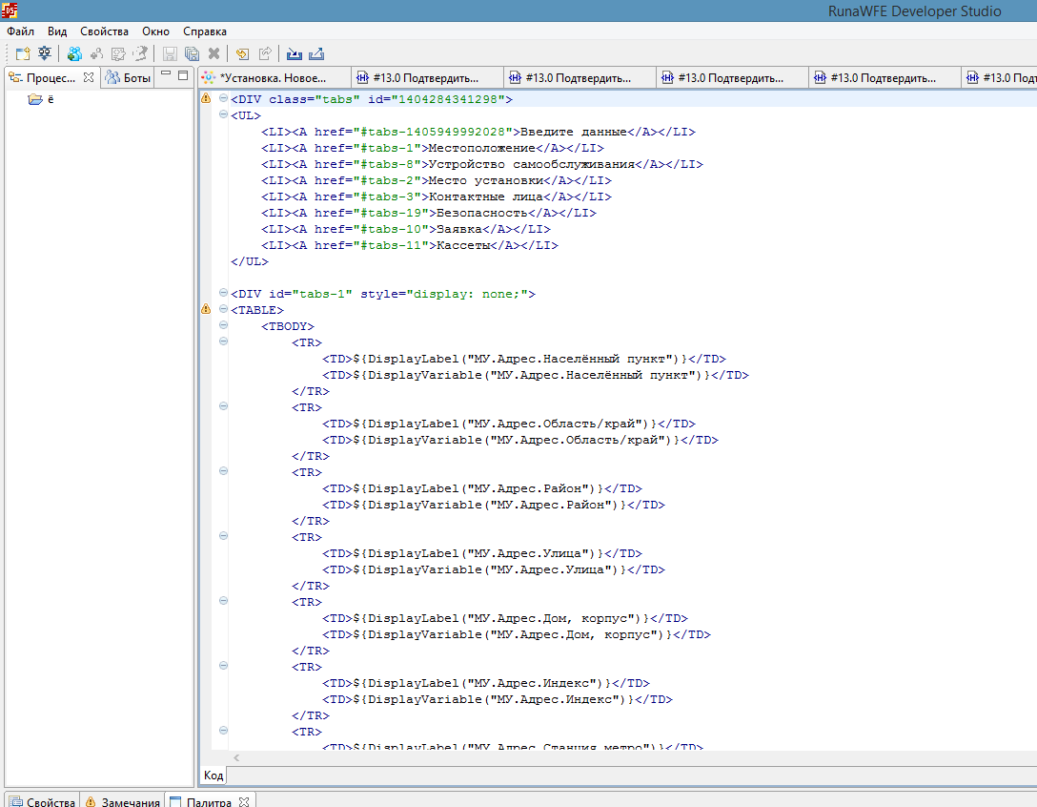

!ENTRY ru.runa.gpd 4 0 2015-02-04 23:21:32.385
!MESSAGE Ошибка при создании графического редактора
!STACK 0
org.eclipse.swt.SWTError: No more handles
at org.eclipse.swt.SWT.error(SWT.java:4308)
at org.eclipse.swt.SWT.error(SWT.java:4197)
at org.eclipse.swt.SWT.error(SWT.java:4168)
at org.eclipse.swt.browser.IE.create(IE.java:270)
at org.eclipse.swt.browser.Browser.<init>(Browser.java:99)
at ru.runa.gpd.formeditor.wysiwyg.WYSIWYGHTMLEditor.createPages(WYSIWYGHTMLEditor.java:229)
at org.eclipse.ui.part.MultiPageEditorPart.createPartControl(MultiPageEditorPart.java:348)
at org.eclipse.ui.internal.EditorReference.createPartHelper(EditorReference.java:670)
at org.eclipse.ui.internal.EditorReference.createPart(EditorReference.java:465)
at org.eclipse.ui.internal.WorkbenchPartReference.getPart(WorkbenchPartReference.java:595)
at org.eclipse.ui.internal.EditorReference.getEditor(EditorReference.java:289)
at org.eclipse.ui.internal.WorkbenchPage.busyOpenEditorBatched(WorkbenchPage.java:2945)
at org.eclipse.ui.internal.WorkbenchPage.busyOpenEditor(WorkbenchPage.java:2850)
at org.eclipse.ui.internal.WorkbenchPage.access$11(WorkbenchPage.java:2842)
at org.eclipse.ui.internal.WorkbenchPage$10.run(WorkbenchPage.java:2793)
at org.eclipse.swt.custom.BusyIndicator.showWhile(BusyIndicator.java:70)
at org.eclipse.ui.internal.WorkbenchPage.openEditor(WorkbenchPage.java:2789)
at org.eclipse.ui.internal.WorkbenchPage.openEditor(WorkbenchPage.java:2773)
at org.eclipse.ui.internal.WorkbenchPage.openEditor(WorkbenchPage.java:2764)
at org.eclipse.ui.ide.IDE.openEditor(IDE.java:747)
at ru.runa.gpd.formeditor.BaseHtmlFormType.openForm(BaseHtmlFormType.java:36)
at ru.runa.gpd.formeditor.FtlFormType.openForm(FtlFormType.java:29)
at ru.runa.gpd.lang.action.OpenVisualFormEditorDelegate.openInEditor(OpenVisualFormEditorDelegate.java:14)
at ru.runa.gpd.lang.action.OpenFormEditorDelegate.run(OpenFormEditorDelegate.java:18)
at org.eclipse.ui.internal.PluginAction.runWithEvent(PluginAction.java:251)
at org.eclipse.jface.action.ActionContributionItem.handleWidgetSelection(ActionContributionItem.java:584)
at org.eclipse.jface.action.ActionContributionItem.access$2(ActionContributionItem.java:501)
at org.eclipse.jface.action.ActionContributionItem$5.handleEvent(ActionContributionItem.java:411)
at org.eclipse.swt.widgets.EventTable.sendEvent(EventTable.java:84)
at org.eclipse.swt.widgets.Widget.sendEvent(Widget.java:1053)
at org.eclipse.swt.widgets.Display.runDeferredEvents(Display.java:4165)
at org.eclipse.swt.widgets.Display.readAndDispatch(Display.java:3754)
at org.eclipse.ui.internal.Workbench.runEventLoop(Workbench.java:2701)
at org.eclipse.ui.internal.Workbench.runUI(Workbench.java:2665)
at org.eclipse.ui.internal.Workbench.access$4(Workbench.java:2499)
at org.eclipse.ui.internal.Workbench$7.run(Workbench.java:679)
at org.eclipse.core.databinding.observable.Realm.runWithDefault(Realm.java:332)
at org.eclipse.ui.internal.Workbench.createAndRunWorkbench(Workbench.java:668)
at org.eclipse.ui.PlatformUI.createAndRunWorkbench(PlatformUI.java:149)
at ru.runa.gpd.Application.start(Application.java:19)
at org.eclipse.equinox.internal.app.EclipseAppHandle.run(EclipseAppHandle.java:196)
at org.eclipse.core.runtime.internal.adaptor.EclipseAppLauncher.runApplication(EclipseAppLauncher.java:110)
at org.eclipse.core.runtime.internal.adaptor.EclipseAppLauncher.start(EclipseAppLauncher.java:79)
at org.eclipse.core.runtime.adaptor.EclipseStarter.run(EclipseStarter.java:344)
at org.eclipse.core.runtime.adaptor.EclipseStarter.run(EclipseStarter.java:179)
at sun.reflect.NativeMethodAccessorImpl.invoke0(Native Method)
at sun.reflect.NativeMethodAccessorImpl.invoke(Unknown Source)
at sun.reflect.DelegatingMethodAccessorImpl.invoke(Unknown Source)
at java.lang.reflect.Method.invoke(Unknown Source)
at org.eclipse.equinox.launcher.Main.invokeFramework(Main.java:622)
at org.eclipse.equinox.launcher.Main.basicRun(Main.java:577)
at org.eclipse.equinox.launcher.Main.run(Main.java:1410)
Более подробное описание возможных настроек для избавления от проблем
http://runawfe.org/rus/doc/Troubleshooting#DeveloperStudioJVMSettings

Если вылезает ошибка SWTError: No more handles - значит недостаточно области Native (управляется опосредованно: используется максимум, выделяемый ОС - Heap - Permanent).
Если вылезает OutOfMemoryError: Java heap space - то недостаточно области Heap (управляется параметрами -Xms, -Xmx).
Если вылезает OutOfMemoryError: PermGen space - то недостаточно области Permanent (управляется параметрами -XX:PermSize, -XX:MaxPermSize).

