Номер – tst33
Название - внеплановое тестирование “Проверка корректности переноса графической истории в 4.х версию”

“…Проверьте, пожалуйста, корректность переноса графической истории в 4.х версию. В репозиторий это пока не загружено (добавим уже в 4.1, после выпуска 4.0)…”

- Простой линейный процесс, проверка правильности отображения графа истории выполнения экземпляра процесса

Создаем простой процесс вида:

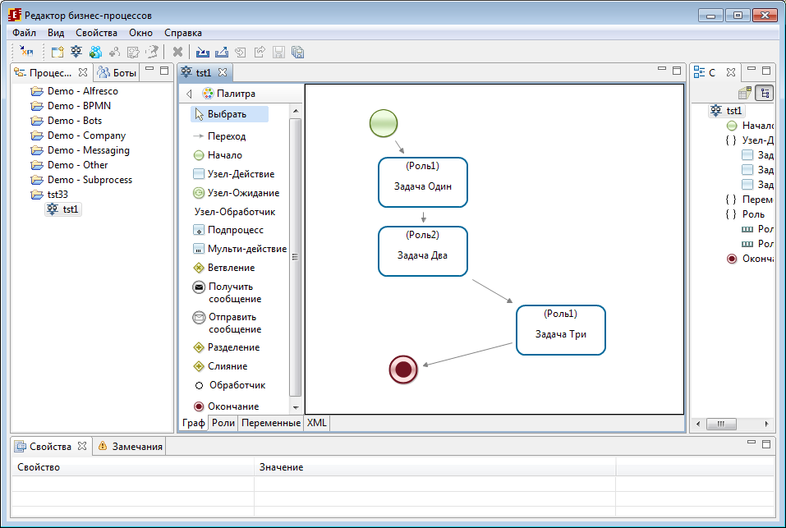

Выполянем поочередно в 3.6/4.x, сравниваем граф истории:

Выполняем в 3.6:

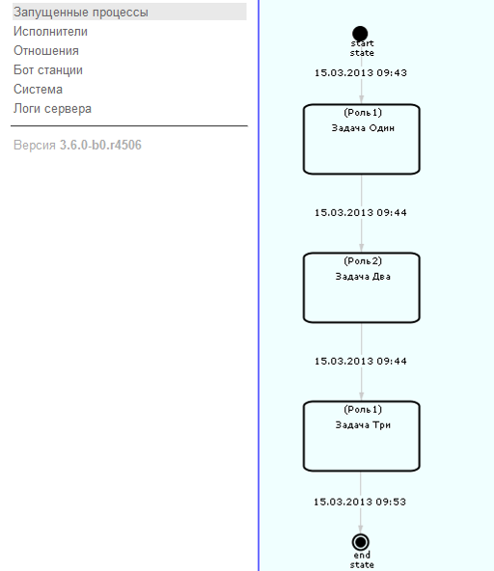

Выполняем этот же процесс в 4.x:

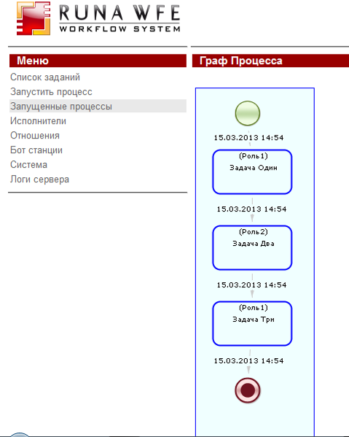

Результат: Все правильно отображается, названия, время

- Добавить в процесс ветвления, при выполнении несколько раз ходить по одним и тем же задачам, проверить отображается ли это в истории выполнения

В 3.6 имеем:

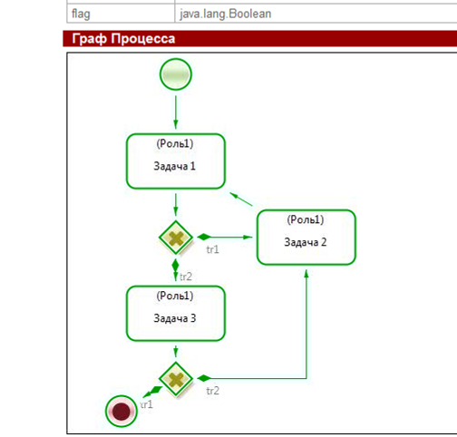

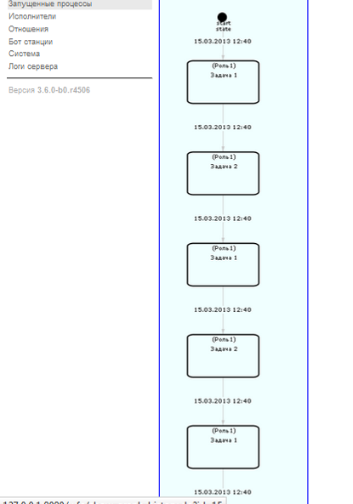

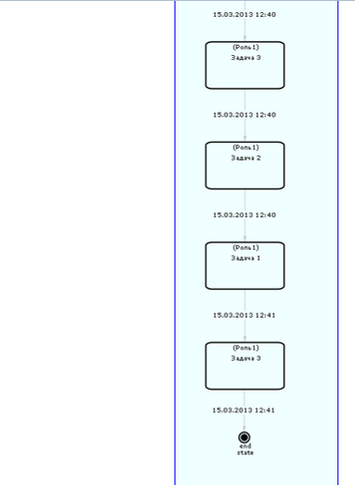

В 4.x имеем:

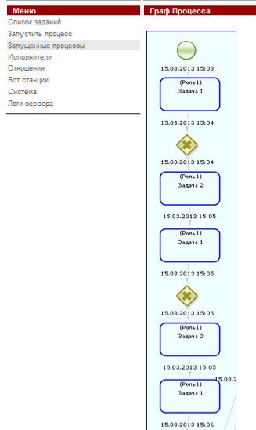

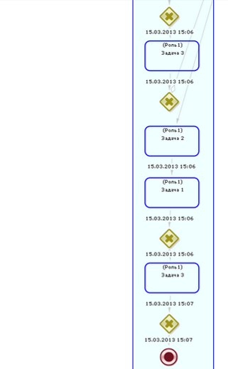

Результат: Граф сформировался правильно, добавились ветвления, время указано верно, но в одном из узлов текст с временем не вместился в граф.

- Проверка истории на процессе с подпроцессами

В 3.6 имели при выполнении:

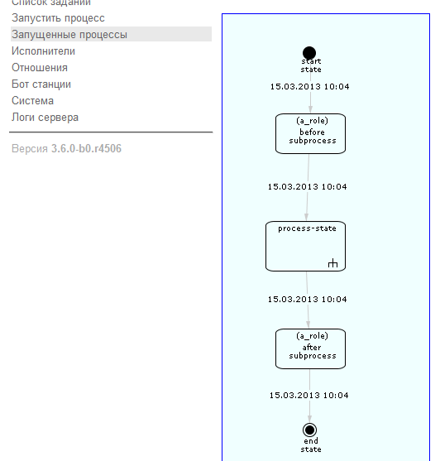

При этом по нажатию на подпроцесс, осуществляется переход на его экземпляр:

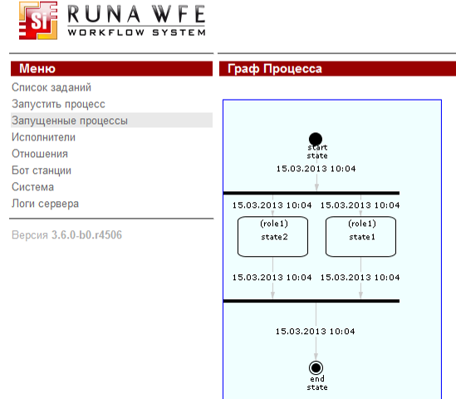
В 4.x имеем:

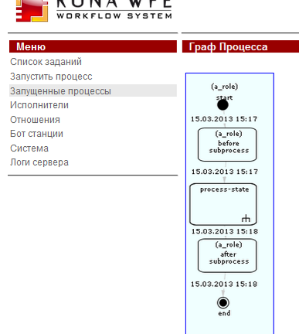

При наведении на узел с подпроцессом, нет ссылки для перехода на данный экземпляр

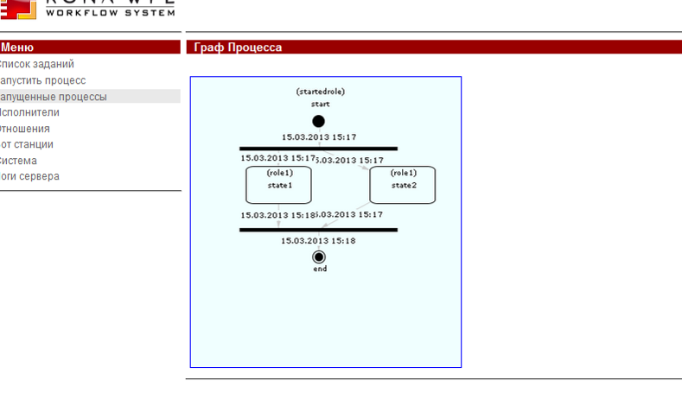
Метки времени наезжают друг на друга

Результат: Есть баги

- Проверить на процессах с мультидействиями

В 3.6 запустили процесс с мультидействиями:

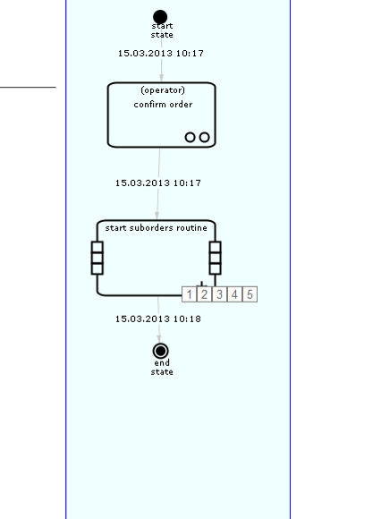
При этом есть возможность перейти на каждое мультидействие из данного графа
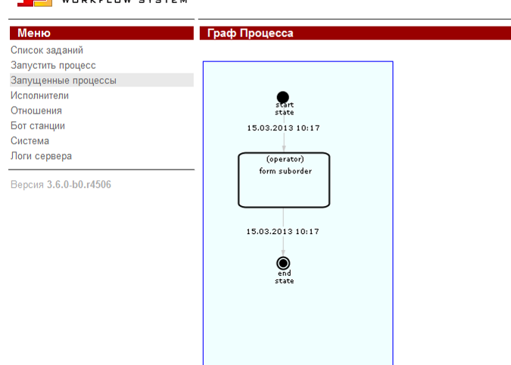

В 4.x имеем:

При попытке выполнить процесс MultiinstanceProcess получил exception:

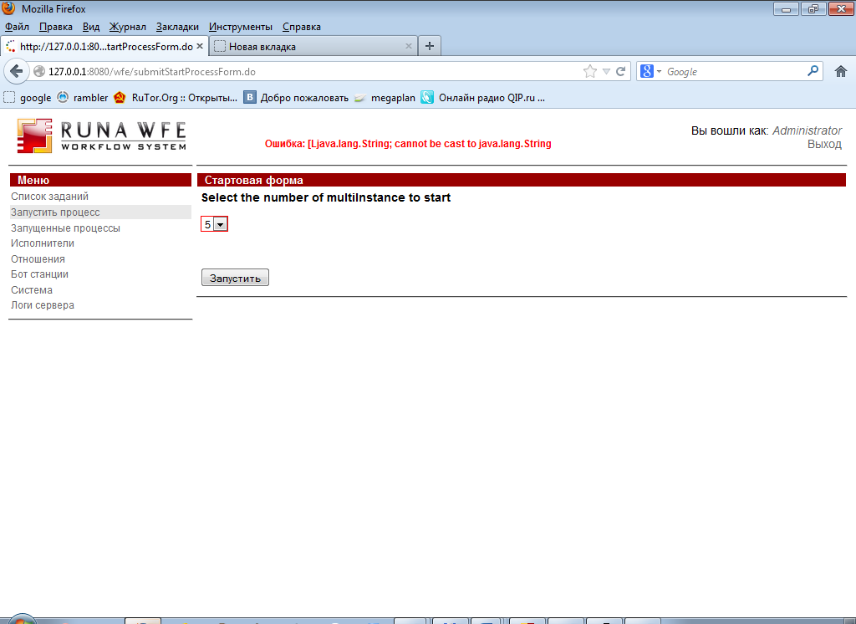

В логах:

2013-03-15 15:31:31,560 DEBUG [org.springframework.orm.hibernate3.SessionFactoryUtils] Closing Hibernate Session
2013-03-15 15:31:31,561 ERROR [ru.runa.wfe.service.interceptors.EjbExceptionSupport] ejb call
java.lang.ClassCastException: [Ljava.lang.String; cannot be cast to java.lang.String
at ru.runa.wfe.var.impl.StringVariable.setStorableValue(StringVariable.java:30)
at ru.runa.wfe.var.Variable.setValue(Variable.java:190)
at ru.runa.wfe.execution.ExecutionContext.setVariable(ExecutionContext.java:186)
at ru.runa.wfe.execution.ExecutionContext.setVariables(ExecutionContext.java:196)
at ru.runa.wfe.extension.handler.GroovyActionHandler.execute(GroovyActionHandler.java:29)
at ru.runa.wfe.lang.Action.execute(Action.java:68)
at ru.runa.wfe.lang.GraphElement.executeActions(GraphElement.java:149)
at ru.runa.wfe.lang.GraphElement.fireEvent(GraphElement.java:138)
at ru.runa.wfe.task.TaskFactory.create(TaskFactory.java:52)
at ru.runa.wfe.lang.TaskNode.execute(TaskNode.java:60)
at ru.runa.wfe.lang.Node.enter(Node.java:153)
at ru.runa.wfe.lang.Transition.take(Transition.java:85)
at ru.runa.wfe.lang.Node.leave(Node.java:185)
at ru.runa.wfe.execution.ProcessFactory.startProcessInternal(ProcessFactory.java:164)
at ru.runa.wfe.execution.ProcessFactory.startProcess(ProcessFactory.java:76)
at ru.runa.wfe.execution.logic.ExecutionLogic.startProcess(ExecutionLogic.java:139)
at ru.runa.wfe.service.impl.ExecutionServiceBean.startProcess(ExecutionServiceBean.java:83)
at sun.reflect.NativeMethodAccessorImpl.invoke0(Native Method)
at sun.reflect.NativeMethodAccessorImpl.invoke(NativeMethodAccessorImpl.java:39)
at sun.reflect.DelegatingMethodAccessorImpl.invoke(DelegatingMethodAccessorImpl.java:25)
at java.lang.reflect.Method.invoke(Method.java:597)
at org.jboss.aop.joinpoint.MethodInvocation.invokeNext(MethodInvocation.java:112)
at org.jboss.ejb3.interceptor.InvocationContextImpl.proceed(InvocationContextImpl.java:166)
at ru.runa.wfe.service.interceptors.EjbTransactionSupport.invokeWithRetry(EjbTransactionSupport.java:100)
at ru.runa.wfe.service.interceptors.EjbTransactionSupport.process(EjbTransactionSupport.java:49)
at sun.reflect.GeneratedMethodAccessor165.invoke(Unknown Source)
at sun.reflect.DelegatingMethodAccessorImpl.invoke(DelegatingMethodAccessorImpl.java:25)
at java.lang.reflect.Method.invoke(Method.java:597)
at org.jboss.ejb3.interceptor.InvocationContextImpl.proceed(InvocationContextImpl.java:118)
at ru.runa.wfe.service.interceptors.EjbExceptionSupport.process(EjbExceptionSupport.java:27)
at sun.reflect.GeneratedMethodAccessor163.invoke(Unknown Source)
at sun.reflect.DelegatingMethodAccessorImpl.invoke(DelegatingMethodAccessorImpl.java:25)
at java.lang.reflect.Method.invoke(Method.java:597)
at org.jboss.ejb3.interceptor.InvocationContextImpl.proceed(InvocationContextImpl.java:118)
at org.jboss.ejb3.interceptor.EJB3InterceptorsInterceptor.invoke(EJB3InterceptorsInterceptor.java:63)
at org.jboss.aop.joinpoint.MethodInvocation.invokeNext(MethodInvocation.java:101)
at org.jboss.ejb3.entity.TransactionScopedEntityManagerInterceptor.invoke

(TransactionScopedEntityManagerInterceptor.java:54)
at org.jboss.aop.joinpoint.MethodInvocation.invokeNext(MethodInvocation.java:101)
at org.jboss.ejb3.AllowedOperationsInterceptor.invoke(AllowedOperationsInterceptor.java:47)
at org.jboss.aop.joinpoint.MethodInvocation.invokeNext(MethodInvocation.java:101)
at org.jboss.ejb3.tx.BMTInterceptor.handleStateless(BMTInterceptor.java:71)
at org.jboss.ejb3.tx.BMTInterceptor.invoke(BMTInterceptor.java:131)
at org.jboss.aop.joinpoint.MethodInvocation.invokeNext(MethodInvocation.java:101)
at org.jboss.aspects.tx.TxPropagationInterceptor.invoke(TxPropagationInterceptor.java:95)
at org.jboss.aop.joinpoint.MethodInvocation.invokeNext(MethodInvocation.java:101)
at org.jboss.ejb3.stateless.StatelessInstanceInterceptor.invoke(StatelessInstanceInterceptor.java:62)
at org.jboss.aop.joinpoint.MethodInvocation.invokeNext(MethodInvocation.java:101)
at org.jboss.aspects.security.AuthenticationInterceptor.invoke(AuthenticationInterceptor.java:77)
at org.jboss.ejb3.security.Ejb3AuthenticationInterceptor.invoke(Ejb3AuthenticationInterceptor.java:110)
at org.jboss.aop.joinpoint.MethodInvocation.invokeNext(MethodInvocation.java:101)
at org.jboss.ejb3.ENCPropagationInterceptor.invoke(ENCPropagationInterceptor.java:46)
at org.jboss.aop.joinpoint.MethodInvocation.invokeNext(MethodInvocation.java:101)
at org.jboss.ejb3.asynchronous.AsynchronousInterceptor.invoke(AsynchronousInterceptor.java:106)
at org.jboss.aop.joinpoint.MethodInvocation.invokeNext(MethodInvocation.java:101)
at org.jboss.ejb3.stateless.StatelessContainer.dynamicInvoke(StatelessContainer.java:304)
at org.jboss.ejb3.remoting.IsLocalInterceptor.invokeLocal(IsLocalInterceptor.java:81)
at org.jboss.ejb3.remoting.IsLocalInterceptor.invoke(IsLocalInterceptor.java:72)
at org.jboss.aop.joinpoint.MethodInvocation.invokeNext(MethodInvocation.java:101)
at org.jboss.ejb3.stateless.StatelessRemoteProxy.invoke(StatelessRemoteProxy.java:107)
at $Proxy212.startProcess(Unknown Source)
at ru.runa.wfe.service.delegate.ExecutionServiceDelegate.startProcess(ExecutionServiceDelegate.java:53)
at ru.runa.wf.web.action.SubmitStartProcessFormAction.executeProcessFromAction

(SubmitStartProcessFormAction.java:69)
at ru.runa.wf.web.action.BaseProcessFormAction.execute(BaseProcessFormAction.java:55)
at org.apache.struts.action.RequestProcessor.processActionPerform(RequestProcessor.java:425)
at org.apache.struts.action.RequestProcessor.process(RequestProcessor.java:228)
at ru.runa.common.web.UTF8RequestProcessor.process(UTF8RequestProcessor.java:41)
at org.apache.struts.action.ActionServlet.process(ActionServlet.java:1913)
at org.apache.struts.action.ActionServlet.doPost(ActionServlet.java:462)
at javax.servlet.http.HttpServlet.service(HttpServlet.java:710)
at javax.servlet.http.HttpServlet.service(HttpServlet.java:803)
at org.apache.catalina.core.ApplicationFilterChain.internalDoFilter(ApplicationFilterChain.java:290)
at org.apache.catalina.core.ApplicationFilterChain.doFilter(ApplicationFilterChain.java:206)
at ru.runa.common.web.filter.HTTPSessionFilter.doFilter(HTTPSessionFilter.java:50)
at ru.runa.common.web.filter.HTTPFilterBase.doFilter(HTTPFilterBase.java:50)
at org.apache.catalina.core.ApplicationFilterChain.internalDoFilter(ApplicationFilterChain.java:235)
at org.apache.catalina.core.ApplicationFilterChain.doFilter(ApplicationFilterChain.java:206)
at ru.runa.af.web.filter.NTLMFilter.doFilter(NTLMFilter.java:54)
at ru.runa.common.web.filter.HTTPFilterBase.doFilter(HTTPFilterBase.java:50)
at org.apache.catalina.core.ApplicationFilterChain.internalDoFilter(ApplicationFilterChain.java:235)
at org.apache.catalina.core.ApplicationFilterChain.doFilter(ApplicationFilterChain.java:206)
at org.jboss.web.tomcat.filters.ReplyHeaderFilter.doFilter(ReplyHeaderFilter.java:96)
at org.apache.catalina.core.ApplicationFilterChain.internalDoFilter(ApplicationFilterChain.java:235)
at org.apache.catalina.core.ApplicationFilterChain.doFilter(ApplicationFilterChain.java:206)
at org.apache.catalina.core.StandardWrapperValve.invoke(StandardWrapperValve.java:230)
at org.apache.catalina.core.StandardContextValve.invoke(StandardContextValve.java:175)
at org.jboss.web.tomcat.security.SecurityAssociationValve.invoke(SecurityAssociationValve.java:182)
at org.jboss.web.tomcat.security.JaccContextValve.invoke(JaccContextValve.java:84)
at org.apache.catalina.core.StandardHostValve.invoke(StandardHostValve.java:127)
at org.apache.catalina.valves.ErrorReportValve.invoke(ErrorReportValve.java:102)
at org.jboss.web.tomcat.service.jca.CachedConnectionValve.invoke(CachedConnectionValve.java:157)
at org.apache.catalina.core.StandardEngineValve.invoke(StandardEngineValve.java:109)
at org.apache.catalina.connector.CoyoteAdapter.service(CoyoteAdapter.java:262)
at org.apache.coyote.http11.Http11Processor.process(Http11Processor.java:844)
at org.apache.coyote.http11.Http11Protocol$Http11ConnectionHandler.process(Http11Protocol.java:583)
at org.apache.tomcat.util.net.JIoEndpoint$Worker.run(JIoEndpoint.java:446)
at java.lang.Thread.run(Thread.java:662)
2013-03-15 15:31:31,570 DEBUG [ru.runa.common.web.ActionExceptionHelper] action exception
java.lang.ClassCastException: [Ljava.lang.String; cannot be cast to java.lang.String
at ru.runa.wfe.var.impl.StringVariable.setStorableValue(StringVariable.java:30)
at ru.runa.wfe.var.Variable.setValue(Variable.java:190)
at ru.runa.wfe.execution.ExecutionContext.setVariable(ExecutionContext.java:186)
at ru.runa.wfe.execution.ExecutionContext.setVariables(ExecutionContext.java:196)
at ru.runa.wfe.extension.handler.GroovyActionHandler.execute(GroovyActionHandler.java:29)
at ru.runa.wfe.lang.Action.execute(Action.java:68)
at ru.runa.wfe.lang.GraphElement.executeActions(GraphElement.java:149)
at ru.runa.wfe.lang.GraphElement.fireEvent(GraphElement.java:138)
at ru.runa.wfe.task.TaskFactory.create(TaskFactory.java:52)
at ru.runa.wfe.lang.TaskNode.execute(TaskNode.java:60)
at ru.runa.wfe.lang.Node.enter(Node.java:153)
at ru.runa.wfe.lang.Transition.take(Transition.java:85)
at ru.runa.wfe.lang.Node.leave(Node.java:185)
at ru.runa.wfe.execution.ProcessFactory.startProcessInternal(ProcessFactory.java:164)
at ru.runa.wfe.execution.ProcessFactory.startProcess(ProcessFactory.java:76)
at ru.runa.wfe.execution.logic.ExecutionLogic.startProcess(ExecutionLogic.java:139)
at ru.runa.wfe.service.impl.ExecutionServiceBean.startProcess(ExecutionServiceBean.java:83)
at sun.reflect.NativeMethodAccessorImpl.invoke0(Native Method)
at sun.reflect.NativeMethodAccessorImpl.invoke(NativeMethodAccessorImpl.java:39)
at sun.reflect.DelegatingMethodAccessorImpl.invoke(DelegatingMethodAccessorImpl.java:25)
at java.lang.reflect.Method.invoke(Method.java:597)
at org.jboss.aop.joinpoint.MethodInvocation.invokeNext(MethodInvocation.java:112)
at org.jboss.ejb3.interceptor.InvocationContextImpl.proceed(InvocationContextImpl.java:166)
at ru.runa.wfe.service.interceptors.EjbTransactionSupport.invokeWithRetry(EjbTransactionSupport.java:100)
at ru.runa.wfe.service.interceptors.EjbTransactionSupport.process(EjbTransactionSupport.java:49)
at sun.reflect.GeneratedMethodAccessor165.invoke(Unknown Source)
at sun.reflect.DelegatingMethodAccessorImpl.invoke(DelegatingMethodAccessorImpl.java:25)
at java.lang.reflect.Method.invoke(Method.java:597)
at org.jboss.ejb3.interceptor.InvocationContextImpl.proceed(InvocationContextImpl.java:118)
at ru.runa.wfe.service.interceptors.EjbExceptionSupport.process(EjbExceptionSupport.java:27)
at sun.reflect.GeneratedMethodAccessor163.invoke(Unknown Source)
at sun.reflect.DelegatingMethodAccessorImpl.invoke(DelegatingMethodAccessorImpl.java:25)
at java.lang.reflect.Method.invoke(Method.java:597)
at org.jboss.ejb3.interceptor.InvocationContextImpl.proceed(InvocationContextImpl.java:118)
at org.jboss.ejb3.interceptor.EJB3InterceptorsInterceptor.invoke(EJB3InterceptorsInterceptor.java:63)
at org.jboss.aop.joinpoint.MethodInvocation.invokeNext(MethodInvocation.java:101)
at org.jboss.ejb3.entity.TransactionScopedEntityManagerInterceptor.invoke

(TransactionScopedEntityManagerInterceptor.java:54)
at org.jboss.aop.joinpoint.MethodInvocation.invokeNext(MethodInvocation.java:101)
at org.jboss.ejb3.AllowedOperationsInterceptor.invoke(AllowedOperationsInterceptor.java:47)
at org.jboss.aop.joinpoint.MethodInvocation.invokeNext(MethodInvocation.java:101)
at org.jboss.ejb3.tx.BMTInterceptor.handleStateless(BMTInterceptor.java:71)
at org.jboss.ejb3.tx.BMTInterceptor.invoke(BMTInterceptor.java:131)
at org.jboss.aop.joinpoint.MethodInvocation.invokeNext(MethodInvocation.java:101)
at org.jboss.aspects.tx.TxPropagationInterceptor.invoke(TxPropagationInterceptor.java:95)
at org.jboss.aop.joinpoint.MethodInvocation.invokeNext(MethodInvocation.java:101)
at org.jboss.ejb3.stateless.StatelessInstanceInterceptor.invoke(StatelessInstanceInterceptor.java:62)
at org.jboss.aop.joinpoint.MethodInvocation.invokeNext(MethodInvocation.java:101)
at org.jboss.aspects.security.AuthenticationInterceptor.invoke(AuthenticationInterceptor.java:77)
at org.jboss.ejb3.security.Ejb3AuthenticationInterceptor.invoke(Ejb3AuthenticationInterceptor.java:110)
at org.jboss.aop.joinpoint.MethodInvocation.invokeNext(MethodInvocation.java:101)
at org.jboss.ejb3.ENCPropagationInterceptor.invoke(ENCPropagationInterceptor.java:46)
at org.jboss.aop.joinpoint.MethodInvocation.invokeNext(MethodInvocation.java:101)
at org.jboss.ejb3.asynchronous.AsynchronousInterceptor.invoke(AsynchronousInterceptor.java:106)
at org.jboss.aop.joinpoint.MethodInvocation.invokeNext(MethodInvocation.java:101)
at org.jboss.ejb3.stateless.StatelessContainer.dynamicInvoke(StatelessContainer.java:304)
at org.jboss.ejb3.remoting.IsLocalInterceptor.invokeLocal(IsLocalInterceptor.java:81)
at org.jboss.ejb3.remoting.IsLocalInterceptor.invoke(IsLocalInterceptor.java:72)
at org.jboss.aop.joinpoint.MethodInvocation.invokeNext(MethodInvocation.java:101)
at org.jboss.ejb3.stateless.StatelessRemoteProxy.invoke(StatelessRemoteProxy.java:107)
at $Proxy212.startProcess(Unknown Source)
at ru.runa.wfe.service.delegate.ExecutionServiceDelegate.startProcess(ExecutionServiceDelegate.java:53)
at ru.runa.wf.web.action.SubmitStartProcessFormAction.executeProcessFromAction

(SubmitStartProcessFormAction.java:69)
at ru.runa.wf.web.action.BaseProcessFormAction.execute(BaseProcessFormAction.java:55)
at org.apache.struts.action.RequestProcessor.processActionPerform(RequestProcessor.java:425)
at org.apache.struts.action.RequestProcessor.process(RequestProcessor.java:228)
at ru.runa.common.web.UTF8RequestProcessor.process(UTF8RequestProcessor.java:41)
at org.apache.struts.action.ActionServlet.process(ActionServlet.java:1913)
at org.apache.struts.action.ActionServlet.doPost(ActionServlet.java:462)
at javax.servlet.http.HttpServlet.service(HttpServlet.java:710)
at javax.servlet.http.HttpServlet.service(HttpServlet.java:803)
at org.apache.catalina.core.ApplicationFilterChain.internalDoFilter(ApplicationFilterChain.java:290)
at org.apache.catalina.core.ApplicationFilterChain.doFilter(ApplicationFilterChain.java:206)
at ru.runa.common.web.filter.HTTPSessionFilter.doFilter(HTTPSessionFilter.java:50)
at ru.runa.common.web.filter.HTTPFilterBase.doFilter(HTTPFilterBase.java:50)
at org.apache.catalina.core.ApplicationFilterChain.internalDoFilter(ApplicationFilterChain.java:235)
at org.apache.catalina.core.ApplicationFilterChain.doFilter(ApplicationFilterChain.java:206)
at ru.runa.af.web.filter.NTLMFilter.doFilter(NTLMFilter.java:54)
at ru.runa.common.web.filter.HTTPFilterBase.doFilter(HTTPFilterBase.java:50)
at org.apache.catalina.core.ApplicationFilterChain.internalDoFilter(ApplicationFilterChain.java:235)
at org.apache.catalina.core.ApplicationFilterChain.doFilter(ApplicationFilterChain.java:206)
at org.jboss.web.tomcat.filters.ReplyHeaderFilter.doFilter(ReplyHeaderFilter.java:96)
at org.apache.catalina.core.ApplicationFilterChain.internalDoFilter(ApplicationFilterChain.java:235)
at org.apache.catalina.core.ApplicationFilterChain.doFilter(ApplicationFilterChain.java:206)
at org.apache.catalina.core.StandardWrapperValve.invoke(StandardWrapperValve.java:230)
at org.apache.catalina.core.StandardContextValve.invoke(StandardContextValve.java:175)
at org.jboss.web.tomcat.security.SecurityAssociationValve.invoke(SecurityAssociationValve.java:182)
at org.jboss.web.tomcat.security.JaccContextValve.invoke(JaccContextValve.java:84)
at org.apache.catalina.core.StandardHostValve.invoke(StandardHostValve.java:127)
at org.apache.catalina.valves.ErrorReportValve.invoke(ErrorReportValve.java:102)
at org.jboss.web.tomcat.service.jca.CachedConnectionValve.invoke(CachedConnectionValve.java:157)
at org.apache.catalina.core.StandardEngineValve.invoke(StandardEngineValve.java:109)
at org.apache.catalina.connector.CoyoteAdapter.service(CoyoteAdapter.java:262)
at org.apache.coyote.http11.Http11Processor.process(Http11Processor.java:844)
at org.apache.coyote.http11.Http11Protocol$Http11ConnectionHandler.process(Http11Protocol.java:583)
at org.apache.tomcat.util.net.JIoEndpoint$Worker.run(JIoEndpoint.java:446)
at java.lang.Thread.run(Thread.java:662)
2013-03-15 15:31:31,576 DEBUG [org.jboss.ejb3.tx.UserTransactionImpl] new UserTx:

org.jboss.ejb3.tx.UserTransactionImpl@189bbd9
2013-03-15 15:31:31,576 DEBUG [org.jboss.ejb3.tx.UserTransactionImpl] UserTx begin: TransactionImple < ac, BasicAction: -

56011544:ccd9:5143168e:c9d status: ActionStatus.RUNNING >
2013-03-15 15:31:31,577 INFO [STDOUT] === ru.runa.wfe.service.impl.DefinitionServiceBean.getStartInteraction(Actor{id=1,

name=Administrator, code=-1}, 17)

- В 3.6 при наведении на задания, показывалась информация вида:

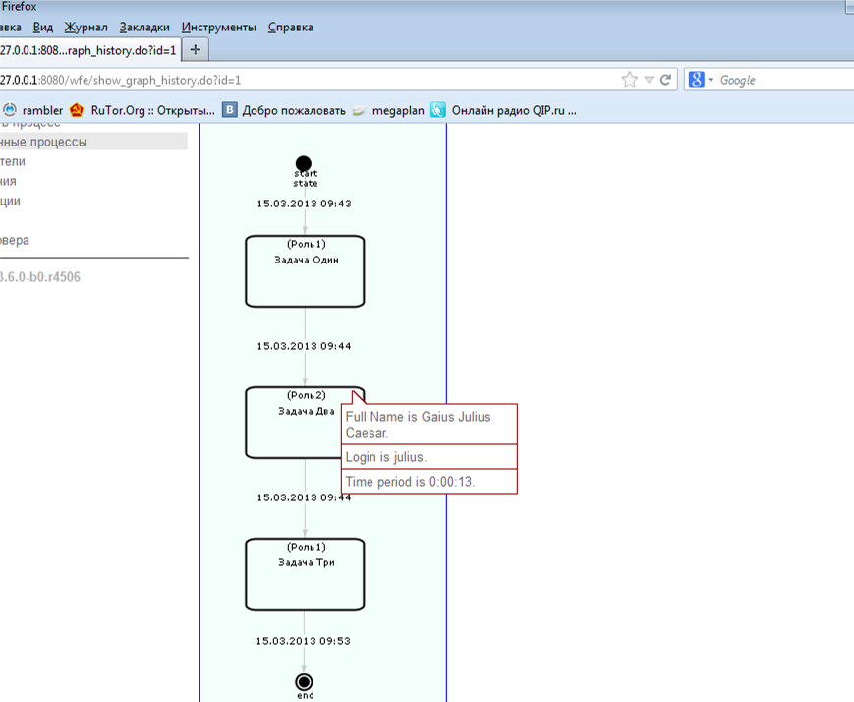

Если наводили на задачу подпроцесс, то выскакивает SubProcess:

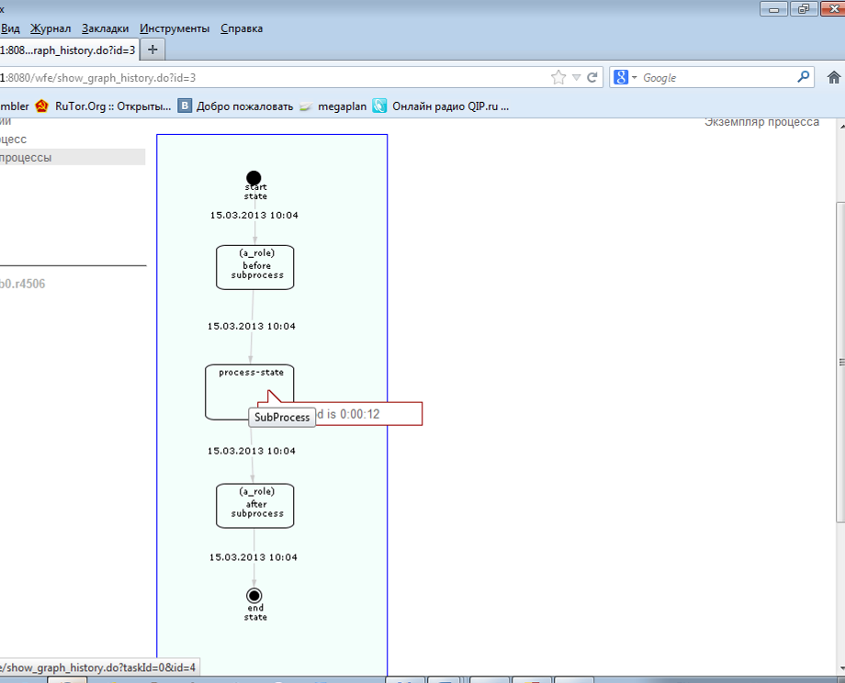

В 4.x есть проблемы:

5.1 “Задача Два” выполнялась Julius, при этом по наведению на данный узел выводится Administrator

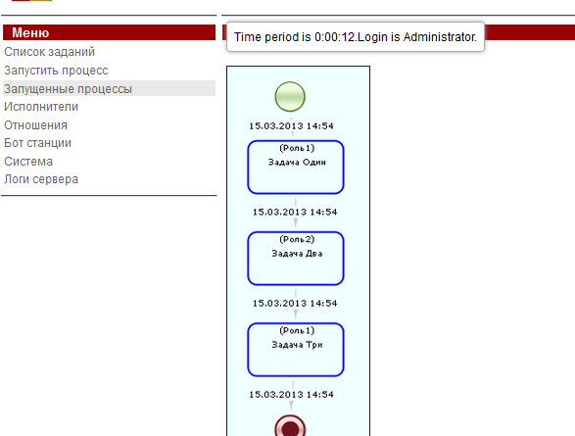

5.2 На графах с длинной цепочкой всплывающая подсказка показывается где-то внизу, и ее не видно

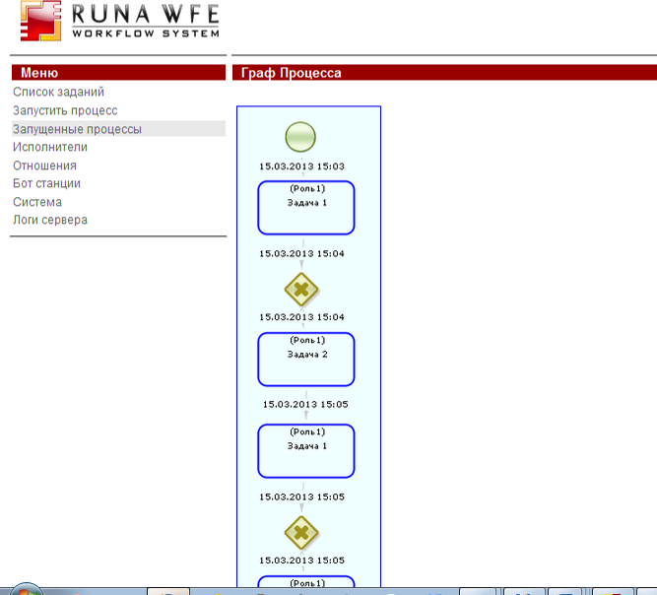

5.3 Нет иформации о подпроцессе по наведению на узел, выводится только timeperiod:

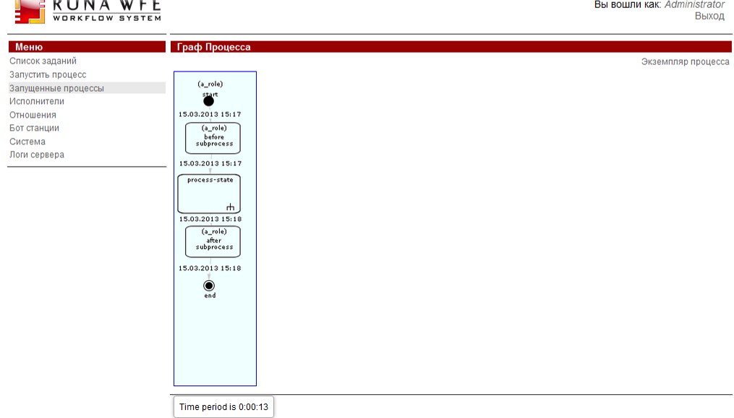

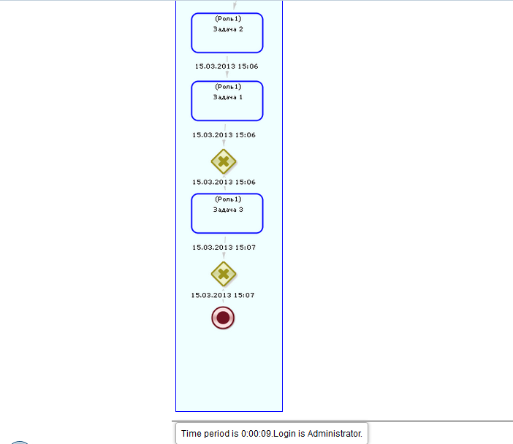

5.4 Отсутствует полное имя исполнителя в выводимой информации:

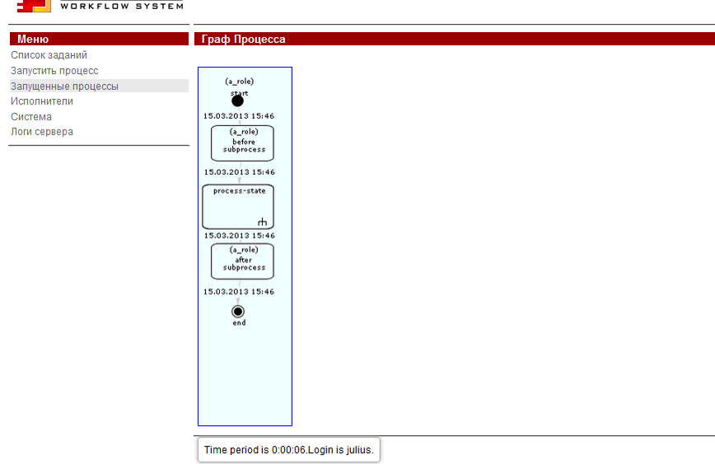

- Проверка графа истории на различных стандартных процессах:

Результат: Найдены те же проблемы, например процесс Overtime Work, стрелки за пределами графа:

