//I. Declaration Statement

//a.

int first;

//Leftmost -------------------------------------------------

begin => program_stmt

=>dec_stmt program_stmt

=>dtype VAR_ID dec_expprogram_stmt

=> INT VAR_ID dec_expprogram_stmt

=>int VAR_ID dec_expprogram_stmt

=>int first dec_expprogram_stmt

=>int first dec_exp2program_stmt

=>int first SEMIprogram_stmt

=>int first;program_stmt

=>int first; empty

=>int first;

//Rightmost -----------------------------------------------

begin => program_stmt

=>dec_stmt program_stmt

=>dec_stmt empty

=> dec_stmt

=>dtype VAR_ID dec_exp

=>dtype VAR_ID dec_exp2

=>dtype VAR_ID SEMI

=>dtype VAR_ID;

=>dtype first;

=> INT first;

=>int first;

**Parse Tree**

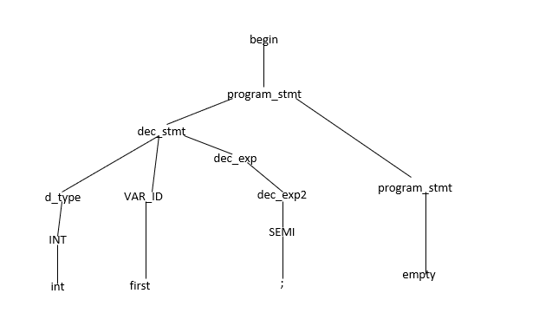

//b.

bool booexp = true;

//Leftmost -----------------------------------------------

start=> program_stmt

=>dec_stmt program_stmt

=>dtype VAR_ID dec_expprogram_stmt

=> BOOL VAR_ID dec_expprogram_stmt

=>boolVAR_ID dec_expprogram_stmt

=>bool booexp dec_expprogram_stmt

=>bool booexp EQUALS ass_argsprogram_stmt

=>bool booexp= ass_argsprogram_stmt

=>bool booexp= literal ass_args2program_stmt

=>bool booexp= bool_val ass_args2 program_stmt

=>bool booexp= TRUE ass_args2 program_stmt

=>bool booexp=true ass_args2 program_stmt

=>bool booexp=true SEMI program_stmt

=>bool booexp=true; program_stmt

=>bool booexp=true; empty

=>bool booexp=true;

//Rightmost ----------------------------------------------

start=>program_stmt

=>dec_stmt program_stmt

=>dec_stmt empty

=>dec_stmt

=>dtype VAR_ID dec_exp

=>dtype VAR_ID EQUALS ass_args

=>dtype VAR_ID EQUALS literal ass_args2

=>dtype VAR_ID EQUALS literal SEMI

=>dtype VAR_ID EQUALS literal ;

=>dtype VAR_ID EQUALS bool_val;

=>dtype VAR_ID EQUALS TRUE;

=>dtype VAR_ID EQUALS true;

=>dtypeVAR_ID=true;

=>dtype booexp = true;

=>BOOL_VAL booexp = true;

=>bool booexp = true;

**Parse Tree**

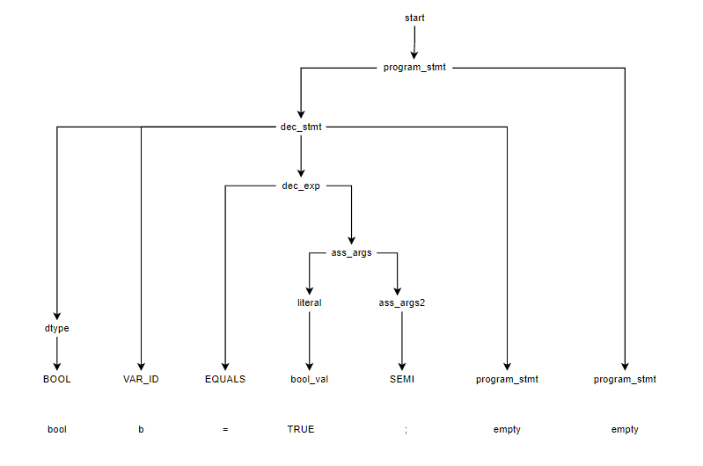

//II. Input Statement

//a.

input(variable);

//Leftmost ---------------------------------------------

start => program_stmt

=>input_stmt program_stmt

=>INPUT LPRN VAR_ID RPRN SEMIprogram_stmt

=>input LPRN VAR_ID RPRN SEMIprogram_stmt

=>input( VAR_ID RPRN SEMIprogram_stmt

=>input(variable RPRN SEMIprogram_stmt

=>input(variable) SEMIprogram_stmt

=>input(variable);program_stmt

=>input(variable); empty

=>input(variable);

//Rightmost --------------------------------------------

start=>program_stmt

=>input_stmt program_stmt

=>input_stmt empty

=>input_stmt

=>INPUT LPRN VAR_ID RPRN SEMI

=> INPUT LPRN VAR_ID RPRN ;

=> INPUT LPRN VAR_ID ) ;

=> INPUT LPRN variable) ;

=> INPUT (variable) ;

=>input (variable) ;

**Parse Tree**

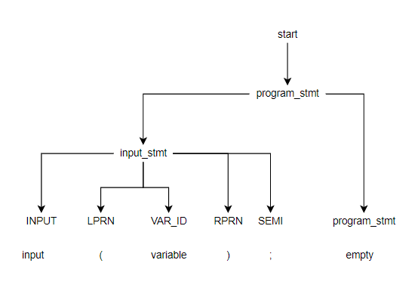

//III. Output Statement

//a.

output (“Hi”);

//Leftmost --------------------------------------------

start=>program_stmt

=>output_stmt program_stmt

=>OUTPUT LPRN output_exp RPRN SEMI program_stmt

=>output LPRN output_exp RPRN SEMI program_stmt

=>output( output_exp RPRN SEMI program_stmt

=>output( output_ext output_concat RPRN SEMI program_stmt

=>output( STR_VAL output_ext output_concat RPRN SEMI program_stmt

=>output(“Hi” output_ext output_concat RPRN SEMI program_stmt

=>output(“Hi” empty output_concat RPRN SEMI program_stmt

=>output(“Hi” empty RPRN SEMI program_stmt

=>output(“Hi”) SEMI program_stmt

=>output(“Hi”); program_stmt

=>output(“Hi”); empty

=>output(“Hi”);

//Rightmost -------------------------------------------

start=>program_stmt

=>output_stmtprogram_stmt

=>output_stmtempty

=>output_stmt

=>OUTPUT LPRN output_exp RPRN SEMI

=> OUTPUT LPRN output_exp RPRN ;

=> OUTPUT LPRN output_exp ) ;

=> OUTPUT LPRN output_ext output_concat ) ;

=> OUTPUT LPRN output_ext empty) ;

=> OUTPUT LPRN STR_VAL output_ext) ;

=> OUTPUT LPRN STR_VAL exmpty) ;

=> OUTPUT LPRN “Hi”) ;

=> OUTPUT (“Hi”) ;

=>output(“Hi”) ;

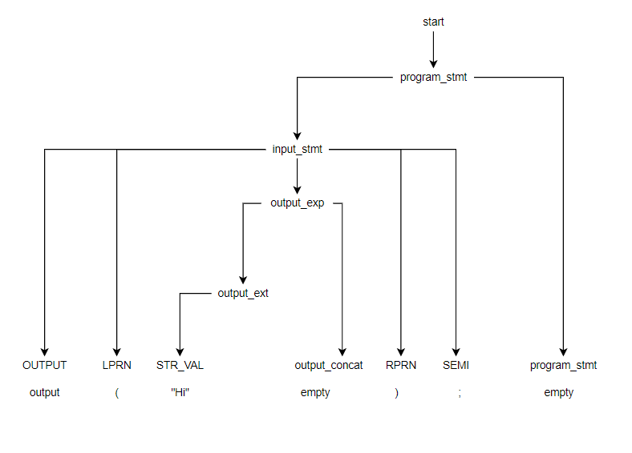**Parse Tree**

//b.

output(variable1);

//Leftmost --------------------------------------------

start=>program_stmt

=>output_stmt program_stmt

=>OUTPUT LPRN output_exp RPRN SEMI program_stmt

=>output LPRN output_exp RPRN SEMI program_stmt

=>output( output_exp RPRN SEMI program_stmt

=>output(VAR_ID output_concat RPRN SEMI program_stmt

=>output(variable1 output_concat RPRN SEMI program_stmt

=>output(variable1 empty RPRN SEMI program_stmt

=>output(variable1) SEMI program_stmt

=>output(variable1); program_stmt

=>output(variable1); empty

=>output(variable1);

//Rightmost -------------------------------------------

start=>program_stmt

=>output_stmt program_stmt

=>output_stmt empty

=>output_stmt

=>OUTPUT LPRN output_exp RPRN SEMI

=> OUTPUT LPRN output_exp RPRN;

=> OUTPUT LPRN output_exp );

=> OUTPUT LPRN VAR_ID output_concat );

=> OUTPUT LPRN VAR_ID empty );

=> OUTPUT LPRN variable1);

=> OUTPUT (variable1);

=>output (variable1);

**Parse Tree**

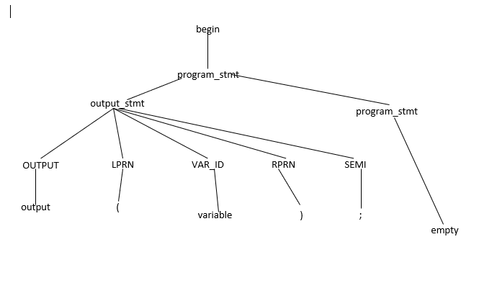

//c.

output(“Hi” + variable1);

//Leftmost --------------------------------------------

start=>program_stmt

=>output_stmt program_stmt

=>OUTPUT LPRN output_exp RPRN SEMI program_stmt

=>output LPRN output_exp RPRN SEMI program_stmt

=>output( output_exp RPRN SEMI program_stmt

=>output( output_ext output_concat RPRN SEMI program_stmt

=>output( STR_VAL output_ext output_concat RPRN SEMI program_stmt

=>output(“Hi” output_ext output_concat RPRN SEMI program_stmt

=>output(“Hi” empty output_concat RPRN SEMI program_stmt

=>output(“Hi” PLUS output_exp RPRN SEMI program_stmt

=>output(“Hi” + output_exp RPRN SEMI program_stmt

=>output(“Hi” + VAR_ID output_concat RPRN SEMI program_stmt

=>output(“Hi” + variable1 output_concat RPRN SEMI program_stmt

=>output(“Hi” + variable1 empty RPRN SEMI program_stmt

=>output(“Hi” + variable1) SEMI program_stmt

=>output(“Hi” + variable1); program_stmt

=>output(“Hi” + variable1); empty

=>output(“Hi” + variable1);

//Rightmost -------------------------------------------

start=>program_stmt

=>output_stmt program_stmt

=>output_stmt empty

=>output_stmt

=>OUTPUT LPRN output_exp RPRN SEMI

=> OUTPUT LPRN output_exp RPRN ;

=> OUTPUT LPRN output_exp );

=> OUTPUT LPRN output_ext output_concat );

=> OUTPUT LPRN output_ext PLUS output_exp);

=> OUTPUT LPRN output_ext PLUS VAR_ID empty);

=> OUTPUT LPRN output_ext PLUS variable1);

=> OUTPUT LPRN output_ext + variable1);

=> OUTPUT LPRN STR_VAL output_ext + variable1);

=> OUTPUT LPRN STR_VAL empty + variable1);

=> OUTPUT LPRN “Hi” + variable1);

=> OUTPUT (“Hi” + variable1);

=>output (“Hi” + variable1);

**Parse Tree**

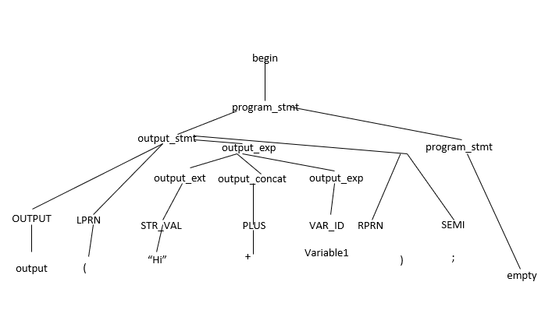

//VI. Assignment Statement

//a.

c = d;

//Leftmost --------------------------------------------

start=>program_stmt

=>ass_stmt program_stmt

=>VAR_ID ass_exp program_stmt

=>c ass_exp program_stmt

=>c EQUALS ass_args program_stmt

=> c = ass_args program_stmt

=> c = VAR_ID ass_args2 program_stmt

=> c = d ass_args2 program_stmt

=> c = d SEMIprogram_stmt

=> c = d;program_stmt

=> c = d;empty

=> c = d;

//Rightmost -------------------------------------------

start=>program_stmt

=>ass_stmt program_stmt

=>ass_stmt empty

=>ass_stmt

=>VAR_ID ass_exp

=> VAR_ID EQUALS ass_args

=> VAR_ID EQUALS VAR_ID ass_args2

=> VAR_ID EQUALS VAR_ID SEMI

=> VAR_ID EQUALS VAR_ID ;

=> VAR_ID EQUALS VAR_ID ;

=> VAR_ID EQUALS d ;

=> VAR_ID = d;

=> c = d;

**Parse Tree**

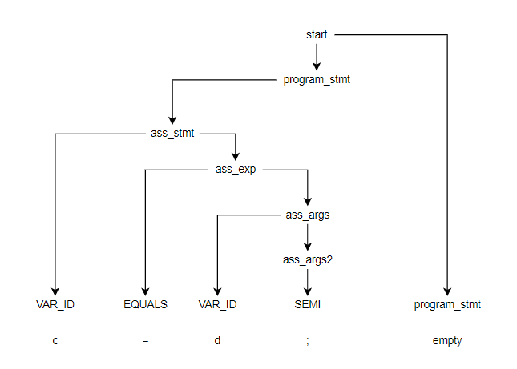

//b.

number = 5;

//Leftmost --------------------------------------------

start=>program_stmt

=>ass_stmt program_stmt

=>VAR_ID ass_exp program_stmt

=>number ass_exp program_stmt

=>number EQUALS ass_args program_stmt

=> number = ass_argsprogram_stmt

=> number = literal ass_args2 program_stmt

=> number = INT_VAL ass_args2 program_stmt

=> number = 5 ass_args2 program_stmt

=> number = 5 SEMIprogram_stmt

=> number = 5; program_stmt

=> number = 5; empty

=> number = 5;

//Rightmost -------------------------------------------

start=>program_stmt

=>ass_stmt program_stmt

=>ass_stmt empty

=>ass_stmt

=>VAR_ID ass_exp

=> VAR_ID EQUALS ass_args

=> VAR_ID EQUALS literal ass_args2

=> VAR_ID EQUALS literal SEMI

=> VAR_ID EQUALS literal ;

=> VAR_ID EQUALS INT_VAL ;

=> VAR_ID EQUALS 5;

=> VAR_ID = 5;

=> number = 5;

**Parse Tree**

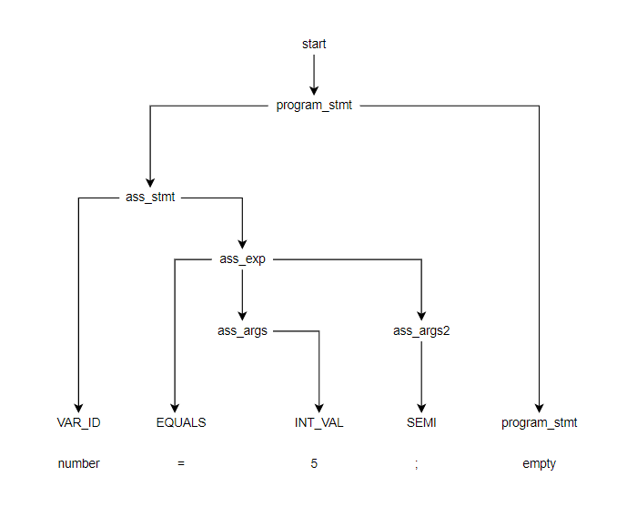

//c.

multiply = (3*5);

//Leftmost --------------------------------------------

start=> program_stmt

=> ass_stmt program_stmt

=> VAR_ID ass_exp program_stmt

=>multiply ass_exp program_stmt

=>multiply EQUALS ass_args program_stmt

=> multiply = ass_args program_stmt

=> multiply = LPRN ass_args RPRN ass_args2 program_stmt

=> multiply = ( ass_args RPRN ass_args2 program_stmt

=> multiply = (literal ass_args2 RPRN ass_args2 program_stmt

=> multiply = (INT_VAL ass_args2 RPRN ass_args2 program_stmt

=> multiply = (3 ass_args2 RPRN ass_args2 program_stmt

=> multiply = (3 ar_op ass_args RPRN ass_args2 program_stmt

=> multiply = (3 MULTI ass_args RPRN ass_args2 program_stmt

=> multiply = (3* ass_args RPRN ass_args2 program_stmt

=> multiply = (3* literal ass_args2 RPRN ass_args2 program_stmt

=> multiply = (3* INT_VAL ass_args2 RPRN ass_args2 program_stmt

=> multiply = (3*5 ass_args2 RPRN ass_args2 program_stmt

=> multiply = (3*5 empty RPRN ass_args2 program_stmt

=> multiply = (3*5 RPRN ass_args2 program_stmt

=> multiply = (3*5) ass_args2 program_stmt

=> multiply = (3*5) SEMI program_stmt

=> multiply = (3*5); program_stmt

=> multiply = (3*5); empty

=> multiply = (3*5);

//Rightmost -------------------------------------------

start=> program_stmt

=> ass_stmt program_stmt

=> ass_stmt program_stmt

=> ass_stmt

=> VAR_ID ass_exp program_stmt

=> VAR_ID ass_exp empty

=> VAR_ID ass_exp

=> VAR_ID EQUALS ass_args

=> VAR_ID EQUALS LPRN ass_args RPRN ass_args2

=> VAR_ID EQUALS LPRN ass_args RPRN SEMI

=> VAR_ID EQUALS LPRN ass_args RPRN ;

=> VAR_ID EQUALS LPRN ass_args );

=> VAR_ID EQUALS LPRN literal ass_args2);

=> VAR_ID EQUALS LPRN literal ar_op ass_args);

=> VAR_ID EQUALS LPRN literal ar_op literal ass_args2);

=> VAR_ID EQUALS LPRN literal ar_op literal empty);

=> VAR_ID EQUALS LPRN literal ar_op INT_VAL);

=> VAR_ID EQUALS LPRN literal ar_op 5);

=> VAR_ID EQUALS LPRN literal MULTI 5);

=> VAR_ID EQUALS LPRN literal * 5);

=> VAR_ID EQUALS LPRN INT_VAL * 5);

=> VAR_ID EQUALS LPRN 3 * 5);

=> VAR_ID EQUALS (3 * 5);

=> VAR_ID = (3 * 5);

=> multiply= (3 * 5);

**Parse Tree**

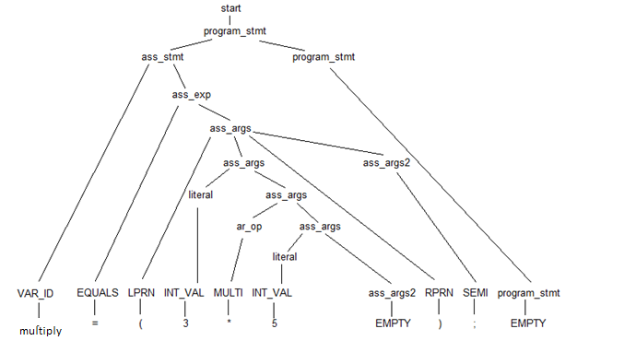

V. Iterative

a. while(a==0)

{

Des = 100;

}

• LEFTMOST

start=>program_stmt

=>loop_stmt program_stmt

=>WHILE cond_exp

LBRC

loop_prog

RBRC program_stmt

=>while cond_exp

LBRC

loop_prog

RBRC program_stmt

=>while LPRN cond_args RPRN LBRC program_stmt RBRC

LBRC

loop_prog

RBRC program_stmt

=>while(cond_args RPRN LBRC program_stmt RBRC

LBRC

loop_prog

RBRC program_stmt

=>while(VAR_ID rel_op cond_args2 RPRN LBRC program_stmt RBRC

LBRC

loop_prog

RBRC program_stmt

=>while(a rel_op cond_args2 RPRN LBRC program_stmt RBRC

LBRC

loop_prog

RBRC program_stmt

=>while(a EQ cond_args2 RPRN LBRC program_stmt RBRC

LBRC

loop_prog

RBRC program_stmt

=>while(a== cond_args2 RPRN LBRC program_stmt RBRC

LBRC

loop_prog

RBRC program_stmt

=>while(a== literal log_args RPRN LBRC program_stmt RBRC

LBRC

loop_prog

RBRC program_stmt

=>while(a== INT_VAL log_args RPRN LBRC program_stmt RBRC

LBRC

loop_prog

RBRC program_stmt

=>while(a==0 log_args RPRN LBRC program_stmt RBRC

LBRC

loop_prog

RBRC program_stmt

=>while(a==0 empty RPRN LBRC program_stmt RBRC

LBRC

loop_prog

RBRC program_stmt

=>while(a==0) LBRC program_stmt RBRC

LBRC

loop_prog

RBRC program_stmt

=>while(a==0) empty program_stmt RBRC

LBRC

loop_prog

RBRC program_stmt

=>while(a==0) empty RBRC

LBRC

loop_prog

RBRC program_stmt

=>while(a==0) empty

LBRC

loop_prog

RBRC program_stmt

=>while(a==0)

{

loop_prog

RBRC program_stmt

=>while(a==0)

{

program_stmt

RBRC program_stmt

=>while(a==0)

{

ass_stmt program_stmt

RBRC program_stmt

=>while(a==0)

{

VAR_ID ass_exp program_stmt

RBRC program_stmt

=>while(a==0)

{

Des ass_exp program_stmt

RBRC program_stmt

=>while(a==0)

{

Des EQUALS ass_args program_stmt

RBRC program_stmt

=>while(a==0)

{

Des = ass_args program_stmt

RBRC program_stmt

=>while(a==0)

{

Des = literal ass_args2 program_stmt

RBRC program_stmt

=>while(a==0)

{

Des = INT_VAL ass_args2 program_stmt

RBRC program_stmt

=>while(a==0)

{

Des = 100 ass_args2 program_stmt

RBRC program_stmt

=>while(a==0)

{

Des = 100 SEMI program_stmt

RBRC program_stmt

=>while(a==0)

{

Des = 100; program_stmt

RBRC program_stmt

=>while(a==0)

{

Des = 100; empty

RBRC program_stmt

=>while(a==0)

{

Des = 100;

} program_stmt

=>while(a==0)

{

Des = 100;

} empty

=>while(a==0)

{

Des = 100;

}

• RIGHTMOST

start=>program_stmt

=>loop_stmt program_stmt

=>loop_stmt empty

=>loop_stmt

=>WHILE cond_exp

LBRC

loop_prog

RBRC

start=> WHILE cond_exp

LBRC

loop_prog

}

start=> WHILE cond_exp

LBRC

program_stmt

}

start=> WHILE cond_exp

LBRC

ass_stmt program_stmt

}

start=> WHILE cond_exp

LBRC

ass_stmt empty

}

start=> WHILE cond_exp

LBRC

VAR_ID ass_exp

}

start=> WHILE cond_exp

LBRC

VAR_ID EQUALS ass_args

}

start=> WHILE cond_exp

LBRC

VAR_ID EQUALS literal ass_args2

}

start=> WHILE cond_exp

LBRC

VAR_ID EQUALS literal SEMI

}

start=> WHILE cond_exp

LBRC

VAR_ID EQUALS literal ;

}

start=> WHILE cond_exp

LBRC

VAR_ID EQUALS INT_VAL ;

}

start=> WHILE cond_exp

LBRC

VAR_ID EQUALS 100;

}

start=> WHILE cond_exp

LBRC

VAR_ID = 100;

}

start=> WHILE cond_exp

LBRC

Des = 100;

}

start=> WHILE cond_exp

{

Des = 100;

}

start=> WHILE LPRN cond_args RPRN LBRC program_stmt RBRC

{

Des = 100;

}

start=> WHILE LPRN cond_args RPRN LBRC program_stmt empty

{

Des = 100;

}

start=> WHILE LPRN cond_args RPRN LBRC empty

{

Des = 100;

}

start=> WHILE LPRN cond_args RPRN empty

{

Des = 100;

}

start=> WHILE LPRN cond_args ) empty

{

Des = 100;

}

start=> WHILE LPRN VAR_ID rel_op cond_args2) empty

{

Des = 100;

}

start=> WHILE LPRN VAR_ID rel_op literal log_args) empty

{

Des = 100;

}

start=> WHILE LPRN VAR_ID rel_op literal empty) empty

{

Des = 100;

}

start=> WHILE LPRN VAR_ID rel_op INT_VAL) empty

{

Des = 100;

}

start=> WHILE LPRN VAR_ID rel_op 0) empty

{

Des = 100;

}

start=> WHILE LPRN VAR_ID EQ 0) empty

{

Des = 100;

}

start=> WHILE LPRN VAR_ID ==0) empty

{

Des = 100;

}

start=> WHILE LPRN a==0) empty

{

Des = 100;

}

start=> WHILE (a==0) empty

{

Des = 100;

}

start=> while(a==0) empty

{

Des = 100;

}

• PARSE TREE

b. while(cond==12)

{

while(cond1==5)

{

Comp = 100;

}

}

• LEFTMOST

start=>program_stmt

=>loop_stmt program_stmt

=>WHILE cond_exp

LBRC

loop_prog

RBRC program_stmt

=>while cond_exp

LBRC

loop_prog

RBRC program_stmt

=>while LPRN cond_args RPRN LBRC program_stmt RBRC

LBRC

loop_prog

RBRC program_stmt

=>while( cond_args RPRN LBRC program_stmt RBRC

LBRC

loop_prog

RBRC program_stmt

=>while(VAR_ID rel_op cond_args2 RPRN LBRC program_stmt RBRC

LBRC

loop_prog

RBRC program_stmt

=>while(cond rel_op cond_args2 RPRN LBRC program_stmt RBRC

LBRC

loop_prog

RBRC program_stmt

=>while(cond EQ cond_args2 RPRN LBRC program_stmt RBRC

LBRC

loop_prog

RBRC program_stmt

=>while(cond== cond_args2 RPRN LBRC program_stmt RBRC

LBRC

loop_prog

RBRC program_stmt

=>while(cond== literal log_args RPRN LBRC program_stmt RBRC

LBRC

loop_prog

RBRC program_stmt

=>while(cond== INT_VAL log_args RPRN LBRC program_stmt RBRC

LBRC

loop_prog

RBRC

=>while(cond==12 log_args RPRN LBRC program_stmt RBRC

LBRC

loop_prog

RBRC program_stmt

=>while(cond==12 empty RPRN LBRC program_stmt RBRC

LBRC

loop_prog

RBRC program_stmt

=>while(cond==12) LBRC program_stmt RBRC

LBRC

loop_prog

RBRC program_stmt

=>while(cond==12) empty program_stmt RBRC

LBRC

loop_prog

RBRC program_stmt

=>while(cond==12) empty RBRC

LBRC

loop_prog

RBRC program_stmt

=>while(cond==12) empty

LBRC

loop_prog

RBRC program_stmt

=>while(cond==12)

{

loop_prog

RBRC

=>while(cond==12)

{

program_stmt

RBRC

=>while(cond==12)

{

loop_stmt program_stmt

RBRC

=>while(cond==12)

{

WHILE cond_exp

LBRC

loop_prog

RBRC program_stmt

RBRC

=>while(cond==12)

{

while cond_exp

LBRC

loop_prog

RBRC program_stmt

RBRC

=>while(cond==12)

{

while LPRN cond_args RPRN LBRC program_stmt RBRC

LBRC

loop_prog

RBRC program_stmt

RBRC

=>while(cond==12)

{

While( cond_args RPRN LBRC program_stmt RBRC

LBRC

loop_prog

RBRC program_stmt

RBRC

=>while(cond==12)

{

While(VAR_ID rel_op cond_args2 RPRN LBRC program_stmt RBRC

LBRC

loop_prog

RBRC program_stmt

RBRC

=>while(cond==12)

{

While(cond1 rel_op cond_args2 RPRN LBRC program_stmt RBRC

LBRC

loop_prog

RBRC program_stmt

RBRC

=>while(cond==12)

{

While(cond1 EQ cond_args2 RPRN LBRC program_stmt RBRC

LBRC

loop_prog

RBRC program_stmt

RBRC

=>while(cond==12)

{

While(cond1== cond_args2 RPRN LBRC program_stmt RBRC

LBRC

loop_prog

RBRC program_stmt

RBRC

=>while(cond==12)

{

While(cond1== literal log_args RPRN LBRC program_stmt RBRC

LBRC

loop_prog

RBRC program_stmt

RBRC

=>while(cond==12)

{

While(cond1== INT_VAL log_args RPRN LBRC program_stmt RBRC

LBRC

loop_prog

RBRC program_stmt

RBRC

=>while(cond==12)

{

While(cond1==5 log_args RPRN LBRC program_stmt RBRC

LBRC

loop_prog

RBRC program_stmt

RBRC

=>while(cond==12)

{

While(cond1==5 empty RPRN LBRC program_stmt RBRC

LBRC

loop_prog

RBRC program_stmt

RBRC

=>while(cond==12)

{

while(cond1==5) LBRC program_stmt RBRC

LBRC

loop_prog

RBRC program_stmt

RBRC

=>while(cond==12)

{

while(cond1==5) empty program_stmt RBRC

LBRC

loop_prog

RBRC program_stmt

RBRC

=>while(cond==12)

{

while(cond1==5) empty RBRC

LBRC

loop_prog

RBRC program_stmt

RBRC

=>while(cond==12)

{

while(cond1==5) empty

LBRC

loop_prog

RBRC program_stmt

RBRC

=>while(cond==12)

{

while(cond1==5)

{

loop_prog

RBRC program_stmt

RBRC

=>while(cond==12)

{

while(cond1==5)

{

program_stmt

RBRC program_stmt

RBRC

=>while(cond==12)

{

while(cond1==5)

{

ass_stmt program_stmt

RBRC program_stmt

RBRC

=>while(cond==12)

{

while(cond1==5)

{

VAR_ID ass_exp program_stmt

RBRC program_stmt

RBRC

=>while(cond==12)

{

while(cond1==5)

{

Comp ass_exp program_stmt

RBRC program_stmt

RBRC

=>while(cond==12)

{

while(cond1==5)

{

Comp EQUALS ass_args program_stmt

RBRC program_stmt

RBRC

=>while(cond==12)

{

while(cond1==5)

{

Comp = ass_args program_stmt

RBRC program_stmt

RBRC

=>while(cond==12)

{

while(cond1==5)

{

Comp = literal ass_args2 program_stmt

RBRC program_stmt

RBRC

=>while(cond==12)

{

while(cond1==5)

{

Comp = INT_VAL ass_args2 program_stmt

RBRC program_stmt

RBRC

=>while(cond==12)

{

while(cond1==5)

{

Comp = 100 ass_args2 program_stmt

RBRC program_stmt

RBRC

=>while(cond==12)

{

while(cond1==5)

{

Comp = 100 SEMI program_stmt

RBRC program_stmt

RBRC

=>while(cond==12)

{

while(cond1==5)

{

Comp = 100; program_stmt

RBRC program_stmt

RBRC

=>while(cond==12)

{

while(cond1==5)

{

Comp = 100; empty

RBRC program_stmt

RBRC

=>while(cond==12)

{

while(cond1==5)

{

Comp = 100;

} program_stmt

RBRC

=>while(cond==12)

{

while(cond1==5)

{

Comp = 100;

} empty

RBRC

=>while(cond==12)

{

while(cond1==5)

{

Comp = 100;

} empty

}

• RIGHTMOST

start=> WHILE cond_exp

LBRC

loop_prog

RBRC

=> WHILE cond_exp

LBRC

loop_prog

}

=> WHILE cond_exp

LBRC

program_stmt

}

=> WHILE cond_exp

LBRC

loop_stmt program_stmt

}

=> WHILE cond_exp

LBRC

loop_stmt empty

}

=> WHILE cond_exp

LBRC

WHILE cond_exp

LBRC

loop_prog

RBRC

}

=> WHILE cond_exp

LBRC

WHILE cond_exp

LBRC

loop_prog

}

}

=> WHILE cond_exp

LBRC

WHILE cond_exp

LBRC

program_stmt

}

}

=> WHILE cond_exp

LBRC

WHILE cond_exp

LBRC

ass_stmt program_stmt

}

}

=> WHILE cond_exp

LBRC

WHILE cond_exp

LBRC

ass_stmt empty

}

}

=> WHILE cond_exp

LBRC

WHILE cond_exp

LBRC

VAR_ID ass_exp

}

}

=> WHILE cond_exp

LBRC

WHILE cond_exp

LBRC

VAR_ID EQUALS ass_args

}

}

=> WHILE cond_exp

LBRC

WHILE cond_exp

LBRC

VAR_ID EQUALS literal ass_args2

}

}

=> WHILE cond_exp

LBRC

WHILE cond_exp

LBRC

VAR_ID EQUALS literal SEMI

}

}

=> WHILE cond_exp

LBRC

WHILE cond_exp

LBRC

VAR_ID EQUALS literal ;

}

}

=> WHILE cond_exp

LBRC

WHILE cond_exp

LBRC

VAR_ID EQUALS INT_VAL ;

}

}

=> WHILE cond_exp

LBRC

WHILE cond_exp

LBRC

VAR_ID EQUALS 100;

}

}

=> WHILE cond_exp

LBRC

WHILE cond_exp

LBRC

VAR_ID = 100;

}

}

=> WHILE cond_exp

LBRC

WHILE cond_exp

LBRC

Comp = 100;

}

}

=> WHILE cond_exp

LBRC

WHILE cond_exp

{

Comp = 100;

}

}

=> WHILE cond_exp

LBRC

WHILE LPRN cond_args RPRN LBRC program_stmt RBRC

{

Comp = 100;

}

}

=> WHILE cond_exp

LBRC

WHILE LPRN cond_args RPRN LBRC program_stmt empty

{

Comp = 100;

}

}

=> WHILE cond_exp

LBRC

WHILE LPRN cond_args RPRN LBRC empty

{

Comp = 100;

}

}

=> WHILE cond_exp

LBRC

WHILE LPRN cond_args RPRN empty

{

Comp = 100;

}

}

=> WHILE cond_exp

LBRC

WHILE LPRN cond_args )

{

Comp = 100;

}

}

=> WHILE cond_exp

LBRC

WHILE LPRN VAR_ID rel_op cond_args2)

{

Comp = 100;

}

}

=> WHILE cond_exp

LBRC

WHILE LPRN VAR_ID rel_op literal log_args)

{

Comp = 100;

}

}

=> WHILE cond_exp

LBRC

WHILE LPRN VAR_ID rel_op literal empty)

{

Comp = 100;

}

}

=> WHILE cond_exp

LBRC

WHILE LPRN VAR_ID rel_op INT_VAL)

{

Comp = 100;

}

}

=> WHILE cond_exp

LBRC

WHILE LPRN VAR_ID rel_op 5)

{

Comp = 100;

}

}

=> WHILE cond_exp

LBRC

WHILE LPRN VAR_ID EQ 5)

{

Comp = 100;

}

}

=> WHILE cond_exp

LBRC

WHILE LPRN VAR_ID ==5)

{

Comp = 100;

}

}

=> WHILE cond_exp

LBRC

WHILE LPRN cond1==5)

{

Comp = 100;

}

}

=> WHILE cond_exp

LBRC

WHILE (cond1==5)

{

Comp = 100;

}

}

=> WHILE cond_exp

LBRC

while(cond1==5)

{

Comp = 100;

}

}

=> WHILE cond_exp

{

while(cond1==5)

{

Comp = 100;

}

}

=> WHILE LPRN cond_args RPRN LBRC program_stmt RBRC

{

while(cond1==5)

{

Comp = 100;

}

}

=> WHILE LPRN cond_args RPRN LBRC program_stmt empty

{

while(cond1==5)

{

Comp = 100;

}

}

=> WHILE LPRN cond_args RPRN LBRC empty

{

while(cond1==5)

{

Comp = 100;

}

}

=> WHILE LPRN cond_args RPRN empty

{

while(cond1==5)

{

Comp = 100;

}

}

=> WHILE LPRN cond_args )

{

while(cond1==5)

{

Comp = 100;

}

}

=> WHILE LPRN VAR_ID rel_op cond_args2)

{

while(cond1==5)

{

Comp = 100;

}

}

=> WHILE LPRN VAR_ID rel_op literal log_args)

{

while(cond1==5)

{

Comp = 100;

}

}

=> WHILE LPRN VAR_ID rel_op literal empty)

{

while(cond1==5)

{

Comp = 100;

}

}

=> WHILE LPRN VAR_ID rel_op INT_VAL)

{

while(cond1==5)

{

Comp = 100;

}

}

=> WHILE LPRN VAR_ID rel_op 12)

{

while(cond1==5)

{

Comp = 100;

}

}

=> WHILE LPRN VAR_ID EQ 12)

{

while(cond1==5)

{

Comp = 100;

}

}

=> WHILE LPRN VAR_ID ==12)

{

while(cond1==5)

{

Comp = 100;

}

}

=> WHILE LPRN cond==12)

{

while(cond1==5)

{

Comp = 100;

}

}

=> WHILE (cond==12)

{

while(cond1==5)

{

Comp = 100;

}

}

=>while(cond==12)

{

while(cond1==5)

{

Comp = 100;

}

}

• PARSE TREE

VI. Condition Statement

a. if(control==‘a’)

{

Sum = 2;

}

• LEFTMOST

start=> IF cond_exp cond_list

=>if cond_exp cond_list

=>if LPRN cond_args RPRN

LBRC

program_stmt

RBRC cond_list

=>if( cond_args RPRN

LBRC

program_stmt

RBRC cond_list

=>if(VAR_ID rel_op cond_args2 RPRN

LBRC

program_stmt

RBRC cond_list

=>if(control rel_op cond_args2 RPRN

LBRC

program_stmt

RBRC cond_list

=>if(control EQ cond_args2 RPRN

LBRC

program_stmt

RBRC cond_list

=>if(control== cond_args2 RPRN

LBRC

program_stmt

RBRC cond_list

=>if(control== literal log_args RPRN

LBRC

program_stmt

RBRC cond_list

=>if(control== CHAR_VAL log_args RPRN

LBRC

program_stmt

RBRC cond_list

=>if(control==’a’ log_args RPRN

LBRC

program_stmt

RBRC cond_list

=>if(control==’a’ empty RPRN

LBRC

program_stmt

RBRC cond_list

=>if(control==’a’)

LBRC

program_stmt

RBRC cond_list

=>if(control==’a’)

{

program_stmt

RBRC cond_list

=>if(control==’a’)

{

ass_stmt program_stmt

RBRC cond_list

=>if(control==’a’)

{

VAR_ID ass_exp program_stmt

RBRC cond_list

=>if(control==’a’)

{

Sum ass_exp program_stmt

RBRC cond_list

=>if(control==’a’)

{

Sum EQUALS ass_args program_stmt

RBRC cond_list

=>if(control==’a’)

{

Sum = ass_args program_stmt

RBRC cond_list

=>if(control==’a’)

{

Sum = literal ass_args2 program_stmt

RBRC cond_list

=>if(control==’a’)

{

Sum = INT_VAL ass_args2 program_stmt

RBRC cond_list

=>if(control==’a’)

{

Sum = 2 ass_args2 program_stmt

RBRC cond_list

=>if(control==’a’)

{

Sum = 2 SEMI program_stmt

RBRC cond_list

=>if(control==’a’)

{

Sum = 2; program_stmt

RBRC cond_list

=>if(control==’a’)

{

Sum = 2; empty

RBRC cond_list

=>if(control==’a’)

{

Sum = 2;

} cond_list

=>if(control==’a’)

{

Sum = 2;

} empty

=>if(control==’a’)

{

Sum = 2;

}

• RIGHTMOST

start=> IF cond_exp cond_list

=> IF cond_exp empty

=> IF LPRN cond_args RPRN

LBRC

program_stmt

RBRC

=> IF LPRN cond_args RPRN

LBRC

program_stmt

}

=> IF LPRN cond_args RPRN

LBRC

ass_stmt program_stmt

}

=> IF LPRN cond_args RPRN

LBRC

ass_stmt empty

}

=> IF LPRN cond_args RPRN

LBRC

VAR_ID ass_exp

}

=> IF LPRN cond_args RPRN

LBRC

VAR_ID EQUALS ass_args

}

=> IF LPRN cond_args RPRN

LBRC

VAR_ID EQUALS literal ass_args2

}

=> IF LPRN cond_args RPRN

LBRC

VAR_ID EQUALS literal SEMI

}

=> IF LPRN cond_args RPRN

LBRC

VAR_ID EQUALS literal ;

}

=> IF LPRN cond_args RPRN

LBRC

VAR_ID EQUALS INT_VAL ;

}

=> IF LPRN cond_args RPRN

LBRC

VAR_ID EQUALS 2 ;

}

=> IF LPRN cond_args RPRN

LBRC

VAR_ID = 2 ;

}

=> IF LPRN cond_args RPRN

LBRC

Sum = 2 ;

}

=> IF LPRN cond_args RPRN

{

Sum = 2 ;

}

=> IF LPRN cond_args)

{

Sum = 2 ;

}

=> IF LPRN VAR_ID rel_op cond_args2)

{

Sum = 2 ;

}

=> IF LPRN VAR_ID rel_op literal log_args)

{

Sum = 2 ;

}

=> IF LPRN VAR_ID rel_op literal empty)

{

Sum = 2 ;

}

=> IF LPRN VAR_ID rel_op CHAR_VAL)

{

Sum = 2 ;

}

=> IF LPRN VAR_ID rel_op ‘a’)

{

Sum = 2 ;

}

=> IF LPRN VAR_ID EQ ‘a’)

{

Sum = 2 ;

}

=> IF LPRN VAR_ID ==‘a’)

{

Sum = 2 ;

}

=> IF LPRN control==‘a’)

{

Sum = 2 ;

}

=> IF (control==‘a’)

{

Sum = 2 ;

}

=>if(control==‘a’)

{

Sum = 2 ;

}

• PARSE TREE

b. if(initial==‘B’)

{

Diff = 0;

}

else

{

Diff = 10;

}

• LEFTMOST

start=> IF cond_exp cond_list

=>if cond_exp cond_list

=>if LPRN cond_args RPRN

LBRC

program_stmt

RBRC cond_list

=>if( cond_args RPRN

LBRC

program_stmt

RBRC cond_list

=>if(VAR_ID rel_op cond_args2 RPRN

LBRC

program_stmt

RBRC cond_list

=>if(Inital rel_op cond_args2 RPRN

LBRC

program_stmt

RBRC cond_list

=>if(Inital EQ cond_args2 RPRN

LBRC

program_stmt

RBRC cond_list

=>if(Inital == cond_args2 RPRN

LBRC

program_stmt

RBRC cond_list

=>if(Inital == literal log_args RPRN

LBRC

program_stmt

RBRC cond_list

=>if(Inital == CHAR_VAL log_args RPRN

LBRC

program_stmt

RBRC cond_list

=>if(Inital ==’B’ log_args RPRN

LBRC

program_stmt

RBRC cond_list

=>if(Inital ==’B’ empty RPRN

LBRC

program_stmt

RBRC cond_list

=>if(Inital ==’B’)

LBRC

program_stmt

RBRC cond_list

=>if(Inital ==’B’)

{

program_stmt

RBRC cond_list

=>if(Inital ==’B’)

{

ass_stmt program_stmt

RBRC cond_list

=>if(Inital ==’B’)

{

VAR_ID ass_exp program_stmt

RBRC cond_list

=>if(Inital ==’B’)

{

Diff ass_exp program_stmt

RBRC cond_list

=>if(Inital ==’B’)

{

Diff EQUALS ass_args program_stmt

RBRC cond_list

=>if(Inital ==’B’)

{

Diff = ass_args program_stmt

RBRC cond_list

=>if(Inital ==’B’)

{

Diff = literal ass_args2 program_stmt

RBRC cond_list

=>if(Inital ==’B’)

{

Diff = INT_VAL ass_args2 program_stmt

RBRC cond_list

=>if(Inital ==’B’)

{

Diff = 0 ass_args2 program_stmt

RBRC cond_list

=>if(Inital ==’B’)

{

Diff = 0 SEMI program_stmt

RBRC cond_list

=>if(Inital ==’B’)

{

Diff = 0; program_stmt

RBRC cond_list

=>if(Inital ==’B’)

{

Diff = 0; empty

RBRC cond_list

=>if(Inital ==’B’)

{

Diff = 0;

} cond_list

=>if(Inital ==’B’)

{

Diff = 0;

}

ELSE

LBRC

program_stmt

RBRC

=>if(Inital ==’B’)

{

Diff = 0;

}

else

LBRC

program_stmt

RBRC

=>if(Inital ==’B’)

{

Diff = 0;

}

else

{

program_stmt

RBRC

=>if(Inital ==’B’)

{

Diff = 0;

}

else

{

ass_stmt program_stmt

RBRC

=>if(Inital ==’B’)

{

Diff = 0;

}

else

{

VAR_ID ass_exp program_stmt

RBRC

=>if(Inital ==’B’)

{

Diff = 0;

}

else

{

Diff ass_exp program_stmt

RBRC

=>if(Inital ==’B’)

{

Diff = 0;

}

else

{

Diff EQUALS ass_args program_stmt

RBRC

=>if(Inital ==’B’)

{

Diff = 0;

}

else

{

Diff = ass_args program_stmt

RBRC

=>if(Inital ==’B’)

{

Diff = 0;

}

else

{

Diff = literal ass_args2 program_stmt

RBRC

=>if(Inital ==’B’)

{

Diff = 0;

}

else

{

Diff = INT_VAL ass_args2 program_stmt

RBRC

=>if(Inital ==’B’)

{

Diff = 0;

}

else

{

Diff = 100 ass_args2 program_stmt

RBRC

=>if(Inital ==’B’)

{

Diff = 0;

}

else

{

Diff = 100 SEMI program_stmt

RBRC

=>if(Inital ==’B’)

{

Diff = 0;

}

else

{

Diff = 100; program_stmt

RBRC

=>if(Inital ==’B’)

{

Diff = 0;

}

else

{

Diff = 100; empty

RBRC

=>if(Inital ==’B’)

{

Diff = 0;

}

else

{

Diff = 100;

}

• RIGHTMOST

start=> IF cond_exp cond_list

=> IF cond_exp

ELSE

LBRC

program_stmt

RBRC

=> IF cond_exp

ELSE

LBRC

program_stmt

}

=> IF cond_exp

ELSE

LBRC

ass_stmt program_stmt

}

=> IF cond_exp

ELSE

LBRC

ass_stmt empty

}

=> IF cond_exp

ELSE

LBRC

VAR_ID ass_exp

}

=> IF cond_exp

ELSE

LBRC

VAR_ID EQUALS ass_args

}

=> IF cond_exp

ELSE

LBRC

VAR_ID EQUALS literal ass_args2

}

=> IF cond_exp

ELSE

LBRC

VAR_ID EQUALS literal SEMI

}

=> IF cond_exp

ELSE

LBRC

VAR_ID EQUALS literal ;

}

=> IF cond_exp

ELSE

LBRC

VAR_ID EQUALS INT_VAL;

}

=> IF cond_exp

ELSE

LBRC

VAR_ID EQUALS 10;

}

=> IF cond_exp

ELSE

LBRC

VAR_ID = 10;

}

=> IF cond_exp

ELSE

LBRC

Diff = 10;

}

=> IF cond_exp

ELSE

{

Diff = 10;

}

=> IF cond_exp

else

{

Diff = 10;

}

=> IF LPRN cond_args RPRN

LBRC

program_stmt

RBRC

else

{

Diff = 10;

}

=> IF LPRN cond_args RPRN

LBRC

program_stmt

}

else

{

Diff = 10;

}

=> IF LPRN cond_args RPRN

LBRC

ass_stmt program_stmt

}

else

{

Diff = 10;

}

=> IF LPRN cond_args RPRN

LBRC

ass_stmt empty

}

else

{

Diff = 10;

}

=> IF LPRN cond_args RPRN

LBRC

VAR_ID ass_exp

}

else

{

Diff = 10;

}

=> IF LPRN cond_args RPRN

LBRC

VAR_ID EQUALS ass_args

}

else

{

Diff = 10;

}

=> IF LPRN cond_args RPRN

LBRC

VAR_ID EQUALS literal ass_args2

}

else

{

Diff = 10;

}

=> IF LPRN cond_args RPRN

LBRC

VAR_ID EQUALS literal SEMI

}

else

{

Diff = 10;

}

=> IF LPRN cond_args RPRN

LBRC

VAR_ID EQUALS literal ;

}

else

{

Diff = 10;

}

=> IF LPRN cond_args RPRN

LBRC

VAR_ID EQUALS INT_VAL ;

}

else

{

Diff = 10;

}

=> IF LPRN cond_args RPRN

LBRC

VAR_ID EQUALS 0;

}

else

{

Diff = 10;

}

=> IF LPRN cond_args RPRN

LBRC

VAR_ID = 0;

}

else

{

Diff = 10;

}

=> IF LPRN cond_args RPRN

LBRC

Diff = 0;

}

else

{

Diff = 10;

}

=> IF LPRN cond_args RPRN

{

Diff = 0;

}

else

{

Diff = 10;

}

=> IF LPRN cond_args )

{

Diff = 0;

}

else

{

Diff = 10;

}

=> IF LPRN VAR_ID rel_op cond_args2)

{

Diff = 0;

}

else

{

Diff = 10;

}

=> IF LPRN VAR_ID rel_op literal log_args)

{

Diff = 0;

}

else

{

Diff = 10;

}

=> IF LPRN VAR_ID rel_op literal empty)

{

Diff = 0;

}

else

{

Diff = 10;

}

=> IF LPRN VAR_ID rel_op CHAR_VAL)

{

Diff = 0;

}

else

{

Diff = 10;

}

=> IF LPRN VAR_ID rel_op ‘B’)

{

Diff = 0;

}

else

{

Diff = 10;

}

=> IF LPRN VAR_ID EQ ‘B’)

{

Diff = 0;

}

else

{

Diff = 10;

}

=> IF LPRN VAR_ID ==‘B’)

{

Diff = 0;

}

else

{

Diff = 10;

}

=> IF LPRN Initial==‘B’)

{

Diff = 0;

}

else

{

Diff = 10;

}

=> IF (Initial==‘B’)

{

Diff = 0;

}

else

{

Diff = 10;

}

=>if(Initial==‘B’)

{

Diff = 0;

}

else

{

Diff = 10;

}

• PARSE TREE

c. if( a == 1)

{

Quo = 3;

}

elsif(a != 1)

{

Quo = 5;

}

else

{

Quo = 7;

}

• LEFTMOST

start => program_stmt

=>cond_stmt program stmt

=> IF cond_exp cond_list program_stmt

=>if cond_exp cond_list program_stmt

=>if LPRN cond_args RPRN

LBRC

program_stmt

RBRC cond_list program_stmt

=>if ( cond args RPRN

LBRC

program_stmt

RBRC cond_listprogram_stmt

=>if (VAR_ID rel_op cond_args2 RPRN

LBRC

program_stmt

RBRC cond_list program_stmt

=>if(a rel_op cond_args2 RPRN

LBRC

program_stmt

RBRC cond_listprogram stmt

=>if (a EQ cond_args2 RPRN

LBRC

program_stmt

RBRC cond_listprogram stmt

=>if(a==cond_args2 RPRN

LBRC

program_stmt

RBRC cond_list

=>if(a==literal log_args RPRN

LBRC

program_stmt

RBRC cond_listprogram stmt

=>if(a==INT_VAL log_args RPRN

LBRC

program_stmt

RBRC cond_listprogram stmt

=>if(a==5 log_args RPRN

LBRC

program_stmt

RBRC cond_listprogram stmt

=>if(a==5 empty RPRN

LBRC

program_stmt

RBRC cond_listprogram stmt

=>if(a==5)

LBRC

program_stmt

RBRC cond_listprogram stmt

=>if(a==5)

{

program_stmt

RBRC cond_listprogram stmt

=>if(a==5)

{

ass_stmt program_stmt

RBRC cond_listprogram stmt

=>if(a==5)

{

VAR_ID ass_exp program_stmt

RBRC cond_listprogram stmt

=>if(a==5)

{

Quo ass_exp program_stmt

RBRC cond_listprogram stmt

=>if(a==5)

{

Quo EQUALS ass_args program_stmt

RBRC cond_listprogram stmt

=>if(a==5)

{

Quo = ass_args program_stmt

RBRC cond_listprogram stmt

=>if(a==5)

{

Quo = literal ass_args2 program_stmt

RBRC cond_listprogram stmt

=>if(a==5)

{

Quo = INT_VAL ass_args2 program_stmt

RBRC cond_listprogram stmt

=>if(a==5)

{

Quo = 3 ass_args2 program_stmt

RBRC cond_listprogram stmt

=>if(a==5)

{

Quo = 3 SEMI program_stmt

RBRC cond_listprogram stmt

=>if(a==5)

{

Quo = 3; program_stmt

RBRC cond_listprogram stmt

=>if(a==5)

{

Quo = 3; program_stmt

RBRC cond_listprogram stmt

=>if(a==5)

{

Quo = 3; empty

RBRC cond_list

=>if(a==5)

{

Quo = 3;

} cond_listprogram stmt

=>if(a==5)

{

Quo = 3;

}

ELSIF cond_exp cond_listprogram stmt

=>if(a==5)

{

Quo = 3;

}

elsif cond_exp cond_listprogram stmt

=>if(a==5)

{

Quo = 3;

}

elsif LPRN cond_args RPRN

LBRC

program_stmt

RBRC cond_listprogram stmt

=>if(a==5)

{

Quo = 3;

}

elsif ( cond_args RPRN

LBRC

program_stmt

RBRC cond_list

=>if(a==5)

{

Quo = 3;

}

elsif (VAR_ID rel_op cond_args2 RPRN

LBRC

program_stmt

RBRC cond_listprogram stmt

=>if(a==5)

{

Quo = 3;

}

elsif (a rel_op cond_args2 RPRN

LBRC

program_stmt

RBRC cond_listprogram stmt

=>if(a==5)

{

Quo = 3;

}

elsif (a NEQ cond_args2 RPRN

LBRC

program_stmt

RBRC cond_listprogram stmt

=>if(a==5)

{

Quo = 3;

}

elsif (a != cond_args2 RPRN

LBRC

program_stmt

RBRC cond_listprogram stmt

=>if(a==5)

{

Quo = 3;

}

elsif (a != literal log_args RPRN

LBRC

program_stmt

RBRC cond_listprogram stmt

=>if(a==5)

{

Quo = 3;

}

elsif (a != INT_VAL log_args RPRN

LBRC

program_stmt

RBRC cond_listprogram stmt

=>if(a==5)

{

Quo = 3;

}

elsif (a != 1 log_args RPRN

LBRC

program_stmt

RBRC cond_listprogram stmt

=>if(a==5)

{

Quo = 3;

}

elsif (a != 1 empty RPRN

LBRC

program_stmt

RBRC cond_listprogram stmt

=>if(a==5)

{

Quo = 3;

}

elsif (a != 1)

LBRC

program_stmt

RBRC cond_listprogram stmt

=>if(a==5)

{

Quo = 3;

}

elsif (a != 1)

{

program_stmt

RBRC cond_listprogram stmt

=>if(a==5)

{

Quo = 3;

}

elsif (a != 1)

{

ass_stmt program_stmt

RBRC cond_listprogram stmt

=>if(a==5)

{

Quo = 3;

}

elsif (a != 1)

{

VAR_ID ass_exp program_stmt

RBRC cond_list

=>if(a==5)

{

Quo = 3;

}

elsif (a != 1)

{

Quo ass_exp program_stmt

RBRC cond_listprogram stmt

=>if(a==5)

{

Quo = 3;

}

elsif (a != 1)

{

Quo EQUALS ass_args program_stmt

RBRC cond_listprogram stmt

=>if(a==5)

{

Quo = 3;

}

elsif (a != 1)

{

Quo = ass_args program_stmt

RBRC cond_listprogram stmt

=>if(a==5)

{

Quo = 3;

}

elsif (a != 1)

{

Quo = literal ass_args2 program_stmt

RBRC cond_listprogram stmt

=>if(a==5)

{

Quo = 3;

}

elsif (a != 1)

{

Quo = INT_VAL ass_args2 program_stmt

RBRC cond_listprogram stmt

=>if(a==5)

{

Quo = 3;

}

elsif (a != 1)

{

Quo = 5 SEMI program_stmt

RBRC cond_listprogram stmt

=>if(a==5)

{

Quo = 3;

}

elsif (a != 1)

{

Quo = 5; program_stmt

RBRC cond_listprogram stmt

=>if(a==5)

{

Quo = 3;

}

elsif (a != 1)

{

Quo = 5; empty

RBRC cond_listprogram stmt

=>if(a==5)

{

Quo = 3;

}

elsif (a != 1)

{

Quo = 5;

} cond_listprogram stmt

=>if(a==5)

{

Quo = 3;

}

elsif (a != 1)

{

Quo = 5;

}

ELSE

LBRC

program_stmt

RBRCprogram stmt

=>if(a==5)

{

Quo = 3;

}

elsif (a != 1)

{

Quo = 5;

}

else

LBRC

program_stmt

RBRCprogram stmt

=>if(a==5)

{

Quo = 3;

}

elsif (a != 1)

{

Quo = 5;

}

else

{

program_stmt

RBRCprogram stmt

=>if(a==5)

{

Quo = 3;

}

elsif (a != 1)

{

Quo = 5;

}

else

{

ass_stmt program_stmt

RBRCprogram stmt

=>if(a==5)

{

Quo = 3;

}

elsif (a != 1)

{

Quo = 5;

}

else

{

VAR_ID ass_exp program_stmt

RBRCprogram stmt

=>if(a==5)

{

Quo = 3;

}

elsif (a != 1)

{

Quo = 5;

}

else

{

Quo ass_exp program_stmt

RBRCprogram stmt

=>if(a==5)

{

Quo = 3;

}

elsif (a != 1)

{

Quo = 5;

}

else

{

Quo EQUALS ass_args program_stmt

RBRCprogram stmt

=>if(a==5)

{

Quo = 3;

}

elsif (a != 1)

{

Quo = 5;

}

else

{

Quo = ass_args program_stmt

RBRCprogram stmt

=>if(a==5)

{

Quo = 3;

}

elsif (a != 1)

{

Quo = 5;

}

else

{

Quo = literal ass_args2 program_stmt

RBRCprogram stmt

=>if(a==5)

{

Quo = 3;

}

elsif (a != 1)

{

Quo = 5;

}

else

{

Quo = INT_VAL ass_args2 program_stmt

RBRCprogram stmt

=>if(a==5)

{

Quo = 3;

}

elsif (a != 1)

{

Quo = 5;

}

else

{

Quo = 7 ass_args2 program_stmt

RBRCprogram stmt

=>if(a==5)

{

Quo = 3;

}

elsif (a != 1)

{

Quo = 5;

}

else

{

Quo = 7 SEMI program_stmt

RBRCprogram stmt

=>if(a==5)

{

Quo = 3;

}

elsif (a != 1)

{

Quo = 5;

}

else

{

Quo = 7; program_stmt

RBRCprogram stmt

=>if(a==5)

{

Quo = 3;

}

elsif (a != 1)

{

Quo = 5;

}

else

{

Quo = 7; empty

RBRCprogram stmt

=>if(a==5)

{

Quo = 3;

}

elsif (a != 1)

{

Quo = 5;

}

else

{

Quo = 7;

}program stmt

=>if(a==5)

{

Quo = 3;

}

elsif (a != 1)

{

Quo = 5;

}

else

{

Quo = 7;

}empty

=>if(a==5)

{

Quo = 3;

}

elsif (a != 1)

{

Quo = 5;

}

else

{

Quo = 7;

}

• RIGHTMOST

start => program_stmt

=> IF cond_exp cond_list

=> IF cond_exp cond_list ELSIF cond_exp cond_list

=> IF cond_exp

ELSIF cond_exp

ELSE

LBRC

program_stmt

RBRC

=> IF cond_exp

ELSIF cond_exp

ELSE

LBRC

program_stmt

}

=> IF cond_exp

ELSIF cond_exp

ELSE

LBRC

ass_stmt program_stmt

}

=> IF cond_exp

ELSIF cond_exp

ELSE

LBRC

ass_stmt empty

}

=> IF cond_exp

ELSIF cond_exp

ELSE

LBRC

VAR_ID ass_exp

}

=> IF cond_exp

ELSIF cond_exp

ELSE

LBRC

VAR_ID EQUALS ass_args

}

=> IF cond_exp

ELSIF cond_exp

ELSE

LBRC

VAR_ID EQUALS literal ass_args2

}

=> IF cond_exp

ELSIF cond_exp

ELSE

LBRC

VAR_ID EQUALS literal SEMI

}

=> IF cond_exp

ELSIF cond_exp

ELSE

LBRC

VAR_ID EQUALS literal ;

}

=> IF cond_exp

ELSIF cond_exp

ELSE

LBRC

VAR_ID EQUALS INT_VAL ;

}

=> IF cond_exp

ELSIF cond_exp

ELSE

LBRC

VAR_ID EQUALS 7 ;

}

=> IF cond_exp

ELSIF cond_exp

ELSE

LBRC

VAR_ID = 7 ;

}

=> IF cond_exp

ELSIF cond_exp

ELSE

LBRC

Quo = 7 ;

}

=> IF cond_exp

ELSIF cond_exp

ELSE

{

Quo = 7 ;

}

=> IF cond_exp

ELSIF cond_exp

else

{

Quo = 7 ;

}

=> IF cond_exp

ELSIF LPRN cond_args RPRN

LBRC

program_stmt

RBRC

else

{

Quo = 7 ;

}

=> IF cond_exp

ELSIF LPRN cond_args RPRN

LBRC

program_stmt

}

else

{

Quo = 7 ;

}

=> IF cond_exp

ELSIF LPRN cond_args RPRN

LBRC

ass_stmt program_stmt

}

else

{

Quo = 7 ;

}

=> IF cond_exp

ELSIF LPRN cond_args RPRN

LBRC

ass_stmt empty

}

else

{

Quo = 7 ;

}

=> IF cond_exp

ELSIF LPRN cond_args RPRN

LBRC

VAR_ID ass_exp

}

else

{

Quo = 7 ;

}

=> IF cond_exp

ELSIF LPRN cond_args RPRN

LBRC

VAR_ID EQUALS ass_args

}

else

{

Quo = 7 ;

}

=> IF cond_exp

ELSIF LPRN cond_args RPRN

LBRC

VAR_ID EQUALS literal ass_args2

}

else

{

Quo = 7 ;

}

=> IF cond_exp

ELSIF LPRN cond_args RPRN

LBRC

VAR_ID EQUALS literal SEMI

}

else

{

Quo = 7 ;

}

=> IF cond_exp

ELSIF LPRN cond_args RPRN

LBRC

VAR_ID EQUALS literal ;

}

else

{

Quo = 7 ;

}

=> IF cond_exp

ELSIF LPRN cond_args RPRN

LBRC

VAR_ID EQUALS INT_VAL ;

}

else

{

Quo = 7 ;

}

=> IF cond_exp

ELSIF LPRN cond_args RPRN

LBRC

VAR_ID EQUALS 5 ;

}

else

{

Quo = 7 ;

}

=> IF cond_exp

ELSIF LPRN cond_args RPRN

LBRC

VAR_ID = 5 ;

}

else

{

Quo = 7 ;

}

=> IF cond_exp

ELSIF LPRN cond_args RPRN

LBRC

Quo = 5 ;

}

else

{

Quo = 7 ;

}

=> IF cond_exp

ELSIF LPRN cond_args RPRN

{

Quo = 5 ;

}

else

{

Quo = 7 ;

}

=> IF cond_exp

ELSIF LPRN cond_args )

{

Quo = 5 ;

}

else

{

Quo = 7 ;

}

=> IF cond_exp

ELSIF LPRN VAR_ID rel_op cond_args2)

{

Quo = 5 ;

}

else

{

Quo = 7 ;

}

=> IF cond_exp

ELSIF LPRN VAR_ID rel_op literal log_args)

{

Quo = 5 ;

}

else

{

Quo = 7 ;

}

=> IF cond_exp

ELSIF LPRN VAR_ID rel_op literal empty)

{

Quo = 5 ;

}

else

{

Quo = 7 ;

}

=> IF cond_exp

ELSIF LPRN VAR_ID rel_op INT_VAL)

{

Quo = 5 ;

}

else

{

Quo = 7 ;

}

=> IF cond_exp

ELSIF LPRN VAR_ID rel_op 1)

{

Quo = 5 ;

}

else

{

Quo = 7 ;

}

=> IF cond_exp

ELSIF LPRN VAR_ID NEQ 1)

{

Quo = 5 ;

}

else

{

Quo = 7 ;

}

=> IF cond_exp

ELSIF LPRN VAR_ID != 1)

{

Quo = 5 ;

}

else

{

Quo = 7 ;

}

=> IF cond_exp

ELSIF LPRN a != 1)

{

Quo = 5 ;

}

else

{

Quo = 7 ;

}

=> IF cond_exp

ELSIF (a != 1)

{

Quo = 5 ;

}

else

{

Quo = 7 ;

}

=> IF cond_exp

elsif(a != 1)

{

Quo = 5 ;

}

else

{

Quo = 7 ;

}

=> IF LPRN cond_args RPRN

LBRC

program_stmt

RBRC

elsif(a != 1)

{

Quo = 5 ;

}

else

{

Quo = 7 ;

}

=> IF LPRN cond_args RPRN

LBRC

program_stmt

}

elsif(a != 1)

{

Quo = 5 ;

}

else

{

Quo = 7 ;

}

=> IF LPRN cond_args RPRN

LBRC

ass_stmt program_stmt

}

elsif(a != 1)

{

Quo = 5 ;

}

else

{

Quo = 7 ;

}

=> IF LPRN cond_args RPRN

LBRC

ass_stmt empty

}

elsif(a != 1)

{

Quo = 5 ;

}

else

{

Quo = 7 ;

}

=> IF LPRN cond_args RPRN

LBRC

VAR_ID ass_exp

}

elsif(a != 1)

{

Quo = 5 ;

}

else

{

Quo = 7 ;

}

=> IF LPRN cond_args RPRN

LBRC

VAR_ID EQUALS ass_args

}

elsif(a != 1)

{

Quo = 5 ;

}

else

{

Quo = 7 ;

}

=> IF LPRN cond_args RPRN

LBRC

VAR_ID EQUALS literal ass_args2

}

elsif(a != 1)

{

Quo = 5 ;

}

else

{

Quo = 7 ;

}

=> IF LPRN cond_args RPRN

LBRC

VAR_ID EQUALS literal SEMI

}

elsif(a != 1)

{

Quo = 5 ;

}

else

{

Quo = 7 ;

}

=> IF LPRN cond_args RPRN

LBRC

VAR_ID EQUALS literal ;

}

elsif(a != 1)

{

Quo = 5 ;

}

else

{

Quo = 7 ;

}

=> IF LPRN cond_args RPRN

LBRC

VAR_ID EQUALS INT_VAL;

}

elsif(a != 1)

{

Quo = 5 ;

}

else

{

Quo = 7 ;

}

=> IF LPRN cond_args RPRN

LBRC

VAR_ID EQUALS 3;

}

elsif(a != 1)

{

Quo = 5 ;

}

else

{

Quo = 7 ;

}

=> IF LPRN cond_args RPRN

LBRC

VAR_ID = 3;

}

elsif(a != 1)

{

Quo = 5 ;

}

else

{

Quo = 7 ;

}

=> IF LPRN cond_args RPRN

LBRC

Quo = 3;

}

elsif(a != 1)

{

Quo = 5 ;

}

else

{

Quo = 7 ;

}

=> IF LPRN cond_args RPRN

{

Quo = 3;

}

elsif(a != 1)

{

Quo = 5 ;

}

else

{

Quo = 7 ;

}

=> IF LPRN cond_args )

{

Quo = 3;

}

elsif(a != 1)

{

Quo = 5 ;

}

else

{

Quo = 7 ;

}

=> IF LPRN VAR_ID rel_op cond_args2)

{

Quo = 3;

}

elsif(a != 1)

{

Quo = 5 ;

}

else

{

Quo = 7 ;

}

=> IF LPRN VAR_ID rel_op literal log_args)

{

Quo = 3;

}

elsif(a != 1)

{

Quo = 5 ;

}

else

{

Quo = 7 ;

}

=> IF LPRN VAR_ID rel_op literal empty)

{

Quo = 3;

}

elsif(a != 1)

{

Quo = 5 ;

}

else

{

Quo = 7 ;

}

=> IF LPRN VAR_ID rel_op INT_VAL)

{

Quo = 3;

}

elsif(a != 1)

{

Quo = 5 ;

}

else

{

Quo = 7 ;

}

=> IF LPRN VAR_ID rel_op 1)

{

Quo = 3;

}

elsif(a != 1)

{

Quo = 5 ;

}

else

{

Quo = 7 ;

}

=> IF LPRN VAR_ID EQ 1)

{

Quo = 3;

}

elsif(a != 1)

{

Quo = 5 ;

}

else

{

Quo = 7 ;

}

=> IF LPRN VAR_ID == 1)

{

Quo = 3;

}

elsif(a != 1)

{

Quo = 5 ;

}

else

{

Quo = 7 ;

}

=> IF LPRN a == 1)

{

Quo = 3;

}

elsif(a != 1)

{

Quo = 5 ;

}

else

{

Quo = 7 ;

}

=> IF (a == 1)

{

Quo = 3;

}

elsif(a != 1)

{

Quo = 5 ;

}

else

{

Quo = 7 ;

}

=>if(a == 1)

{

Quo = 3;

}

elsif(a != 1)

{

Quo = 5 ;

}

else

{

Quo = 7 ;

}

