Cohort Exercise 2

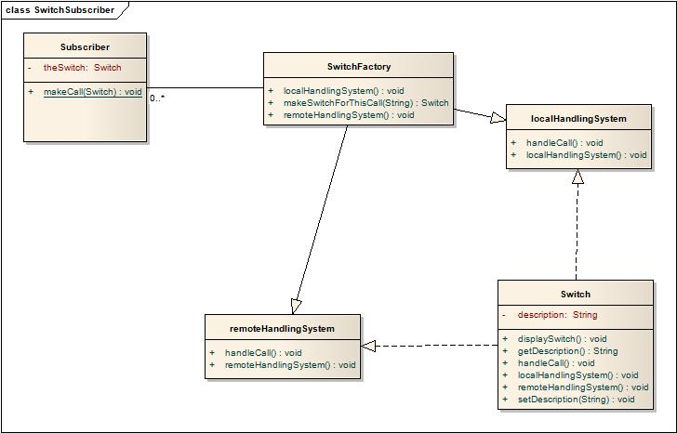Cohort Exercise 5

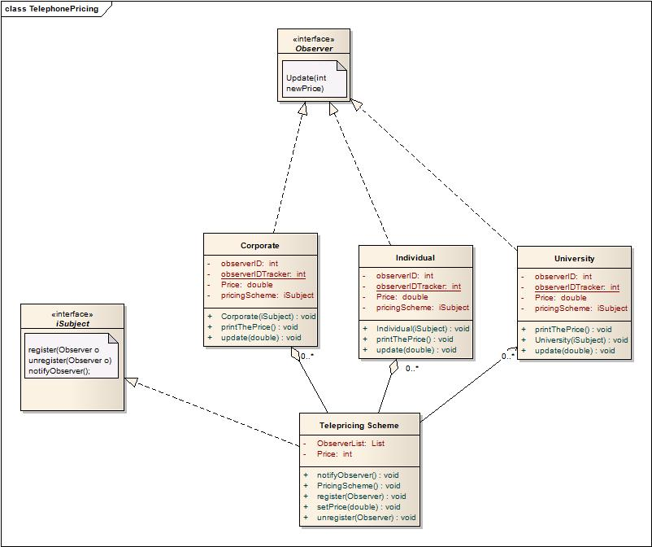Cohort Exercise 6

Homework Question 1:

Here, I used the MVC (Model, View Controller) design pattern. It decomposes the game into the model, the view and the controller subsystems.

Homework Question 2:

Here I used the Command design pattern. I created the *Candidate* interface, acting as a command. I have also created an *Electorate* class which acts as a request. I have Person A and Person B implementing *Candidate* interface which will do actual command processing. *Electorate* uses *Election* to demonstrate Election pattern.