For each host, record the percentage of packets sent that resulted in a successful response. Record also the minimum, average, and maximum round trip times for the packets that resultedd in a response

|  |  |  |  |  |
| --- | --- | --- | --- | --- |
| Website | Successful Percentage | Min RTT | Average RTT | Max RTT |
| www.csail.mit.edu | 100 | 4.446 | 10.140 | 21.5 |
| [www.berkeley.edu](http://www.berkeley.edu) | 100 | 198.646 | 258.697 | 330.078 |
| www.usyd.edu.au | 100 | 144.812 | 218.010 | 342.852 |
| www.kyoto-u.ac.jp | 100 | 82.931 | 89.931 | 95.794 |

Based on the above results, The first website has the shortest response time, followed by Kyoto university, UYSD university and lastly Berkeley university. This is because the time it takes to route to MIT’s server is the shortest, going through the fewest routers while Berkeley requires the most.

Repeat the exercise using packet sizes of 56, 512, and 1024 bytes. Record the minimum, average, and maximum round trip times for each of the packet sizes. Why are the minimum round-trip times to the same hosts different when using 56, 512, and 1024-byte packets?

|  |  |  |  |  |  |
| --- | --- | --- | --- | --- | --- |
| Website | Data byte packets | Successful Percentage % | Min RTT | Average RTT | Max RTT |
| [www.csail.mit.edu](http://www.csail.mit.edu) | 56 | 100 | 4.996 | 10.889 | 25.725 |
|  | 512 | 100 | 6.433 | 9.859 | 17.199 |
|  | 1024 | 0 |  |  |  |
| www.berkeley.edu | 56 | 100 | 197.432 | 297.165 | 582.712 |
|  | 512 | 100 | 201.268 | 234.335 | 299.291 |
|  | 1024 | 0 |  |  |  |
| www.uysd.edu.au | 56 | 100 | 147.118 | 243.177 | 511.716 |
|  | 512 | 100 | 146.202 | 228.544 | 446.127 |
|  | 1024 | 0 |  |  |  |
| [www.kyoto-u.ac.jp](http://www.kyoto-u.ac.jp) | 56 | 100 | 90.769 | 93.870 | 106.050 |
|  | 512 | 100 | 80.932 | 86.666 | 94.966 |
|  | 1024 | 0 |  |  |  |
|  |  |  |  |  |  |
|  |  |  |  |  |  |

Record the percentage of the packets sent to [www.wit.ac.za](http://www.wit.ac.za) that resulted in a successful response. What are some possible reasons why you may not have received a response? (Be sure to check the host in a web server)

This website had blocked ping requests for security reasons

Trace route is a utility that records the route (the specific gateway computers at each hop) through the Internet between your computer and a specified destination computer. It also calculates and displays the amount of time each hop took.

When entering the trace route command, the utility initiates the sending of a packet (using the Internet Control Message Protocol or ICMP) , including in the packet a time limit value (known as the “time to live” (TTL) that is designed to be exceeded by the first router that receives it, which will return a time exceeded message. This enables traceroute to determine the time required for the hop to the first router. Increasing the time limit value, it resends the packet so that it will reach the second router in the path to the destination, which returns another Time Exceeded message and so forth. Traceroute determines whether the packet has reached the destination by including a port number that is outside the normal range. When it’s received, a Port Unreachable message is returned, enabling traceroute to measure the time length of the final hop. As the trace routing progresses, the records are displayed for you hop by hop. Actually, each hop is measured three times.

Q4.

All packets were lost.

From Amsterdam:

Tracing route to 213.214.121.210 over a maximum of 30 hops.

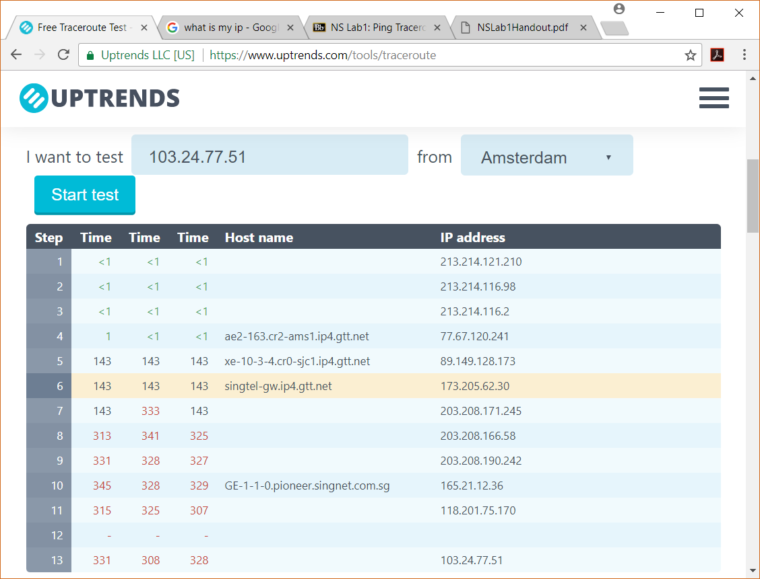

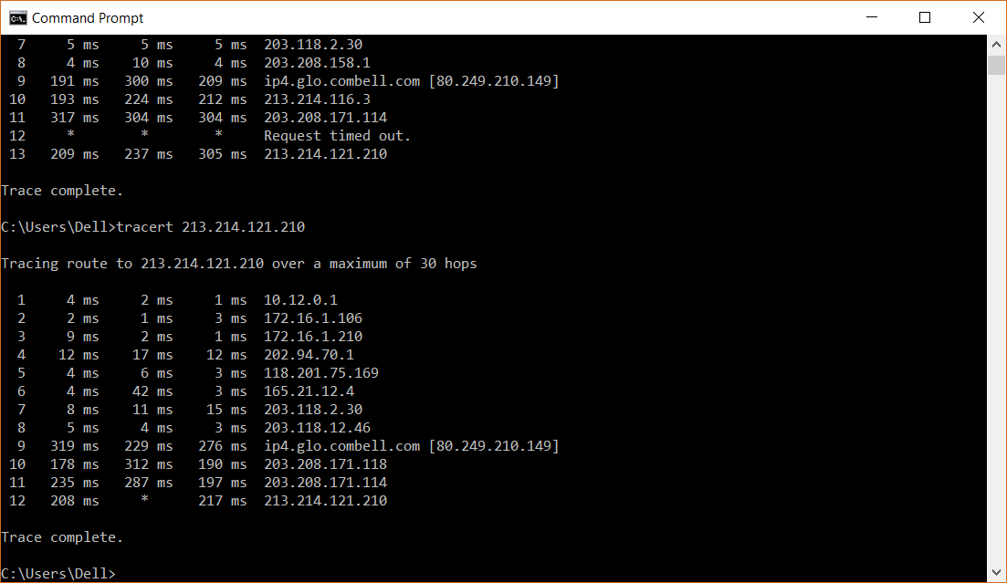Both outputs show that traceroute goes through a few local servers before going to router 118.201.75.X where X is the port number. The traceroute takes an average of 12 to 13 hops to get from one end to another.

The routes travelled are not exactly the same. They first go through local servers (172.16.1.X for this computer to Amsterdam and 213.214.121.X from Amsterdam) before going to a regional net (118.201.75.169, 165.21.12.4belongs to Singnet, 203.118.X.X belongs to Starhub IP and Internet Exchange,) moving across to another ISP (ip4.glo.combell.com at 80.249.210.149 belongs to Amsterdam Internet Exchange BV) before routing through a remote local server.

From New York

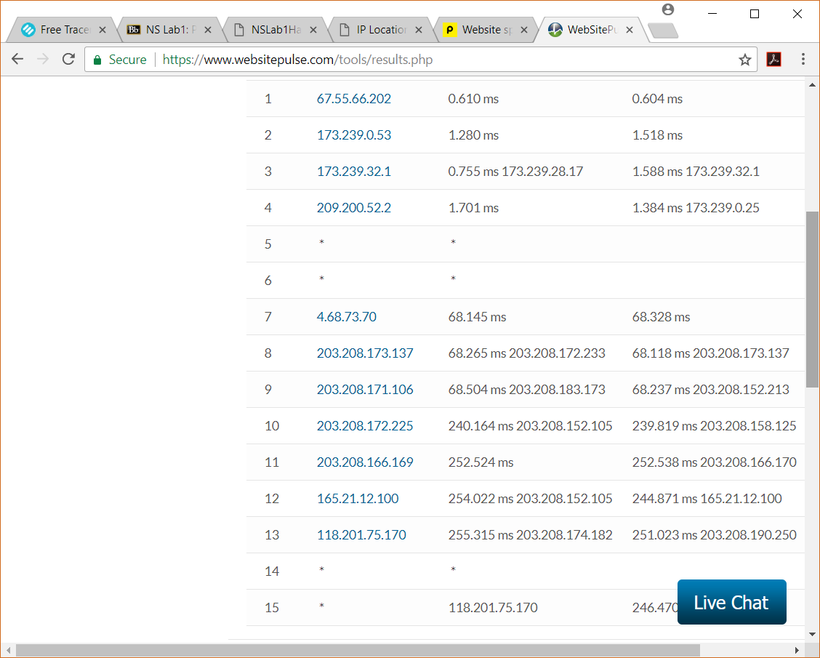

To New York

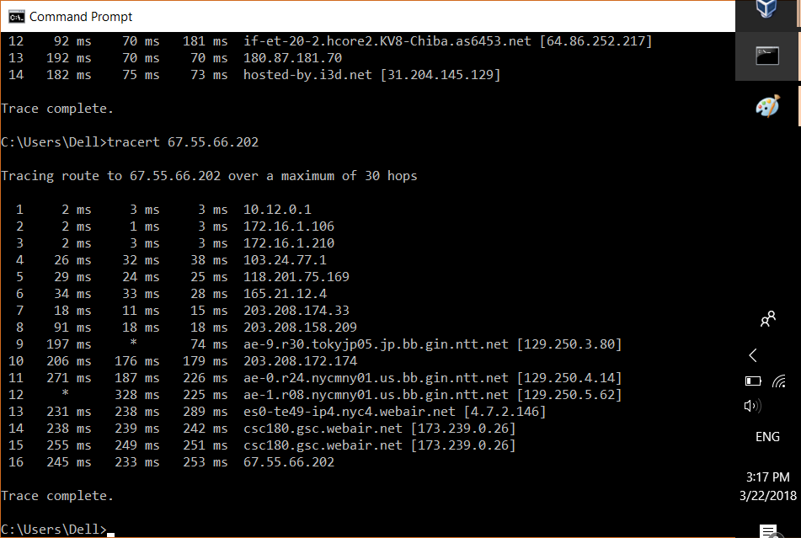

The connection of networks between New York and Singapore is less reliable (Asterisks indicating the loss of packets from Hop 9 and Hop 12 in the To New York and Hops 5 and 6 from New York) but still goes through the same principles of going from local ISP to local Exchange Point (Hop 8 on To New York route) to international ISP. It appears that Hop 9 on the To New York is a Japanese Internet Exchange Point and the route was re-routed back to Singapore before heading to NTT’s New York location and subsequently going through the local ISP in New York. It appears not to be an accident such that Hops 14 and 15 are towards the same IP address. It is possible that they are going from one port to another port on the same IP address.

From Tokyo

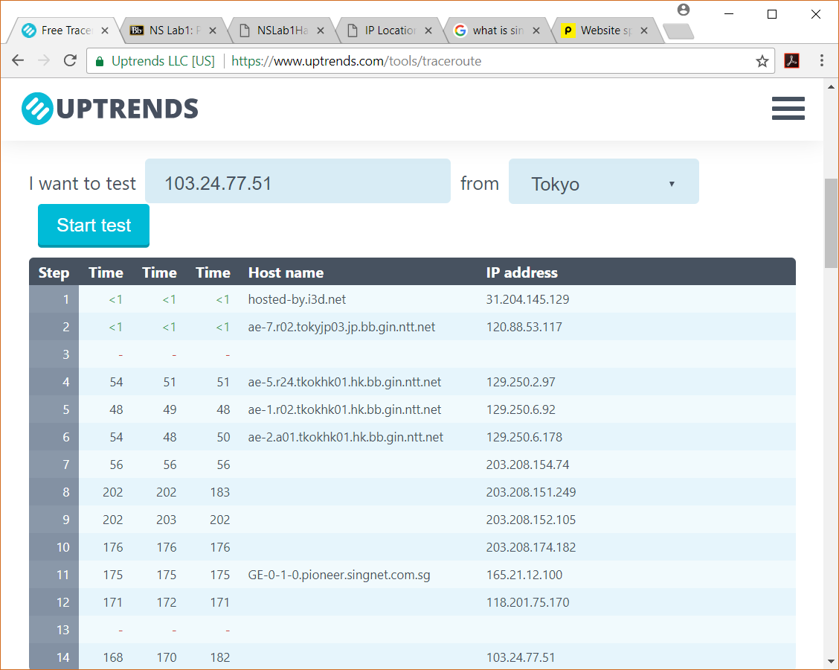To Tokyo

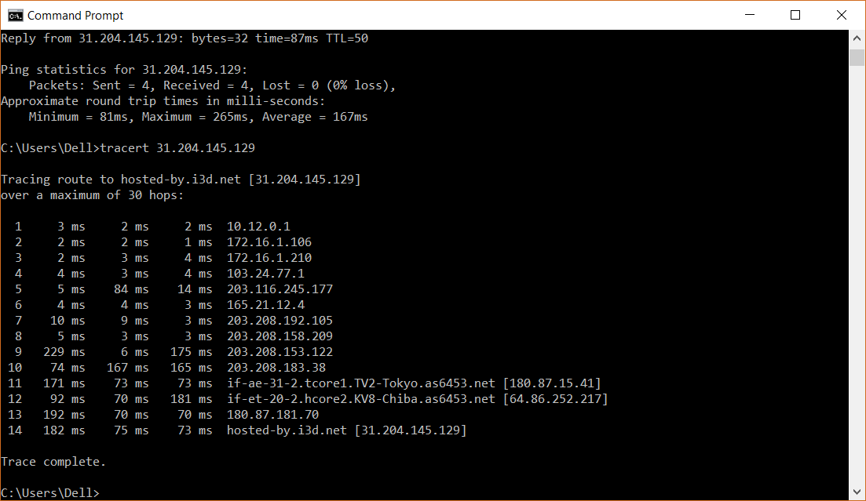Tracing from Singapore, It shares the first three hops with Amsterdam before going to a default ISP address(203.116.245.177) and opts to go to Singtel’s ISP) before heading to a Japanese ISP (Hops 11 and 12) before proceeding to the Tokyo ISP at Tata Communications Pte Ltd (Hop 14). From Tokyo, it appears to go through a different ISP (NTT Communications) before going to Singapore. Both still take 14 hops.