**What is the normal time required to download the webpage on h1 from h2**

1.039s wget time

**What was your initial expectation for the congestion window size over time:**

Increases like an exponential curve.

**After starting iperf on h1, did you observer something interesting in the ping RTT**

Ping slows down. From ping avg of 20ms to 138 ms

**After starting iperf on h1, why does the web page take so much longer to download?**

|  |
| --- |
| When you put it on a larger queue all packets get delayed due to bufferbloat. Packets from the high speed connection are delaying packets from the single wget command because it has to wait for more packets in the queue. |
|  |

**Please provide the figures for the first experiment (with qlen 100 and only one queue)**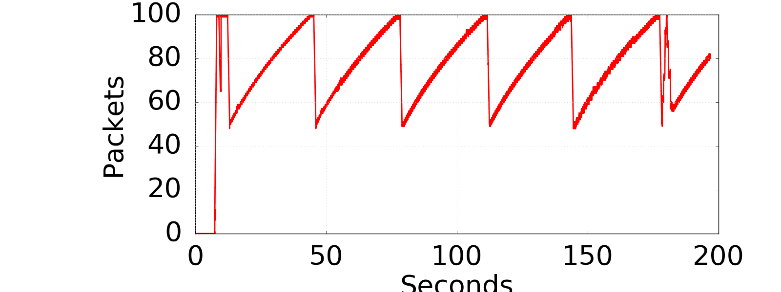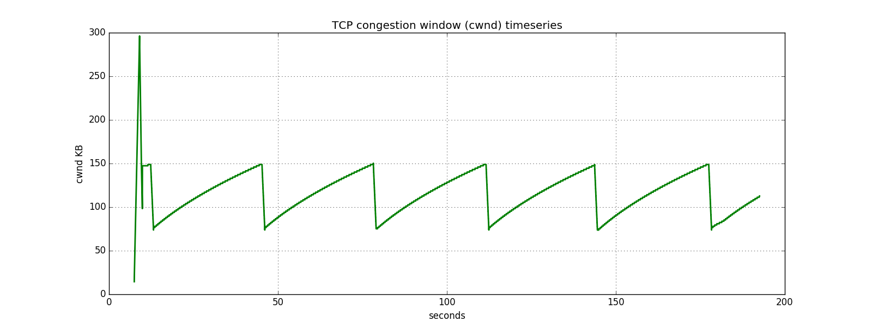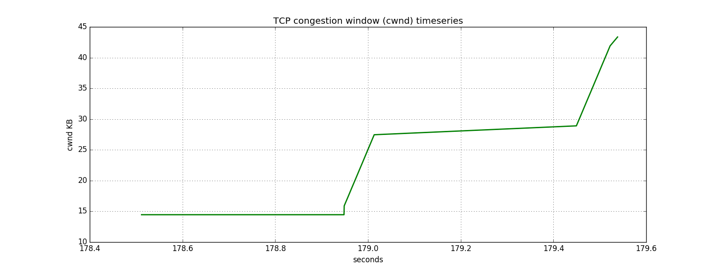

We see the sawtooth diagram that shows a drop from 150 KB in cwmd to 75 KB.

With a router buffer of 100 packets:

Average fetch time: 8.394

Standard Deviation of fetch times: 0.334738

**Please provide the figures for the first experiment (with qlen 20 and only one queue)**

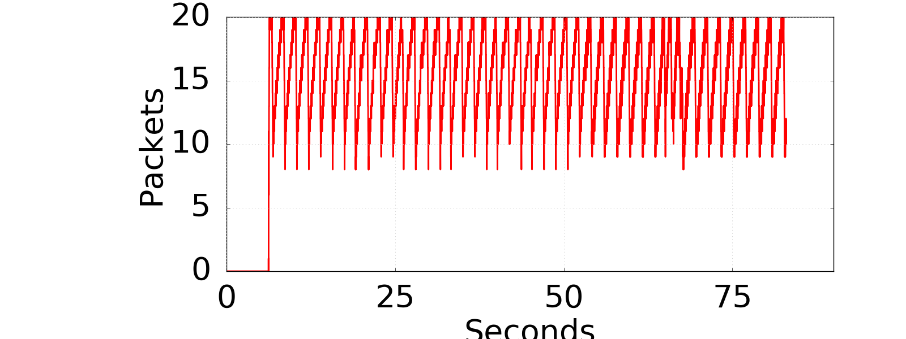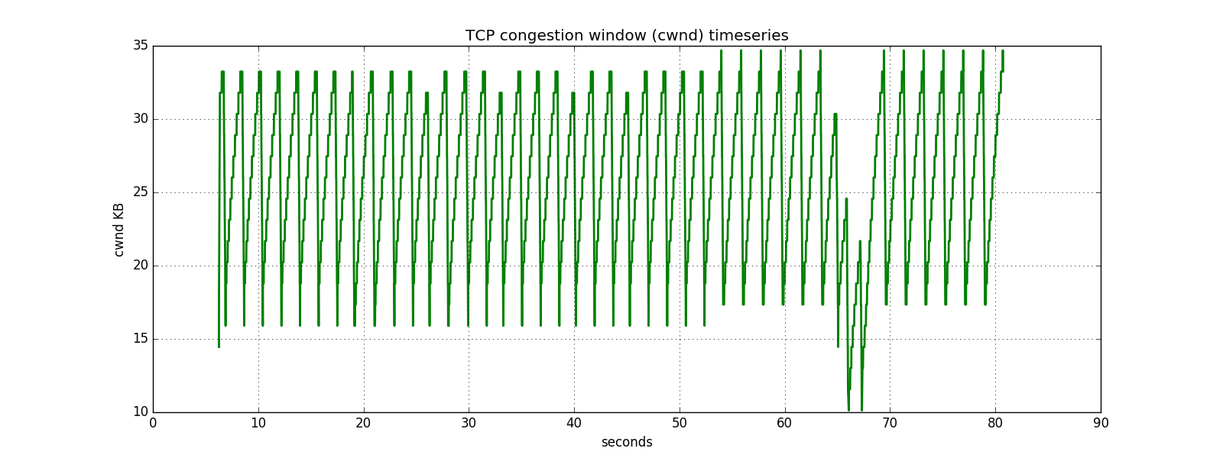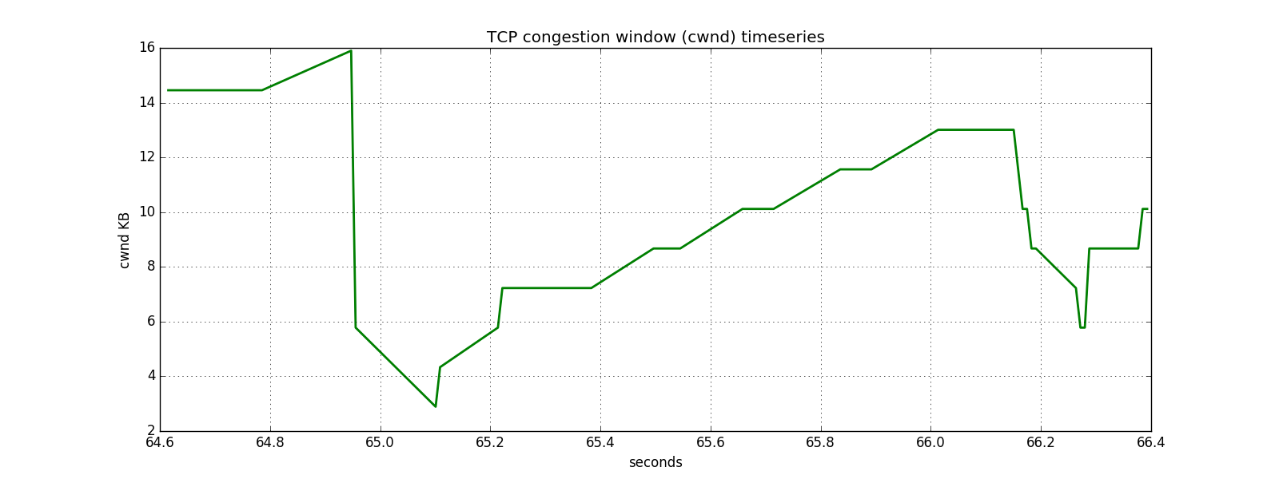

With a router buffer of 20 packets:

Average fetch time: 2.5063

Standard deviation of fetch times: 0.05473

**Comparison:**

The packets when the buffer is 100 packets long will wait in the queue instead of being dropped. The TCP will continue sending packets with a larger window, further bloating the buffer instead of reducing its window.

When the buffer is 20 packets, packets will be dropped and TCP will reduce its window. Thus, one (or a few) packets must be resent, which is less overhead than a large number of packets waiting in the buffer.