# Introduction

Last weekend I met my old friend from Moscow (capital of Russian Federation). That evening was amazing we haven’t met for three years. We talked some hours about our jobs, personal file and ideas about our future plans. Eventually he told me that he wants to start his own business. His choose is some strange for me because his is an engineer and wants to open a beer shop.

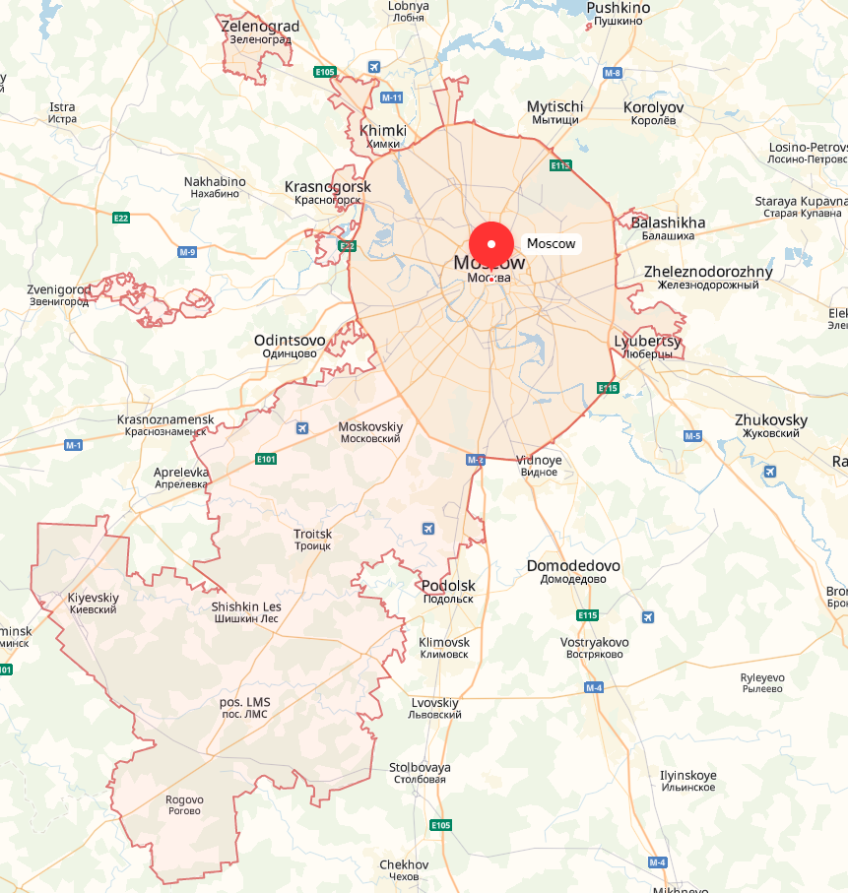Moscow is a big city. It is approximate 13000000 people. There are many business opportunities in big cities.

Moscow map

Moscow has been great extended over the last few years (some Moscow regions became the part of the city).

My friend has some amount of money that has saved over the past few years. This amount is enough to open a beer store, but not enough to advertise it, so he decided to choose a franchise shop. There are a lot of “craft beer” franchises in Moscow city. It depends on kind of beers, initial financial investments, monthly income and so on.

I decided to help him make a choice. It’s a good practice for me and helps to complete my Data Science specialization. So I decided to help my old friend.

He has already selected a franchise shops:

1. Pivoteka 465. <http://pivoteka465.ru/franshiza_pivoteka_465.html>

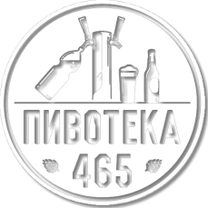

1. Kalinkino.

<http://kalinkino.com/franchise.html>



1. Pinta.

<http://pinta-company.ru/franshiza>.



1. Piv&ko

<https://franchise-pivko.ru>



1. BeerMag. <https://www.russtartup.ru/franchising/vsefranshiza/franchajzing-pivnogo-magazina-birmag.html>

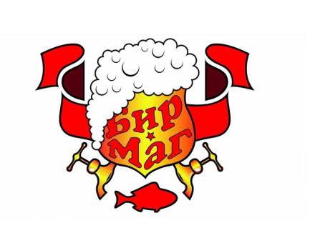

All these trademarks are really good. They are work very long time in Moscow but they are so different.

A good reason is to look up other trademarks.

# Customer requirements

My customer (my old friend) has these requirements:

1. My shop has to be located in the appropriate district.
2. My shop has to be located near my house.
3. I want to have back my investments as soon as possible.
4. What’s the best price/quality trademark

# Business problems

All the trademarks have different customers. That mainly depends on a menu, prices etc.

My customer doesn’t have so much money so he can’t choose really expensive franchise.

All the districts in Moscow city have different residents (according to monthly earnings). So a really expensive shop is not a good choice for all the districts.

My customer wants to have a shop near his house. He wants to get to the shop by car every day.

There are a lot of beer shops in the city. So there is no point in opening the shops near the same trademark shops. The place for the shop would be crowded.

The main business problems:

1. What is the best trademark according to menu and kind of beers?
2. What is the best trademark (according to my friend’s investments)?
3. What is the best place of the city to open a beer shop according to standard of living?
4. What is the most visited place for the shop?
5. What is the best place for the shop depending on city’s traffic jam?