**Purpose**

Terraform to deploy a Web Server in public subnet (within VPC)

**Resources Deployed**

* VPC - 1
* Subnet - 3
* Internet Gateway -1
* Nat gateway -1
* Security Group – 3
* Route Table – 2
* EC2 – 3
* ALB -1
* EIP – 3
* SSH Key -1

**Pre-Requisites**

1. Create a file called “**credentials**” in the folder location ->  **%USERPROFILE%\.aws\config** and add the access key id and secret access key of a user with a profile name [You can use the same keys as well**]**  
   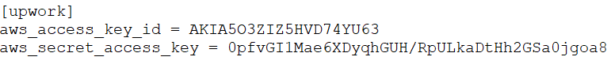
2. Download the Terraform.exe and put it in any folder you like
3. Add the Terraform.exe path to Environment variable  
   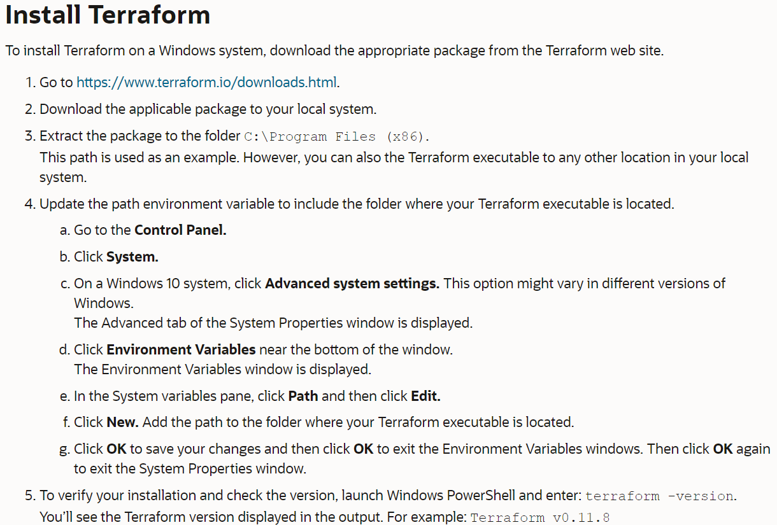

**Terraform Files**

1. In **provider.tf**, change the region name as you wish and update credentials file
2. In **Terraform.tfvars**, change the values as you wish, but note **AMI_ID** is region specific. Therefore, go to the AWS console and pick up your AMI ID in the specific region

**Commands**

1. Issue “**terraform init**” to install the required plugins
2. Issue “**terraform plan**” to see what are the resources deployed
3. Issue “**terraform apply**” and type “**yes**” to deploy the resources. IP Address of the EC2s/ALB will be shown in the output
4. View the web page (Check after 3 minutes, as packages are installed in background)
5. Issue “**terraform destroy**” and type “**yes**” to destroy all the resources