**Script Details**

1. The script is named as “**Word-Analyzer.ps1**”
2. This script takes “**Folder**” as parameter where “.doc” and “.docx” files are located. Folder path should be Full Path. The script recursively searches for child sub directories and filters files with above extensions only
3. Executing the script –
   * Change to the folder where script located
   * .\Word-Analyzer.ps1 -Folder <Full Path>

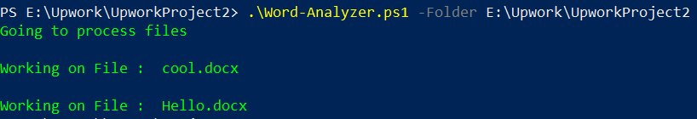

1. The script stores the output in “**Details_WordDocs.csv**” file in the current directory.
2. Following details about “.doc” and “.docx” are captured,
   1. File Name
   2. File Path
   3. Author
   4. Last author – (Last Modified By)
   5. Creation date
   6. Last save time (Last Modified Time)
   7. Number of pages
   8. Number of words
   9. Number of characters
   10. Number of characters (with spaces)
   11. No of Images