ASSIGNMENT 4
NEWTON-RAPHSON METHOD
Formula: $xₙ₊₁ = xₙ -\frac{ f(xₙ)}{f'(xₙ)}$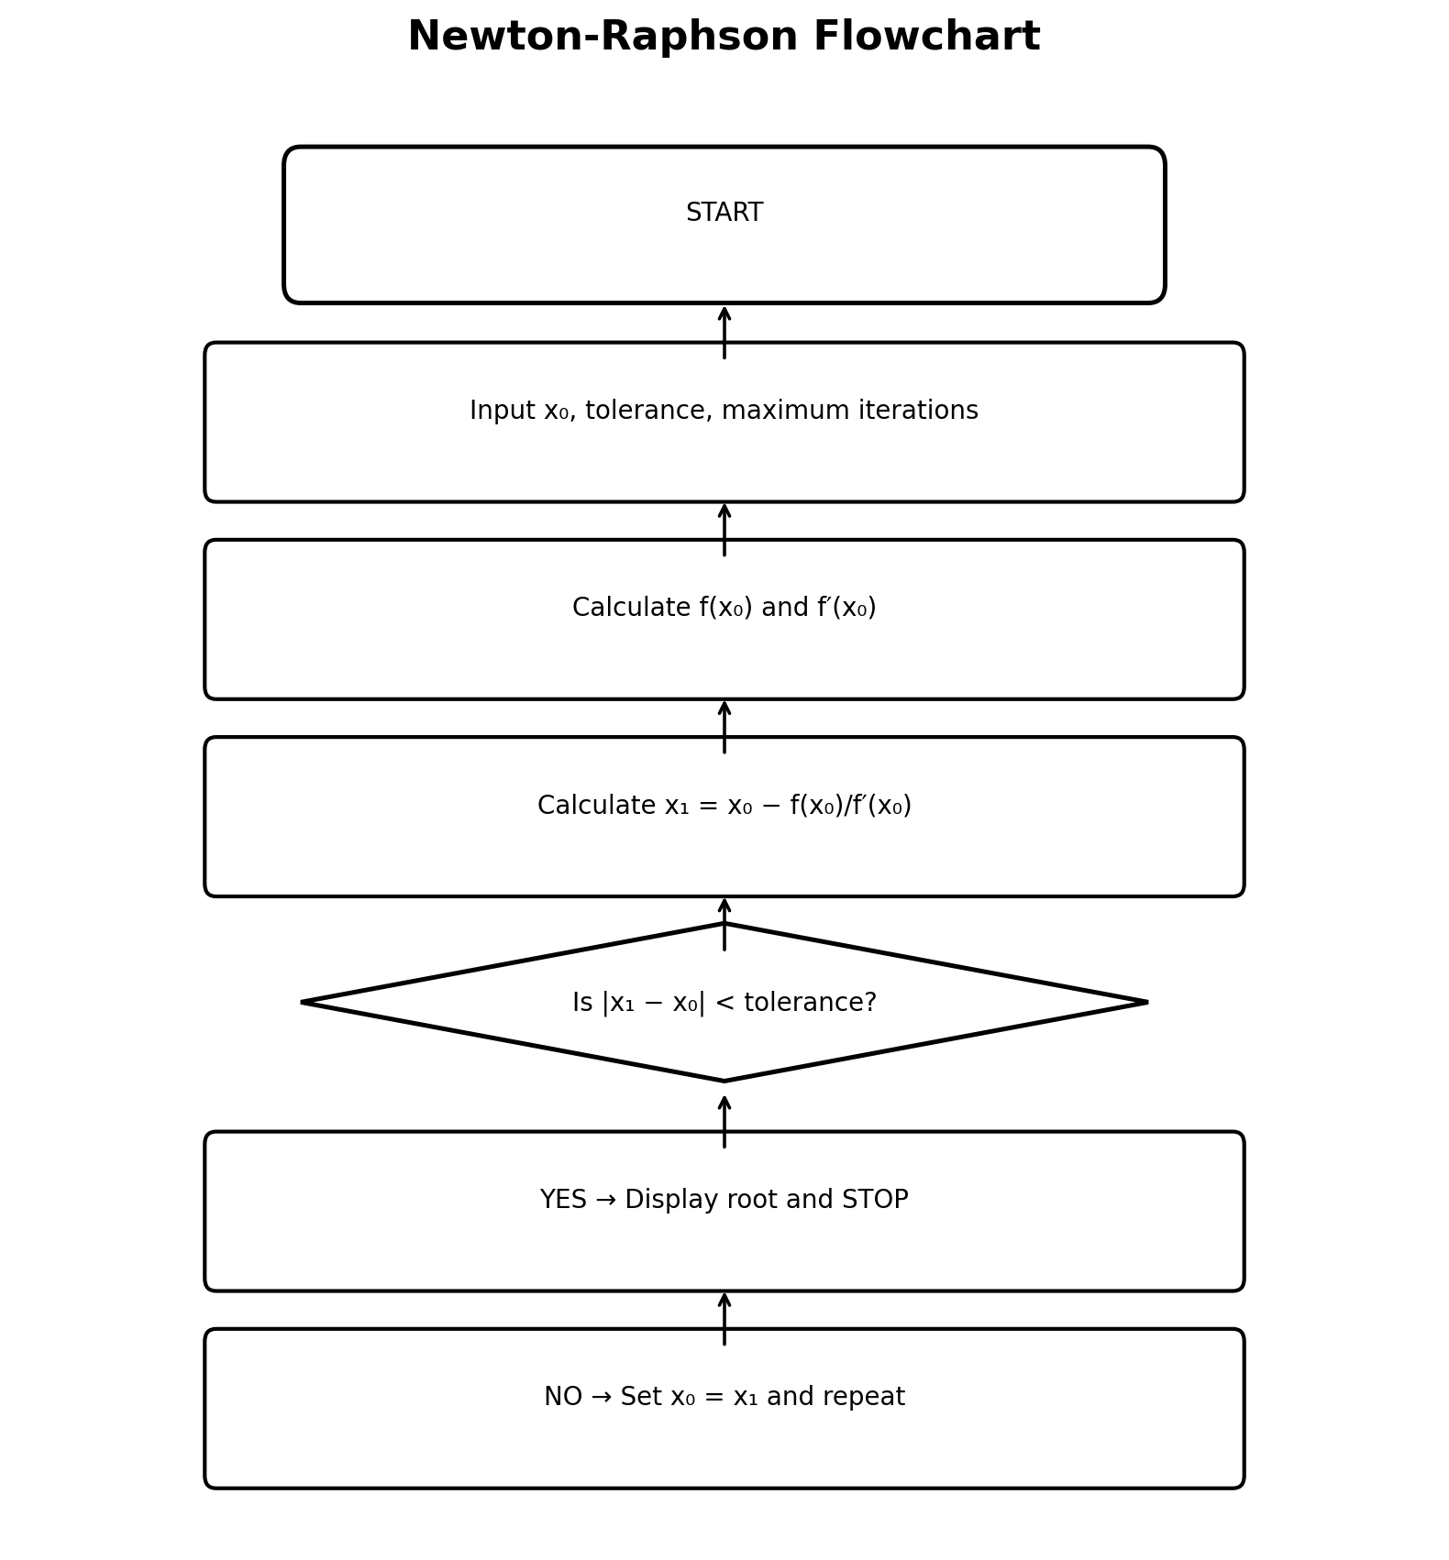
Newton-Raphson Pseudocode
START
Input x0, tolerance and maximum iterations
FOR n = 1 to maximum iterations
Calculate f(x0) and f′(x0)
x1 = x0 − f(x0)/f′(x0)
error = |x1 − x0|
IF error < tolerance, display x1 and STOP
x0 = x1
END FOR
Display root
STOP
Newton-Raphson MATLAB — FOR loop
clc;
clear;
close all;
f = @(x) x.^3 + 7*x.^2 + 5*x - 4;
df = @(x) 3*x.^2 + 14*x + 5;
x = 0;
tol = 1e-8;
maxIter = 100;
for n = 1:maxIter
xnew = x - f(x)/df(x);
if abs(xnew-x) < tol
break
end
x = xnew;
end
fprintf('Root = %.10f\n',xnew);

Newton-Raphson MATLAB — WHILE loop
clc;
clear;
close all;
f = @(x) x.^3 + 7*x.^2 + 5*x - 4;
df = @(x) 3*x.^2 + 14*x + 5;
x = 0; tol = 1e-8; err = Inf; n = 0; maxIter = 100;
while err > tol && n < maxIter
xnew = x - f(x)/df(x);
err = abs(xnew-x);
x = xnew;
n = n + 1;
end
fprintf('Root = %.10f\n',x);

SECANT METHOD
Formula: $xₙ₊₁ = xₙ - \frac{f(xₙ)(xₙ-xₙ₋₁)}{ [f(xₙ)-f(xₙ₋₁)]}$
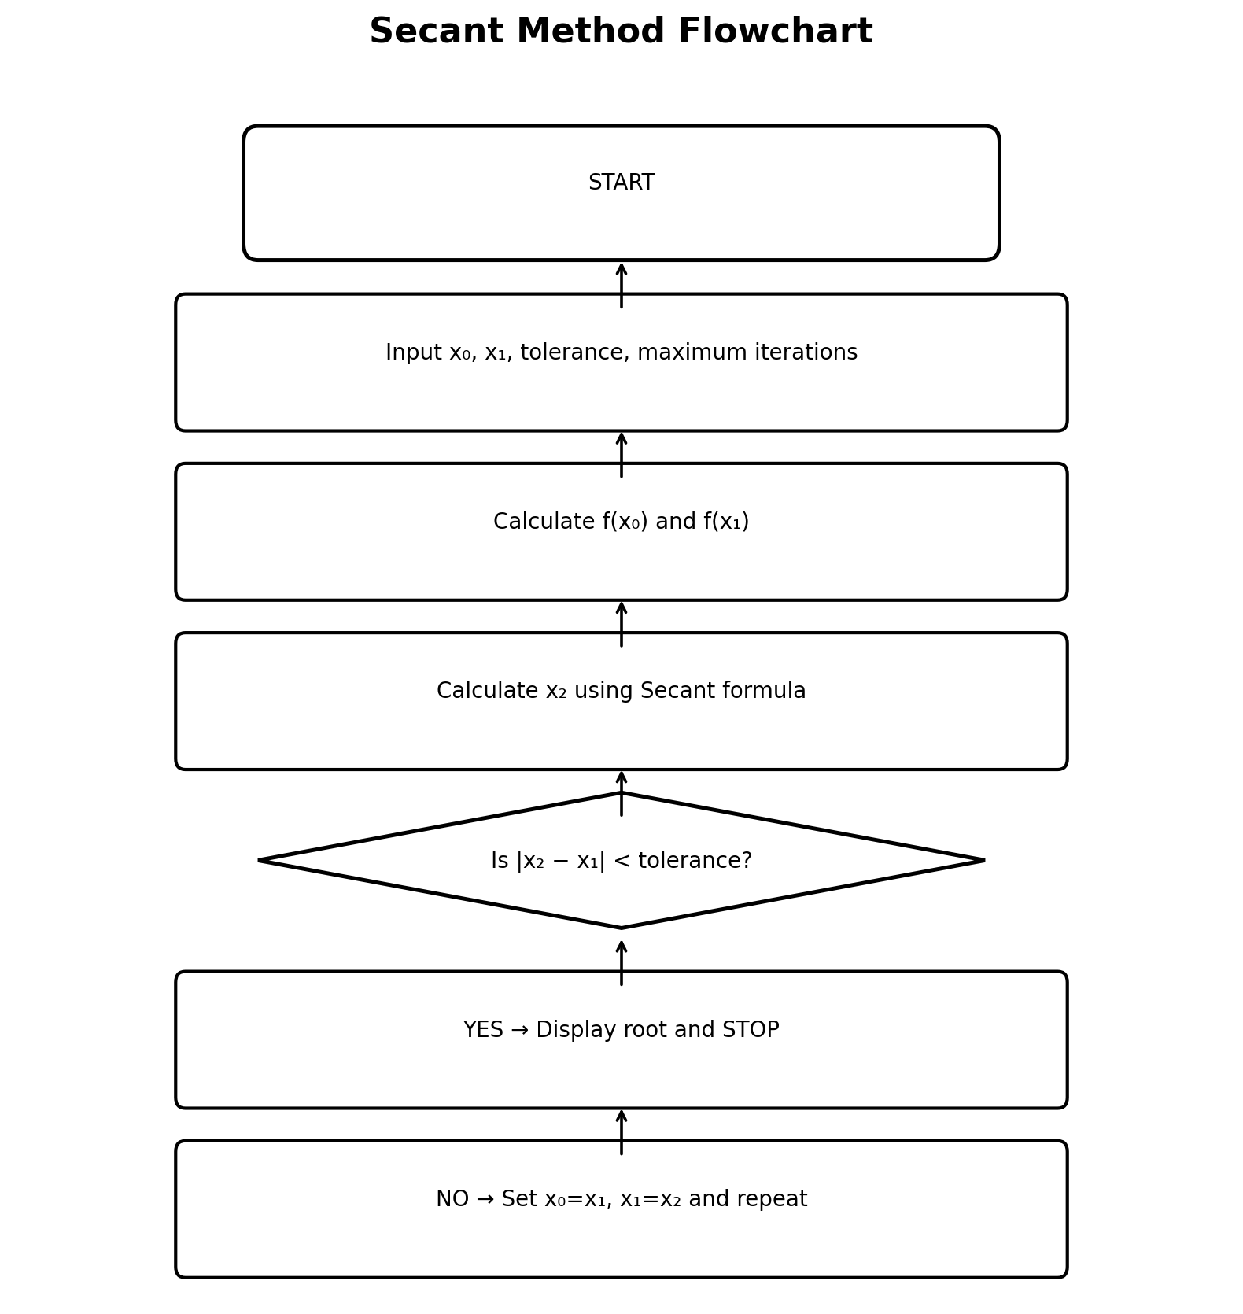

Secant Pseudocode
START
Input x0, x1, tolerance and maximum iterations
FOR n = 1 to maximum iterations
Calculate x2 using the Secant formula
error = |x2 − x1|
IF error < tolerance, display x2 and STOP
x0 = x1
x1 = x2
END FOR
Display root
STOP

Secant MATLAB — FOR loop
clc;
clear;
close all;
f = @(x) x.^3 + 7*x.^2 + 5*x - 4;
x0 = 0; x1 = 1; tol = 1e-8; maxIter = 100;
for n = 1:maxIter
x2 = x1 - f(x1)*(x1-x0)/(f(x1)-f(x0));
if abs(x2-x1) < tol
break
end
x0 = x1;
x1 = x2;
end
fprintf('Root = %.10f\n',x2);

Secant MATLAB — WHILE loop
clc;
clear;
close all;
f = @(x) x.^3 + 7*x.^2 + 5*x - 4;
x0 = 0;
x1 = 1;
tol = 1e-8;
err = Inf;
n = 0;
maxIter = 100;
while err > tol && n < maxIter
x2 = x1 - f(x1)*(x1-x0)/(f(x1)-f(x0));
err = abs(x2-x1);
x0 = x1;
x1 = x2;
n = n + 1;
end
fprintf('Root = %.10f\n',x1);

RUNGE-KUTTA 4TH ORDER (RK4)
dy/dt = −F(y)/F′(y),
$$RK4:$$
$$k1=g(y_{n});$$
$$k2=g(y_{n}+hk\frac{1}{2});$$
$$k2=g(y_{n}+hk\frac{2}{2});$$
$$k2=g(y_{n}+hk\frac{3}{2});$$
$y_{(n+1)}=y_{n}+h(k1+2k2+2k3+k4)/6.$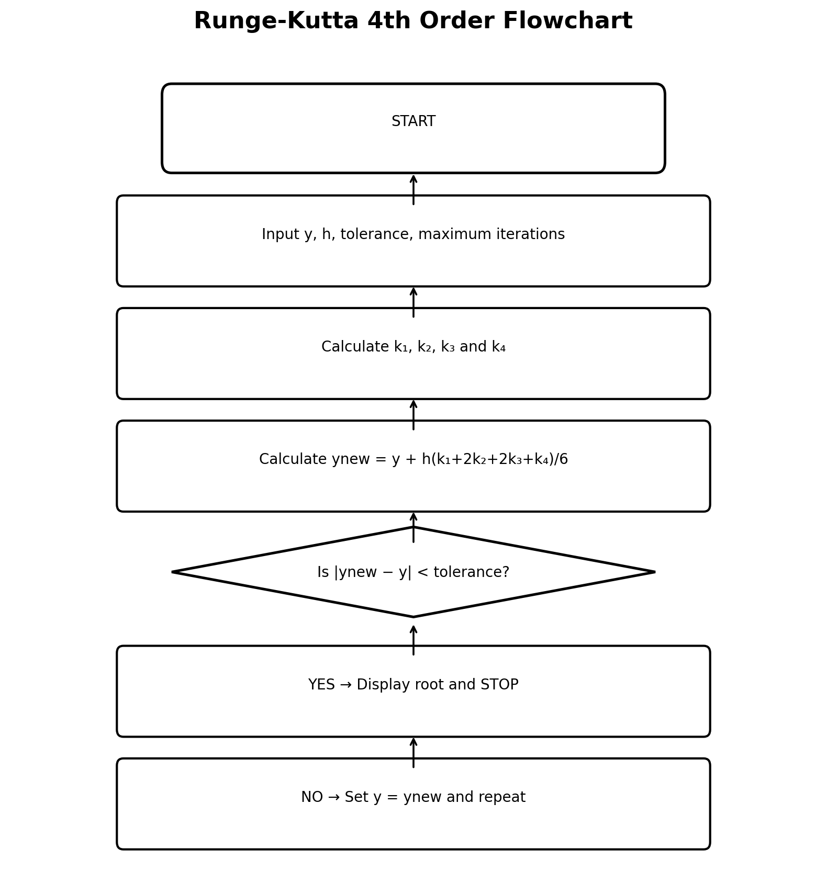
RK4 Pseudocode
START
Input y, h, tolerance and maximum iterations
Define g(y) = −F(y)/F′(y)
FOR n = 1 to maximum iterations
Calculate k1, k2, k3 and k4
ynew = y + h(k1+2k2+2k3+k4)/6
error = |ynew − y|
IF error < tolerance, display ynew and STOP
y = ynew
END FOR
Display root
STOP

RK4 MATLAB — FOR loop
clc;
clear;
close all;

F = @(y) y.^3 + 7*y.^2 + 5*y - 4;
dF = @(y) 3*y.^2 + 14*y + 5;
g = @(y) -F(y)./dF(y);
y = 0.5; h = 0.01; tol = 1e-8; maxIter = 10000;
for n = 1:maxIter
k1 = g(y);
k2 = g(y + h*k1/2);
k3 = g(y + h*k2/2);
k4 = g(y + h*k3);
ynew = y + h*(k1+2*k2+2*k3+k4)/6;
if abs(ynew-y) < tol
break
end
y = ynew;
end
fprintf('Root = %.10f\n',ynew);

RK4 MATLAB — WHILE loop
clc;
clear;
close all;

F = @(y) y.^3 + 7*y.^2 + 5*y - 4;
dF = @(y) 3*y.^2 + 14*y + 5;
g = @(y) -F(y)./dF(y);
y = 0.5; h = 0.01; tol = 1e-8;
err = Inf; n = 0; maxIter = 10000;
while err > tol && n < maxIter
k1 = g(y);
k2 = g(y + h*k1/2);
k3 = g(y + h*k2/2);
k4 = g(y + h*k3);
ynew = y + h*(k1+2*k2+2*k3+k4)/6;
err = abs(ynew-y);
y = ynew;
n = n + 1;
end
fprintf('Root = %.10f\n',y);

Final Results
Method | Root 1 | Root 2 | Root 3
Newton-Raphson | −6.06724009 | −1.40274987 | 0.46998995
Secant | −6.06724009 | −1.40274987 | 0.46998995
RK4 continuous Newton | ≈−6.06724009 | ≈−1.40274987 | ≈0.46998995

