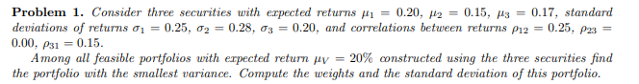

m is: [0.2 0.15 0.17]

u is: [1 1 1]

C matrix is:

[[0.0625 0.0175 0.0075]

[0.0175 0.0784 0. ]

[0.0075 0. 0.04 ]]

here is the inverse of C:

[[17.4863388 -3.90320062 -3.27868852]

[-3.90320062 13.62635218 0.73185012]

[-3.27868852 0.73185012 25.6147541 ]]

calculating M:

Intermediate Calculations:

M\*C^-1 = [2.35441062 1.38772722 3.80854801]

u\*C^-1 = [10.30444965 10.45500167 23.06791569]

here is M:

[[ 1.32649437 7.55068585]

[ 7.55068585 43.82736701]]

here is M inverse:

[[38.99583251 -6.71829728]

[-6.71829728 1.18026146]]

The weight in minimum variance portfolio is:

[0.2351145 0.23854962 0.52633588]

The Expected return of the MVP is:

0.17228244274809162

Variance is:

intermediate calculation: w\*c = [0.02281679 0.02281679 0.02281679]

wCwT = Varinace =

0.022816793893129773

The Std.Dev of the portfolio is:

0.1510522886060644

\*\*\*\*\*\*\*\*\*\*\*\*\*\*\*\*\*\*\*\*

calculating for a and b:

[a, b].T = M^-1 \* [m, u].T \* C^-1

this is vector a: [ 22.583846 -16.124231 -6.459615]

this is vector b: [-3.65568565 3.01647152 1.63921413]

a, b doesnt change for each portfolio on the minimum variance line

to get the weights that satisfy a specific E[Kv],

we solve the linear equation: w = mu \* a + b

w = [ 0.86108355 -0.20837468 0.34729113]

Variance is:

intermediate calculation: w\*c = [ 0.05277585 -0.00126761 0.02034977]

wCwT = Varinace =

0.052775848382615884

The Std.Dev of the portfolio is:

0.22972994663869115

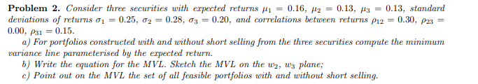

m is: [0.16 0.13 0.13]

u is: [1 1 1]

C matrix is:

[[0.0625 0.021 0.0075]

[0.021 0.0784 0. ]

[0.0075 0. 0.04 ]]

here is the inverse of C:

[[18.02816901 -4.82897384 -3.38028169]

[-4.82897384 14.04857718 0.9054326 ]

[-3.38028169 0.9054326 25.63380282]]

calculating M:

Intermediate Calculations:

M\*C^-1 = [1.81730382 1.17138546 2.90925553]

u\*C^-1 = [ 9.81891348 10.12503593 23.15895372]

here is M:

[[ 0.82125194 5.89794481]

[ 5.89794481 43.10290313]]

here is M inverse:

[[70.36176802 -9.6278857 ]

[-9.6278857 1.34062289]]

The weight in minimum variance portfolio is:

[0.22780167 0.2349038 0.53729452]

The Expected return of the MVP is:

0.1368340502150645

Variance is:

intermediate calculation: w\*c = [0.02320029 0.02320029 0.02320029]

wCwT = Varinace =

0.023200293421359743

The Std.Dev of the portfolio is:

0.1523164253170345

calculating for a and b:

[a, b].T = M^-1 \* [m, u].T \* C^-1

this is vector a: [ 33.33333333 -15.06193694 -18.2713964 ]

this is vector b: [-4.33333333 2.29588964 3.03744369]

for mu = 0:

w = [-4.33333333 2.29588964 3.03744369]

for mu = 0.1:

w = [-1. 0.78969595 1.21030405]

mu=0, w2 = 2.2958896396396455

mu=0, w3 = 3.0374436936937044

mu=0.1, w'2 = 2.2958896396396455

mu=0.1, w'3 = 3.0374436936937044

equation for slope: slope = (w3 - w'3) / (w2 - w'2)

slope = 1.2130841121495333, for graph with (x var: w2, y var: w3)

equation for the line on plane (x var: w2, y var: w3):

= 1.2130841121495333 \* w2 + 0.252336448598133

sample points:

0 1 2 3 4 5

x axis 0.000000 0.200000 0.40000 0.600000 0.800000 1.000000

y axis 0.252336 0.494953 0.73757 0.980187 1.222804 1.465421

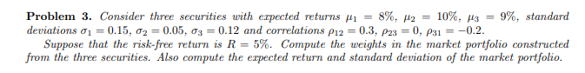

m is: [0.08 0.1 0.09]

u is: [1 1 1]

C matrix is:

[[ 0.0225 0.00225 -0.0036 ]

[ 0.00225 0.0025 0. ]

[-0.0036 0. 0.0144 ]]

here is the inverse of C:

[[ 51.08556833 -45.97701149 12.77139208]

[-45.97701149 441.37931034 -11.49425287]

[ 12.77139208 -11.49425287 72.63729246]]

\*\*\*\*\*\*\*\*\*\*\*\*\*\*\*\*\*\*\*\*

weights in a market portfolio = ((m-R\*u) \* C^-1)/((m-R\*u)\* C^-1 \* uT)

intermediate steps: m-R\*u = [0.03 0.05 0.04]

(m-R\*u)\* C^-1 = [-0.25542784 20.22988506 2.71392082]

market portfolio weights = [-0.01125809 0.89164087 0.11961722]

expected value is 0.09902898958626513

Variance is:

intermediate calculation: w\*C = [0.00132226 0.00220377 0.00176302]

wCwT = Varinace = 0.0021609737599800507

The Std.Dev of the portfolio is:

0.04648627496347767

