ASESMEN STRUKTUR DATA – 18/11/25
IF-12-07
Nama : Keishin Naufa Alfaridzhi
NIM : 103112400061

- SOURCE CODE

- Soal 1:
#include <iostream>
#include <string>
using namespace std;

struct Node {
string data;
Node* next;
};

Node* head = nullptr;

Node* createNode(string data) {
Node* newNode = new Node();
newNode->data = data;
newNode->next = nullptr;
return newNode;
}

void insertFront(string data) {
Node* newNode = createNode(data);
newNode->next = head;
head = newNode;
cout << "Data inserted di depan: " << data << endl;
}

void insertBehind(string data) {
Node* newNode = createNode(data);
if (head == nullptr) {
head = newNode;
} else {
Node* temp = head;
while (temp->next != nullptr) {
temp = temp->next;
}
temp->next = newNode;
}
}

void deleteNode(string data) {
if (head == nullptr) {
cout << "List empty.\n";
return;
}

Node* temp = head;
Node* prev = nullptr;

if (temp != nullptr && temp->data == data) {
head = temp->next;
delete temp;
cout << "Data " << data << " deleted successfully\n";
return;
}

while (temp != nullptr && temp->data != data) {
prev = temp;
temp = temp->next;
}

if (temp == nullptr) {
cout << "No data.\n";
return;
}

prev->next = temp->next;
delete temp;
cout << "Data " << data << " deleted successfully\n";
}

void printInfo() {
if (head == nullptr) {
cout << "No data.\n";
return;
}

Node* temp = head;
cout << "Data pesanan:\n";
while (temp != nullptr) {
cout << temp->data << " -> ";
temp = temp->next;
}
cout << "NULL\n";
}

int main() {
int input;
string data;

do {
cout << "\n === Warung Nasi Huy cabang Sumampir ===\n";
cout << "1. Insert Front\n";
cout << "2. Insert Behind\n";
cout << "3. Delete Data\n";
cout << "4. Print List\n";
cout << "0. Exit\n";
cout << "Inputkan disini le: ";
cin >> input;

switch (input) {
case 1:
cout << "Insert data (depan): ";
cin >> data;
insertFront(data);
printInfo();
break;
case 2:
cout << "Insert data (balakang): ";
cin >> data;
insertBehind(data);
printInfo();
break;
case 3:
cout << "Delete data: ";
cin >> data;
deleteNode(data);
printInfo();
break;
case 4:
printInfo();
break;
default:
cout << "Input invalid.\n";
}
} while (input != 0);
}

Output & Langkah:
- 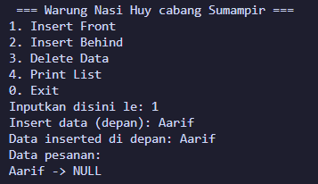 2. 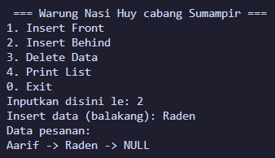
3. 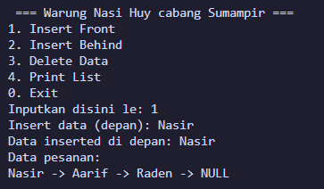 4. 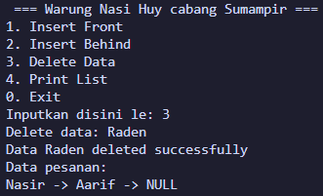
5. 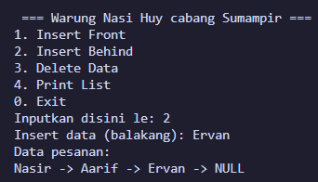 Output akhir
Penjelasan:
Program antrian warung menggunakan singly linked-list. Dapat melakukan insert pada belakang atau depan antrian.
- InsertFront(): insert paling depan antrian, dengan cara memundurkan antrian lainnya sebanyak 1 kali, lalu masukkan antrian baru pada head.
- InsertBehind(): insert paling belakang antrian, dengan cara iterasi dari head hingga antrian akhir, lalu masukkan antrian baru pada next (setelah antrian akhir).
- deleteData(): Menghapus antrian paling depan (head) lalu menggeser antrian lainnya ke depan sebanyak 1 kali.

- Soal 2:
#include <iostream>
#include <string>
using namespace std;

struct Stack {
string info[20];
int top;
};

void CreateStack(Stack &S) {
S.top = -1;
}

void push(Stack &S, string x) {
if (S.top < 19) {
S.top++;
S.info[S.top] = x;
} else {
cout << "Stack full.\n";
}
}

string pop(Stack &S) {
if (S.top >= 0) {
string x = S.info[S.top];
S.top--;
return x;
} else {
cout << "Stack empty.\n";
return " ";
}
}

void printInfo(const Stack &S) {
if (S.top == -1) {
cout << "Stack empty.\n";
} else {
cout << "[TOP] ";
for (int i = S.top; i >= 0; i--) {
cout << S.info[i] << " ";
}
cout << endl;
}
}

int main() {
Stack S;
Stack meja;
CreateStack(S);

push(S, "K");
push(S, "E");
push(S, "I");
push(S, "S");
push(S, "H");
push(S, "I");
push(S, "N");
cout << "Stack S:";
printInfo(S);

push(meja, pop(S));
push(meja, pop(S));
push(meja, pop(S));
push(meja, pop(S));
push(meja, pop(S));
push(meja, pop(S));
push(meja, pop(S));

cout << "Stack meja:";
printInfo(meja);
cout << "Stack S:";
printInfo(S);
}
Output:
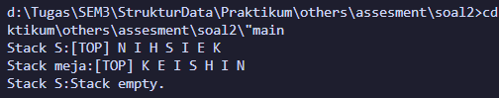

Penjelasan:
Program puzzle stack. Memasukkan (push) huruf secara terurut kemudian mengambilnya (pop) kembali untuk menyusun kata sebenarnya. Dilakukan dengan syntax “push(meja, pop(S))”.
- push(): Memasukkan huruf ke dalam stack, first in last out.
- pop(): Mengambil huruf paling atas (top).

- Soal 3:
#include <iostream>
using namespace std;

const int MAX = 10;

struct Queue {
string info[MAX];
int head, tail;
};

void CreateQueue(Queue &Q) {
Q.head = -1;
Q.tail = -1;
}

bool isEmptyQueue(const Queue &Q) {
return (Q.head == -1 && Q.tail == -1);
}

bool isFullQueue(const Queue &Q) {
return (Q.tail + 1) % MAX == Q.head;
}

void enqueue(Queue &Q, string x) {
if (isFullQueue(Q)) {
cout << "Queue full.\n";
} else {
if (isEmptyQueue(Q)) {
Q.head = Q.tail = 0;
} else {
if (Q.tail == MAX - 1) {
Q.tail = 0;
} else {
Q.tail++;
}
}
Q.info[Q.tail] = x;
cout << "Antrian masuk: " << x << endl;
}
}

string dequeue(Queue &Q) {
if (isEmptyQueue(Q)) {
cout << "Queue empty.\n";
} else {
cout << "Dequeue: " << Q.info[Q.head] << endl;
if (Q.head == Q.tail) {
Q.head = Q.tail -1;
} else
if (Q.head == MAX - 1) {
Q.head = 0;
} else {
Q.head++;
}
}
}

void printInfo(const Queue &Q) {
if (isEmptyQueue(Q)) {
cout << "Queue empty.\n";
} else {
cout << "Queue: ";
int i = Q.head;

while (i != Q.tail) {
cout << Q.info[i] << " -> ";
i = (i + 1) % MAX;
}

cout << Q.info[Q.tail] << " \n";
}
}

int main() {
Queue Q;
CreateQueue(Q);
int input;
string data;

do {
cout << "\n === Antrean ===\n";
cout << "1. Enqueue\n";
cout << "2. Dequeue\n";
cout << "3. Print List\n";
cout << "0. Exit\n";
cout << "Inputkan disini le: ";
cin >> input;

switch (input) {
case 1:
cout << "Tambah antrean: ";
cin >> data;
enqueue(Q, data);
printInfo(Q);
break;
case 2:
cout << "Dequeue antrean: ";
dequeue(Q);
printInfo(Q);
break;
case 3:
printInfo(Q);
break;
default:
cout << "Input invalid.\n";
}
} while (input != 0);
}

Output & Langkah:
- 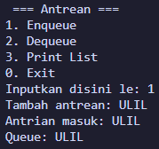 2. 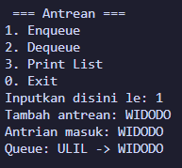
3. 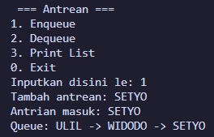 4. 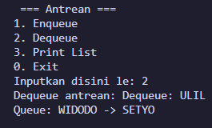
5. 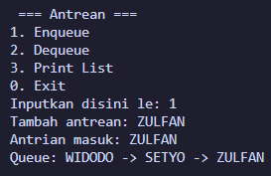 6. 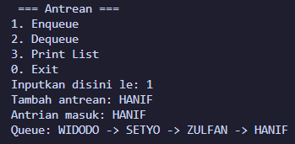
7. 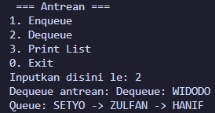
8. 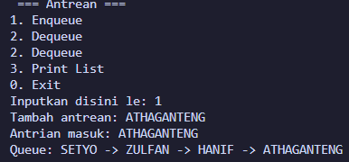 Output akhir
Penjelasan:
Program antrean apotek dengan circular queue. Antrean dilakukan secara terurut.
- enqueue(): menambahkan antrian pada paling belakang (tail).
- dequeue(): mengambil antrian pada paling depan (head).

