📈 TraderAI Pro

AI-Powered Trading Dashboard for Day Traders

🌐 Live Demo

👉 Click Here to Try TraderAI Pro

📋 Project Overview
TraderAI Pro is a comprehensive AI-powered trading dashboard developed as the final project for the TalentSprint AIML Program (Stage 2).
Project | Database and GenAI-Powered Visualization Tool for Day Traders
Domain | Financial Services
Author | Rishi
Version | F
Program | TalentSprint AIML - Stage 2

✨ Key Features

🌍 Multi-Market Support
- 22 Global Markets: US, India, UK, Germany, Japan, France, China, Hong Kong, Australia, Canada, Brazil, Korea, Singapore, Switzerland, and more
- Alternative Assets: Crypto, ETF, Forex, Commodities
- Multi-Currency: $, ₹, £, €, ¥, and more

📊 Technical Analysis
- Real-time Charts: Interactive candlestick charts with zoom/pan
- Indicators: RSI, MACD, SMA (20/50), Bollinger Bands
- Signals: Automated Buy/Sell/Hold recommendations

🤖 AI-Powered Features
- AI Trading Assistant: Context-aware financial analysis
- Sentiment Analysis: Reddit & StockTwits integration
- Smart Recommendations: Entry points, stop-loss, targets

📈 Trading Tools
- Stock Screener: Filter by RSI, signals, market
- Watchlist: Track favorite stocks
- Portfolio Management: P&L tracking
- Price Alerts: Custom notifications

🛠️ Technology Stack
Layer | Technology
Frontend | React 18, Vite, TailwindCSS
Backend | FastAPI, Python 3.11
Data Source | Yahoo Finance (yfinance)
AI/ML | Groq API (LLaMA 3), Sentiment Analysis
Visualization | Plotly, Recharts
Testing | Cypress (180+ tests), Pytest
Deployment | Streamlit Cloud

🚀 Quick Start

Prerequisites
- Python 3.9+
- Node.js 18+
- npm 9+

Backend Setup
cd backend
pip install -r requirements.txt
python main.py
# API runs at http://localhost:8000

Frontend Setup
cd frontend
npm install
npm run dev
# App runs at http://localhost:5173

Streamlit Demo (Standalone)
pip install streamlit pandas numpy plotly
streamlit run streamlit_app.py
# Demo runs at http://localhost:8501

📁 Project Structure
TraderAI_Pro/
├── backend/
│ ├── main.py # FastAPI entry point
│ ├── v5_complete.py # Consolidated backend
│ ├── market_data_service.py
│ ├── genai_services.py
│ ├── sentiment_service.py
│ └── requirements.txt
├── frontend/
│ ├── src/
│ │ ├── App.jsx # Main React component
│ │ └── components/
│ ├── package.json
│ └── vite.config.js
├── tests/
│ ├── cypress/ # 180+ E2E tests
│ └── backend/ # API tests
├── streamlit_app.py # Standalone demo
├── README.md
└── docs/
└── TraderAI_Pro_Project_Report.docx

🧪 Testing

Test Coverage
Category | Tests | Status
Backend Endpoints | 8 | ✅ Pass
UI Components | 50+ | ✅ Pass
User Journeys | 20+ | ✅ Pass
Market Coverage | 22 | ✅ Pass
Total | 180+ | ✅ All Pass

Run Tests
# Backend
cd backend && pytest -v

# Frontend
cd frontend && npx cypress run

📊 Screenshots

Dashboard Overview

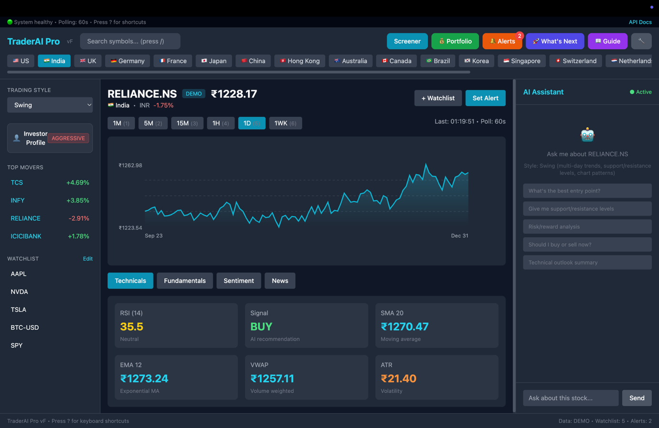

AI Analysis

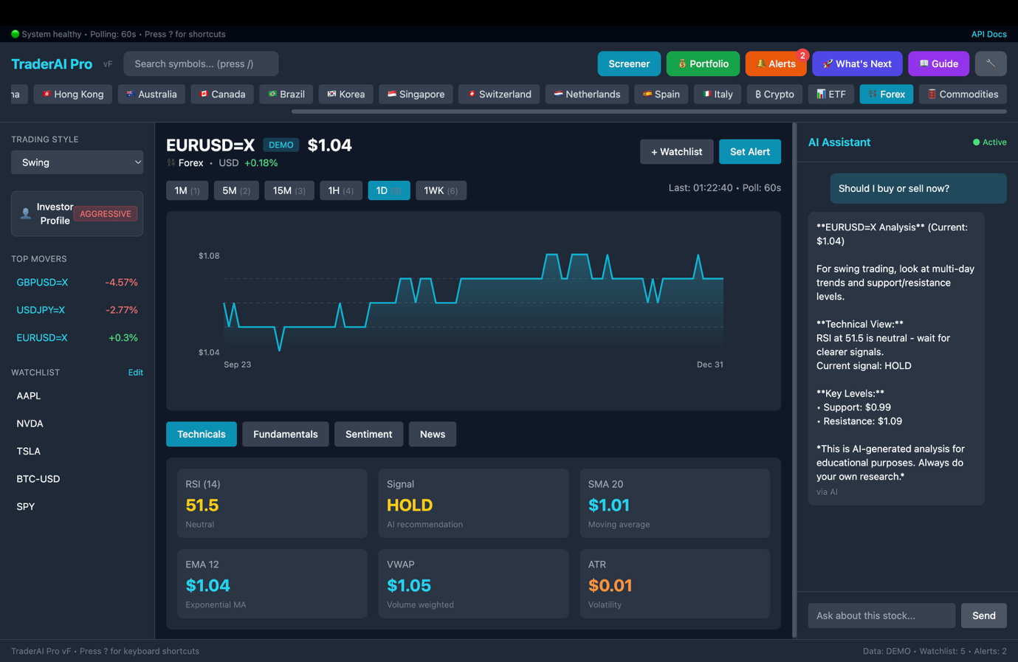

Stock Screener

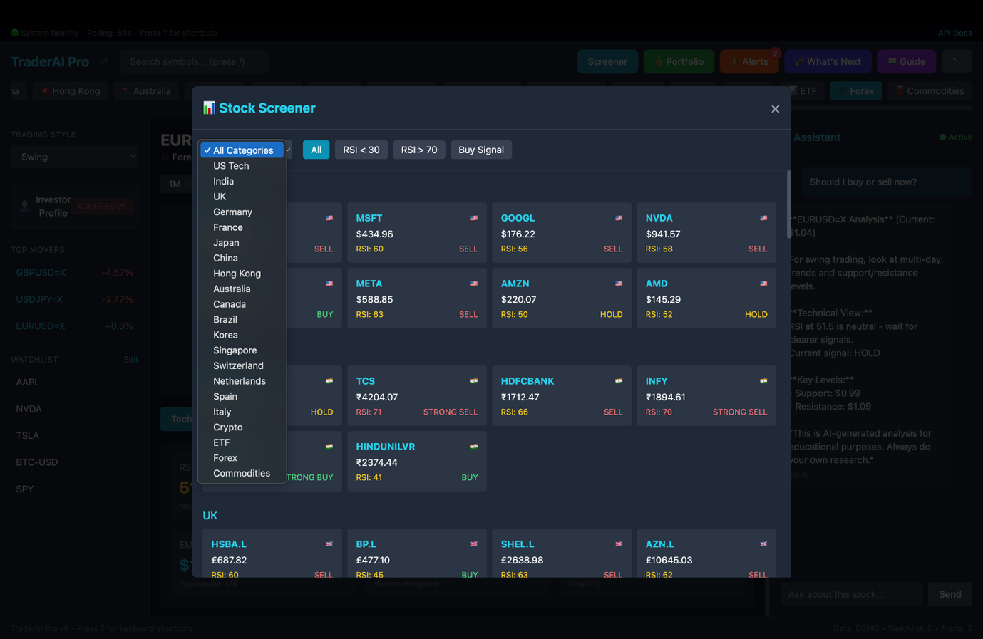

🔗 Links
Resource | URL
🚀 Live Demo | https://trader-ai-pro-demo.streamlit.app
📂 GitHub Repo | https://github.com/kukretirishi91keti/Trader-AI-Pro
🎥 Demo Video | [Link to Video]

📈 Data Sources
Data Type | Source | Status
Stock Prices | Yahoo Finance (yfinance) | ✅ Live
Technical Indicators | Calculated locally | ✅ Live
News Headlines | News APIs | ✅ Live
Social Sentiment | Reddit, StockTwits | ✅ Live
AI Analysis | Groq LLM (LLaMA 3) | ✅ Live

⚠️ Disclaimer
This is an academic demonstration project for the TalentSprint AIML Program.
- Data shown may be simulated in demo mode
- This is NOT financial advice
- Always consult a qualified financial advisor before making investment decisions
- Past performance does not guarantee future results

🙏 Acknowledgments
- TalentSprint - AIML Program
- Yahoo Finance - Market data
- Groq - AI inference
- Streamlit - Demo hosting
- Open source community

📝 License
Academic Project - TalentSprint AIML Program Stage 2

📈 TraderAI Pro v5.8.6
AI-Powered Trading Dashboard for Day Traders
Live Demo • GitHub
TalentSprint AIML Program - Stage 2 Final Project

