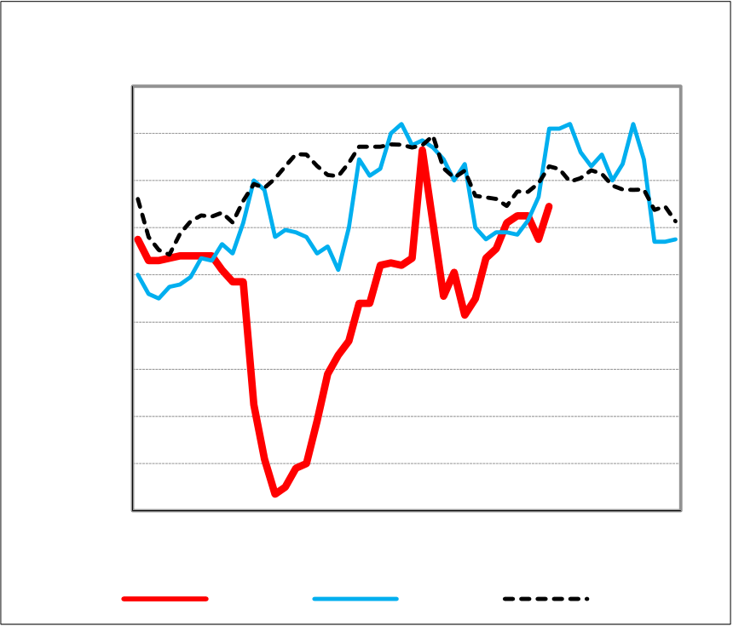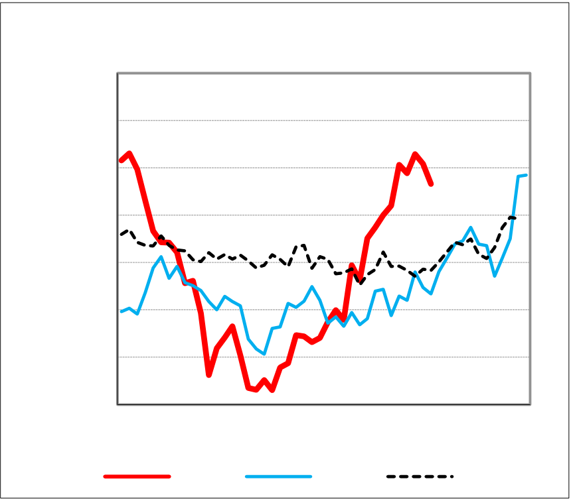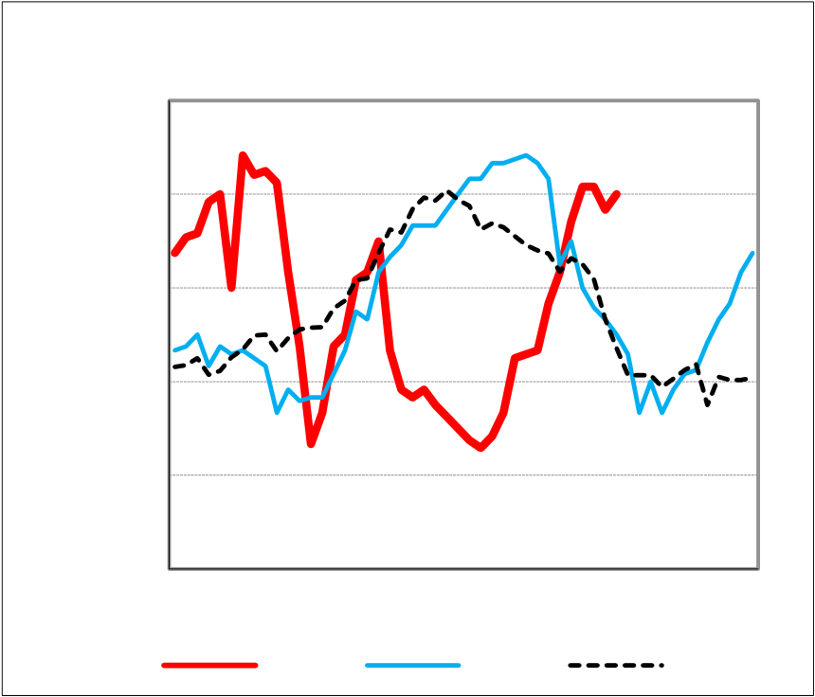

|  |  |  |
| --- | --- | --- |
| **National Weekly Ag Energy Round-Up** | **Fri, Oct 02, 2020** | **USDA Livestock, Poultry & Grain Market News** |

|  |  |  |  |  |  |  |  |  |  |  |  |  |  |  |  |  |  |  |  |  |  |  |  |  |  |  |  |  |  |  |  |  |  |  |  |  |  |  |  |  |  |  |  |  |  |  |  |  |  |  |  |  |  |  |  |  |  |  |  |  |  |  |  |  |
| --- | --- | --- | --- | --- | --- | --- | --- | --- | --- | --- | --- | --- | --- | --- | --- | --- | --- | --- | --- | --- | --- | --- | --- | --- | --- | --- | --- | --- | --- | --- | --- | --- | --- | --- | --- | --- | --- | --- | --- | --- | --- | --- | --- | --- | --- | --- | --- | --- | --- | --- | --- | --- | --- | --- | --- | --- | --- | --- | --- | --- | --- | --- | --- | --- |
| |  |  |  |  | | --- | --- | --- | --- | | **W/E 10/02/20** | **Last Week** | **Year Ago** | **Internet Report Link** | | |  |  | | --- | --- | | 1.60 | **Iowa Ethanol** |   1.50  1.40  1.30   |  |  | | --- | --- | | **$/gal** | 1.20 |   1.10  1.00  0.90  0.80   |  |  |  |  |  |  |  |  |  |  |  |  |  | | --- | --- | --- | --- | --- | --- | --- | --- | --- | --- | --- | --- | --- | | 0.70 | J | F | M | A | M | J | J | A | S | O | N | D | | 2020 | 2019 | 5 Yr Avg | |   **Central Illinois Crude Soybean Oil** 38.00  36.00  34.00   |  |  | | --- | --- | | **cents/lb** | 32.00  30.00 |   28.00  26.00   |  |  |  |  |  |  |  |  |  |  |  |  |  | | --- | --- | --- | --- | --- | --- | --- | --- | --- | --- | --- | --- | --- | | 24.00 | J | F | M | A | M | J | J | A | S | O | N | D | | 2020 | 2019 | 5 Yr Avg | |   **Central U.S. Choice White Grease**  30.00  27.00   |  |  | | --- | --- | | **$/cwt** | 24.00 |   21.00  18.00   |  |  |  |  |  |  |  |  |  |  |  |  |  | | --- | --- | --- | --- | --- | --- | --- | --- | --- | --- | --- | --- | --- | | 15.00 | J | F | M | A | M | J | J | A | S | O | N | D | | 2020 | 2019 | 5 Yr Avg | | |
| |  |  |  |  |  | | --- | --- | --- | --- | --- | | **Ethanol ($/gal)** | 1.27 - 1.42 | 1.14 - 1.30 | 1.42 - 1.60 | [Iowa Ethanol](https://mymarketnews.ams.usda.gov/filerepo/reports?field_slug_id_value=3199&name=&field_slug_title_value=&field_published_date_value=&field_report_date_end_value=&field_api_market_types_target_id=All) | | Iowa | | Minnesota | unq | 1.14 | 1.37 - 1.40 | [Minnesota Ethanol](https://mymarketnews.ams.usda.gov/filerepo/reports?field_slug_id_value=3199&name=&field_slug_title_value=&field_published_date_value=&field_report_date_end_value=&field_api_market_types_target_id=All) | | Nebraska | 1.23 - 1.42 | 1.16 - 1.39 | 1.35 - 1.57 | [Nebraska Ethanol](https://mymarketnews.ams.usda.gov/filerepo/reports?field_slug_id_value=3199&name=&field_slug_title_value=&field_published_date_value=&field_report_date_end_value=&field_api_market_types_target_id=All) | | South Dakota | unq | 1.13 | 1.28 | [South Dakota Ethanol](https://mymarketnews.ams.usda.gov/filerepo/reports?field_slug_id_value=3199&name=&field_slug_title_value=&field_published_date_value=&field_report_date_end_value=&field_api_market_types_target_id=All) | | Eastern Cornbelt | 1.36 - 1.41 | 1.22 - 1.28 | 1.53 - 1.68 | [Eastern Cornbelt Ethanol](https://mymarketnews.ams.usda.gov/filerepo/reports?field_slug_id_value=3199&name=&field_slug_title_value=&field_published_date_value=&field_report_date_end_value=&field_api_market_types_target_id=All) | | Wisconsin | 1.42 | unq | 1.47 | [Wisconsin Ethanol](https://mymarketnews.ams.usda.gov/filerepo/reports?field_slug_id_value=3199&name=&field_slug_title_value=&field_published_date_value=&field_report_date_end_value=&field_api_market_types_target_id=All) | |
| |  |  |  |  |  | | --- | --- | --- | --- | --- | | **Biodiesel B100 (SME) ($/gal)** | 3.02 | 2.71 - 2.74 | 2.73 | [Biodiesel B100](https://mymarketnews.ams.usda.gov/filerepo/reports?field_slug_id_value=3199&name=&field_slug_title_value=&field_published_date_value=&field_report_date_end_value=&field_api_market_types_target_id=All) | | Iowa | | IL/IN/OH | 2.19 - 2.22 | 2.89 - 2.93 | 3.07 | |
| |  |  |  |  |  | | --- | --- | --- | --- | --- | | **Bio Mass (IA/MN/NE/SD/KS/MO/IL)** | 50.42 | 46.25 | unq | [Biomass Report](https://mymarketnews.ams.usda.gov/filerepo/reports?field_slug_id_value=2804&name=&field_slug_title_value=&field_published_date_value=&field_report_date_end_value=&field_api_market_types_target_id=All) | | Cornstalks | | Straw | 93.33 | 71.43 | 103.50 | | Grass | 61.82 | 74.75 | 101.25 | |
| |  |  |  |  |  | | --- | --- | --- | --- | --- | | **Crude Soybean Oil (cents/lb)** | 32.94 - 33.69 | 26.67 - 26.97 | 28.48 - 28.88 | [Central Illinois Soybean Processor](https://mymarketnews.ams.usda.gov/filerepo/reports?field_slug_id_value=3190&name=&field_slug_title_value=&field_published_date_value=&field_report_date_end_value=&field_api_market_types_target_id=All) | | Central Illinois | | Indiana/Ohio | 33.19 - 33.62 | 26.67 - 28.42 | 28.38 - 30.13 | [Indiana/Ohio Soybean Processor](https://mymarketnews.ams.usda.gov/filerepo/reports?field_slug_id_value=3221&name=&field_slug_title_value=&field_published_date_value=&field_report_date_end_value=&field_api_market_types_target_id=All) | | Iowa | 33.37 - 34.12 | 27.67 - 28.42 | 28.33 - 30.08 | [Iowa Soybean Processor](https://mymarketnews.ams.usda.gov/filerepo/reports?field_slug_id_value=3222&name=&field_slug_title_value=&field_published_date_value=&field_report_date_end_value=&field_api_market_types_target_id=All) | | Minnesota | 33.37 - 34.12 | 27.67 - 28.17 | 28.88 - 30.08 | [Minneapolis Soybean Processor](https://mymarketnews.ams.usda.gov/filerepo/reports?field_slug_id_value=3047&name=&field_slug_title_value=&field_published_date_value=&field_report_date_end_value=&field_api_market_types_target_id=All) | |
| |  |  |  |  |  | | --- | --- | --- | --- | --- | | **Crude Corn Oil (cents/lb)** | 42.25 | 48.98 | 27.70 - 28.00 | [Central Illinois Corn Processor](https://mymarketnews.ams.usda.gov/filerepo/reports?field_slug_id_value=3189&name=&field_slug_title_value=&field_published_date_value=&field_report_date_end_value=&field_api_market_types_target_id=All) | | Midwest (Food Grade) | |
| |  |  |  |  |  | | --- | --- | --- | --- | --- | | **Inedible Packer Bleachable Tallow ($/cwt)** | unq | unq | 27.50 | [Tallows, Proteins and Hides](https://mymarketnews.ams.usda.gov/filerepo/reports?field_slug_id_value=2837&name=&field_slug_title_value=&field_published_date_value=&field_report_date_end_value=&field_api_market_types_target_id=All) | | Chicago | |
| |  |  |  |  |  | | --- | --- | --- | --- | --- | | **Edible Tallow ($/cwt)** | unq | unq | unq | [Tallows, Proteins and Hides](https://mymarketnews.ams.usda.gov/filerepo/reports?field_slug_id_value=2837&name=&field_slug_title_value=&field_published_date_value=&field_report_date_end_value=&field_api_market_types_target_id=All) | | Chicago | |
| |  |  |  |  |  | | --- | --- | --- | --- | --- | | **Choice White Grease ($/cwt)** | 27.00 | 18.50 - 20.50 | 22.50 | [Tallows, Proteins and Hides](https://mymarketnews.ams.usda.gov/filerepo/reports?field_slug_id_value=2837&name=&field_slug_title_value=&field_published_date_value=&field_report_date_end_value=&field_api_market_types_target_id=All) | | Central U.S. | | Minneapolis | 28.00 - 29.50 | unq | 24.00 - 26.25 | [Minneapolis Weekly Feedstuffs](https://mymarketnews.ams.usda.gov/filerepo/reports?field_slug_id_value=3040&name=&field_slug_title_value=&field_published_date_value=&field_report_date_end_value=&field_api_market_types_target_id=All) | |
| |  |  |  |  |  | | --- | --- | --- | --- | --- | | **Yellow Grease ($/cwt)** | 25.25 | unq | 22.00 | [Tallows, Proteins and Hides](https://mymarketnews.ams.usda.gov/filerepo/reports?field_slug_id_value=2837&name=&field_slug_title_value=&field_published_date_value=&field_report_date_end_value=&field_api_market_types_target_id=All) | | Central U.S. | | Minneapolis | 21.00 - 26.00 | 15.00 - 19.00 | 22.00 - 25.00 | [Minneapolis Weekly Feedstuffs](https://mymarketnews.ams.usda.gov/filerepo/reports?field_slug_id_value=3040&name=&field_slug_title_value=&field_published_date_value=&field_report_date_end_value=&field_api_market_types_target_id=All) | | San Joaquin Valley | 25.00 - 28.50 | 25.00 - 28.50 | 24.00 - 27.00 | [California Weekly Feedstuffs](https://mymarketnews.ams.usda.gov/filerepo/reports?field_slug_id_value=3143&name=&field_slug_title_value=&field_published_date_value=&field_report_date_end_value=&field_api_market_types_target_id=All) | | San Francisco | unq | 21.00 - 25.40 | 21.00 - 23.00 | [California Weekly Feedstuffs](https://mymarketnews.ams.usda.gov/filerepo/reports?field_slug_id_value=3143&name=&field_slug_title_value=&field_published_date_value=&field_report_date_end_value=&field_api_market_types_target_id=All) | | Los Angeles | 25.50 - 29.00 | 24.50 - 29.50 | 24.50 - 27.50 | [California Weekly Feedstuffs](https://mymarketnews.ams.usda.gov/filerepo/reports?field_slug_id_value=3143&name=&field_slug_title_value=&field_published_date_value=&field_report_date_end_value=&field_api_market_types_target_id=All) | |
| |  |  |  |  |  | | --- | --- | --- | --- | --- | | **Nearby Futures** | 1.3900 | 1.1350 | 1.4100 | [CME Group](http://www.cmegroup.com/trading/energy/ethanol/cbot-ethanol.html) | | CME Group Ethanol ($/gal) | | CME Group Soybean Oil (cents/lb) | 31.95 | 27.54 | 29.90 | [CME Group](http://www.cmegroup.com/trading/agricultural/grain-and-oilseed/soybean-oil.html) | | NYMEX Crude Oil ($/barrel) | 36.87 | 38.72 | 52.75 | [CME Group](http://www.cmegroup.com/trading/energy/crude-oil/light-sweet-crude.html) | | NYMEX RBOB ($/gal) | 1.1173 | 1.1942 | 1.5746 | [CME Group](http://www.cmegroup.com/trading/energy/refined-products/rbob-gasoline_quotes_globex.html) | | NYMEX Natural Gas (mmBtu) | 2.4470 | 1.4820 | 2.3850 | [CME Group](http://www.cmegroup.com/trading/energy/natural-gas/natural-gas.html) | | NYMEX Heating Oil ($/gal) | 1.0794 | 1.1556 | 1.8954 | [CME Group](http://www.cmegroup.com/trading/energy/refined-products/heating-oil.html) | |
| |  |  | | --- | --- | | USDA Livestock, Poultry & Grain Market News 210 Walnut Street, Room 767  Des Moines, Iowa 50309 | Email: desm.lpgmn@usda.gov  [www.ams.usda.gov/LPSMarketNewsPage](http://www.ams.usda.gov/LPSMarketNewsPage) | |