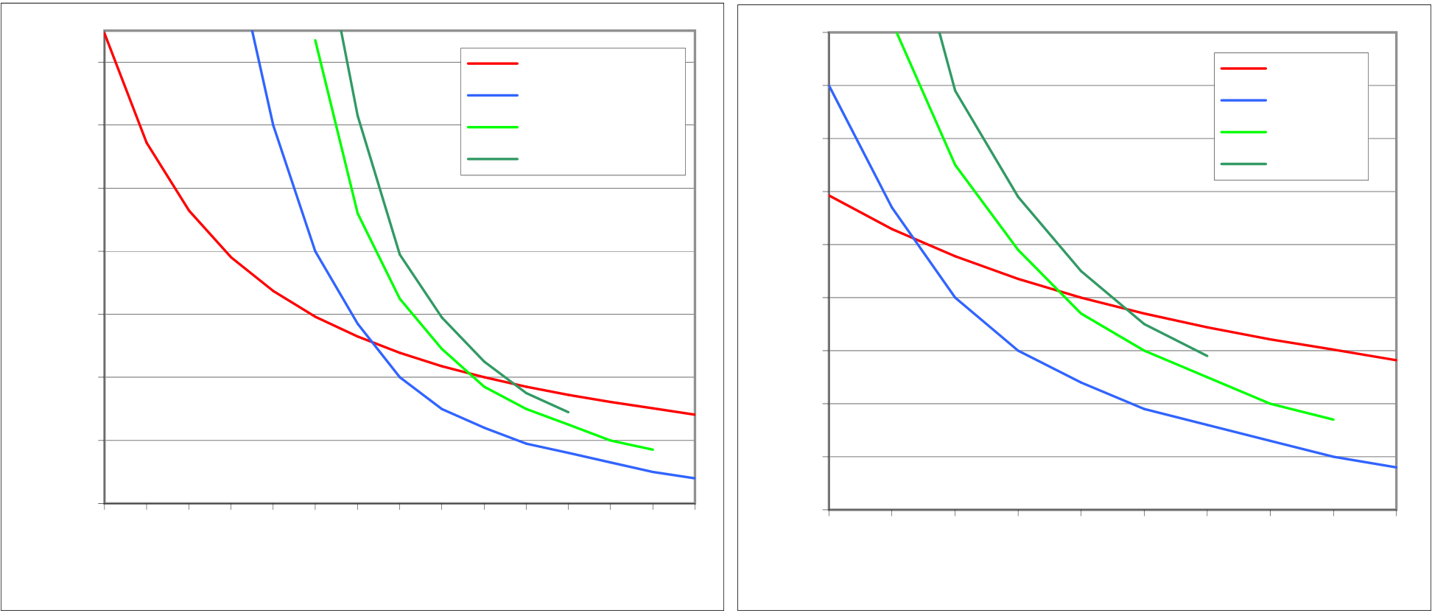

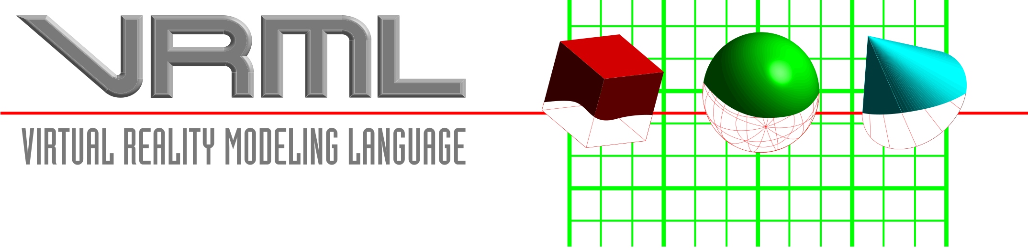

A Graphical Representation of Inverse VRML Uptake

90

|  |  |  |  |  |  |
| --- | --- | --- | --- | --- | --- |
| **Inverse usage** | 140 | Programmers | **Inverse log usage** | 80 | Artists |
| Technical Writers | Musicians |
| 120 | QA | 70 | Politicians |
| 100 | Other | 60 | Dentists |
| 80 | 50 |
| 60 | 40 |
| 30 |

40   
 20

|  |  |  |  |  |  |  |  |  |  |  |  |  |  |  |  |  |  |  |  |  |  |  |  |  |  |  |
| --- | --- | --- | --- | --- | --- | --- | --- | --- | --- | --- | --- | --- | --- | --- | --- | --- | --- | --- | --- | --- | --- | --- | --- | --- | --- | --- |
| 20 | 0 | 10 | 20 | 30 | 40 | 50 | 60 | 70 | 80 | 90 | 100 | 110 | 120 | 130 | 140 | 10 | 50 | 60 | 70 | 80 | 90 | 100 | 110 | 120 | 130 | 140 |
| 0 | 0 |
| **Days after download** | | | | | **Days after download** | | |

Change the number in red below to adjust for download rate and/or bandwidth.

|  |  |  |  |
| --- | --- | --- | --- |
| |  | | --- | | **1** | | The number 1 represents an engineer with an "average" cube * | |
| **CF** | **Min** | |  |  |  |  | | --- | --- | --- | --- | | **fsw** | **Air** | **EANx 32%** | **EANx 36%** | | **0** |  |  |  | | **10** |  |  |  | | **20** |  |  |  | | **30** | **180** |  |  | | **40** | **120** |  |  | | **50** | **80.0** | **147.0** | **192.0** | | **60** | **57.0** | **92.0** | **123.0** | | **70** | **40.0** | **65.0** | **79.0** | | **80** | **30.0** | **49.0** | **59.0** | | **90** | **24.0** | **37.0** | **45.0** | | **100** | **19.0** | **30.0** | **35.0** | | **110** | **16.0** | **25.0** | **29.0** | | **120** | **13.0** | **20.0** | **n/a** | | **130** | **10.0** | **17.0** | **n/a** | | **140** | **8.0** | **n/a** | **n/a** | |
| 80.0 149.12 61.4 114.43 49.8 92.846 41.9 78.102 36.2 67.402 31.8 59.275 | |
| 28.4 | 52.9 |
| 25.6 47.774 23.4 43.543 21.5 40.001 | |
| 19.9 | 37 |
| 18.5 34.409 17.3 32.154 16.2 30.178 15.1 28.202 | |