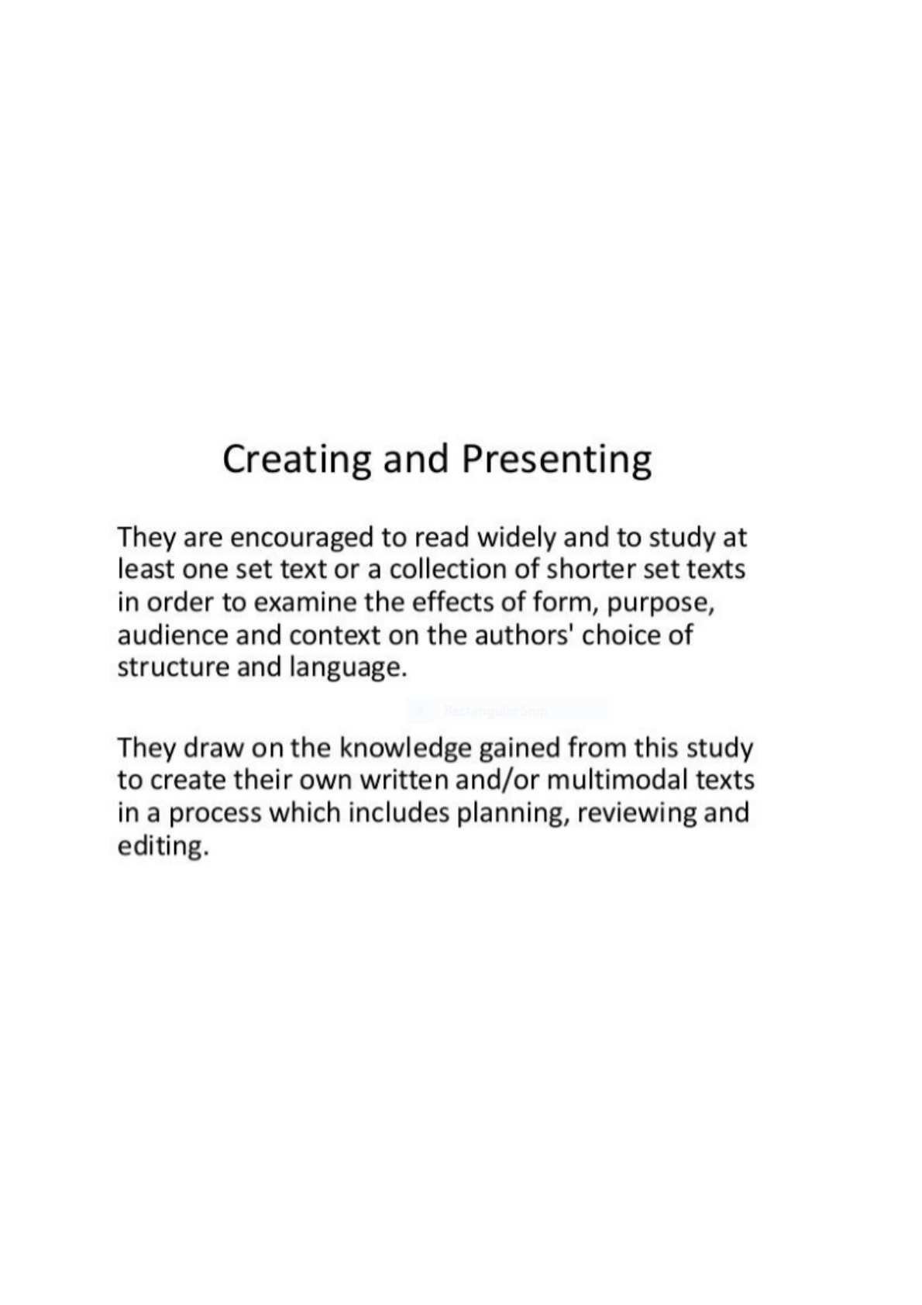

This is displayed text. Note the OCR-ed text behind the image, which is ignored with default ocr=0.