# City Flows from Networks of Cameras

Evgeny Toropov, Liangyan Gui, Shanghang Zhang, Satwik Kottur, and José M. F. Moura

Carnegie Mellon University

[moura@cmu.edu](mailto:moura@cmu.edu), [www.ece.cmu.edu/~moura](http://www.ece.cmu.edu/~moura)

This paper reports on our results of extracting reliable counts of moving vehicles from a large number of cameras (hundreds) pointed to streets in an extended city. The cameras continuously stream video at different time and spatial resolutions, in very different light conditions, night and day, and at various weather patterns, rain, sunshine, or snow. The raw data may add to several terabytes of video data per single day. Extracting traffic counts *x1(t), ∙∙∙ , x2N(t)* from *N* monocular optical cameras is not trivial, and existing approaches fail to identify moving vehicles in the low quality videos of interest, because they commonly assume small movements of automobiles across sequential frames. In contrast, the very low frame rate precludes motion based techniques in the streamed videos of interest. The paper will explain the algorithms developed and their performance, and how this work is at the physical layer of a larger project that aims to broadly understand population flows in cities.

**Evgeny Toropov**, **Liangyan Gui**, **Shanghang Zhang**,and **Satwik Kottur** are graduate students in the Department of Electrical and Computer Engineering at CMU pursuing their PhD.

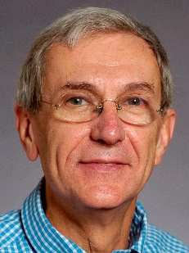**José M. F. Moura** is the Philip L. and Marsha Dowd University Professor at CMU, with interests in data science. A sequence detector of two of his patents (co-inventor Kavcic) is found in 2.4 billion disk drives of 60% of all computers sold worldwide in the last 10 years. He cofounded SpiralGen that commercializes the Spiral technology (www.spiral.net). He was elected 2016 IEEE VP for Technical Activities and served as IEEE Board Director, President of the IEEE Signal Processing Society (SPS), and Editor in Chief for the Transactions on SP. Moura received the IEEE SPS *Technical Achievement Award* and *Society Award*. He is a Fellow of the IEEE, a Fellow of AAAS, a corresponding member of the Academy of Sciences of Portugal, and a member of the US National Academy of Engineering.