**Bus Tracker**

**A bus tracking app optimized for CMU students**

**User Requirements Document**

**Prepared by:**

Daniel Stoll

Ryler Hockenbury

Evgeny Toropov

**System Overview:**

**Motivation:** There is a big problem with the Pittsburgh bus system. Many people, especially newcomers to school in the area, do not know how to get around. On top of that, the bus system is often unreliable and does not arrive according to schedule. New students often do not know which bus to take when attempting to travel places in Pittsburgh. The main goal of our app is to let users track the Pittsburgh Port Authority buses and/or CMU shuttles around campus bus stations. Currently, students need to cross-reference route information between CMU shuttles and Pittsburgh Port Authority to find the best route. Students would be able to use this app to search what time a bus would arrive at campus to travel to a specific address.

**Goal:** To provide a way to see the arrival time of the next bus with a few clicks.

**Target User:** The target audience for the bus tracker app are CMU students. A student may use the app multiple times per day to locate buses. For example, on the way to the CMU campus in the morning, a student would reference the app and find out what time a particular bus will be at the closest bus station.

**High Level Features:**

Some features that this app would have include:

* Regular schedule without the internet connection - it could access the servers once to download the bus schedule. That makes the app different from Google Maps and such.
* The app will have a minimalistic interface designed for CMU and further customized by a user so that it is easy to use the app in cold weather.
* There is a new Port Authority system being tested that allows real-time tracking of buses. If possible, this app would also provide an interface to that system when internet is available.
* Besides the Port Authority transportation system, the app could also provide schedules to the CMU shuttles.

**Requirements:**

1. The system will maintain accurate information by accessing schedule information available from the CMU shuttle service website (<http://www.cmu.edu/police/shuttleandescort/>) and the Port Authority website (<http://www.portauthority.org/paac/default.aspx>).
2. The system will contain information on both CMU shuttle service and Port Authority buses. This information may include stops, schedules, and current location for each bus route.
3. The system will support the following utilities:
   1. Bus stop lookup - a user may find a listing of all bus stops listed by distance from user, or from a specified address
   2. Bus route lookup - a user may find a listing of schedules for a particular bus
   3. Closest bus stop lookup - a user may locate the closest bus stop based on their current location.
   4. Potential Feature: Map lookup - a user may search for a bus route by looking at a map overlaid with all the bus routes
4. The system will support role-based access for the following user types:
   1. New User - a student may obtain route information for Pittsburgh Port Authority buses and CMU shuttle service
   2. Administrator - an administrator may add, delete or modify bus routes.

**Features: (**Select at least 10 from list on Slide 22 – Document how these features will be used in your implementation)

1. Hardware Audio
2. S-Beam
3. Location
4. Network-based Geo location
5. GPS
6. MultiWindow
7. Compass Sensor
8. Touchscreen
9. SQL Lite DB
10. Web Services

**Use Cases:**

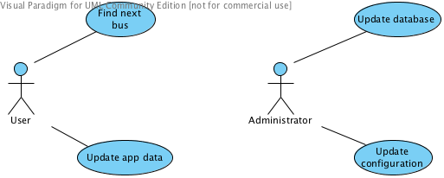

Use Case 1

|  |  |
| --- | --- |
| Use Case Name: | Student searches for next bus. |
| Actor(s): | CMU Student in Pittsburgh campus, App |
| Description: | Student selects the buses he needs and the bus stop, and gets the arrival times for next several buses |
| Pre-conditions: | The app is open |
| Events: | 1. Student selects bus routes from the list and selects direction  2. System offers to choose the bus stop  3. Student chooses the bus stop either by distance or by street  4. System lists the upcoming buses for the specified bus stop. |
| Post-conditions: | A list of buses with corresponding arrival times is displayed |
| Alternative Events: | App has not been initialized yet or App is informed by the server that data update is available. => App offers Student to update local data. If the Student agrees, System performs the update (User Case 2), then bus tracking proceeds. |
| Exceptions: | 1. No GPS signal and no geo-location data => The choice of the bus stop based on distance is disabled  2. No internet connection => Schedule update and real-time bus locations lookup is disabled.  3. There is internet, but the connection to Port Authority Services cannot be established => Check for data update, if none - report an error and proceed without real-time bus locations lookup. |
| Assumptions: | Student knows what bus routes he/she needs |
| Issues: | None |

Use Case 2:

|  |  |
| --- | --- |
| Use Case Name: | Student updates app data |
| Actor(s): | CMU Student in Pittsburgh campus, App |
| Description: | Student updates local database from the server |
| Pre-conditions: | There is internet connection |
| Events: | 1. Student chooses to do an update or App could not connect to Port Authority and prompts Student to do an update  2. App performs update  3. App returns to bus tracking |
| Post-conditions: | Databases and configurations are updated |
| Exceptions: | System could not connect to the server => The user is asked to try later. |
| Assumptions: | None |
| Issues: | None |

Use Case 3:

|  |  |
| --- | --- |
| Use Case Name: | Administrator updates database info |
| Actor(s): | Service administrator, System |
| Description: | Administrator logs in to the server and updates information on bus routes, stops addresses, and bus schedule |
| Pre-conditions: | All databases already exist on the server |
| Events: | 1. Administrator logs in to the server.  2. Administrator selects to update a certain database  3. Administrator performs add/update/delete actions on database entries  4. System updates databases, and informs installed Apps that an update is available during the next communication of apps to the server.  5. Administrator logs out |
| Post-conditions: | Database is updated. Installed apps are notified on next connection that update is available |
| Exceptions: |  |
| Assumptions: | Administrator has a valid username + password |
| Issues: | None |

Use Case 4:

|  |  |
| --- | --- |
| Use Case Name: | Administrator updates configurations |
| Actor(s): | Administrator |
| Description: | Administrator logs in and updates configurations of using Port Authority web-service that allows real-time bus tracking. |
| Pre-conditions: | None |
| Events: | 1. Administrator logs in to the server.  2. Administrator edits configuration entries that defines how the Port Authority services can be reached from the App  3. System tests configurations.  4. System updates databases, and informs Apps installed on smartphones that an update is available.  5. Administrator logs out |
| Post-conditions: | Configurations are updated |
| Exceptions: | Configurations were found invalid while testing at step 3. The system offers to enter different configurations. |
| Assumptions: | Administrator has a valid username + password |
| Issues: | None |

**UI Illustrations:**

Loading Screen: The page which is displayed when the app is loading.

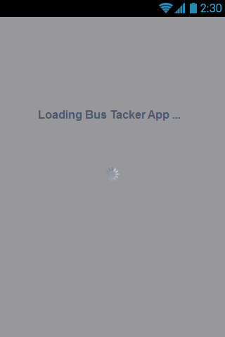

Home Page: The page which is displayed when the app first begins containing opens to do a text based search, a map based search, login with a CMU id and enter home address.

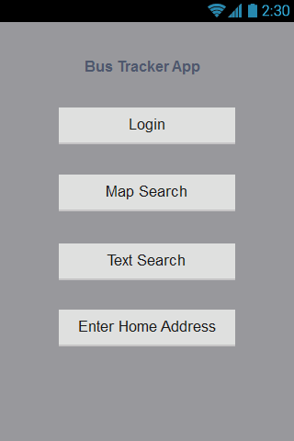

Text-based Search Page: Displays a search bar, and prompts on-screen keyboard for data entry. Loads the search page results page after query is returned.

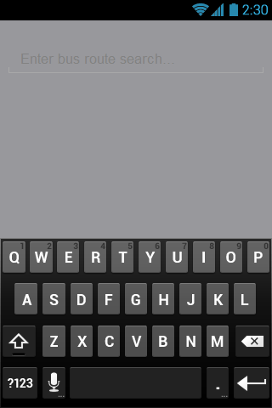

Search Page Results Page: Displays a list of routes matching the search term the user entered. Enables single tap selection for user to select route, and loads schedule display page.

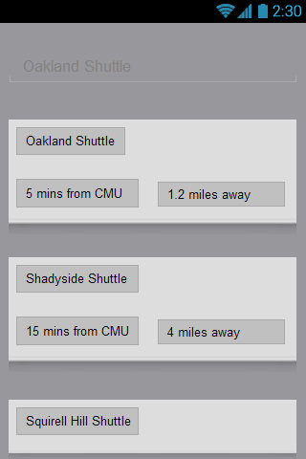

Map-based Search Page: Displays a map overlaid with bus routes. Options to pinch zoom, double-tap zoom and single tap select are enabled. Schedule display page is loaded after successful selection of a route.

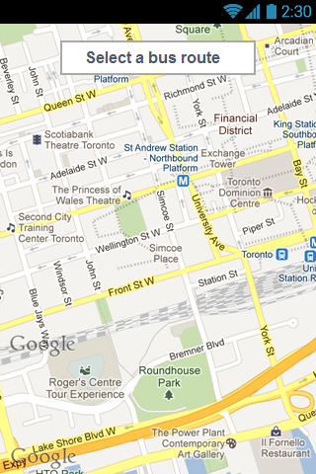

Login Page: Displays two text forms to accept email and password. On-screen keyboard appears. Displays whether login is successful. User is returned to home page after login.

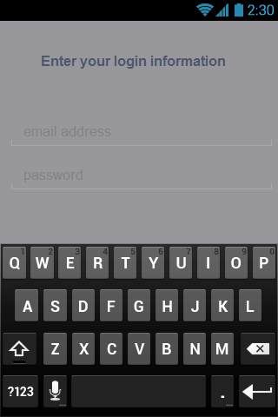

Home Address Enter Page: Displays appropriate text forms for a street address. On-screen keyboard appears. Displays whether address is valid (address is in Pittsburgh). User is returned to home page after successful address entry.

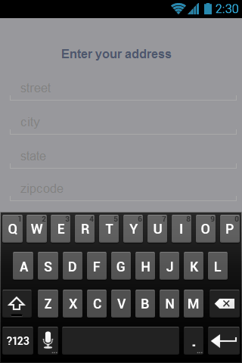

Schedule Display Page: Displays a schedule of a selected route.

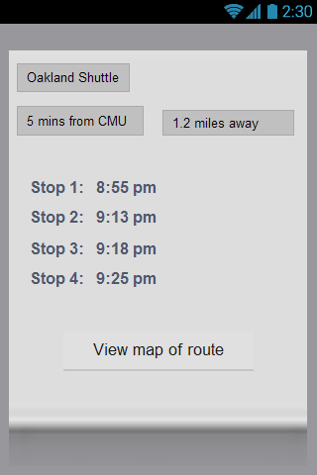

**References:**

[**http://www.cmu.edu/homepage/computing/2011/summer/wheres-the-bus.shtml**](http://www.cmu.edu/homepage/computing/2011/summer/wheres-the-bus.shtml)