**jQuery – How it works**

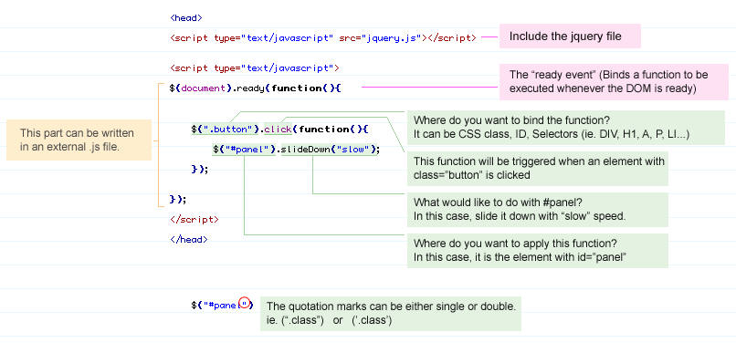

## **Summary**

|  |  |
| --- | --- |
| **Syntax** | **Description** |
| $(this) | Current HTML element |
| $("p") | All <p> elements |
| $("p.intro") | All <p> elements with class="intro" |
| $("p#intro") | All <p> elements with id="intro" |
| $("p#intro:first") | The first <p> element with id="intro" |
| $(".intro") | All elements with class="intro" |
| $("#intro") | The first element with id="intro" |
| $("ul li:first") | The first <li> element of the first <ul> |
| $("ul li:first-child") | The first <li> element of every <ul> |
| $("[href$='.jpg']") | All elements with an href attribute that ends with ".jpg" |
| $("div#intro .head") | All elements with class="head" inside a <div> element with id="intro" |

|  |  |
| --- | --- |
| **Event Method** | **Description** |
| $(document).ready(function) | Binds a function to the ready event of a document (when the document is finished loading) |
| $(*selector*).click(function) | Triggers, or binds a function to the click event of selected elements |
| $(*selector*).dblclick(function) | Triggers, or binds a function to the double click event of selected elements |
| $(*selector*).focus(function) | Triggers, or binds a function to the focus event of selected elements |
| $(*selector*).mouseover(function) | Triggers, or binds a function to the mouseover event of selected elements |