**jQuery – How it works**

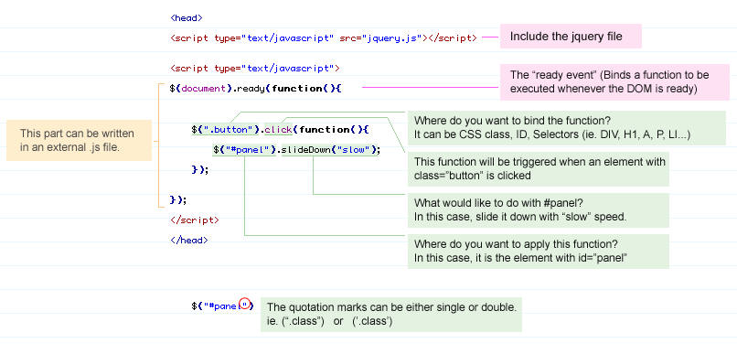

## **Summary**

|  |  |
| --- | --- |
| **Syntax** | **Description** |
| $(this) | Current HTML element |
| $("p") | All <p> elements |
| $("p.intro") | All <p> elements with class="intro" |
| $("p#intro") | All <p> elements with id="intro" |
| $("p#intro:first") | The first <p> element in a container with with id="intro" |
| $(".intro") | All elements with class="intro" |
| $("#intro") | The first element with id="intro" |
| $("ul li:first") | The first <li> element of the first <ul> |
| $("ul li:first-child") | The first <li> element of every <ul> |
| $("[href$='.jpg']") | All elements with an href attribute that ends with ".jpg" |
| $("div#intro .head") | All elements with class="head" inside a <div> element with id="intro" |

|  |  |
| --- | --- |
| **Event Method** | **Description** |
| $(document).ready(function) | Binds a function to the ready event of a document (when the document is finished loading) |
| $(*selector*).click(function) | Triggers, or binds a function to the click event of selected elements |
| $(*selector*).dblclick(function) | Triggers, or binds a function to the double click event of selected elements |
| $(*selector*).focus(function) | Triggers, or binds a function to the focus event of selected elements |
| $(*selector*).mouseover(function) | Triggers, or binds a function to the mouseover event of selected elements |

**Attribute Selectors**

jQuery uses **XPath** expressions to select elements with **given attributes**. Note the prevalence of the square brackets as a string within the parenthesis. The selectors are also strings in this case. Also note if the attributes are assigned values then they are quoted in single quotes. Escape properly.

$("[href]") select all elements with an href attribute.

$("[href='#']") **select all elements with an href value equal to "#".**

$("[href!='#']") **select all elements with an href attribute NOT equal to "#",i.e with a URL.**

$("[href$='.jpg']") **select all elements with an href attribute that ends with ".jpg".**

**Snippets**

*Accordion*

$(document).ready(function(){

//Delegation with Mutual Exclusion Flags

$(".accordion h3:first").addClass("active");

$(".accordion p:not(:first)").hide();

$(".accordion h3").click(function(){

$(this).next("p").slideToggle("slow")

.siblings("p:visible").slideUp("slow");

$(this).toggleClass("active");

$(this).siblings("h3").removeClass("active");

});

});

**Image Replacement**

$(document).ready(function(){

$("h2").append('<em></em>')

$(".thumbs a").click(function(){

var largePath = $(this).attr("href");

var largeAlt = $(this).attr("title");

$("#largeImg").attr({ src: largePath, alt: largeAlt });

$("h2 em").html(" (" + largeAlt + ")"); return false;

});

});

**Parsing JSON object**

$(window).load(function(){

$(document).ready(function(){

var data = '[{"image":"asia-de-cuba-london-1.jpg"},

{"image":"cafe-des-amis-london-1.jpg"},{"image":"oxo-tower-london-1.jpg"},{"image":" tuttons-london-1.jpg"},{"image":"http:\/\/www.goldhawk-college.com\/istudio\/type-1\/images\/thumbnails\/cafe-des-amis-london-1.jpg"}]';

var obj = $.parseJSON(data);

$.each(obj, function(index,item) {

$('#imagewrap').append('<img class="lazy images"

src="'+item.image+'" />');

});

});

});