**PSU ME 429/529 Lab Sessions for:**

**“Transmission Electron Microscopy and Chemical Analysis of Materials” Laboratory Videos**

Besides the simulated TEM, the OEMP also has a library of instructional videos covering protocols and techniques demonstrated on CEMN’s FEI Tecnai G2 F-20 S-TWIN TEM in PSU’s Science Building One.

These can be watched within the simulator, so you can follow along on your own, manipulating controls and examining the ray paths of the TEM as you emulate real-world analyses.

**TEM Basic Alignment Procedures**

Nearly every time we use the TEM, we must correct slight misalignment of the electron optics. This is done through completion of straight-forward, simplified, “direct alignments”. Iterative completion of the direct alignments will drastically improve the quality of the data you obtain from the TEM.

To start the alignment, we will have to open the column valves within the simulator, and also bring up the Microscope Setup window.

**Open**

**Closed**

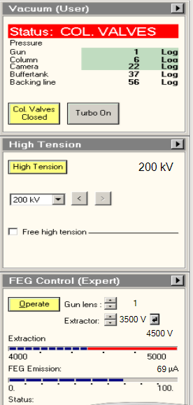 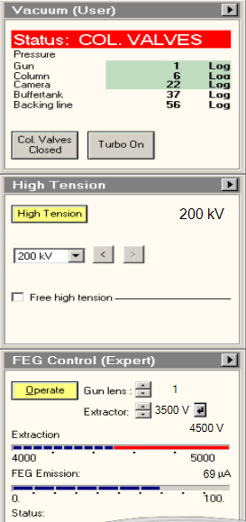

Opening the Col. Valve within the simulator.

You should be able to see the electron beam on the screen, if not, follow the instruction in the video below:

[**Video 7. Finding the Beam and Specimen**](https://www.e-microscopy.org/public/video/PSU%20Microscope_Video%207.mp4)

To learn how to complete these alignments, click the down arrow next to the “- None -“ field, and select “Direct Alignments” from the menu, as shown below.

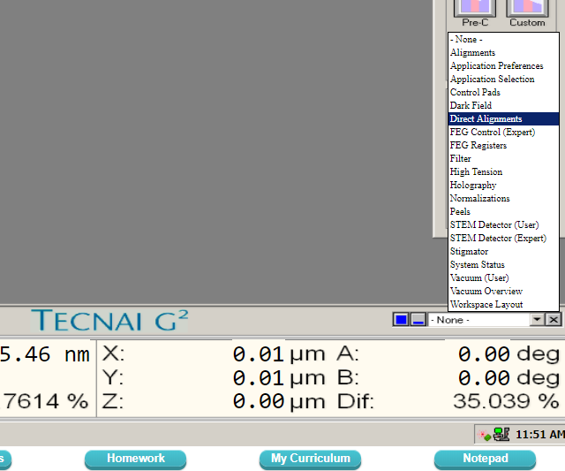

Opening the direct alignment window with auto-help within the TEM.

Be sure to check the “Auto help” box to see additional instructions.

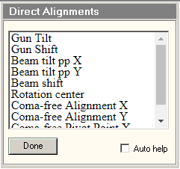Now you are ready to watch the video below and follow along on the virtual TEM.

[**Video 13. Direct Alignments**](https://www.e-microscopy.org/public/video/PSU%20Microscope_Video%2013.mp4)

If you can’t find your right hand control panel, you may need to close any recently opened windows and drag it to a new position.

**Imaging and Diffraction Patterns**

Electron diffraction is arguably the most useful phenomenon observed in the TEM -- we use it to orient ourselves, our specimina, and can even draw quantitative data from the striking patterns formed by electron wave interference. Diffraction patterns are also utilized during the setup of many imaging conditions.

To see instructions and examples relating to the use of diffraction patterns, watch:

[**Video 14. TEM Brightfield (BF) and Darkfield (DF)**](https://www.e-microscopy.org/public/video/PSU%20Microscope_Video%2014.mp4)

[**Video 15. TEM Centered Brightfield (CBF) Centered Darkfield (CDF) and Weak-Beam Darkfield (WBDF)**](https://www.e-microscopy.org/public/video/PSU%20Microscope_Video%2015.mp4)

[**Video 16. TEM Selected Area Electron Diffraction (SAED)**](https://www.e-microscopy.org/public/video/PSU%20Microscope_Video%2016.mp4)

[**Video 17. TEM Convergent Beam Electron Diffraction (CBED)**](https://www.e-microscopy.org/public/video/PSU%20Microscope_Video%2017.mp4)