**Lab-2 Assignment**

**Submitted by:**

**Kul Bahadur Budhathoki**

**Student ID: 23036835**

**Submitted to:**

**Professor: Nawaz Chowdhury**

**Subject: Web Development 2**

**Course code: CSD213**

Honesty Statement: “I declare that this submission is my own work in compliance with Sault College Academic Policies.”

**Due date: 16th September, 2024**

**Table of Content**

**Assignment Steps** 3

**Assignment Steps-1** 3

**Assignment Steps-2** 5

# 

# **Assignment Steps**

## **Assignment Steps-1**

Below are the codes of my row and column website:

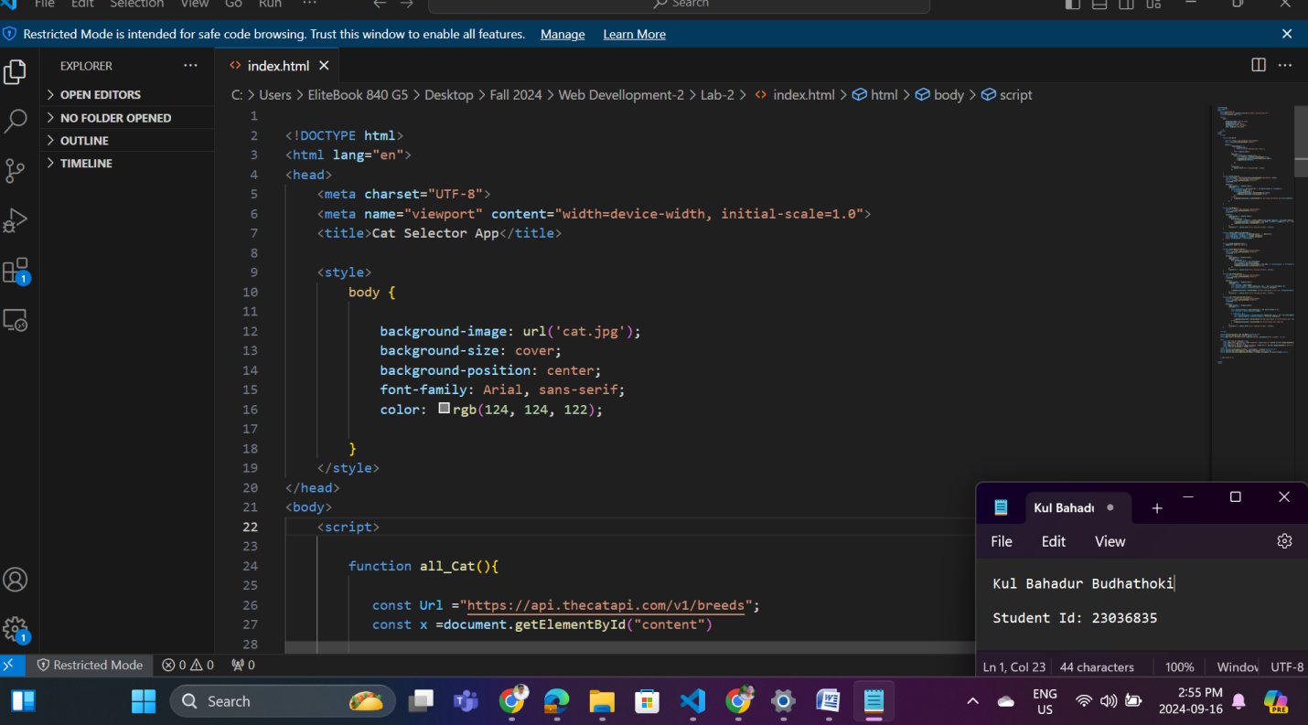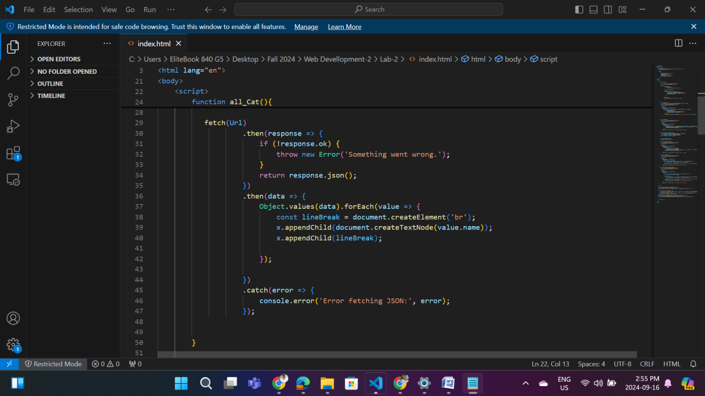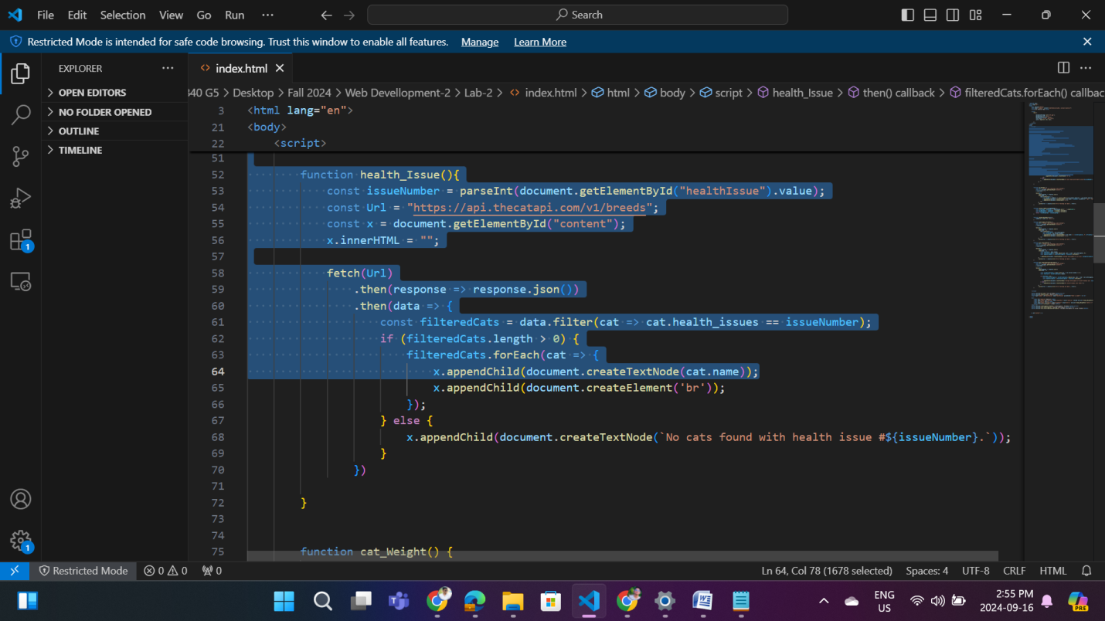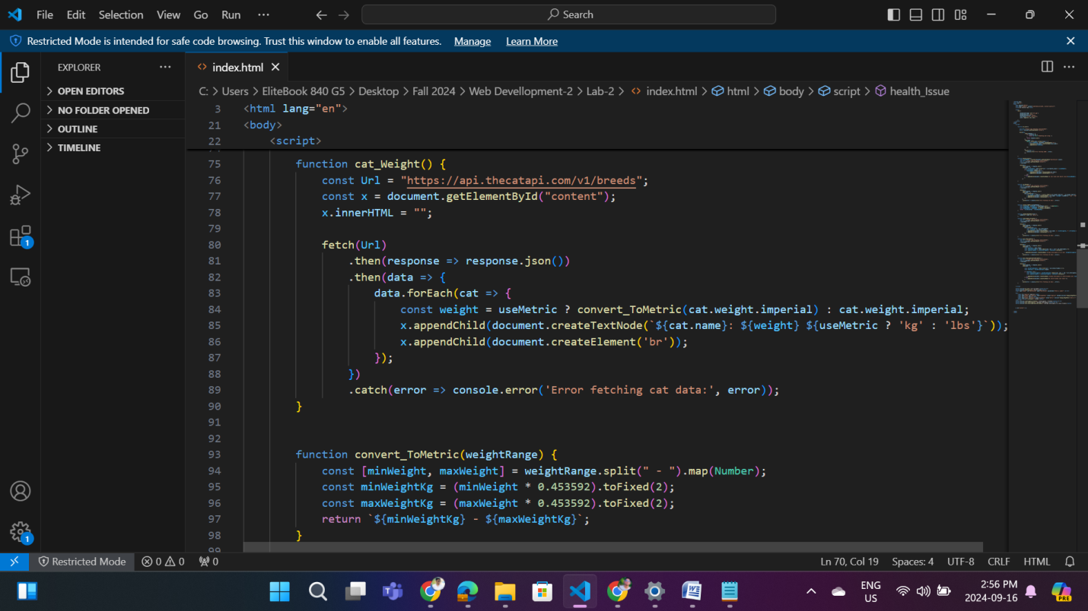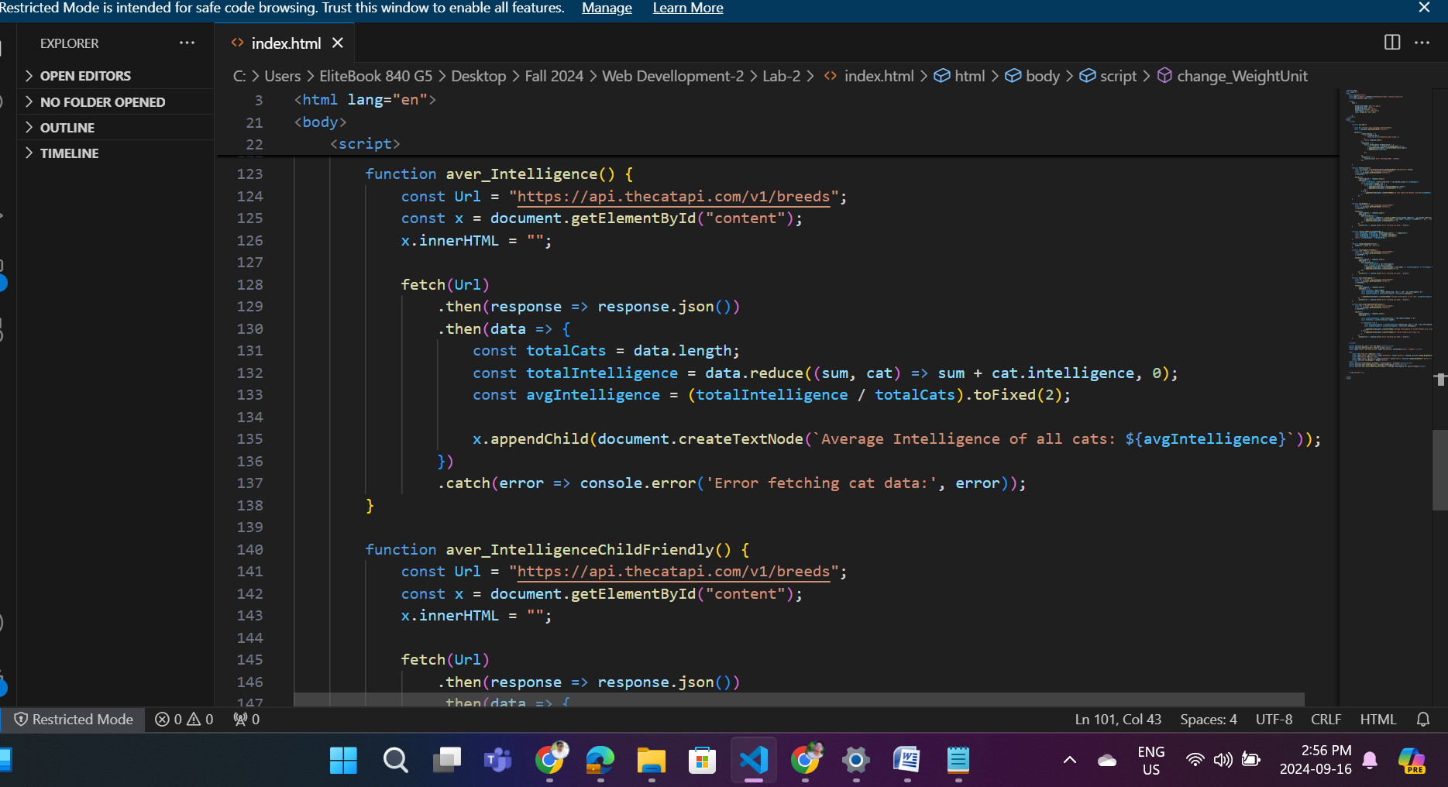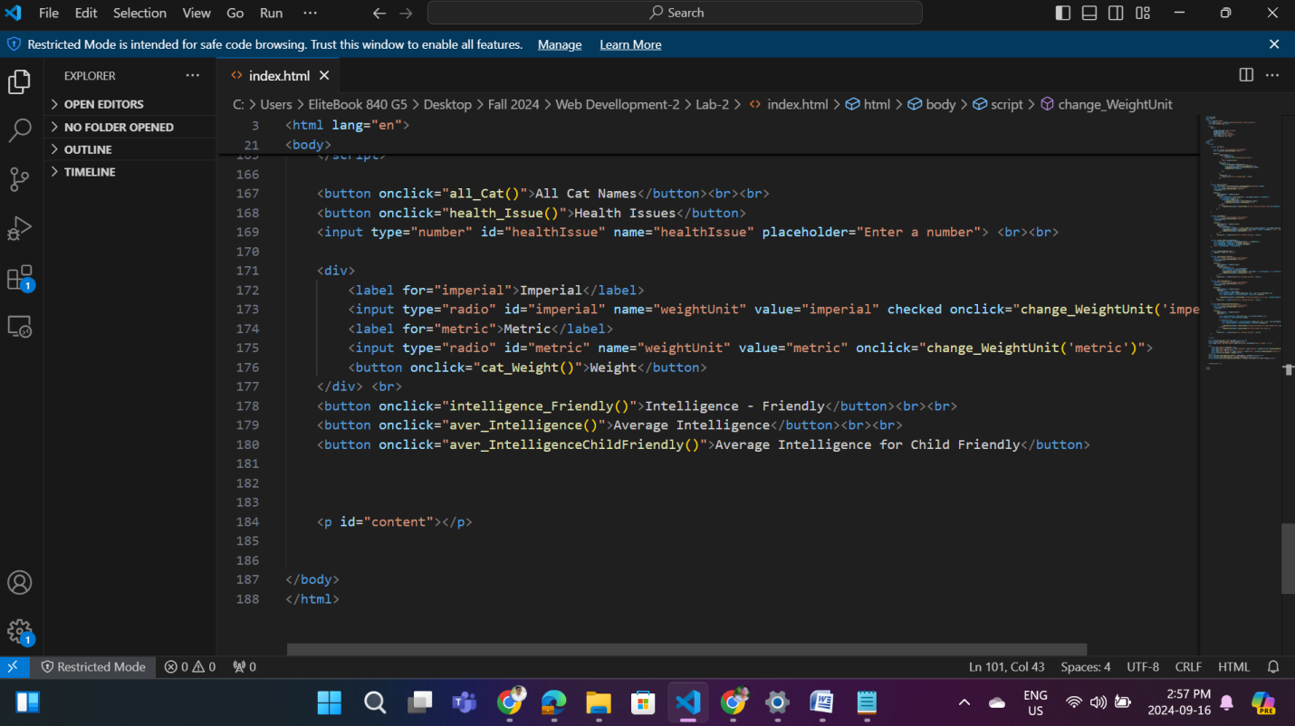

## 

## **Assignment Steps-2**

Following is the output of my above codes:

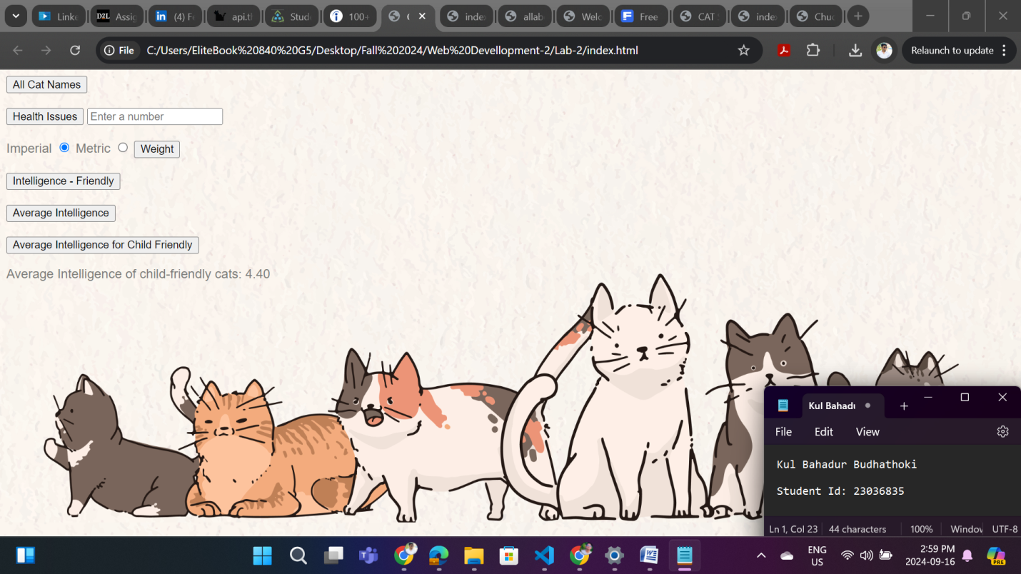

**Thank you.**