Customer Shopping Behavior Analysis / Power BI Dashboard Compiled By: KULDEEP UPADHYAY

1. INTRODUCTION
In the modern retail and e-commerce industry, understanding customer shopping behavior is essential for improving sales performance, customer satisfaction, and long-term business growth. With the increasing availability of customer transaction data, organizations can leverage data analytics to uncover hidden patterns, customer preferences, and purchasing trends.
This project, titled Customer Shopping Behavior Analysis, focuses on analyzing customer purchase data to derive meaningful business insights. The project follows an end-to-end data analytics approach, starting from raw data ingestion and preprocessing using Python, storing the cleaned data in a relational database, performing analytical queries using SQL, and finally interpreting the results through a dashboard.
The project closely resembles real-world data analyst responsibilities and demonstrates practical skills in data cleaning, feature engineering, SQL analysis, and business insight generation.

2. ABSTRACT
The Customer Shopping Behavior Analysis project aims to analyze and understand customer purchasing patterns using transactional data. The dataset contains information related to customer demographics, purchase history, product details, discounts, subscriptions, and payment methods.Python and the Pandas library were used to clean and preprocess the data, including handling missing values, standardizing column names, and creating new analytical features such as age groups and purchase frequency in days. The processed dataset was then loaded into a PostgreSQL database using SQLAlchemy.
SQL queries were written to answer important business questions such as revenue contribution by gender and age group, spending behavior of subscribed customers, impact of discounts on purchases, customer segmentation based on loyalty, and product performance based on ratings and sales.The project concludes with key business insights that can help organizations optimize marketing strategies, improve customer retention, and increase revenue. This project demonstrates the practical application of data analytics techniques in a real-world business context.

3. PROBLEM STATEMENT

Retail businesses generate large volumes of customer transaction data, but without proper analysis, this data cannot be effectively used for decision-making. Businesses often face challenges in understanding customer preferences, identifying loyal customers, evaluating the impact of discounts, and determining whether subscription programs increase revenue.
The objective of this project is to analyze customer shopping data and transform raw transactional records into actionable insights that can support data-driven business decisions.

4. OBJECTIVES OF THE PROJECT

The key objectives of this project are:
- To analyze customer purchase behavior using transactional data.
- To identify revenue patterns across different customer segments.
- To study the impact of discounts and subscriptions on customer spending.
- To segment customers based on purchase history.
- To evaluate product performance using ratings and purchase frequency.
- To demonstrate an end-to-end data analytics workflow using Python and SQL.

5. DATASET DESCRIPTION

The dataset used in this project is a customer shopping behavior dataset stored in CSV format.
- Total Records: 3,900
- Total Attributes: 18 (before feature engineering)
Key Attributes:
- Customer ID
- Age
- Gender
- Item Purchased
- Category
- Purchase Amount (USD)
- Location
- Review Rating
- Subscription Status
- Discount Applied
- Previous Purchases
- Payment Method
- Frequency of Purchases

6. TOOLS AND TECHNOLOGIES USED

Programming Language:
- Python
Libraries:
- Pandas
- SQLAlchemy
- Psycopg2
- PyMySQL
- PyODBC
Databases:
- PostgreSQL
- MySQL
- Microsoft SQL Server
Development Environment:
- Jupyter Notebook
Visualization Tool:
- Power BI

7. DATA CLEANING AND PREPROCESSING

Data cleaning and preprocessing were performed using Python and the Pandas library. The following steps were carried out:
- The dataset was loaded into a Pandas DataFrame.
- Data types and missing values were inspected using info() and isnull() methods.
- Missing values in the review_rating column were handled by imputing the median rating based on product category.
- Column names were standardized using snake_case for better readability.
- Redundant columns were identified and removed after validation.
These steps ensured that the dataset was clean, consistent, and suitable for analysis.

8. FEATURE ENGINEERING
To enhance the analytical capabilities of the dataset, new features were created:
- Age Group: Customers were divided into four age groups (Young Adult, Adult, Middle-aged, Senior) using quartile-based binning.
- Purchase Frequency Days: Purchase frequency categories were converted into numerical values representing days.
Feature engineering helped in deeper segmentation and improved analytical insights.

9. SQL ANALYSIS
SQL queries were written on the PostgreSQL platform to answer key business questions:
- Total revenue generated by male and female customers.
- Identification of high-spending customers who used discounts.
- Top products based on average review ratings.
- Comparison of purchase amounts by shipping type.
- Spending behavior of subscribed versus non-subscribed customers.
- Products with the highest percentage of discounted purchases.
- Customer segmentation into New, Returning, and Loyal customers.
- Top three most purchased products within each category.
- Subscription behavior of repeat buyers.
- Revenue contribution by different age groups.
Advanced SQL concepts such as aggregations, subqueries, Common Table Expressions (CTEs), window functions, and CASE statements were used.

10. DASHBOARD AND VISUALIZATION
An interactive dashboard was created using Power BI to visually represent the results of the analysis. The dashboard includes:
- Revenue distribution by gender and age group
- Customer segmentation analysis
- Product performance insights
- Subscription and discount impact analysis
The dashboard allows stakeholders to quickly interpret insights and supports data-driven decision-making.
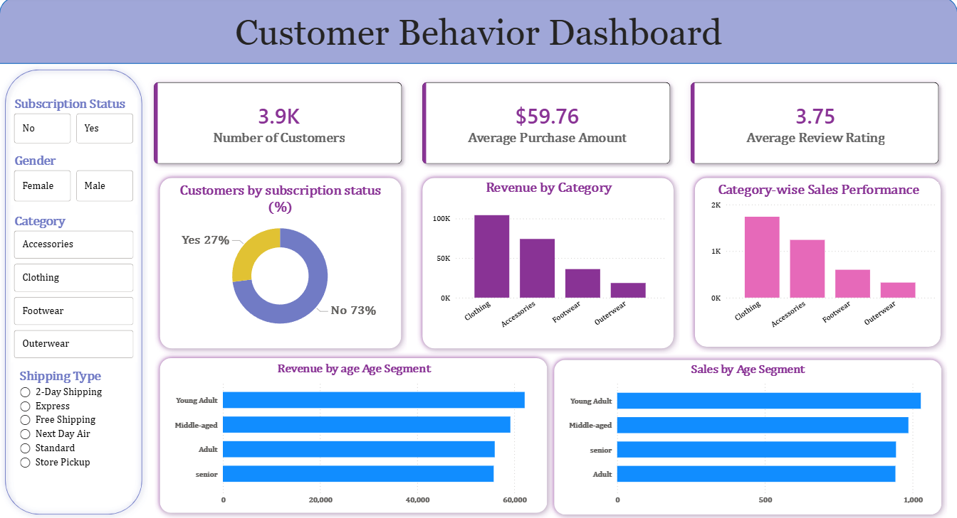

11. Conclusion
The Customer Shopping Behavior Analysis project demonstrates a complete data analytics lifecycle, from raw data preprocessing to database-driven analysis and business insight generation. The project highlights practical skills in Python, SQL, data modeling, and analytical thinking.This project is highly relevant for data analyst and business intelligence roles, as it reflects real-world business problems and analytical solutions. The insights derived from this analysis can help organizations improve customer engagement, optimize pricing strategies, and enhance overall business performance.

