Step1:-

Add required libraries as below:-

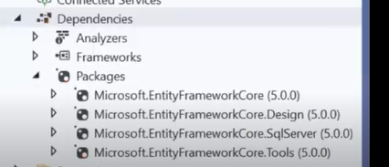

Steps2:-

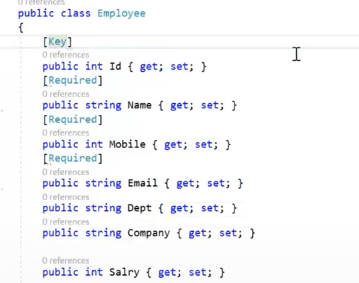

Steps3:-

Add connection string

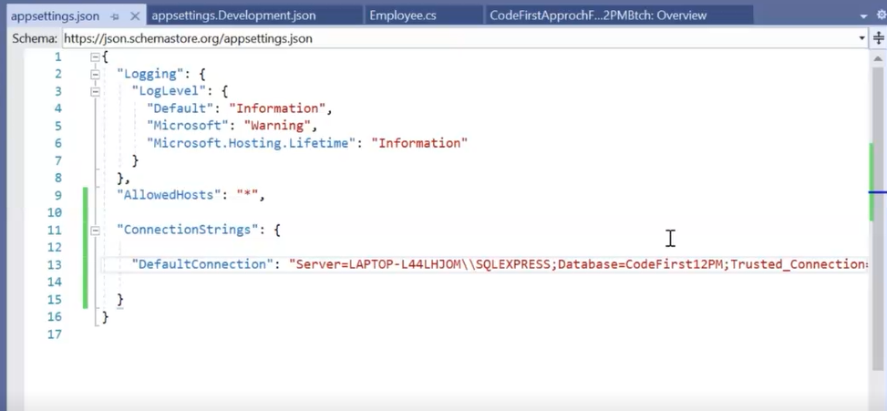

"ConnectionStrings": {

"DefaultConnection": "Server=LAPTOP-L44LHJOM\\SQLEXPRESS;Database=CodeFirst;Trusted_Connection=True;"

}

Step4:-

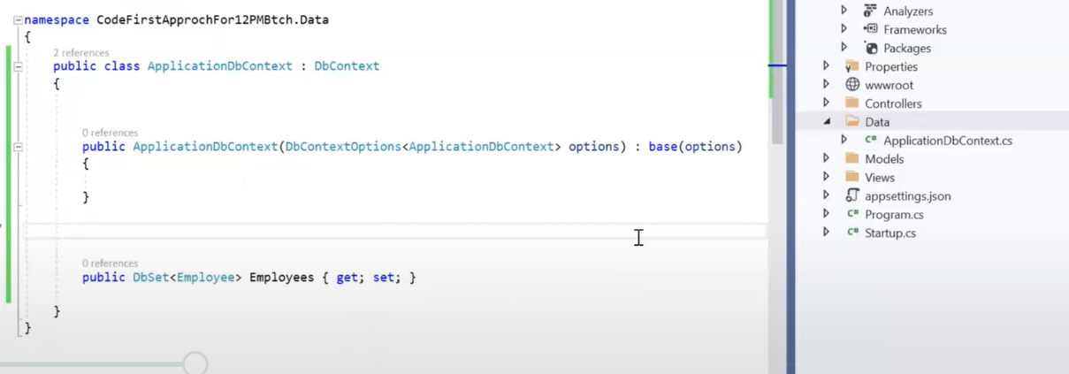

public class ApplicationDbContext : DbContext

{

public ApplicationDbContext(DbContextOptions<ApplicationDbContext> options) : base(options)

{

}

public DbSet<Employee> Employees { get; set; }

}

Steps5:-

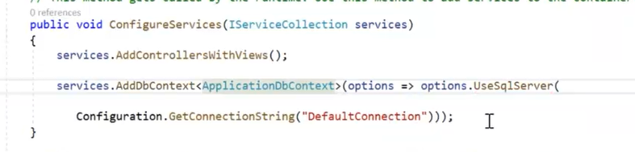

public void ConfigureServices(IServiceCollection services)

{

services.AddControllersWithViews();

services.AddDbContext<ApplicationDbContext>(options => options.UseSqlServer(

Configuration.GetConnectionString("DefaultConnection")));

}

Steps6:-

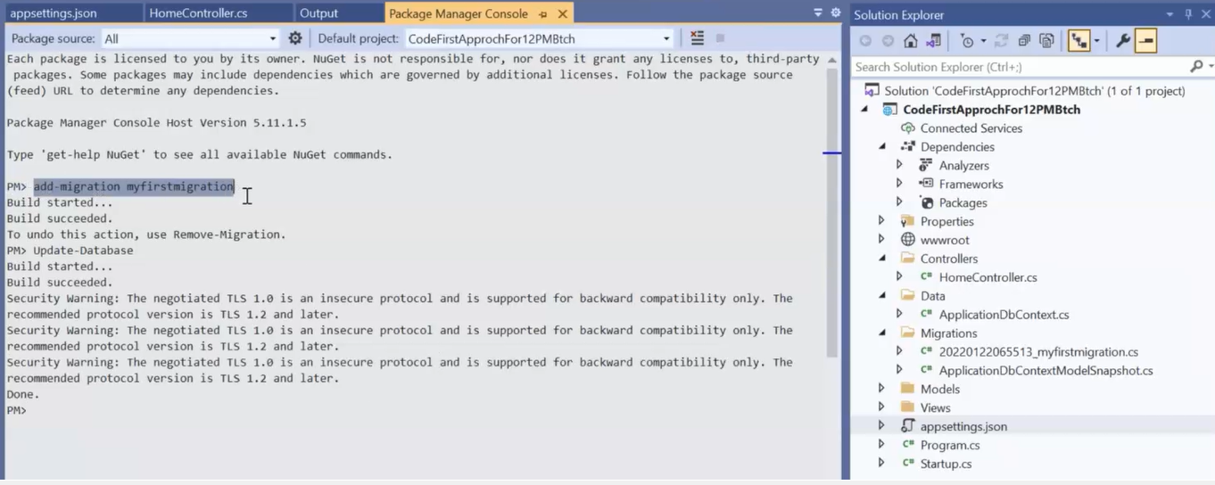

add-migration MyFirstMigration

Update-Database

Update-database MyFirstMigration