**Lab-3 CSS and Bootstrap**

1. Design vertical navigation bar like following

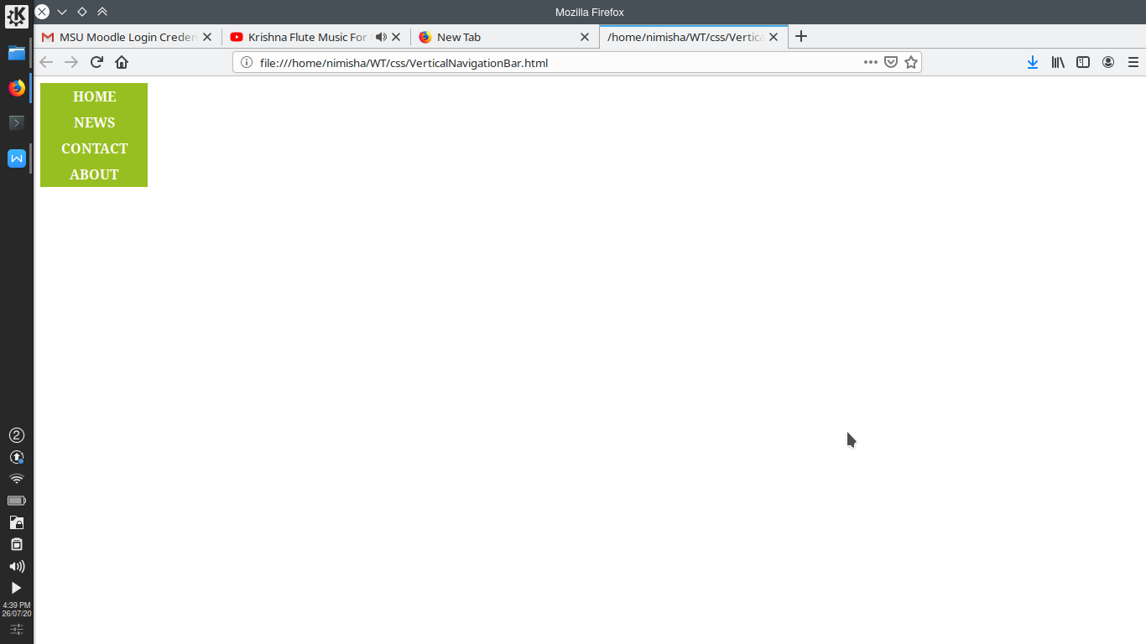

1. Design horizontal navigation bar like following

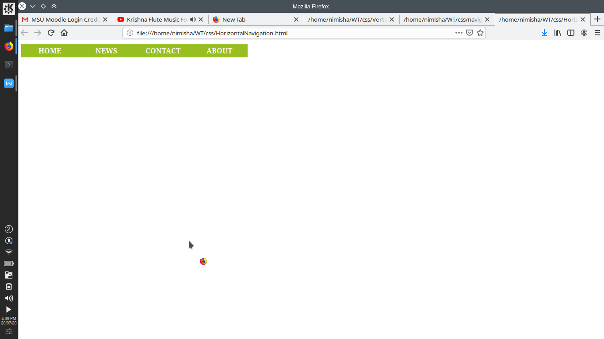

1. Create art and craft photo album using bootstrap.
2. Create student marksheet using bootstrap.
3. Create employment application form like below

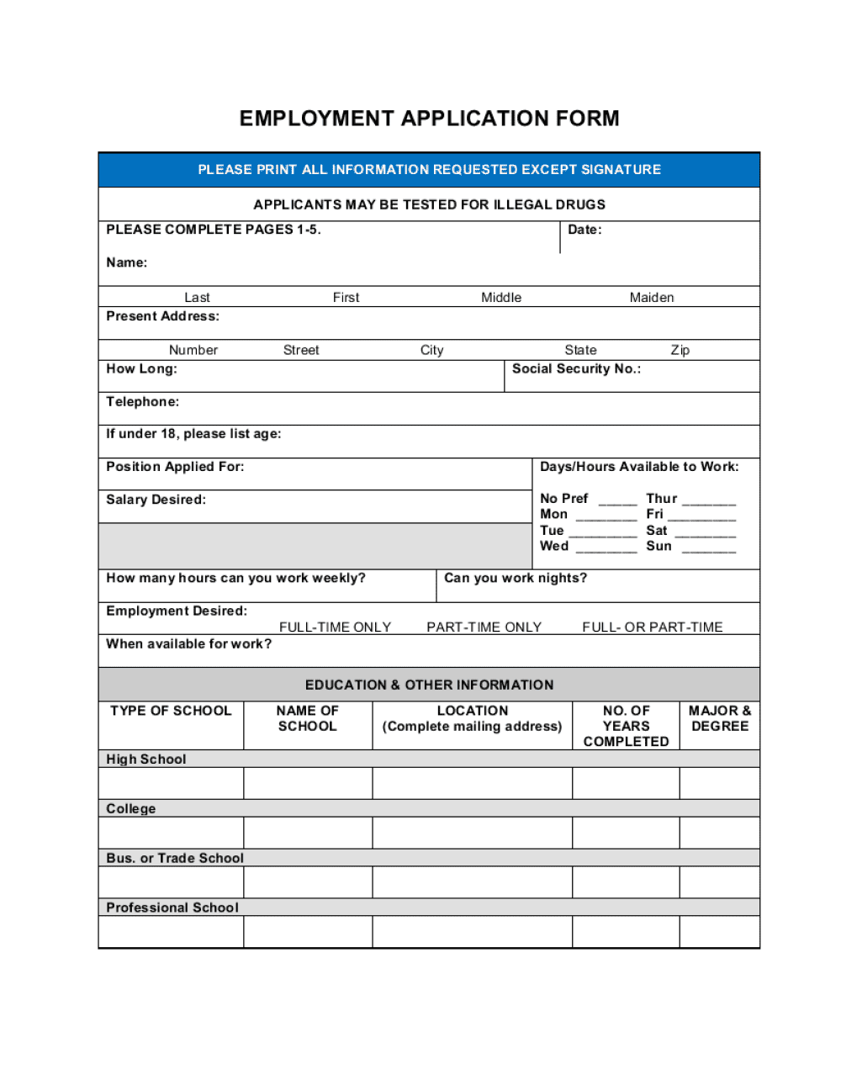

1. Design home of flipKart in which Navigation bar with dropdown is available using bootstrap.