DPPW – SMART BLIND GLASSES
An Assistive Device for Visually Impaired People
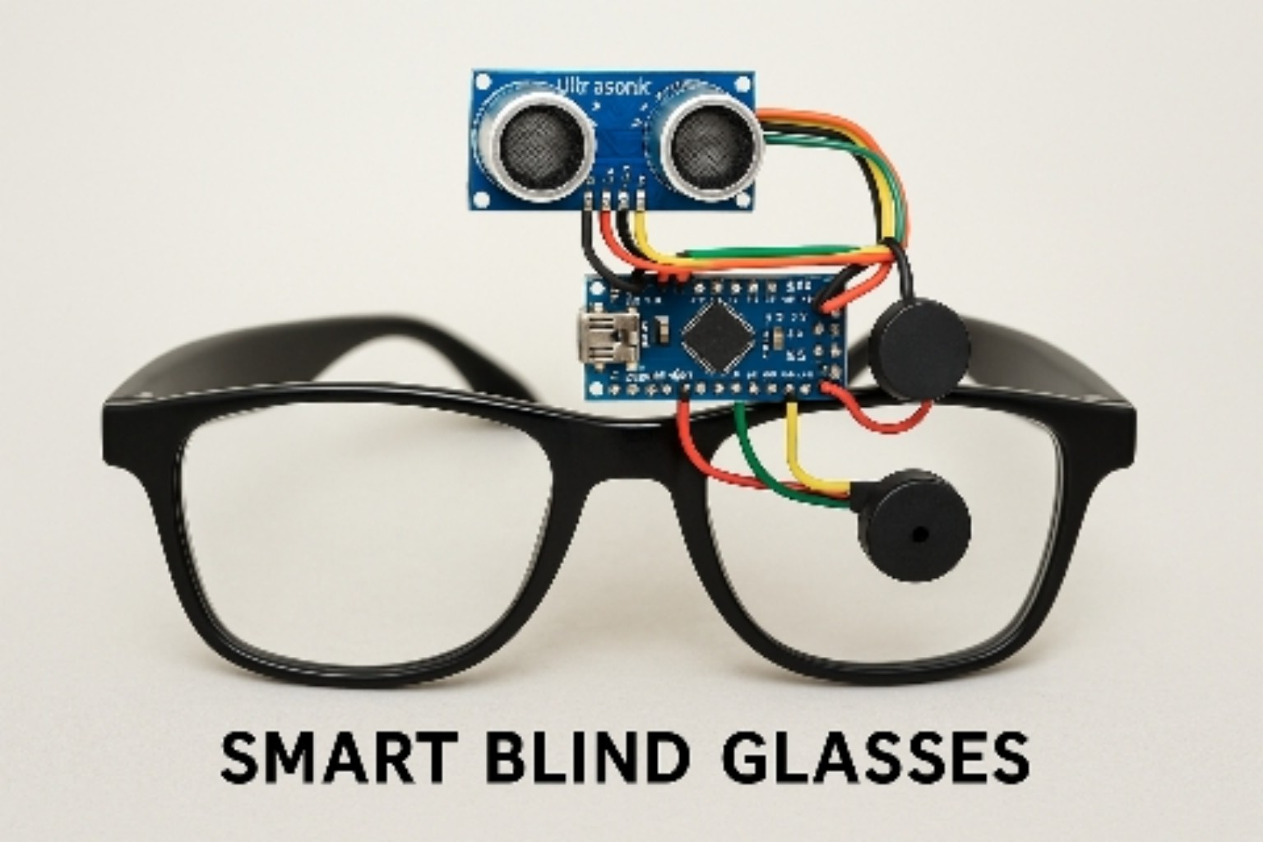
Figure 1: Smart Blind Glasses Prototype
1. Project Introduction
Smart Blind Glasses is an Arduino-based assistive technology project designed to help visually impaired people detect obstacles in front of them. The system uses an HC-SR04 Ultrasonic Sensor to measure the distance of nearby objects and provides alerts through a Piezo Buzzer and Vibration Motor.
2. Objectives
- To develop a low-cost assistive device for visually impaired people.
- To detect obstacles using an ultrasonic sensor.
- To provide audio and vibration-based alerts.
- To make the device lightweight and portable.
- To demonstrate the practical use of Arduino and sensors.
- To encourage innovation in assistive technology.
3. Circuit / Wiring Diagram
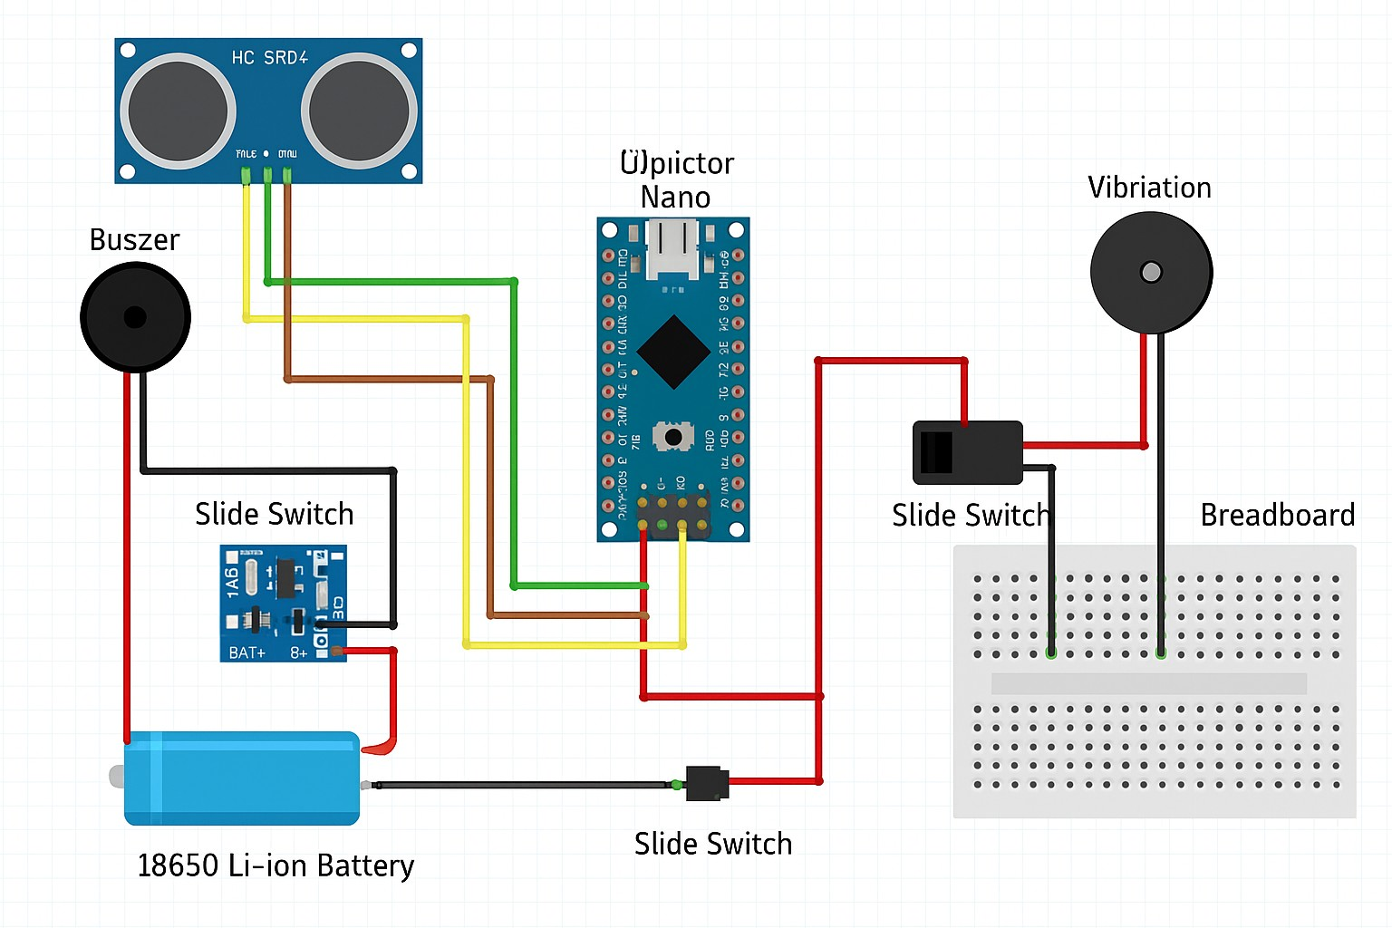
Figure 2: Circuit and Wiring Diagram
4. Required Components
Component | Approx. Cost | Purpose
Arduino Nano | ₹180 – ₹250 | Microcontroller board used to control the complete system.
HC-SR04 Ultrasonic Sensor | ₹30 – ₹50 | Measures the distance of obstacles using ultrasonic waves.
Piezo Buzzer | ₹10 – ₹20 | Produces an audio alert.
Vibration Motor | ₹20 – ₹40 | Provides a vibration-based warning.
18650 Li-ion Battery | ₹120 – ₹200 | Portable power source.
TP4056 Charging Module | ₹25 – ₹40 | Used for charging the Li-ion battery.
Breadboard | ₹30 – ₹50 | Used for temporary, solderless circuit connections.
Jumper Wires | ₹30 – ₹50 | Used to connect electronic components.
Slide Switch | ₹5 – ₹10 | Used to turn the project ON/OFF.
Spectacle Frame | ₹50 – ₹100 | Used as the wearable frame for the prototype.
Estimated Total Cost: ₹500 – ₹810 approximately.
5. Components Used in the Prototype
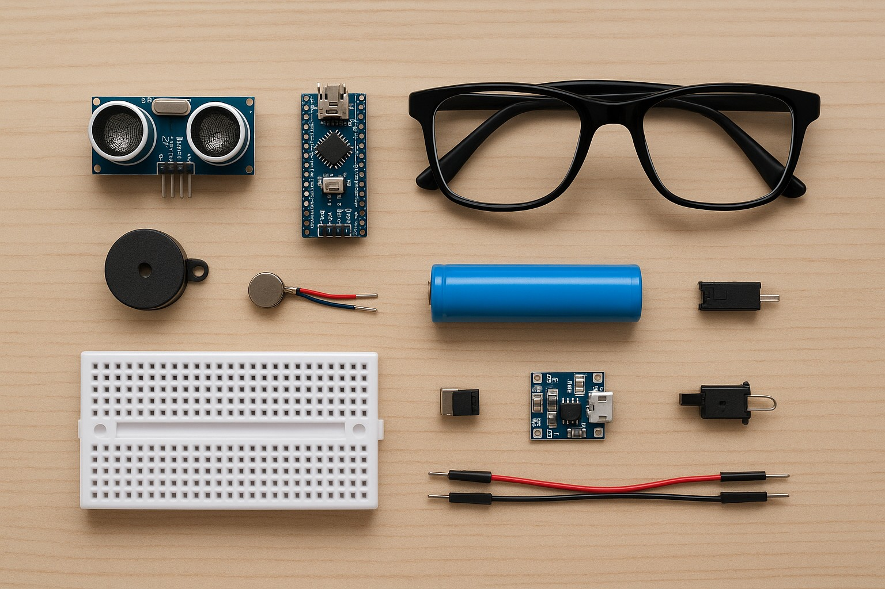
Figure 3: Main Components Required for the Project
6. Working Principle
The HC-SR04 ultrasonic sensor sends ultrasonic waves toward an object. When the waves reflect back, the Arduino Nano calculates the approximate distance based on the travel time. If an obstacle is detected within a predefined distance, the buzzer and vibration motor provide an alert to the user. The warning can be programmed to become faster as the obstacle gets closer.
7. Arduino Nano Pin Connections
- HC-SR04: VCC → 5V, GND → GND, TRIG → D9, ECHO → D10.
- Piezo Buzzer: Positive (+) → D6, Negative (–) → GND.
- Vibration Motor: Controlled through a transistor/MOSFET from D5; use a suitable motor supply and common GND.
- Power: Battery → Slide Switch → suitable regulated power input for the Arduino Nano.
- TP4056: BAT+ → Battery +, BAT– → Battery –, IN+ / IN– → 5V USB charger input.
Safety/technical note: A vibration motor should not normally be connected directly to an Arduino Nano digital pin. Use a transistor/MOSFET and a protection diode. Also ensure the 18650 battery is charged and regulated appropriately for the Arduino and other components.
8. Main Features
- Obstacle detection using ultrasonic sensing.
- Audio warning through a Piezo Buzzer.
- Tactile warning through a vibration motor.
- Portable wearable design.
- Rechargeable battery-based operation.
- Low-cost and easily available components.
9. Advantages
- Can help visually impaired users detect nearby obstacles.
- May reduce the risk of collisions with objects.
- Provides both sound and vibration alerts.
- Portable and wearable.
- Affordable prototype using commonly available components.
- Combines electronics, programming and social innovation.
10. Applications
- Assistive technology prototypes for visually impaired people.
- School and science exhibitions.
- Arduino and robotics learning projects.
- Wearable electronics projects.
- Obstacle-detection demonstrations.
11. Limitations
- The prototype mainly detects objects within the sensor's field of view.
- Ultrasonic sensors may not reliably detect every type of surface or object.
- It should not be considered a replacement for a white cane, guide dog or professional mobility aid.
- Battery life depends on the battery capacity and circuit design.
- The prototype requires further testing before real-world use.
12. Future Improvements
- Multiple ultrasonic sensors for wider coverage.
- Voice guidance and audio messages.
- GPS and location assistance.
- Bluetooth/mobile application integration.
- AI-based object recognition.
- USB-C charging.
- Miniaturized PCB-based circuit.
- Adaptive vibration patterns based on obstacle distance.
13. Social Impact
Smart Blind Glasses demonstrate how science and technology can be used to address a real-world accessibility challenge. The project combines Arduino, sensors, electronics and programming to create a practical assistive technology prototype that can provide additional obstacle information to visually impaired users.
14. Conclusion
Smart Blind Glasses are a low-cost Arduino-based assistive technology prototype that uses ultrasonic sensing, sound and vibration alerts to help detect nearby obstacles. The project demonstrates how simple electronic components and programming can be combined to develop a meaningful solution to a real-world problem.
Project Theme: Assistive Technology + Robotics + Electronics + Social Impact

