***Abstract***

*Computers have come a long way to become a part and parcel of people’s everyday life. There is a rising need to provide innovative solutions to meet the ever-increasing need and provide new features which will make work easier for people. This report gives a detailed insight into one such new feature which would possibly soon see the light of the day. The idea is to create air type keyboard, which would take the typing technology one step further by doing away the need for physical keyboard. The gloves worn by the user would allow it to type directly on the surface. This report first introduces to the background and explains the idea followed by providing a detailed explanation of the algorithm used and its working. The description is first categorized in two broad category of hardware side and the software side. The Hardware part focuses mainly on the sensors and the motherboard used followed by the glove construction details and its implementation. The software category gives a detailed explanation of the algorithm used and the following code implemented.*

# Introduction

As the product becomes more popular, more and more innovations are required to ease the current challenges and provide more features. It is important that product should keep its pace and keep on upgrading. Since the advent of computers, a keyboard has undergone a vast change in its design and features. The current generation of keyboard take it to a new level with idea being to do away with the physical keyboard. A different variant of this scheme in the form of finger sensor keyboard is being proposed in this report. Now every computer user have their own unique typing pattern, with some using their Index finger to type most of characters while others use all of their fingers to type. This correlation between fingers and the keys is known as the Keystroke Dynamics. Every user will have his own unique Keystroke Dynamic. Finger Motion Keyboard uses this correlation to become their personal keyboard by learning the keystroke dynamics of all the individual users. The device makes use of the hand gloves to monitor finger motion and learn the user’s keystroke dynamics thus eliminating the requirement of physical keyboard.

The main objective of this report is to design gloves with motion sensor, pressure sensor along with an algorithm to associate keys with finger motion and to design an algorithm which makes use of the training data to omit resultant keys.

Keyboard Technology

In early era when computer technology was an infant, type writers were used as text based entry device. Modern computer keyboard evolved from early teleprinters and keypunch devices. As continues use of QWERTY layout, invented by Christopher Sholes in 1870s, in typewriter the same layout were adopted by electromechanical keyboard because of its widely use. He could not have known that his design persists for 150 years even in digital world also. In this rapid change of high technology, computer keyboard is undoubted king of computer input device.

Some recent technology started taking place of keyboard and requirement of physical keyboard has been seriously threatened. Innovation in image processing, speech recognition and gester control are raising its power to replace physical existence of computer keyboard. There are some existing keyboard technologies or concepts which eliminates the need of physical key describes below.

Projection Keyboad

<https://en.wikipedia.org/wiki/Projection_keyboard>

Engineers at IBM patented optical virtual keyboard in 1992. This keyboard takes human finger movement input by camera mounted on device and it tracks key pressing actions and interprets it as operations which make on physically non-existent input device like a plain surface or keyboard layout printed surface. This keyboard uses laser or beamer to project virtual keyboard on a surface. One camera or sensor has been mounted on this device to track down movement of keyboard. They use second infrared based layer just above the surface to track down keystrokes action. When this sensor breaks or get inference in layer, it track down finger coordinates to predict key.

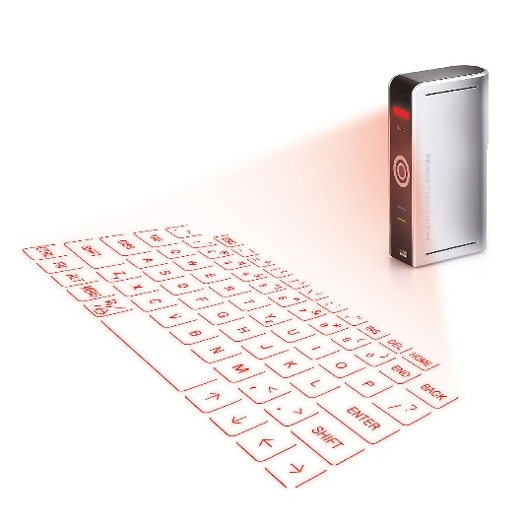

http://www.uncommongoods.com/images/items/24900/24904_1_1200px.jpg

Orbital Keyboard Technology

Orbitouch keyboard is one of the keyboard technology that doesn’t need fingers or wrist motion to type. It uses two domes and it can slides through 8 direction in its orbit. To type a letter, user needs to slides right dome to that letter and left dome to its corresponding color irrespective to which dome moves first. These keyboard is well used for person with low vision, Cerebral palsy and other disabilities.

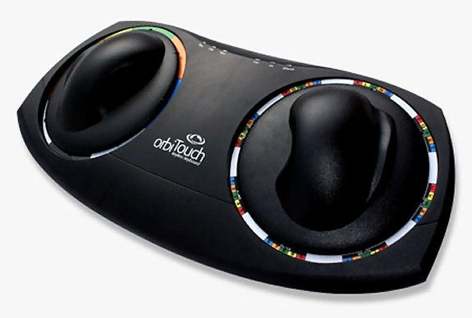

http://dev2.blueorb.me/wp-content/uploads/2014/12/orbitouch_white_background_1024x1024.jpg

<http://orbitouch.com/>

No-key keyboard

http://www.yankodesign.com/2008/06/12/lights-camera-glassaction/

<http://gizmodo.com/5015723/no-key-glass-touch-keyboard-is-antithesis-of-steampunk/>

No- Keyboard is concept keyboard designed by Kong Fanwen. This keyboard is design is minimalistic and uses projecting laser touch. This keyboard uses a very thin light beam just above the well etched glass sheet and camera inline with light beam. Camera senses user’s contact with glass and send appropriate information to PC. This ultimate motion capture technology is design is water proof also.

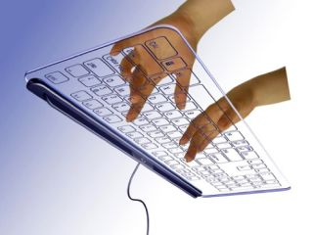

Gest

<https://gest.co/>

https://www.kickstarter.com/projects/asdffilms/gest-work-with-your-hands

Gest is wearable keyboard that allows user to control computer or mobile with hand gestures. It uses IMU(inertial measurement unit) to track down finger movement. It also used for designing, gesture based any operation and typing. This is also used for some virtual reality devices to control actions. This wearable is designed for pro typist who can actually type as pre-defined keystroke dynamics.

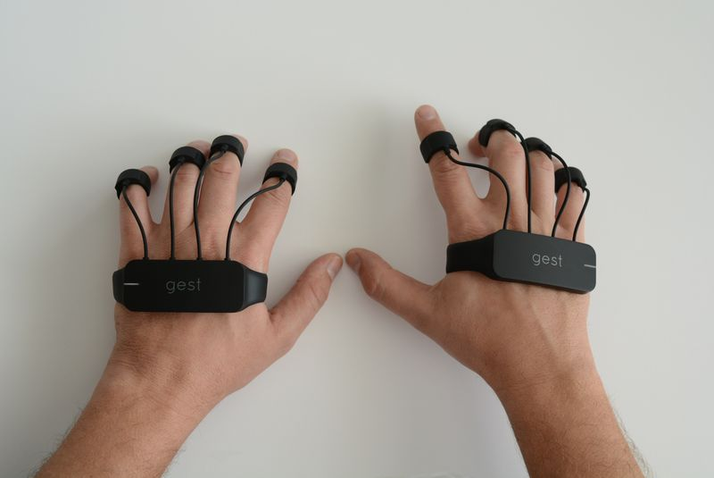

https://cdn0.vox-cdn.com/thumbor/0_0gAXUOI5KpDxp3ksaCfqhgI8g=/800x0/filters:no_upscale()/cdn0.vox-cdn.com/uploads/chorus_asset/file/4208015/DSC_4261.0.JPG

The ring

<https://www.kickstarter.com/projects/1761670738/ring-shortcut-everything>

The ring is wearable input device that allows user to control. This device allows user to use gesture control, text based typing and alerts. It uses letter recognizing software to recognize letter by action of writing that letter. They use motion sensors and senses finer motion for every letter and predict letter. This is similar to handwriting recognition with its motion.

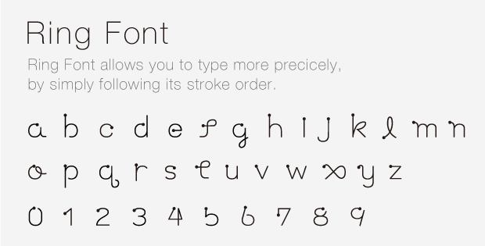

https://ksr-ugc.imgix.net/assets/001/684/308/5a26f009a1e10b8058810ada74289f40_original.png?w=680&fit=max&v=1393497222&auto=format&lossless=true&s=aacd298f5ce26ccd9cdff0d4acc109cc

Tap

<http://www.tapwithus.com/>

Tap is wearable input device that allows user to type and control mobile as well as computer devices. It is one hand device that user needs to wear on fingers which track finger movements to predict letters. It doesn’t work with traditional QWERTY layout keyboard, instead it uses pre-defined finger taping for character like taping one finget will give best fit vowel and combination of other fingers throw defined character. Device uses Bluetooth to send all commands to connected devices. This also used for people who uses VR environment. They also provide some practice games and sources to get used to with this keyboard interface.

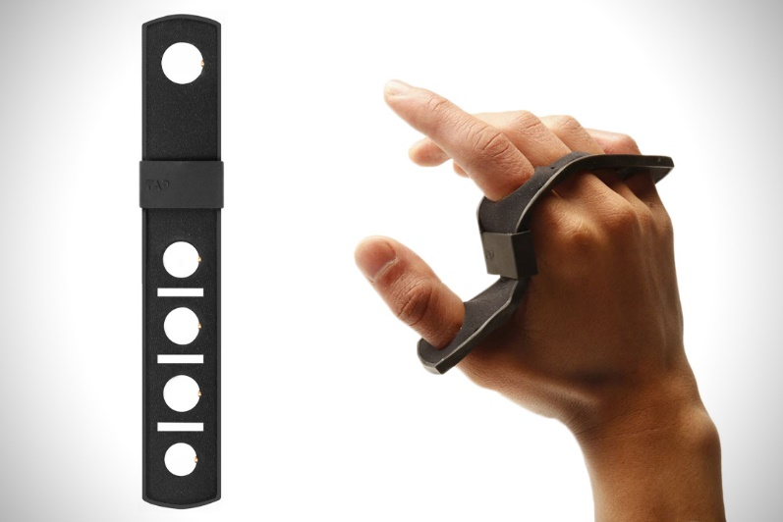

http://cdn.hiconsumption.com/wp-content/uploads/2016/05/Tap-wearable-Keyboard-01.jpg

# **Gloves design**

This chapter of thesis is divided in two subsections. In the first subsection we discuss about the designing of sensor gloves (Hardware work). While the second subsection describes the proposed algorithm to train the system and utilize it to predict words. (Software work)

## Hardware Work

The key challenge in creating the AIRtouch keyboard is the need to measure the finger motion with apt precision. An important requirement for this is to design wearable sensors gloves with specific focus on bending and tapping sensors. Bending sensor will provide the angular position of finger while tapping sensor senses key pressing activity.

In our approach it is of prime importance to find out which finger is being used by the user to press the key, accordingly Tapping sensor will help in finding out which finger is utilized. Since a user can use multiple finger for pressing the same key as well as press different keys with the same finger, tapping sensor alone stands insufficient in deciding which key is being pressed. This is 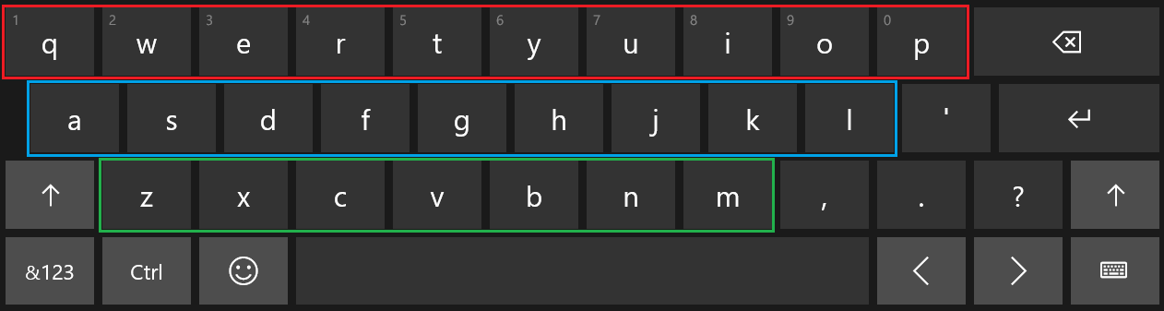

**Figure 1: Three different layers of keyboard**

where bending sensor comes into the play. Based on the curvature of the bend or the angle along with the data from the tapping sensor the decision is made for which key is pressed. This is a pivotal role in the entire functioning of the keyboard and at the same time it is equally tedious. To simplify it further and to get more accurate results the keyboard is further divided into three layers. Fig.1 depicts the three different layers. Red rectangle indicates Upper Layer of the keyboard, blue rectangle indicates Middle Layer, and green rectangle indicates Lower Layer. After setting up the sensors on the gloves it is important to note that besides its ability to measure bending motion, gloves should be easy donning, easy removals, cost effective, durable, and comfortable.

Another vital component of this design is mother board. A rapid evolution in controller technology makes selection of controller harder. Merging functionality and faster processing times are fundamentals of controller. Considering the vision of future development in this design, open source development kit was chosen. Among all open source platforms, Arduino is one of the best open source electronics pattern development platform with flexibility in use of hardware and software. Arduino is good at sensing environment through interfacing various sensors and processing in real time data using ATmega328P. *add all controller options.

Two sensors are needed to fulfill the goal, one to sense the pressing activity and other for determining motion activity. Therefore, Sensor gloves are made with two sensors: Flex sensor and Force Sensitive Sensor.

## Bending Sensors

### Microbending sensors

Microbend sensors are based on coupling and leakage of modes that are propagating in a deformed fibre. Usually one achieves this deformation by employing corrugated plates that deforms the fibre into a series of sharp bend with small bending radii. In our laboratories we have developed a highly sensitive chemical sensor by inducing permanent microbends on a bare plastic optical fibre. The output intensity is found to be linearly dependent on the logarithm of concentration of the absorbing species surrounding the the bent portion of the fibre. This sensor can even detect very low concentrations , of the order of nanomoles per liter. and the dynamic range of the sensor is found to 6 order of magnitude. By carefully choosing the reagents this microbend  sensor can be used to detect different chemical species.

<http://photonics.cusat.edu/Research_Fiber%20Sensors_work%20at%20ISP.html>

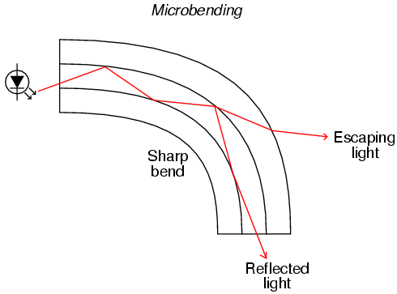

http://obrazki.elektroda.pl/2733383600_1383139811.png

### Flex Sensor

Flexion Sensor (from Latin flectere, ’to bend’) also called bend sensor, measures amount of deflection caused by bending of the sensor. This is nothing but flexible conductive ink printed on flexible layer of polymer. As sensor bends, it stretches flexible ink inside, extending itself, which results in reduction of cross section area of ink layer. As the sensor flex, resistance across its two point change accordingly.

As microbending sensors are very expensive and it has very rare support as well as it needs some laboratory experimental devices to use it. Whereas flex sensors are easily available, much cheaper option and it has support which describes the use sensors with various microcontroller and processor based system.

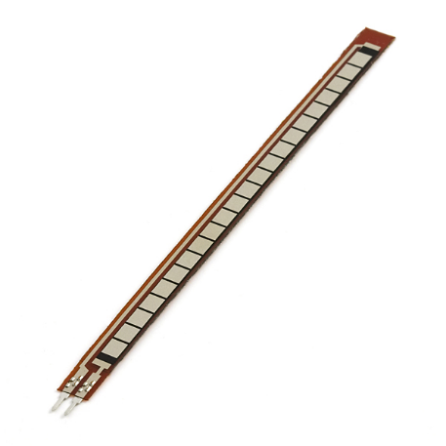

**Figure 2 : Flex Sensor \*\***

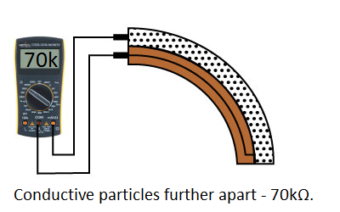 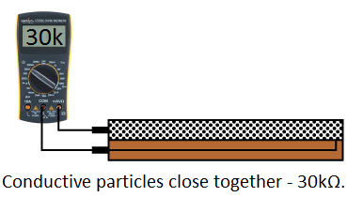

<https://learn.sparkfun.com/tutorials/flex-sensor-hookup-guide>

The simplest way to implement this circuit in my project is using voltage divider circuit, where we pass current from one pin and measure voltage from another end. Based on input current and output voltage with input voltage value we can calculate resistance value using below equation.

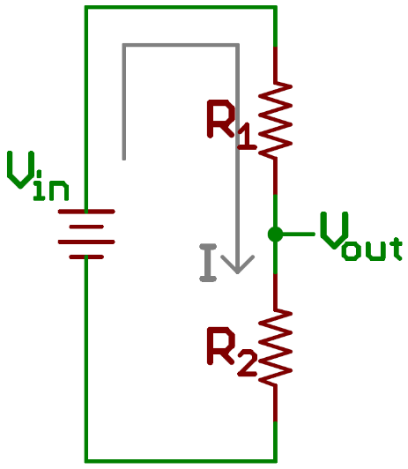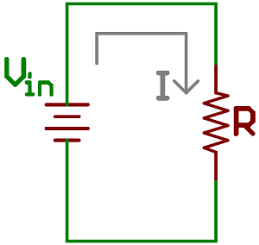

Here R1 is flex sensor, R2 is voltage divider resister, Vin is input provided by Arduino board, Vout is output voltage given to analog pin of Arduino board.

Taking effective total resistance R = R1 + R2

Current I = Vin / R

Vout = R2 * Vin / (R1 + R2)

Using above equation, we know value of R2, input voltage Vin and measured output voltage Vout, we can calculate value flex sensor resistance R1.

### Force Sensitive Sensor

The purpose of Force Sensitive Resistor also known as FSR is to measure amount of force or pressure. It contains conductive polymer which are used in Bend Sensors. The conductive polymer changes resistance when force is applied on the sensor. Here, this sensor is used to detect finger tapping considering it same as key pressing activity. Various force sensitive sensors are available in market, as per my thesis requirement, I want sensor that fits on fingertip and also it should be printed over flexible PCB so that it can fit beneth the fingertip without hassle. To cover finger taping activity, choice of round shaped sensor is the good option among rectangular, square and strip shape sensor.

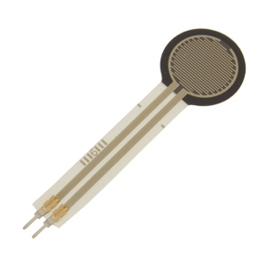

**Figure 3 :Force Sensitive Resistor \*\***

### Arduino Board

Arduino is a company which design and develop open source computer hardware and software. They develop hardware based on microcontroller and user friendly coding language with general purpose interface support. They have designed several kits based on different requirements. Sensor gloves require eight digital input pins to detect finger tapping action, eight analog input pins to detect bending of fingers and UART interface to transmit data to computer. Arduino mega seems a good fit as it fulfills all the requirements for the glove development. The Arduino Board runs over a 5V power adapter input or USB power. In early project process, I used Arduino UNO board by Arduino that cost me around $25. That board has 6 analog input pins and 2 PWM pins which I (<https://arduino.stackexchange.com/questions/10041/can-i-connect-a-pwm-pin-on-one-arduino-to-an-analog-input-on-another>) used as analog pins by making resistor capacitor circuit and adding small programming module. Arduino UNO has 8 digital input pins. Due to wire mishandling board got burnt and it started showing random behavior. At the same time, I got deal on Arduino Mega board from craigslist. Due to budget constrain, we must go with cheaper option.

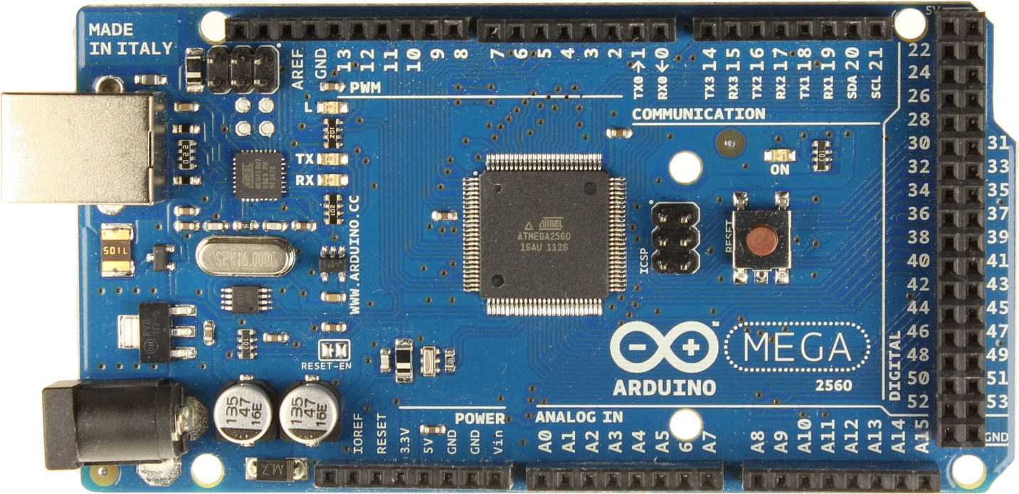

**Figure 4 : Arduino Uno \*\***

### Gloves construction:

To make the gloves easy to wear and more comfortable for the user and knowing that ease of use would be of prime importance, few models were made to experiment with various size and distinctive material of gloves. Different permutation and combinations were done. Several materials like cotton, rubber and leather were tried, but it was important that the material exhibit stretch so that fingers’ motion would not be restricted because of gloves’s less adaptability and sensors must slide on material instead of stick on it. Once the gloves to be used were finalized the pressure sensors were mounted correctly on finger tip with accurate precision with the sole intention that the sensors gave key pressing notification in all three layers. Flex sensors were placed on top of finger with sliding mechanism on proximal phalanx of finger and fixed from tip of finger. Figure # presents the gloves along with their connection to arduino board. Wires from sensors pluged in to bread board to give all connection line pull ups with registers 22K and 10K, to flex sensor and to pressure sensor respectively.

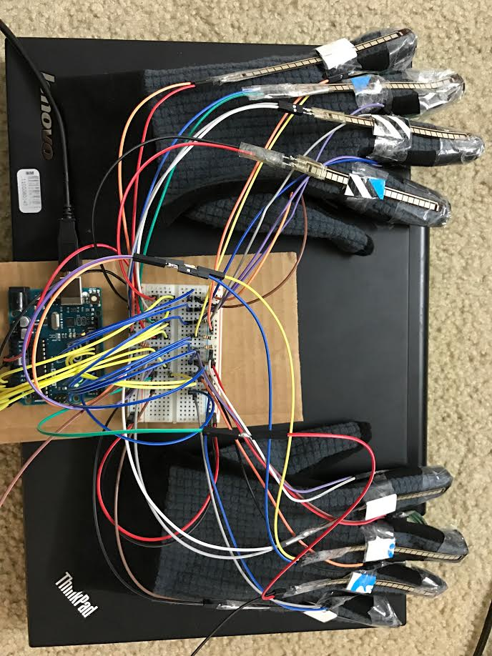

**Figure 5 : Sensor gloves and arduino board \*\***

### Hardware Schematic Diagram

Figure # shows schematic of gloves design, Resistance value of R1-R8 is 22K Ohm and R10-R17 is 10K Ohm. As a result of several trial and errors, I concluded these values of resisters to get desired result. Explain this

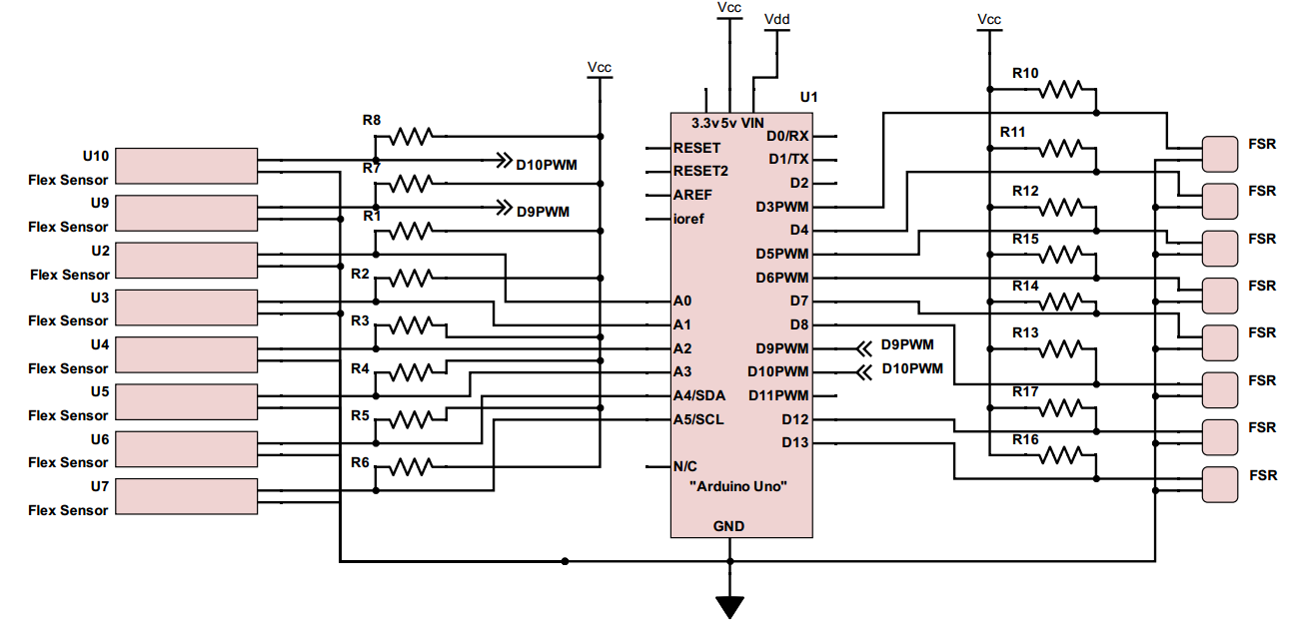

**Figure 6 : Schematic diagram**

## Top Level Block Diagram

Explain this

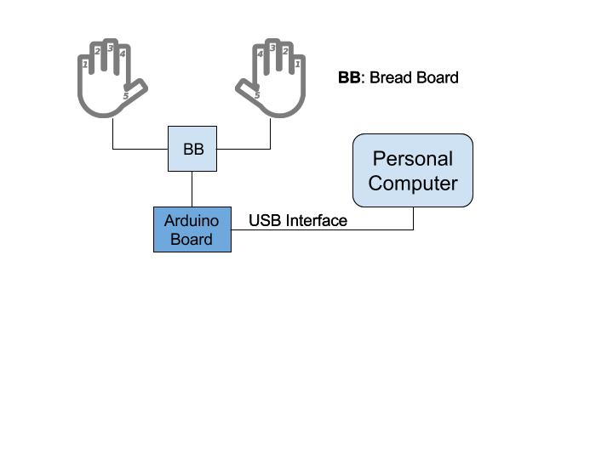

**Figure 7 : Top level block diagram**

# Software:

My thesis used following software and codes to execute.

1) Arduino code

2)‘PLX-DAQ’ - Parallax Data Acquisition Tool

3) Python code.

## Arduino Code

The code is written to collect data from sensors in Arduino language. The coding structure of Arduino always consists two parts: Setup function and Loop function. Which setup function used?

**Setup Function**: This function initializes all the pins as per the requirements. It also initializes variables which are used in Loop function.

**Loop Function**: This function runs in loop and continuously send data to computer on UART interface.

## PLX_DAQ

PLX-DAQ, Parallel data acquisition tool, used to get data from microcontroller with sensor system to Microsoft excel. PLX_DAQ is an add-on for Microsoft excel, acquires up to 26 channels from any parallel microcontroller interface. This tool gives real time data input facility on any COM port with baud rate up to 128K. Figure # displays reading of flex sensors coming from Arduino board. The data is exported to an excel sheet for determining word phase once training phase has been done.

Now, I have created python module which takes input from COM port and store it in CSV file. I don’t need this tool anymore.

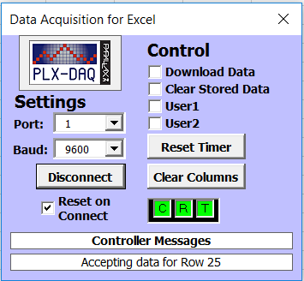

**Figure 8 : PLX-DAQ tool**

3) Python code for data acquisition

PLX- DAQ is good tool for sensor based microcontroller system. Our system required to process these data in realtime within the excel spreadsheet where PLX-DAQ stores data. PLX-DAQ spreadsheet doesn’t allow any other operation to work on its spreadsheet. So every time fetching this data to another excel spreadsheet and to process it, makes this process bit slower and more complex. We found better option of using python as these programming language has pool of libraries that interact with hardware also. Python library pySerial encapsulate the access of the serial port. ( <https://pythonhosted.org/pyserial/pyserial.html#overview> ) This library allows user to take input in different bit size, stop bits, and parity flow control with RTC(Real Time Clock). It also allows to set input delay. It also compatible with all I/O libraries of python.

## Algorithms

### Decision tree

Decision tree is decision support algorithm which uses branch and tree structure to portray possible outcomes. It constructs classification model in form of tree structure. Every node of a decision tree is divided into smaller subsets and design an associated decision tree with incremental development. Final tree carries tree nodes and decision nodes. One of the approaches to implement decision tree is ID3 algorithm.

Construction of decision tree follows top down approach from root node and imply classification of data into its subset that contain different values. ID3 algorithm uses entropy of attributes and collect information based on calculated entropy and target values. Why I thought of using this?

### Markov chain Model

Markov chain introduced by Andrew Markov, is an algorithm that calculates probabilistic model of system which changes system state over a time. Markov chain follows the principle of ‘Memoryless property’, a property of certain probability distributions. Using this model one can predict the probability of future states solely based on the current state instead of sequence of states. This nature of algorithm makes it easy to calculate conditional probability that is to be applied in numerous applications. Markov chain records previous state changes and calculate conditional probability transition matrix to predict future state transition probability. Markov chain provides run time training features. Algorithm can change transition probability at runtime based on current data input. This feature will help AIRtype to get train from users while users are using it.

Why your own technique?

### Selection of Algorithm

As decision tree is constructed based on entropy of attributes of a system, it is harder to update decision tree when the probability of any attribute changes in real time. This forces the system to reconstruct a decision tree every time the probability of any attribute changes. While Markov chain helps to overcome this redundant reconstruction activity and makes it faster by chaining particular probability only. That is why, I decided to use Markov chain model over the decision tree.

To use Markov chain process for my model, We need to compute finger – character probability and have to multiply with character transition matrix. After processing these multiplication, maximum probability by finger to character is my possible prediction. In my thesis I wanted to predict two parameters one is layer and one is character after predicting the layer, while complex Markov theory only applies to predict only one prediction.

## AIRtype Keyboard algorithm

Viterbi Algorithm:

The Viterbi algorithm is a [dynamic programming](https://en.wikipedia.org/wiki/Dynamic_programming) [algorithm](https://en.wikipedia.org/wiki/Algorithm) for finding the most [likely](https://en.wikipedia.org/wiki/Likelihood_function) sequence of hidden states – called the Viterbi path – that results in a sequence of observed events, especially in the context of [Markov information sources](https://en.wikipedia.org/wiki/Markov_information_source) and [hidden Markov models](https://en.wikipedia.org/wiki/Hidden_Markov_model).(wiki). Markov process which is finite-state discrete-time process comes under compound decision theory, which decides probability of upcoming event based on observations.

In this product, our observation sequence is alphabets** in word, and our desired output is to predict what would be the next alphabet based on previous alphabets typed in a word.

** remove Viterbi and come up with mathematical computation of your own algorithm. Why Viterbi? Alternatives not?

Training Device:

Certain assumptions were made while designing training phase to run device algorithm fluently. As this device is using user’s typing pattern to predict alphabets while user use this device, so training becomes an essential part of this process. In training phase device learn user’s typing pattern based on following parameters: Finger which is used to type letter, Finger bending angle, layer in which key resides and letter which is pressed. Training phase mainly rely on Finger, training letter which is pressed and bending angle of finger. As user is typing on actual keyboard while getting trained layer parameter does not consider because keyboard layout is prefixed and location of each key (relation between key and layer) is known.

Training process:

To train gloves user needs to teach his/her typing pattern to gloves. We designed training dataset which contains all alphabets in various combination of words. This data was made from pangram sentences (pangram words – sentence which contain all 26 letters of alphabets) which used to test out new typewriters. We are using this data to learn typist’s typing pattern. We are recording typist’s finger and finger bending angle for each letter in training dataset. As we already assumed user is typing correct letter only while training gloves, we can determine layer in which particular key resides. System only takes input when pressure sensor changes it’s input from 0 to 1, that process determine key pressing activity of user. At key pressing activity, algorithm takes finger bending input from particular finger only. Which helps device to determine/set layer determine parameter while system is in use. We are taking input from finger bending at every 100 milliseconds for smooth data. Usually user presses one key for around 500miliseconds to 900 miliseconds, so we are getting 5 to 9 inputs of bending angle for every key. To smooth it we determine it’s maximum and minimum value among all sample data which will be used to set layer’s minimum and maximum limit for particular finger. One 3*16 matrix is maintained which stores minimum and maximum layer limit for each finger. System also update one more matrix database which contain data of finger vs alphabet, which helps system to understand user’s typing behavior. It describes relation between which finger user uses to presses particular key. It will associate sets of letters to particular finger with probability to press that keys with the finger. Now we have all information about finger bending angle to determine layer and finger-letter associativity to determine which key is pressed with probability data, which are enough to determine user’s typing behavior. Once user complete training, system will be ready in use.

*Update block Diagram once you complete writing

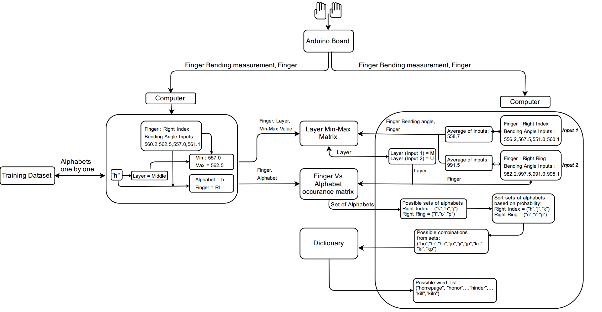

Device In Use:

After device got trained, we can put this device in use. This device runs over certain limitations and assumptions. This device learns user’s typing pattern to predict key value based on user’s finger movements. User must have predictable typing pattern; random typing pattern may lead this device to an unpredictable state. In training part algorithm capture finger bending angle range for each keyboard layer. To predict correct layer user can not lift wrist once starts typing.

Limitations: As of now system uses a dictionary created from Shakespeare’s work, to predict word. So, system is unpredictable for nouns. Nouns which are used in Shakespeare’s work can be predict using this device. Right now, system is designed to predict word which contain only alphabets.

Input parameters while device in use : Finger, Finger bending angle

Pre-req : Layer Min-Max matrix, Finger VS. Alphabets occurrence matrix, Viterbi transition matrix – already updated letter transition based on dictionary words, premade word dictionary

When system is in “Device in Use mode”, connect gloves with Arduino board and connect Arduino board with Computer on COM1. Arduino transmit information in serial data form, serial.py module receive data from serial port COM1 and separate information about finger and finger bending angle. System derive layer information from Layer Min-Max matrix. Now system has three parameters: Finger name, Finger bending angle and Layer Information. Among those parameters finger and layer information used to predict possible alphabets set from Finger Vs. Alphabet occurrence matrix. From every input system fetch sets of alphabets and rearrange based on occurrence of that alphabet by input finger so that most probable pressed alphabet with input finger comes first in set. At every fetches system create combination of alphabets except first fetch. Now possible combinations again rearrange based on current alphabets to following alphabets probability from Viterbi matrix. New set of combinations again checks possible words from dictionary and suggest to user. If system doesn’t find a word from dictionary, it auto corrects up to two alphabets using two distance word correction algorithm. Once user confirm the word, system updates following data: 1. It updates particular word frequency in dictionary so that next time that word comes first with given combinations of alphabets set. 2. It updates Viterbi matrix, helps to predict best alphabets combinations. 3. System records finger inputs until user confirm the word so that system can update alphabets occurrence for associate finger in finger Vs. Alphabet occurrence matrix.

**Machine learning**

Machine learning is a method of data analysis that automates analytical model building. Using algorithms that iteratively learn from data, machine learning allows computers to find hidden insights without being explicitly programmed where to look. (<https://www.sas.com/en_us/insights/analytics/machine-learning.html>) .

**Training data**

As we know machine learning deals with program learning from data sets. Training data is the data on which the machine learning program learn to perform correlation tasks.

Every machine learning algorithm needs sets of data, which is called training dataset. Training data sets and input data together we believe that construct predictive relationship between input data and output action. Training data should be as closer to the actual output as possible. A well pre-labeled and impartial data will help trained classifier to perform more accurate prediction. Amount of training data set depends on complexity of the concept of predictive model.

Our algorithm required training data sets of alphabets as we are predicting alphabets. Concept device designed to predict all alphabets only, so our training dataset would cover all alphabets with enough frequency. We designed training text dataset from pangram sentences which covers all alphabets in meaningful sentences. (available on) Write more

*“The five boxing wizards jump quickly”*

*“Sixty zippers were quickly picked from the woven jute bag”*

*“Sphinx of black quartz: judge my vow.”*

**Layer Min_Max Matrix**

As discussed in setup procedure, we divided computer keyboard alphabets in three layers : Upper layer (keys:‘q’,’w’,’e’,’r’,’t’,’y’,’u’,’I’,’o’,’p’), middle layer (keys: ‘a’,’s’,’d’,’f’,’g’,’h’,’j’,’k’,’l’) and lower layer (keys: ‘z’,’x’,’c’,’v’,’b’,’n’,’m’). This 3 X 16 matrix contain data of flex sensor input for each layer row wise. Left part of half matrix (3X8) contains minimum value of flex sensors while typing in particular layer by fingers. Remaining half part contains maximum value of flex sensors for the same process. By default we set all values to 2000 because our flex sensor only goes from 100 – 1200, that means after training if we find any two values 2000, we can conclude non used finger in particular layer.

|  |  |  |  |  |  |  |  |  |
| --- | --- | --- | --- | --- | --- | --- | --- | --- |
|  | F_min0 | F_max0 | F_min1 | F_max1 | F_min2 | F_max2 | F_min3 | F_max3 |
| L0 | 571 | 629 | 474 | 810 | 463 | 752 | 474 | 857 |
| L1 | 401 | 658 | 618 | 846 | 506 | 879 | 521 | 973 |
| L2 | 582 | 662 | 774 | 857 | 615 | 890 | 589 | 1078 |

|  |  |  |  |  |  |  |  |  |
| --- | --- | --- | --- | --- | --- | --- | --- | --- |
|  | F_min4 | F_max4 | F_min5 | F_max5 | F_min6 | F_max6 | F_min7 | F_max7 |
| L0 | 557 | 853 | 474 | 1295 | 155 | 984 | 387 | 600 |
| L1 | 701 | 987 | 557 | 1364 | 209 | 973 | 376 | 759 |
| L2 | 698 | 1157 | 1074 | 1327 | 2000 | 0 | 387 | 832 |

**Training Phase:**

|  |  |
| --- | --- |
| **Input Observations:** | Q1,Q2,Q3,Q4,Q5…Qn where Q1,Q2,…Qn are flex sensor inputs from Arduino board. |
| Minimum = Qmin = min(Q1,Q2,Q3,….Qn) | |
| Maximum = Qmax = max(Q1,Q2,Q3,….Qn) | |
| **Output:** | [Layerx][Finger_miny] = min([Layerx][Finger_miny] , Qmin)  [Layerx][Finger_maxy] = max([Layerx][Finger_maxy] , Qmax) where x € {0,1,2} that denotes the layer and y € {0,1,2,3,4,5,6,7} that denotes the fingers. |

**System In Use:**

|  |  |
| --- | --- |
| **Input Observations:** | Q1,Q2,Q3,Q4,Q5…Qn where Q1,Q2,…Qn are flex sensor inputs from Arduino board.  F where F denotes finger input from Arduino board having values from 0 to 7. Values 0 to 7 denotes LL, LR, LM, LI, RI, RM, RR and RL respectively. |
| Qavg = avg(Q1, Q2, Q3 … Qn) where avg() gives arithmetic average. | |
| **Output:** | {I: [Layeri][Finger_miny] <= Qavg <=[Layeri][Finger_maxy] || i € {0,1,2}, y = F} |

**Finger Vs Alphabets occurrence matrix**

Our algorithm selects most probable alphabet for that finger in that layer. To achieve this goal, matrix is constructed by monitoring occurrence of alphabets by finger and updating it in format like alphabets in row and finger in columns. This matrix updates in both phase training phase and when device is in actual use. It is 27X10 sized matrix with labeled finger name in first row and alphabets in first column. Second column filled with layer information in form of ‘0’,’1’ or ‘2’. ‘0’ represent Upper Layer(UL) , ‘1’ represent Middle Layer(ML) and ‘2’ represent Lower Layer(LL)

|  |  |  |  |  |  |  |  |  |  |  |
| --- | --- | --- | --- | --- | --- | --- | --- | --- | --- | --- |
| LETTER | LAYER | LL | LR | LM | LI | RI | RM | RR | RL | Total_Occurrences |
| q | 0 | 0 | 7 | 0 | 0 | 0 | 1 | 0 | 0 | 8 |
| w | 0 | 0 | 23 | 0 | 1 | 1 | 1 | 0 | 1 | 27 |
| e | 0 | 1 | 0 | 61 | 0 | 0 | 2 | 2 | 3 | 69 |
| r | 0 | 0 | 0 | 2 | 28 | 1 | 1 | 0 | 0 | 32 |
| t | 0 | 0 | 0 | 0 | 46 | 1 | 0 | 0 | 1 | 48 |
| y | 0 | 0 | 0 | 0 | 2 | 12 | 6 | 0 | 1 | 21 |
| u | 0 | 0 | 1 | 0 | 0 | 11 | 17 | 1 | 0 | 30 |
| i | 0 | 0 | 0 | 0 | 0 | 1 | 34 | 5 | 3 | 43 |
| o | 0 | 0 | 0 | 0 | 2 | 2 | 22 | 43 | 0 | 69 |
| p | 0 | 0 | 0 | 0 | 1 | 0 | 2 | 11 | 0 | 14 |
| a | 1 | 36 | 10 | 0 | 0 | 1 | 0 | 0 | 3 | 50 |
| s | 1 | 1 | 31 | 3 | 0 | 1 | 0 | 0 | 2 | 38 |
| d | 1 | 0 | 0 | 8 | 10 | 0 | 0 | 0 | 1 | 19 |
| f | 1 | 0 | 0 | 0 | 14 | 0 | 0 | 0 | 1 | 15 |
| g | 1 | 0 | 0 | 1 | 10 | 2 | 0 | 0 | 1 | 14 |
| h | 1 | 1 | 0 | 1 | 0 | 33 | 1 | 0 | 0 | 36 |
| j | 1 | 0 | 0 | 0 | 0 | 9 | 0 | 0 | 0 | 9 |
| k | 1 | 0 | 0 | 0 | 0 | 0 | 14 | 4 | 0 | 18 |
| l | 1 | 0 | 0 | 1 | 2 | 0 | 2 | 27 | 0 | 32 |
| z | 2 | 5 | 3 | 0 | 0 | 0 | 0 | 0 | 0 | 8 |
| x | 2 | 0 | 2 | 6 | 0 | 0 | 0 | 0 | 0 | 8 |
| c | 2 | 0 | 0 | 8 | 10 | 0 | 0 | 0 | 1 | 19 |
| v | 2 | 0 | 0 | 0 | 14 | 0 | 0 | 0 | 0 | 14 |
| b | 2 | 0 | 0 | 0 | 0 | 15 | 1 | 0 | 0 | 16 |
| n | 2 | 0 | 0 | 0 | 2 | 34 | 4 | 0 | 2 | 42 |
| m | 2 | 0 | 0 | 0 | 0 | 21 | 2 | 0 | 1 | 24 |

**Training Phase:**

|  |  |
| --- | --- |
| **Input Observations:** | F0,F1,…F7 , where F0,F1,…F7 are inputs from Arduino board for fingers LL, LR, LM, LI, RI, RM, RR and RL respectively.  L0, L1 and L2 where L0, L1 and L2 are identified layer from Layer Min_Max Matrix.  C0,C1,….Cn , where C0,C1,….Cn are single character input from training data. |
| **Output:** | FAM[Fx][Cy] = FAM[Fx][Cy] + 1 where x € {0,1,2,3,4,5,6,7} and y €{0,1,2,…n} and FAM is Finger Vs. Alphabet Matrix |

**In Use** :

|  |  |
| --- | --- |
| **Input Observations:** | F0,F1,…F7 , where F0,F1,…F7 are finger inputs from Arduino board  L0, L1 and L3 where L0, L1 and L3 are Identified layer from Layer Min_Max Matrix |
| **Output:** | Set {C0,C1…Cn} = FAM[Lx][Fx] where set{} would be sets of alphabets. |

**Transition Matrix**

To make prediction more powerful, we use probability of transition of alphabets in words. It is 26X26 sized matrix with considering labels alphabets from a-z in row and column both. This matrix contains occurrences of alphabet to the following alphabet. Purpose of building this matrix is to predict next probable alphabets based on current alphabet input and also remove unwanted zero probability alphabets.

This matrix is already constructed based on words from a dictionary, which will be used to predict the words. This matrix also gets updated when device is in actual use to get more accurate prediction. (Refer Image on Page#18)

**Training Phase:**

|  |  |
| --- | --- |
| **Input Observations:** | CCUR , CPRE where CCUR is current character and CPRE is previous character typed by user. |
| **Output:** | [CCUR][CPRE] = N+1 where N denotes occurrences of this combination of characters. |

**System In Use:**

|  |  |
| --- | --- |
| **Input Observations:** | CCUR , CPRE where CCUR is current character and CPRE is previous character typed by user. |
| **Output:** | N = [CCUR][CPRE] where N denotes occurrences of this combination of characters. |

**Dictionary**

One dictionary is maintained to predict final word based on input alphabets. This is pool of words collected from open source Shakespeare’s work. Concept device only predict words from dictionary only.

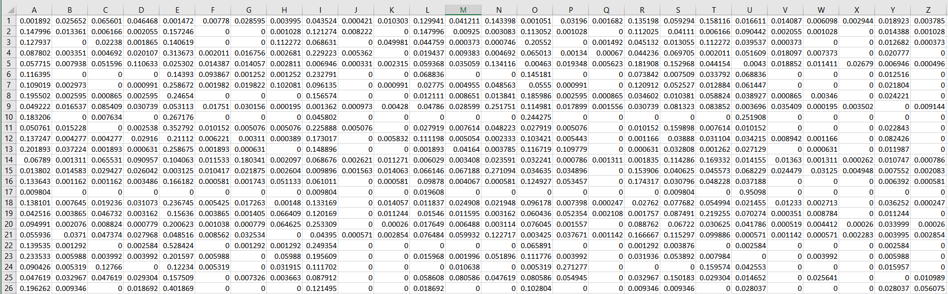

(<http://www.rinkworks.com/words/pangrams.shtml> (pagramword))