Project(11) - CI/CD Pipeline for Attendance Application
Kuldeep Dinkar Patil

Amazon S3 Buckets Used for Source and Deployment
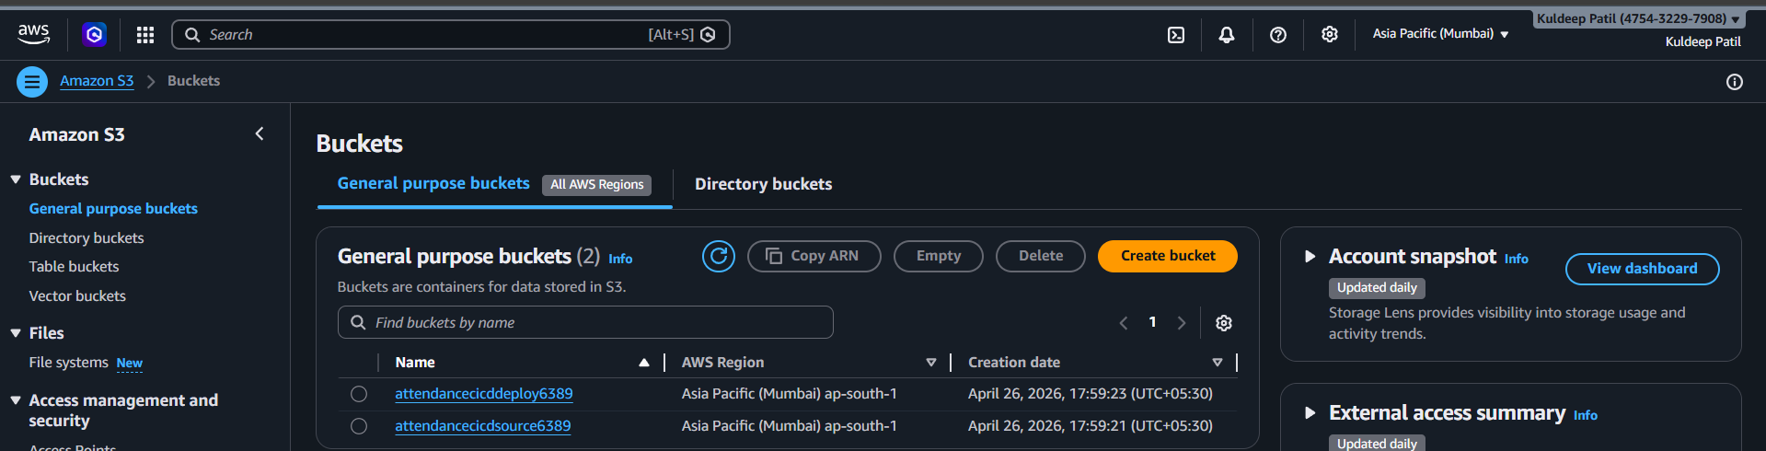
Successful Execution of AWS CodePipeline for Attendance Application
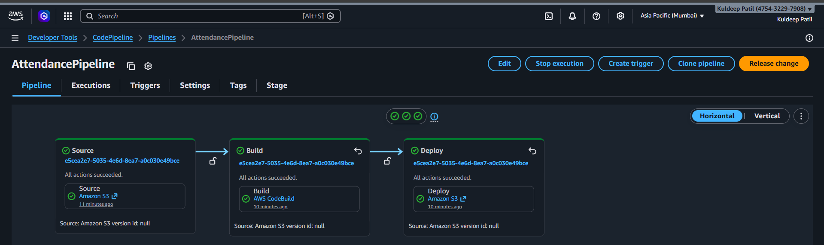
Attendance Application Successfully Hosted on Amazon S3
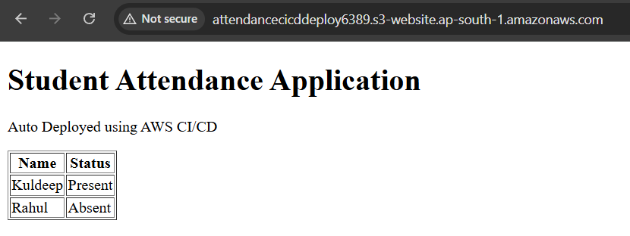

Successful Build Process Using AWS CodeBuild
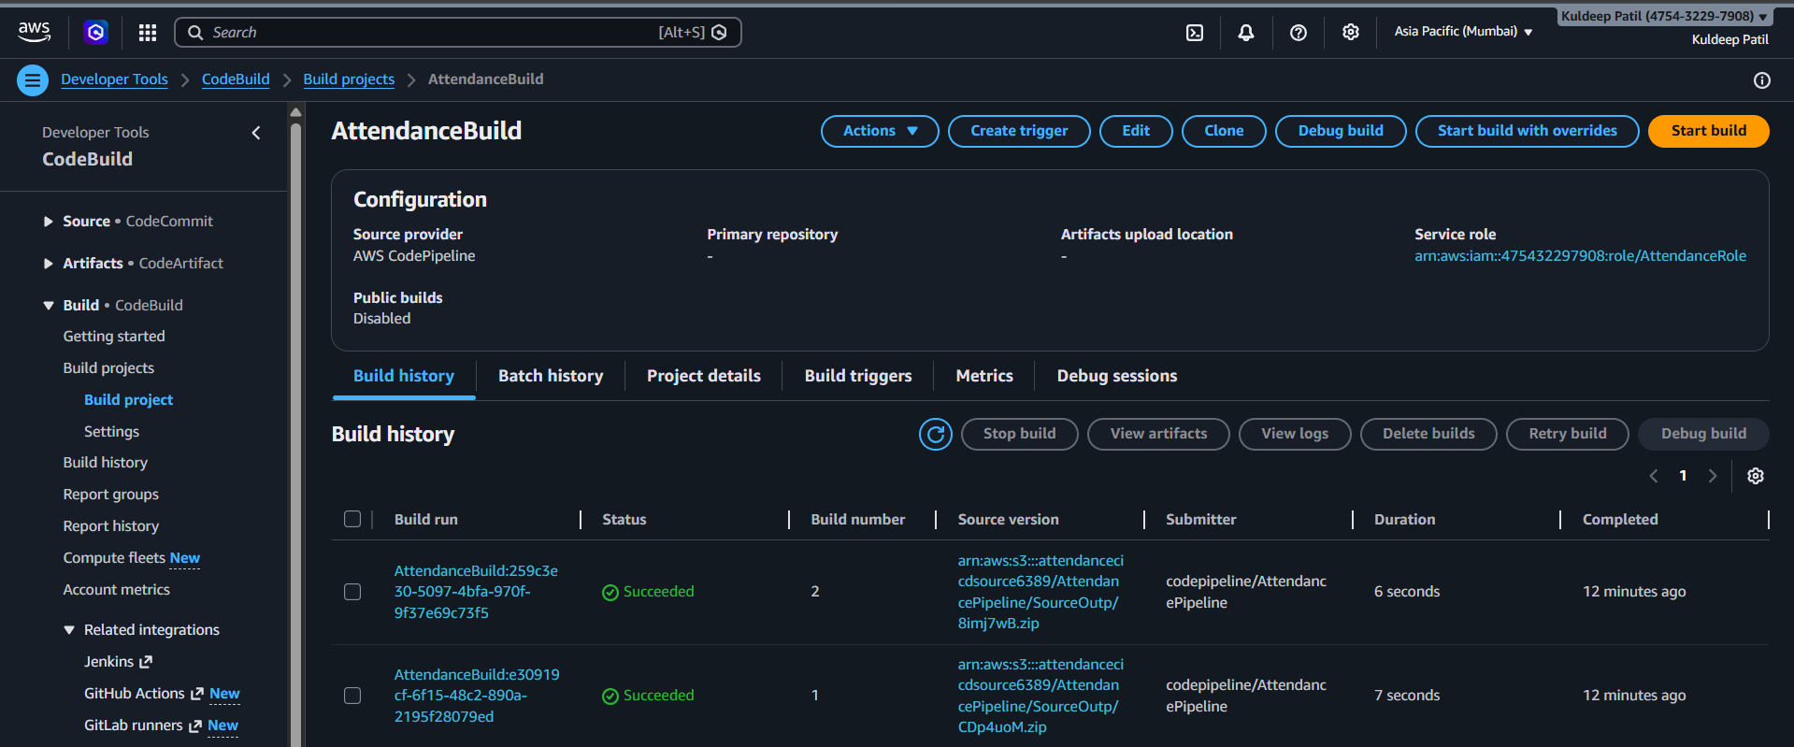
Static Website Hosting Configuration in Amazon S3
